CHAPTER 15
The Goal of Life
Strategic Lessons from Mahābhārata | Exam-Ready Revision Notes | Book pages 187 to 193
Chapter at a glance
- Core idea: Sanātana Dharma is not against wealth: the Avāhanti homa lists wealth, purity of mind, knowledge and students in order; the right sequence of goals is kāma (healthy desire) → artha → dharma → mokṣa (inner peace), and Vyāsa's four Bhārata Sāvitrī verses sum up the Itihāsa: never give up Dharma.
- Taittirīya Upaniṣad – Avāhanti homa seeks 4 things in order: dhana-prāpti, citta-śuddhi, jñāna-prāpti, śiṣya-prāpti.
- 'Tato me śriyam āvaha': wealth only after intelligence/dharmaśāstra knowledge – money is dangerous in the hands of the unintelligent.
- Correct sequence: Kāma (healthy) → Artha → Dharma → Mokṣa (inner independence, peace); today the goal is just Kāma with ends justified.
- Society's yardsticks (degrees, cars, titles) breed competition over collaboration.
- Bhārata Sāvitrī: 4 verses at the end of MB; reading them = benefit of the whole epic; key: Dharma is eternal, never abandon it.

1. Complete Summary
The chapter asks us to pause and ponder the deeper purpose of our many goals. It first corrects a popular notion: Sanātana Dharma is not against money-making, fame or a good life; it is not against building a flourishing business with branches worldwide. The Taittirīya Upaniṣad prescribes the Avāhanti homa for four things in this order: dhana-prāpti (obtaining wealth), citta-śuddhi (purity of mind), jñāna-prāpti (knowledge) and śiṣya-prāpti (students with whom to share it).
The order matters: money comes first because it is needed to perform karma and even karma yoga and to work for society's well-being; the wealth must then be used so that it leads to a pure mind, and with a pure mind we obtain knowledge, then teach others to preserve the paramparā (tradition). Even having children preserves the paramparā: they extend the parents. The Upaniṣad says 'tato me śriyam āvaha', 'after that bring Lakṣmī to me'; 'after' here means after gaining intelligence, meaning worldly literacy before setting goals, because money is dangerous in the hands of an unintelligent person and prosperity to an unwise man causes evil. So one needs knowledge of dharmaśāstra, which tells what to use money for and what not. The book also warns about giving children excess pocket money: they lack the maturity to spend purposefully and may fall into cigarettes, drugs or alcohol, especially under peer pressure and declining moral values. Sanātana Dharma calls for earning and spending through Dharma; treating money as Lakṣmī Devī brings judiciousness. The Vedic view is earning plenty and giving plenty.
Modern success: school excellence, a prestigious university (even Harvard), going abroad, a business, a house; for a poor man, a tea shop, vegetable shop or pushcart. Society reinforces these: parental love equated with school performance, jobs decided by university brand rather than skill, medals and trophies, car emblems, credit-card colours and university crests. We compete rather than collaborate, trample others and forsake togetherness, disregard faith, compassion, love, integrity, politeness, truthfulness and loyalty, cannot accept or manage failure, and treat money, possessions and fame as the only yardsticks. Society then compartmentalises people as prince or pauper.
The Ṛṣis declared four things to achieve: Dharma, Artha, Kāma, Mokṣa, and the book gives the correct sequence: as ordinary humans we have kāma (desire), which should not damage our health: healthy food, thoughts and habits, healthy body, mind and intellect, 'a sound mind in a sound body', the best instrument for action. With this we gain success, fame and money (artha), use it for dharmic purposes, and ultimately reach mokṣa. For now, let mokṣa mean inner independence, peace and happiness: being able to relax and enjoy life. Many people instead drag their lives as a burden, helpless in old age, confined to apartments or care homes, with the past gushing in, the future filled with anxiety and no present. We need to create space within.
Today a graduate of top institutions gets the idea that the goal of life is kāma: fulfil all desires without discernment (big car, house, screens). To get kāma needs artha, and for money people justify any means, calling it 'Dharma these days' (e.g. taking bribes because everyone does). But adharma has consequences: enjoyment, happiness, peace and mokṣa go out the door. Here Mahābhārata becomes relevant: no literary work compares; it exposes every aspect of life and dharma: how to live, what victory and failure are, who you are, what the goal is. It shows that all victories and accomplishments ultimately come to nothing.
Vyāsa summarised the Itihāsa in four closing verses called Bhārata Sāvitrī, traditionally said to give the same benefit as reading the whole Mahābhārata. Meaning: countless fathers, mothers, sons and wives come and go in saṃsāra, an endless flux; there are innumerable reasons to rejoice and as many to fear; the fool suffers daily, the wise stay calm; Vyāsa cries out with raised arms yet no one listens; Dharma leads to Artha and Kāma, yet it is neglected; never abandon Dharma for pleasure, fear, greed or even to save one's life; happiness and sorrow are fleeting, only Dharma and the soul are eternal, and the body that holds the soul is not everlasting.

2. Section-wise Detailed Notes

A. Wealth and Sanātana Dharma
- Misconception: Dharma opposes wealth, fame, business. Reality: not against any of them.
- Avāhanti homa (Taittirīya Upaniṣad) for 4 things in order: 1 dhana-prāpti, 2 citta-śuddhi, 3 jñāna-prāpti, 4 śiṣya-prāpti.
- Why money first: needed for karma, karma yoga, and social well-being.

B. Order and purpose
- Wealth → pure mind → knowledge → teach to preserve paramparā (children also preserve paramparā).
- 'Tato me śriyam āvaha': wealth after intelligence (worldly literacy).
- Money is dangerous for the unintelligent; need dharmaśāstra to know uses.
- Pocket money warning: excess leads to cigarettes, drugs, alcohol; Lakṣmī Devī view brings judiciousness; earn plenty, give plenty.

C. Modern ideas of success
- Top university, going abroad, business, house; poor man's dream: tea shop, vegetable shop, pushcart.
- Parental love tied to school performance; university brand over skill; medals, car emblems, card colours.
- Outcome: compete not collaborate; neglect faith, compassion, love, integrity, politeness, truthfulness, loyalty; cannot handle failure; prince vs pauper labels.

D. The correct sequence
- Kāma (desire) kept healthy: sound mind in sound body.
- Artha: success, fame, money from a sound instrument.
- Dharma: use wealth for dharmic purposes.
- Mokṣa: for now inner independence, peace, happiness.
- Opposite today: dragging life as a burden; old age in flat or care home; past gushes, future anxious, no present.

E. Where society goes wrong
- Graduates think the goal is Kāma (big car, house, screens) without discernment.
- Justify any means: bribes 'are Dharma these days'.
- Adharma's consequence: enjoyment, happiness, peace, mokṣa lost.

F. Mahābhārata's answer: Bhārata Sāvitrī
- MB teaches how to live, victory, failure, who you are, the goal; worldly wins amount to nothing.
- Bhārata Sāvitrī = 4 closing verses; reading = benefit of whole MB.
- Message: people come and go; joys and fears abound; Vyāsa cries out; Dharma yields Artha and Kāma; never abandon Dharma; Dharma and soul eternal; body not.

3. Key Terms and Keywords
Term | Meaning / Why it matters
Avāhanti homa | Sādhanā in the Taittirīya Upaniṣad performed for wealth, mental purity, knowledge and students.
Dhana-prāpti | Obtaining wealth.
Citta-śuddhi | Purity of mind; a dharmic mind.
Jñāna-prāpti | Obtaining knowledge.
Śiṣya-prāpti | Obtaining students to share knowledge.
Paramparā | Tradition/lineage preserved through teaching and children.
Tato me śriyam āvaha | 'After that bring Lakṣmī to me': wealth after intelligence.
Dharmaśāstra | Scripture on duties, telling how to use money.
Lakṣmī Devī | Goddess of prosperity; money is regarded as her form.
Mokṣa (simplified) | Inner independence, peace and happiness.
Bhārata Sāvitrī | Four concluding verses of MB summarising its essence.
Saṃsāra | World of flux and rebirth.

4. Numbers, Facts and Figures
Fact | Detail
Goals in Avāhanti homa | 4, in the order wealth, mind purity, knowledge, students
Puruṣārthas | 4: Dharma, Artha, Kāma, Mokṣa
Bhārata Sāvitrī | 4 verses
Correct sequence of goals | Kāma → Artha → Dharma → Mokṣa
Source | Taittirīya Upaniṣad (Avāhanti homa)
Benefit claimed | Reading Bhārata Sāvitrī = benefit of reading entire Mahābhārata

5. People, Places and Texts
Name | Role / Significance in this chapter
Ṛṣis | Declared the four human aims.
Vyāsa | Composed Bhārata Sāvitrī; cries that no one listens.
Students of top institutions | Example of those taking kāma as the goal.
Parents and children | Pocket-money example.
Lakṣmī Devī | Goddess of prosperity.

6. Ślokas, Sayings and Sources
Śloka / Source | Meaning and use
tato me śriyam āvaha (Taittirīya Upaniṣad) | After that (intelligence), bring Lakṣmī to me.
mātā-pitṛ-sahasrāṇi putra-dāra-śatāni ca; saṃsāreṣv anubhūtāni yānti yāsyanti cāpare | Thousands of parents and hundreds of sons and wives have come and gone in saṃsāra.
harṣa-sthāna-sahasrāṇi bhaya-sthāna-śatāni ca; divase divase mūḍham āviśanti na paṇḍitam | Many reasons for joy and fear trouble the fool daily, not the wise.
dharmād arthaś ca kāmaś ca sa kimartham na sevyate | Artha and kāma come from Dharma; why not follow Dharma?
na jātu kāmān na bhayān na lobhād dharmaṃ tyajej jīvitasyāpi hetoḥ; nityo dharmaḥ sukha-duḥkhe tv anitye jīvo nityo hetur asya tv anityaḥ | Never abandon Dharma for desire, fear, greed or life; Dharma and the soul are eternal, pleasure, pain and the body are not.

7. Comparisons and Frameworks

Avāhanti homa: the four goals in order
No. | Goal | Why in this place
1 | Dhana-prāpti (wealth) | Needed to perform karma, karma yoga and serve society
2 | Citta-śuddhi (pure mind) | Wealth must be used so it purifies the mind
3 | Jñāna-prāpti (knowledge) | A pure mind can receive knowledge
4 | Śiṣya-prāpti (students) | Knowledge must be shared to preserve the paramparā

Correct vs modern sequence of life goals
 | Correct (Ṛṣis) | Modern pattern
Start | Healthy kāma in a sound body and mind | Kāma without discernment (big car, house, screens)
Means | Artha earned and spent by Dharma | Any means justified ('Dharma these days')
End | Mokṣa: inner peace and freedom | Stress, anxiety, loneliness; no present

8. Mind Map
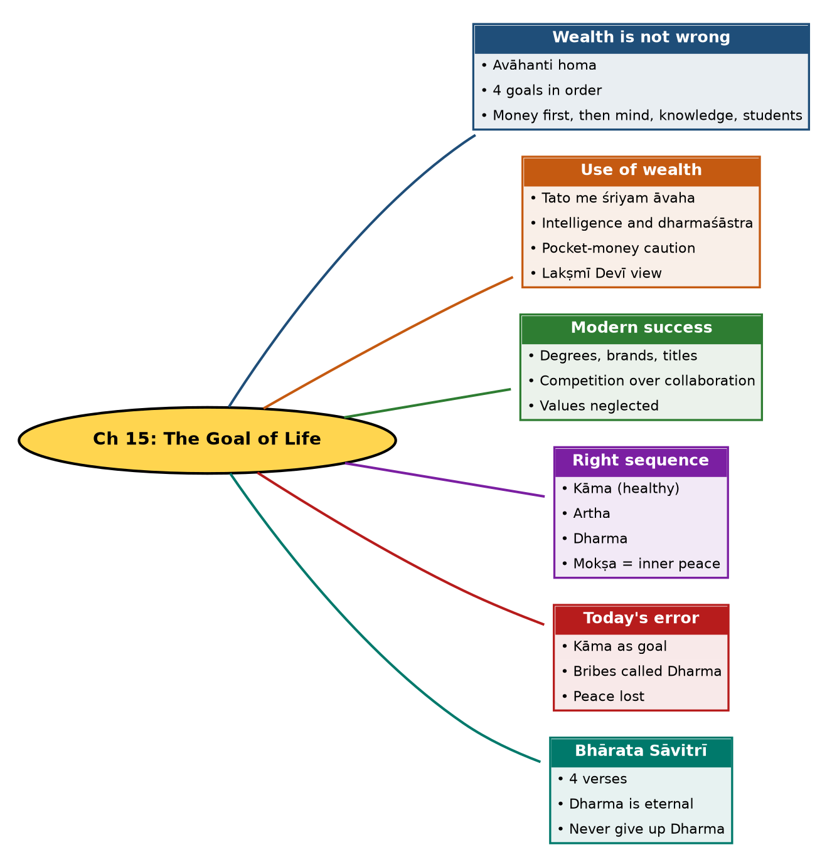

Tree view (text version for quick revision)
Ch 15: The Goal of Life
- Wealth is not wrong
  - Avāhanti homa
  - 4 goals in order
  - Money first, then mind, knowledge, students
- Use of wealth
  - Tato me śriyam āvaha
  - Intelligence and dharmaśāstra
  - Pocket-money caution
  - Lakṣmī Devī view
- Modern success
  - Degrees, brands, titles
  - Competition over collaboration
  - Values neglected
- Right sequence
  - Kāma (healthy)
  - Artha
  - Dharma
  - Mokṣa = inner peace
- Today's error
  - Kāma as goal
  - Bribes called Dharma
  - Peace lost
- Bhārata Sāvitrī
  - 4 verses
  - Dharma is eternal
  - Never give up Dharma

10. Quick Revision: Memory Aids
- Avāhanti homa = D-C-J-S: Dhana, Citta-śuddhi, Jñāna, Śiṣya.
- Right sequence = K-A-D-M (Kāma, Artha, Dharma, Mokṣa).
- 'Tato' = after intelligence; money without sense is dangerous.
- Bhārata Sāvitrī = 4 verses = whole MB's benefit.
- Mokṣa (for now) = inner independence and peace.
- Final message: Dharma (and the soul) eternal; pleasure and pain fleeting.

11. Exam Practice: Questions and Model Answers
Q1. Is Sanātana Dharma against wealth? Explain with the Avāhanti homa.
Ans: No. The Avāhanti homa in the Taittirīya Upaniṣad seeks wealth, purity of mind, knowledge and students, in that order.
Q2. Why is wealth mentioned first in the Avāhanti homa?
Ans: Money is needed to perform karma and even karma yoga and to work for society's well-being.
Q3. What does 'tato me śriyam āvaha' signify?
Ans: Lakṣmī should be brought after gaining intelligence, because prosperity to the unwise causes evil; one should know dharmaśāstra on how to use money.
Q4. What does the chapter caution about pocket money for children?
Ans: Excess money without maturity may lead to harmful habits such as smoking, drugs and alcohol; Dharma teaches earning and spending judiciously.
Q5. How does the chapter criticise modern notions of success?
Ans: Success is tied to degrees, brands, titles and possessions, promoting competition over collaboration and neglect of faith, compassion, integrity and truthfulness.
Q6. State the correct sequence of life goals given by the chapter.
Ans: Healthy kāma, then artha earned through a sound body and mind, used for dharma, leading to mokṣa as inner independence and peace.
Q7. What goes wrong when kāma becomes the goal?
Ans: Desires are pursued without discernment, ends justify means (e.g. bribery called Dharma), and happiness, peace and mokṣa are lost.
Q8. What is the Bhārata Sāvitrī?
Ans: Four closing verses by Vyāsa summarising Mahābhārata; reading them is said to give the benefit of the whole epic.
Q9. State the message of the Bhārata Sāvitrī.
Ans: People and relationships come and go; joys and fears abound; Dharma leads to artha and kāma; never abandon Dharma for desire, fear, greed or life; happiness and sorrow are transient while Dharma and the soul are eternal.
Q10. How does Mahābhārata help in defining the goal of life?
Ans: It addresses how to live, what victory and failure are, who we are and the goal, showing that worldly accomplishments ultimately count for nothing without Dharma.

Self-test: one-line recall
- Avāhanti homa goals = ? Wealth, pure mind, knowledge, students.
- Right order = ? Kāma, Artha, Dharma, Mokṣa.
- Number of Bhārata Sāvitrī verses = ? 4.
- Mokṣa (for now) = ? Inner peace.

