<https://eksctl.io/>

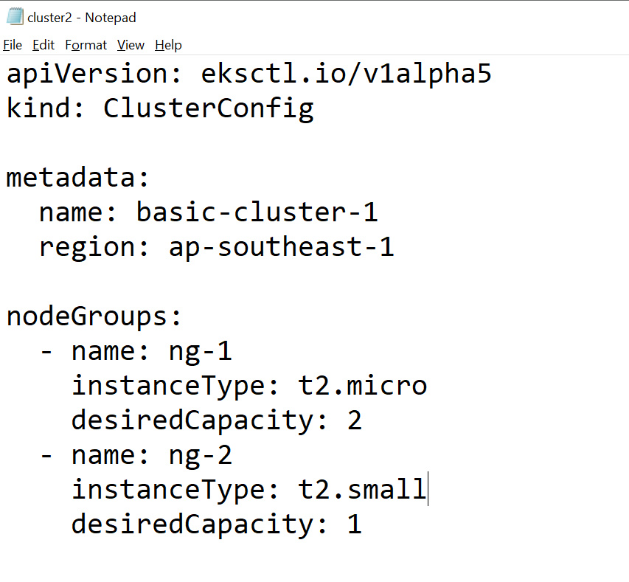

# eksctl create cluster -f cluster2.yml

# aws eks --region ap-southeast-1 update-kubeconfig --name basic-cluster-1

<https://kubernetes.io/docs/tasks/administer-cluster/namespaces-walkthrough/>

<https://kubernetes.io/docs/concepts/overview/working-with-objects/namespaces/>

# kubectl create namespace lwns

# kubectl config set-context --current --namespace=lwns

# kubectl config view

# eksctl get cluster --region ap-southeast-1

# eksctl get nodegroup --cluster basic-cluster-1 --region ap-southeast-1

# kubectl create deployment myweb --image=vimal13/apache-webserver-php

# kubectl scale deploy myweb --replicas=3

# kubectl get pods -o wide

# kubectl expose deploy myweb --type=LoadBalancer --port=80

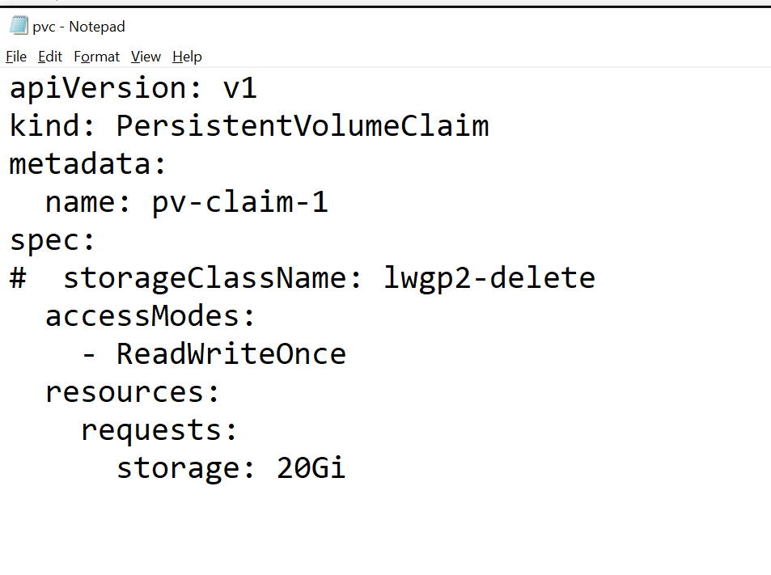

# kubectl edit deploy myweb

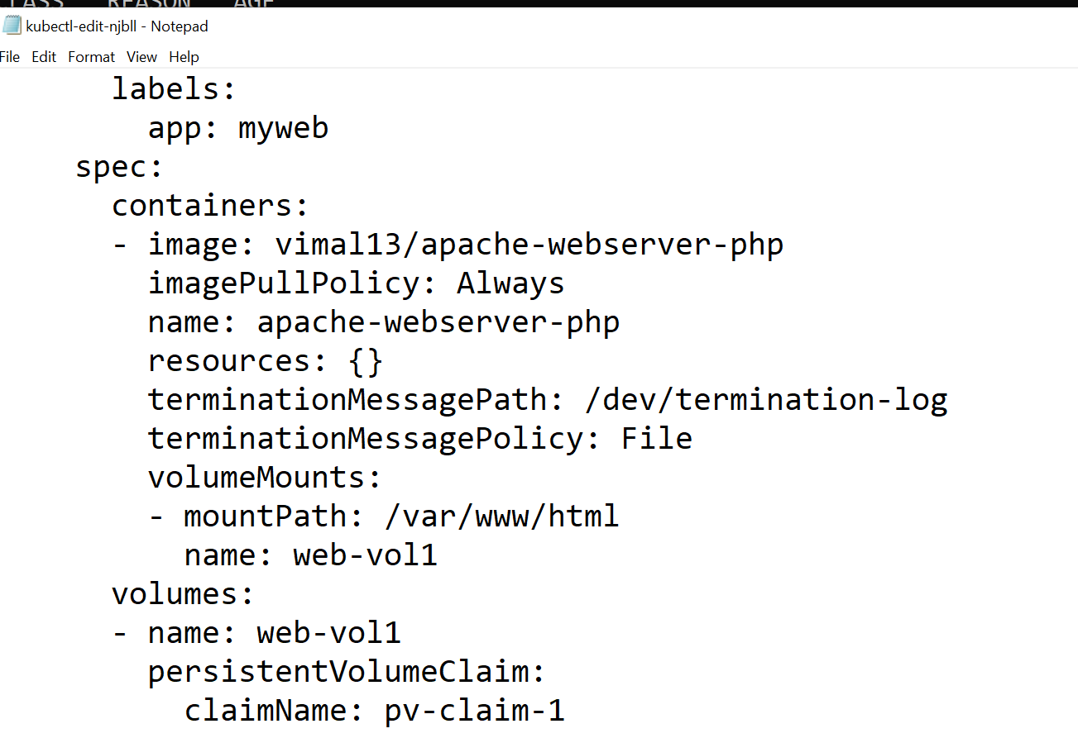

# kubectl cp index.php myweb-5cc8f48979-fqjdq:/var/www/html

# kubectl scale deploy myweb --replicas=10

<https://docs.aws.amazon.com/AWSEC2/latest/UserGuide/using-eni.html>

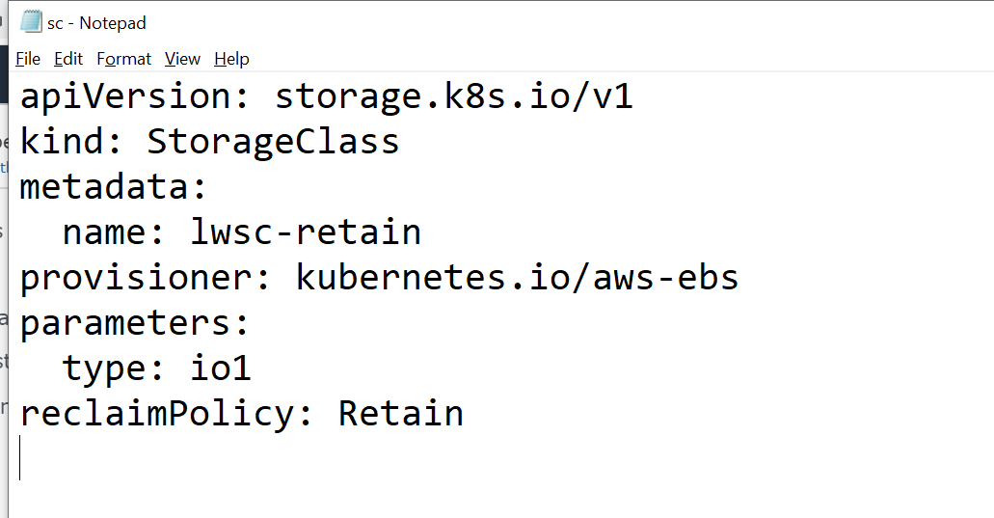

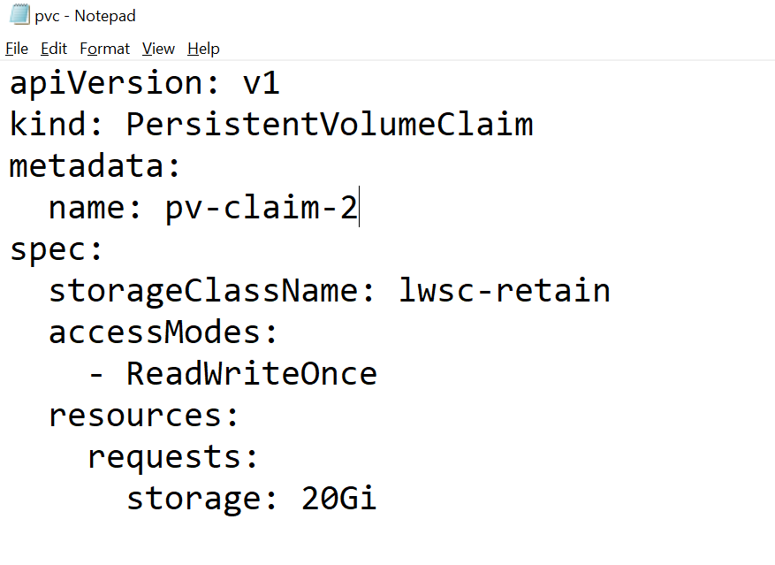

# eksctl delete cluster -f cluster2.yml

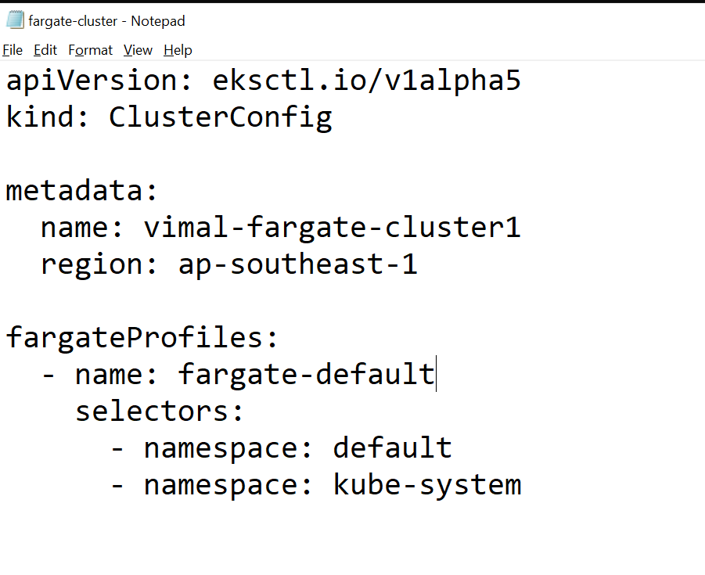

# eksctl create cluster -f fargate-cluster.yml

# aws eks --region ap-southeast-1 update-kubeconfig --name vimal-fargate-cluster1