Assignment-1
• java -version
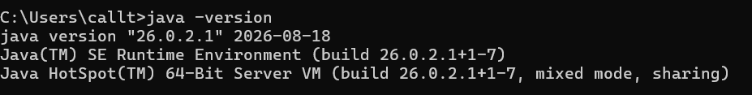
• javac -version
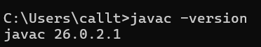
Brief answers (2–3 lines each):
• What is JDK?
JDK stands for Java Development Kit. It is used to develop, compile, debug, and run Java programs. It contains tools such as the Java compiler (javac).
• What is JVM?
JVM stands for Java Virtual Machine. It executes Java bytecode and allows Java programs to run on different operating systems.
• What is JRE?
JRE stands for Java Runtime Environment. It provides the environment and libraries required to run Java applications. It includes the JVM.
• Difference between JDK, JRE, and JVM.

Feature | JDK | JRE | JVM
Full Form | Java Development Kit | Java Runtime Environment | Java Virtual Machine
Main Purpose | Used to develop Java programs | Used to run Java programs | Used to execute Java bytecode
Contains | JRE + Development Tools | JVM + Libraries | Execution Engine
Used By | Developers | Users/Applications | Java Runtime
Example | javac, debugger | Java libraries + JVM | Executes .class files

