Assignment-2
• Writing of Source Code (.java file)
• Compilation of the source code into (.class file)
• Execution of the bytecode

1. Submit one word containing:
• Screenshot of the Java source code (HelloWorld.java).
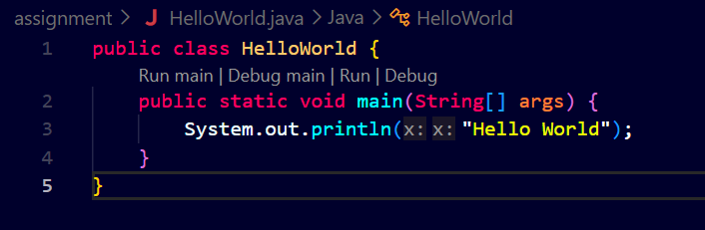
• Screenshot of the compilation command (javac HelloWorld.java).
• Screenshot showing the generated .class file.

• Screenshot of the execution command (java HelloWorld).
• Screenshot of the output for all practical tasks.
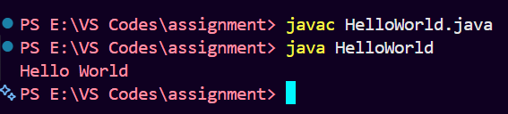

2. A brief explanation (2–3 lines) of:
• What is a Java program?
A Java program is a set of instructions written in the Java programming language to perform a specific task. It is saved with the .java extension and converted into bytecode during compilation.
• What is the purpose of the main() method?
The main() method is the starting point of a Java program. The JVM starts executing the program from the main() method
• What is the difference between javac and java?

javac | java
Used to compile Java source code | Used to execute Java bytecode
Converts .java into .class | Runs the .class file
Example: javac HelloWorld.java | Example: java HelloWorld

3. Explain the Java Program Structure in details
Explain Java Program Structure in Detail
A Java program follows a basic structure that makes the code easy to write, understand, and execute. Most Java programs contain a class, the main() method, and some statements that perform the required task.
Example of a Java Program
public class HelloWorld {
public static void main(String[] args) {
System.out.println("Hello World");
}
}
1. Class Declaration
In Java, the program is usually written inside a class. A class is created using the class keyword.
In the above example, HelloWorld is the name of the class.
public class HelloWorld
2. Main Method
The main() method is the starting point of a Java program. When we run a Java program, the JVM starts executing the program from the main() method.
public static void main(String[] args)
Here:
- public means the method can be accessed by the JVM.
- static means we can run the method without creating an object.
- void means the method does not return any value.
- main is the name of the method.
- String[] args is used to accept command-line arguments.
3. Statements
Statements are the instructions that tell the computer what to do. They are written inside the main() method.
For example:
System.out.println("Hello World");
This statement prints Hello World on the screen.
4. Curly Braces
Curly braces { } are used to show the beginning and end of a class or method.
For example:
public class HelloWorld {
public static void main(String[] args) {
}
}
The outer braces belong to the class, while the inner braces belong to the main() method.
5. Semicolon
A semicolon ; is used at the end of most statements in Java.
For example:
System.out.println("Hello World");
Without the semicolon, Java may show a compilation error.
6. Import Statements
If we want to use classes from Java's built-in packages, we can use an import statement.
For example, to use the Scanner class:
import java.util.Scanner;
This allows us to take input from the user.
7. Variables
Variables are used to store data in a program. For example:
int age = 20;
String name = "Priyanshu";
Here, age stores an integer value and name stores a text value.
8. Methods
Methods are blocks of code that are created to perform a particular task. They help us organize the program and avoid writing the same code again and again.
For example:
void display() {
System.out.println("Hello");
}

