Assignment-3
Question 1: Sum of Two Numbers Write a Java program to: • Accept two integer numbers from the user. • Calculate their sum. • Display the result.
import java.util.Scanner;
public class SumOf2No {
public static void main(String[] args) {
Scanner sc = new Scanner(System.in);
System.out.print("Enter First Number: ");
int num1 = sc.nextInt();
System.out.print("Enter Second Number: ");
int num2 = sc.nextInt();
int sum = num1 + num2;
System.out.println("Sum = " + sum);
}
}
OUTPUT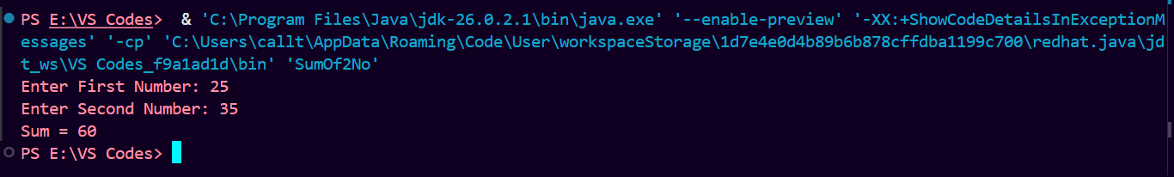

Question 2: Email Address Input Write a Java program to: • Accept the user's full name. • Accept the user's email address. • Display both values in a formatted manner.
import java.util.Scanner;
public class EmailInput{
public static void main(String[] args) {
Scanner sc = new Scanner(System.in);
System.out.print("Enter Name: ");
String name = sc.nextLine();
System.out.print("Enter Email: ");
String email = sc.nextLine();
System.out.println("Student Details");
System.out.println("---------------");
System.out.println("Name : " + name);
System.out.println("Email : " + email);
}
}
OUTPUT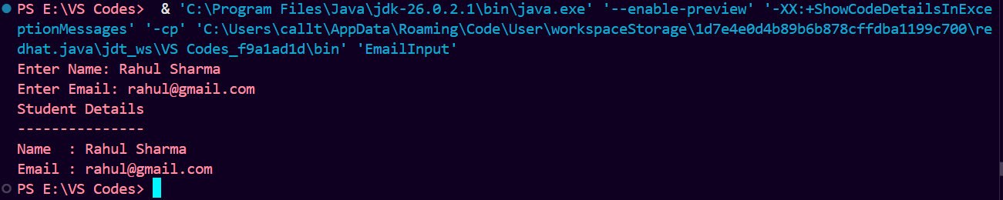

Question 3: Simple Interest Calculator Write a Java program to calculate using the formula:SI = (P × R × T) / 100 Where: • = Principal Amount • = Rate of Interest • = Time (in years)
import java.util.Scanner;
public class SI {
public static void main(String[] args) {
Scanner sc = new Scanner(System.in);
System.out.print("Enter Principal Amount: ");
double p = sc.nextDouble();
System.out.print("Enter Rate of Interest: ");
double r = sc.nextDouble();
System.out.print("Enter Time (Years): ");
double t = sc.nextDouble();
double si = (p * r * t) / 100;
System.out.println("Simple Interest = " + si);
}
}
OUTPUT