Marketing Planning Assistant Agent

  - Course Name: Agentic AI

Institution Name: Medicaps University – Datagami Skill Based Course

Student Name(s) & Enrollment Number(s):
Sr no | Student Name | Enrollment Number
1 | CHARU RATHOD | EN23CS3T1007
2 | RUDRAKSH SHARMA | EN22CS301832
3 | PRATHAM DESHMUKH | EN22CS301741
4 | PIYUSH PATIDAR | EN22CS301705
5 | ROHAN JAIN | EN22CS301817
6 | PRIYANSH MEWADA | EN22CS301763

Group Name: 03D7
Project Number: AAI-26
Industry Mentor Name:
University Mentor Name: Prof. Ajeet Singh Rajput
Academic Year: 2025-2026

Problem Statement & Objectives

Problem Statement
In the modern digital economy, developing an effective marketing plan is essential for business success. Marketing strategy creation involves multiple complex tasks such as competitor analysis, keyword research, budget planning, and campaign scheduling. These activities require expertise, time, and access to specialized tools, which many startups, small businesses, and individuals often lack.
Manual marketing planning can lead to unstructured strategies, inefficient budget allocation, and suboptimal targeting decisions. Despite advancements in Artificial Intelligence and Large Language Models (LLMs), there is still a gap in systems that can intelligently transform high-level marketing goals into structured and actionable execution plans.
Therefore, there is a need for an AI-powered solution that can assist users by automating marketing plan generation, improving strategic structure, and simplifying decision-making. This project addresses this need by developing an AI-Powered Marketing Planning Assistant Agent that leverages LLM-based reasoning, modular tools, and an interactive Streamlit interface.

Project Objectives
The primary objectives of this project are:
• To design and develop an AI-powered Marketing Planning Assistant Agent
• To automate the generation of structured marketing execution plans
• To leverage Large Language Models (LLMs) for intelligent reasoning and strategy formulation
• To integrate modular tools for keyword research, budgeting, scheduling, and ad analysis
• To develop an interactive and user-friendly graphical interface using Streamlit
• To enable export of marketing plans in PDF format
• To implement persistent data storage using MySQL database
• To enhance user experience through features like plan history, search, deletion, and dark mode

Scope of the Project
This project focuses on developing an AI-powered Marketing Planning Assistant Agent that generates structured marketing plans based on high-level user goals. The system utilizes Large Language Models (LLMs) through LangChain to provide intelligent strategy recommendations.
The scope includes:
• User interaction via Streamlit-based graphical interface
• Automated marketing plan generation
• Integration of tools for keyword research, budgeting, scheduling, and ad analysis
• Features such as plan history, search, loading, and deletion
• PDF export functionality
• Persistent storage using MySQL database

Proposed Solution
An AI-driven Marketing Planning Assistant Agent was developed that accepts a high-level marketing goal from the user and produces a structured execution plan. The system uses Large Language Models (LLMs) integrated through LangChain, supported by modular tools for keyword research, budgeting, scheduling, and ad analysis.
A Streamlit-based graphical interface enables easy interaction, while MySQL ensures persistent storage of plans.
- Key features
• AI-powered marketing plan generation
• Structured execution workflow
• Tool-integrated reasoning
• Streamlit interactive GUI
• Dark mode UI
• Plan history & retrieval
• PDF download option
• MySQL database integration
• Delete & search plans
- Overall Architecture / Workflow
The AI-Powered Marketing Planning Assistant Agent follows a modular and layered architecture designed to ensure scalability, flexibility, and ease of interaction. The system integrates a user-friendly interface, core AI logic, auxiliary tools, and a persistent database layer.

Workflow Overview:
1.User Interaction
The user enters a high-level marketing goal through the Streamlit graphical interface.
2.Input Processing
The input goal is passed to the MarketingAgent for analysis and reasoning.
3.LLM Invocation
The MarketingAgent invokes the Large Language Model (Google Generative AI) via LangChain to interpret the goal and generate a structured marketing plan.

4.Tool Integration (Optional)
When required, the agent utilizes integrated tools such as Keyword Tool, Budget Tool, Scheduler Tool, and Ad Library Tool to enrich the response.
5.Plan Generation
A structured marketing execution plan is generated based on AI reasoning and tool outputs.
6.Output Presentation
The generated plan is displayed within the Streamlit interface.
7.PDF Export
The system enables users to download the plan as a PDF using ReportLab.
8.Database Storage
The plan, along with its metadata, is stored in the MySQL database for persistence.
9.History & Retrieval
Users can search, load, and delete previously generated plans via the sidebar.

Workflow Steps:
- User submits a high-level marketing goal.
- System interprets the goal.
- Planner Agent decomposes it into sub-tasks.
- Tasks are validated.
- Dependencies are identified.
- Execution schedule is generated.
- Final structured plan is displayed.

- Tools & Technologies Used:

Python
Python is the primary programming language used to build the Marketing Planning Assistant Agent. It was chosen due to its simplicity, readability, and strong ecosystem for AI and automation. Python enables rapid development and easy integration with AI frameworks, APIs, and data processing tools.
Key uses in the project:
- Implementing the planner agent logic
- Managing workflows and task execution
- Handling data structures and tool interactions
- Building a CLI-based user interface

AI Planning Concepts
AI planning refers to the process of breaking down a high-level objective into smaller, executable steps to achieve a goal efficiently.
In this project, planning concepts are used to:
- Decompose marketing goals into actionable tasks
- Determine execution order and dependencies
- Validate resource availability before execution
- Generate structured execution plans
This allows the agent to simulate intelligent decision-making rather than performing a single static action.

In-Memory Data Structures (Lists & Dictionaries)
The system uses Python’s in-memory data structures to store and manipulate planning information efficiently.
Lists are used for:
- Task sequencing
- Step-by-step execution flows
- Maintaining ordered plans
Dictionaries are used for:
- Storing task metadata (status, tools required, dependencies)
- Mapping actions to resources
- Representing structured plan outputs
These structures allow fast data access and flexible plan modification during runtime.

CLI Interface (Command Line Interface)
A CLI interface is implemented to allow users to interact with the agent via terminal commands.
Benefits:
- Lightweight and fast interaction
- Easy testing and debugging
- No dependency on graphical environments
- Suitable for automation workflows
Users can input high-level goals, and the agent responds with structured plans and execution steps.

Agentic AI Principles
Agentic AI refers to AI systems capable of autonomous reasoning, planning, and action execution.
This project incorporates agentic principles such as:
- Goal-driven behavior
- Multi-step reasoning loops
- Tool usage for task completion
- Iterative validation and refinement
- Autonomous decision-making
This transforms the system from a simple script into an intelligent agent capable of problem-solving.

LangChain (Conceptual Reference)
LangChain is a framework designed to build applications powered by language models.
Although not fully implemented, its concepts inspired the project architecture, including:
- Tool integration for enhanced agent capabilities
- Chains for sequential reasoning
- Memory handling for context retention
- Structured prompt orchestration
These ideas guided the design of modular agent workflows.

CrewAI (Conceptual Reference)
CrewAI enables collaboration between multiple AI agents working together to complete tasks.
The project draws conceptual inspiration from CrewAI by:
- Structuring tasks as coordinated workflows
- Defining responsibilities for planning and execution
- Simulating multi-agent reasoning through modular components
This approach improves scalability and clarity in task orchestration.

OpenAI API (Conceptual Reference)
The OpenAI API provides access to advanced language models capable of reasoning, planning, and generating structured outputs.
In this project, the API is referenced conceptually for:
- Generating intelligent planning steps
- Enhancing natural language understanding
- Producing structured execution strategies
- Enabling future integration for real-time AI planning
This ensures the system can evolve into a fully AI-powered planner.

Results & Output
- Screenshots / outputs
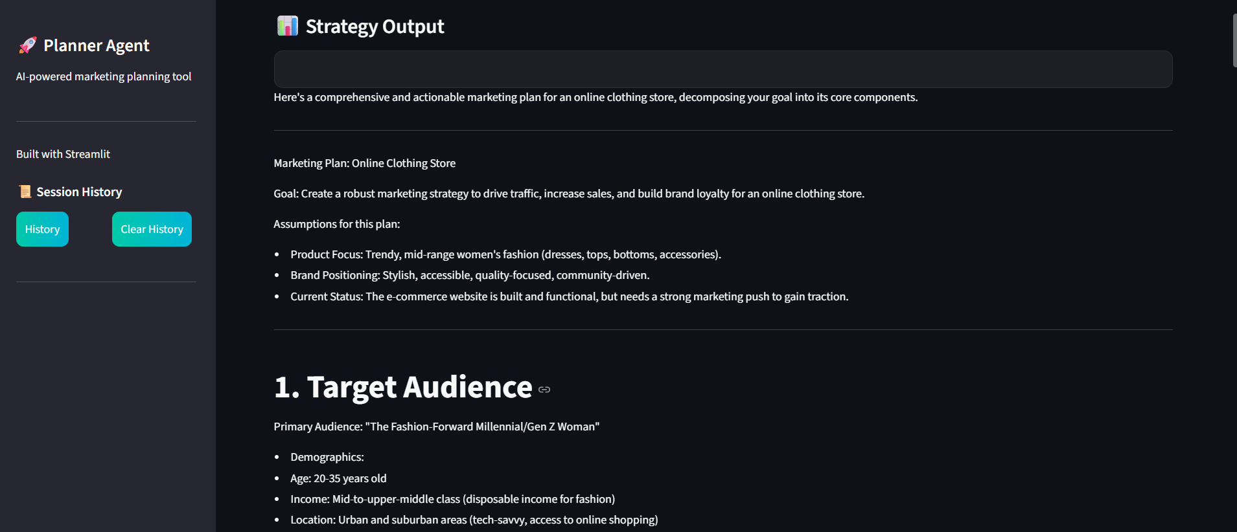\

- Reports / dashboards / models

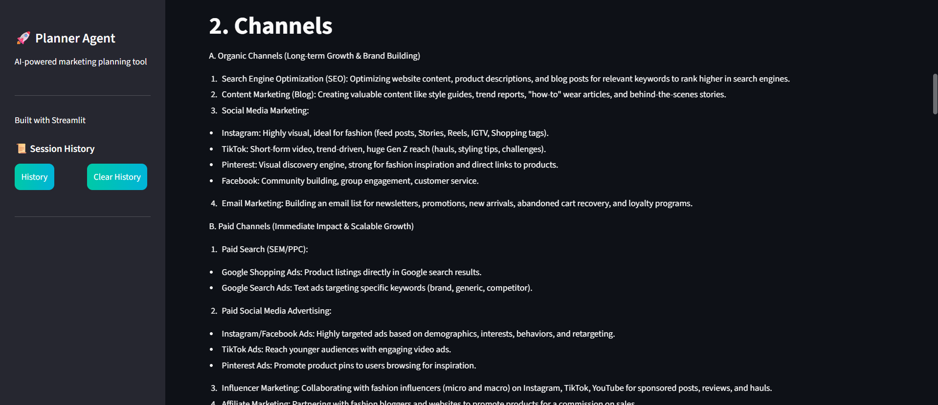

- Download feature of report and history
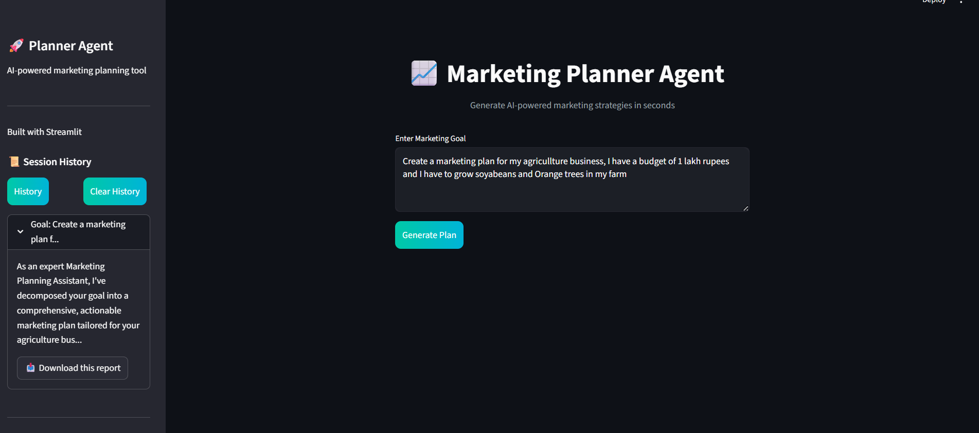

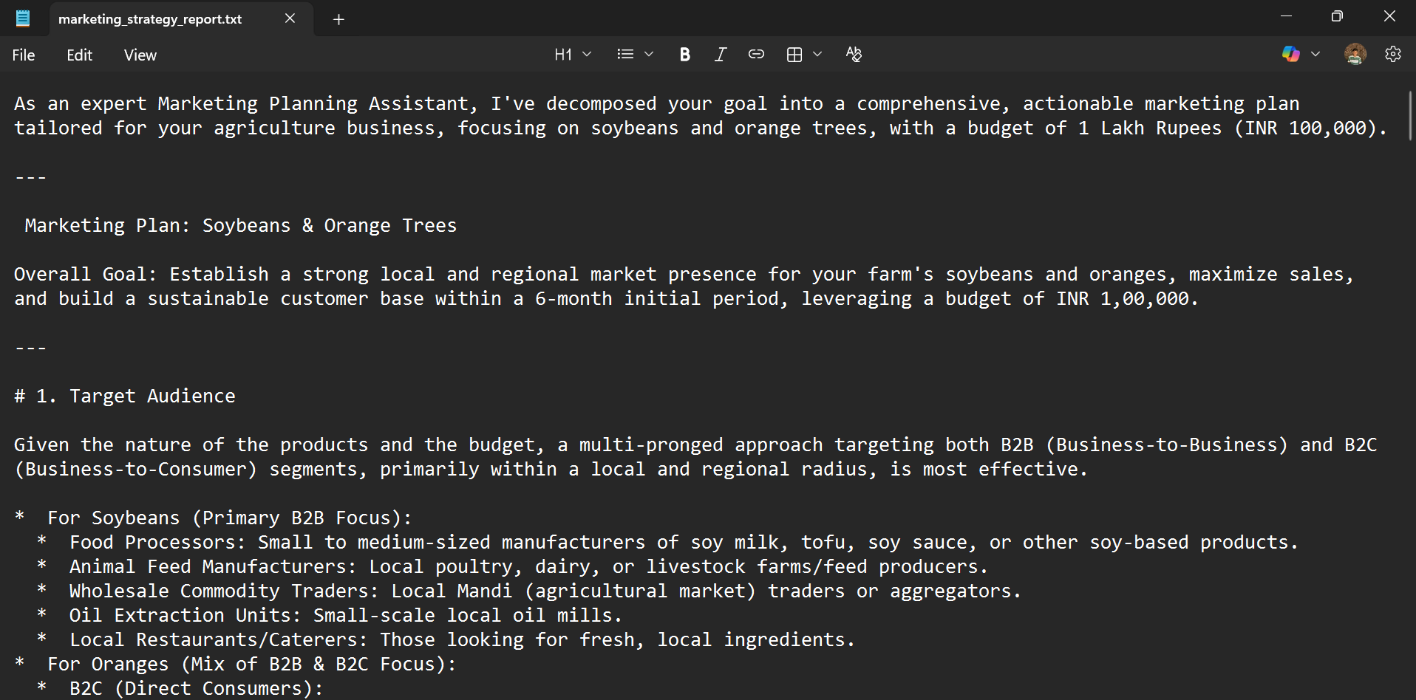
- Key outcomes
Functional AI-powered marketing planning assistant developed
• Automated structured marketing plan generation achieved
• End-to-end workflow from user input to output implemented
• Integration of Large Language Model using LangChain completed
• Interactive GUI-based interface using Streamlit designed
• PDF export and downloadable reporting implemented
• Persistent MySQL database storage integrated
• Enhanced UX features including history, search, deletion, and dark mode added

Conclusion
The Marketing Planning Assistant Agent successfully demonstrates how Agentic AI can automate marketing planning processes.
The system transforms high-level marketing goals into structured and optimized execution plans. By implementing modular design, intelligent planning mechanisms, and stateless architecture, the project ensures scalability, efficiency, and maintainability.

This project enhanced our understanding of:
- AI planning systems
- Modular architecture design
- System design principles
- Agent-based automation
- High-Level Design documentation
Overall, the project showcases the practical application of Agentic AI in solving real-world marketing planning challenges.

Future Scope & Enhancements
The system can be enhanced in the following ways:
- Web-based dashboard interface.
- Integration with real marketing APIs.
- Database storage for historical plans.
- User authentication and role-based access.
- Caching mechanism for frequently used templates.
- Machine learning-based task optimization.
- Real-time competitor analysis integration.

