🎓 Student Performance Dashboard – Power BI
📌 Project Overview
The Student Performance Dashboard is an interactive analytics solution developed using Power BI to analyze student academic performance, attendance, and behavior records.
This dashboard helps in identifying performance trends, attendance patterns, and behavioral insights using data visualization and DAX calculations.
The project demonstrates:
- Data Modeling
- Data Cleaning
- DAX Measures
- Time Intelligence
- Interactive Visualizations
- Drillthrough & Tooltip Features
- Bookmark Navigation
- Mobile Responsive Layout

🗂️ Dataset Information
The project uses four CSV datasets:
1. Students.csv
Contains student master information.
Column Name | Description
StudentID | Unique student identifier
Name | Student name
Gender | Gender
Class | Student class
Section | Student section

2. Scores.csv
Contains academic score records.
Column Name | Description
StudentID | Student identifier
Subject | Subject name
ExamType | Type of exam
Score | Obtained score
MaxScore | Maximum score
Term | Academic term

3. Attendance.csv
Contains attendance details.
Column Name | Description
StudentID | Student identifier
Date | Attendance date
Status | Present / Absent
Reason | Absence reason

4. Behavior.csv
Contains student behavior records.
Column Name | Description
StudentID | Student identifier
Date | Record date
BehaviorType | Behavior category
Notes | Additional remarks

🧹 Data Cleaning & Transformation
The following preprocessing steps were performed using Power Query:
- Corrected column datatypes
- Removed blank/null values
- Renamed columns for consistency
- Formatted percentage values
- Established relationships using StudentID

🔗 Data Modeling
A Star Schema approach was used for creating relationships.
Relationships Created
Students[StudentID] → Scores[StudentID]
Students[StudentID] → Attendance[StudentID]
Students[StudentID] → Behavior[StudentID]
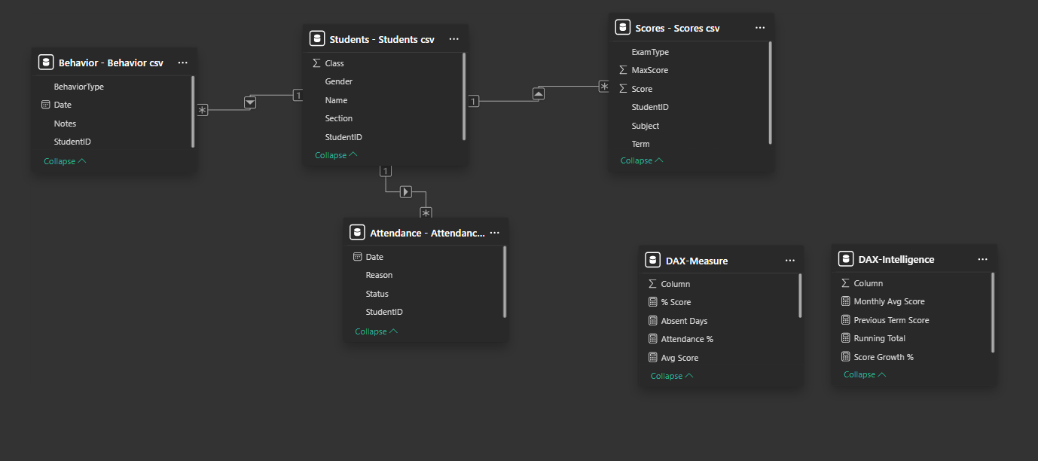

📊 DAX Measures Implemented
Basic Measures
% Score =
DIVIDE(
SUM(Scores[Score]),
SUM(Scores[MaxScore])
) * 100
Attendance % =
DIVIDE(
CALCULATE(
COUNT(Attendance[Status]),
Attendance[Status] = "Present"
),
COUNT(Attendance[Status])
) * 100
Avg Score =
AVERAGE(Scores[Score])
Behavior Count =
COUNT(Behavior[BehaviorType])
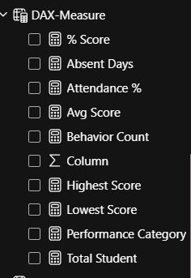

📈 Time Intelligence Measures
Running Total
Running Total =
CALCULATE(
SUM(Scores[Score]),
FILTER(
ALL(Attendance[Date]),
Attendance[Date] <= MAX(Attendance[Date])
)
)
Score Growth %
Score Growth % =
DIVIDE(
[Avg Score] - [Previous Term Score],
[Previous Term Score]
) * 100
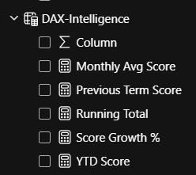

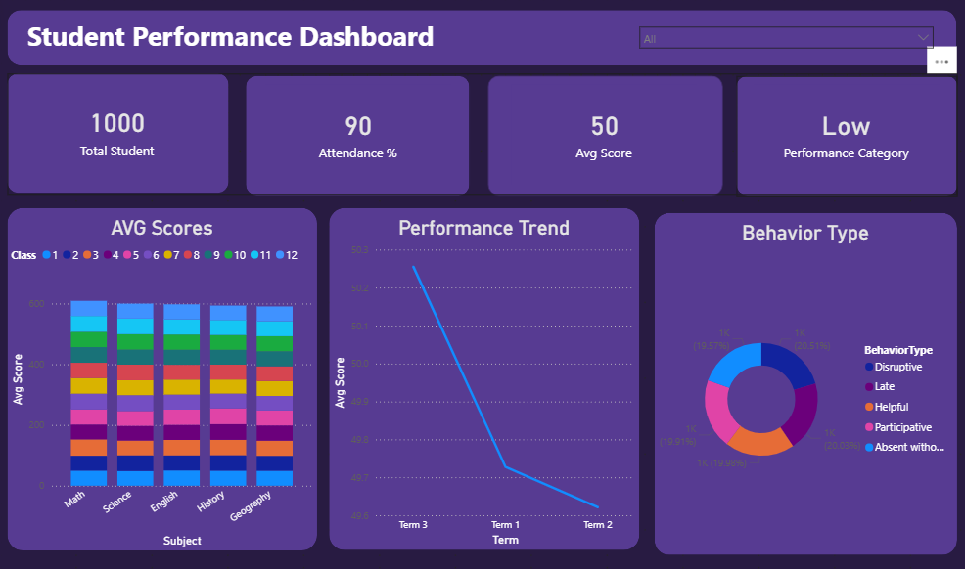
🖥️ Dashboard Features
📌 KPI Cards
The dashboard contains KPI cards for:
- Total Students
- Attendance Percentage
- Average Score
- Performance Category

📊 Visualizations Used
1. Bar Chart
Displays:
- Average scores by subject and class

2. Line Chart
Displays:
- Student performance trend across terms

3. Donut Chart
Displays:
- Behavior type distribution

4. Table Visualization
Displays:
- Student-wise scores
- Attendance percentage
- Performance category
Conditional Formatting Applied
Condition | Color
Score > 80% | Green
Score < 40% | Red

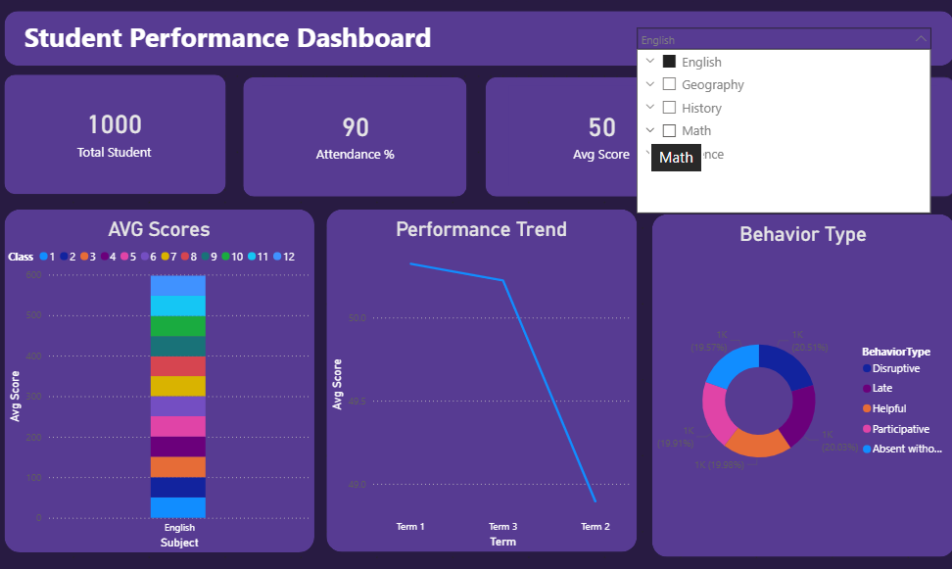
⚡ Interactivity Features
🔍 Slicers
Interactive slicers were added for:
- Subject
- Class
- Section
- Term

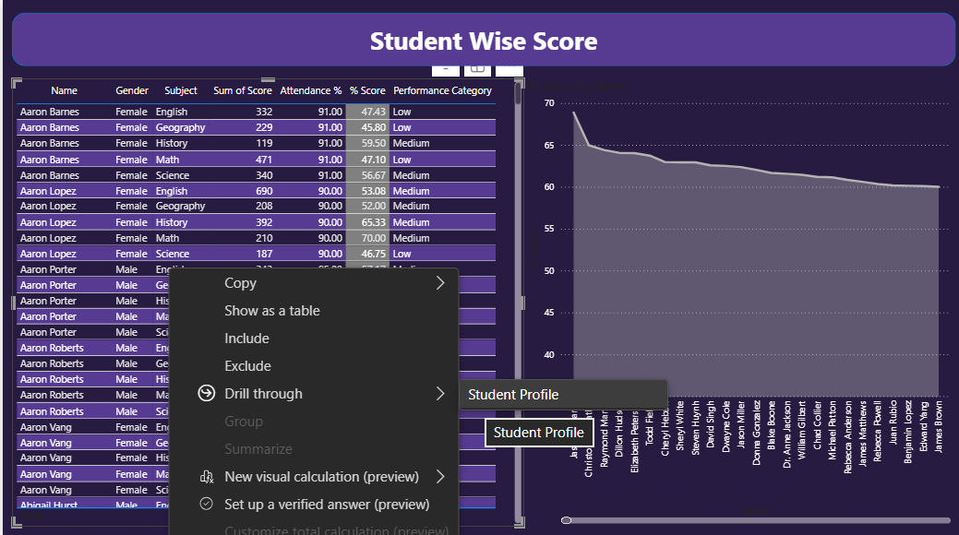
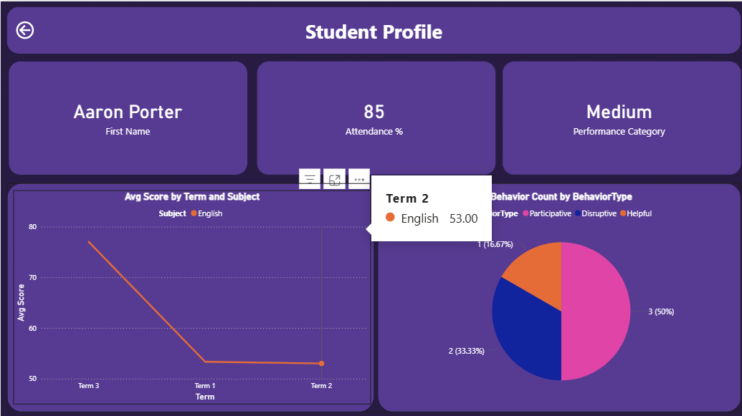
👤 Drillthrough Page
A separate Student Profile page was created containing:
- Attendance %
- Performance category
- Subject-wise score trends
- Behavior analysis

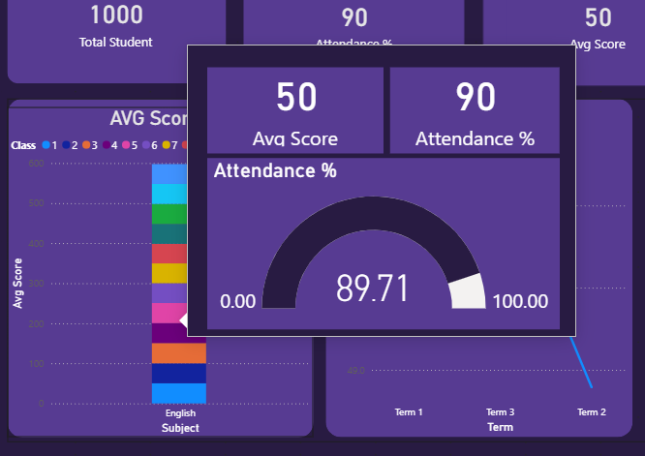
💡 Tooltips
Custom tooltip pages were designed to show:
- Average score
- Attendance %
- Mini charts and metrics

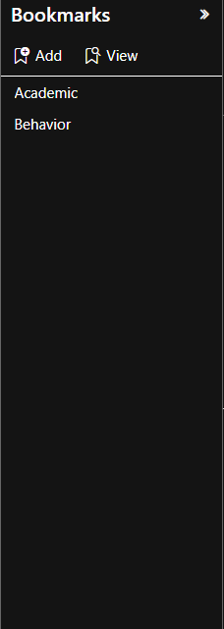
🔁 Bookmark Navigation
Bookmarks were used for switching between:
- Academic View
- Behavioral View

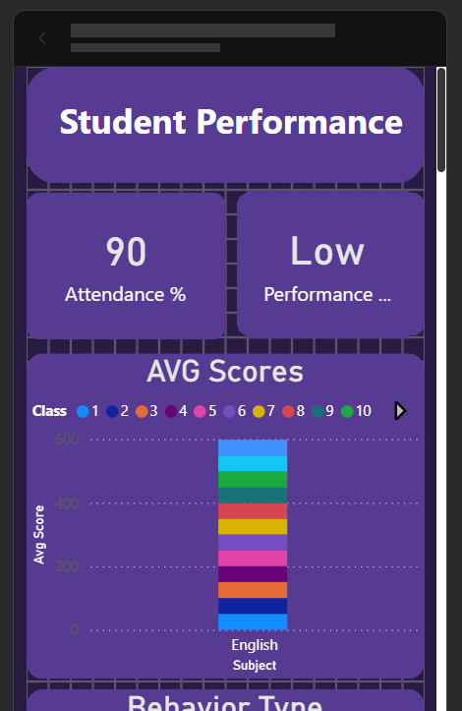
📱 Mobile Layout
A responsive mobile layout was also created to improve dashboard accessibility on smaller screens.

📌 Key Insights
- Attendance percentage has a strong impact on academic performance.
- Students with lower attendance generally showed lower average scores.
- Behavior analysis helped identify disciplinary trends.
- Subject-wise analysis highlighted weaker subjects across classes.
- Performance trend analysis helped track improvement across terms.

🛠️ Tools & Technologies Used
Technology | Purpose
Power BI | Dashboard Development
Power Query | Data Cleaning
DAX | Calculations & Measures
CSV Files | Data Source

✅ Conclusion
This project successfully demonstrates the use of:
- Data Modeling
- Advanced DAX
- Time Intelligence
- Interactive Visualizations
- Drillthrough Reports
- Tooltips
- Bookmark Navigation
to build a complete and interactive Student Performance Analytics Dashboard in Power BI.
The dashboard provides meaningful insights into student academics, attendance, and behavior, helping users perform efficient educational analysis and decision-making.

👨‍💻 Developed By
Priyansh Vekariya
Student Performance Dashboard Project
Developed using Power BI, DAX, Power Query, and interactive data visualization techniques.

