Final Examination Report
Mathematics for Data Science — Loan Applications Dataset

Dataset: loan_applications.csv | 5,000 records | 7 features
Tools: Python, NumPy, Pandas, Matplotlib, SciPy

Part A – Theory (Short Questions)

Q1. Explain Mean, Median, Mode in the context of customer income.
Ans: Mean is the arithmetic average of all customer incomes, computed as the sum of all incomes divided by the number of customers. It gives a single representative value but can be skewed by outliers (e.g., very high earners). Median is the middle value when incomes are sorted in ascending order; it is more robust to outliers and gives a better sense of the 'typical' customer income. Mode is the most frequently occurring income value in the dataset. From the Loan Applications dataset: Mean Income ≈ ₹69,417.77, Median Income ≈ ₹69,236.50, Mode Income = ₹15,000. The mean and median are very close, indicating a roughly symmetric income distribution, while the mode being much lower suggests a cluster of low-income applicants.

Q2. Differentiate between Standard Deviation and Variance using loan amounts.
Ans: Variance measures the average squared deviation of each data point from the mean, capturing the overall spread of loan amounts in squared units. Standard Deviation is simply the square root of the variance, expressed in the same unit as the original data, making it more interpretable. From the dataset: Variance of Loan Amount ≈ 770,245,609.88 (₹²), and Standard Deviation ≈ ₹27,753.30. A higher standard deviation means loan amounts are spread widely around the mean, indicating diverse borrowing behaviour.

Q3. What is a Random Variable? Give one example from the dataset.
Ans: A Random Variable is a numerical quantity whose value depends on the outcome of a random experiment. It can be Discrete (taking countable values) or Continuous (taking any value in an interval). Example from the dataset: 'Default_Status' can be treated as a discrete random variable X where X = 1 if the customer defaults (Yes) and X = 0 otherwise (No). Another example is 'Income', which is a continuous random variable representing the annual income of a loan applicant.

Q4. Explain Conditional Probability in terms of loan defaults.
Ans: Conditional Probability is the probability of an event occurring given that another event has already occurred, denoted P(A|B). In the context of loan defaults: P(Default | Low Credit Score) asks 'What is the probability that a customer defaults, given that their credit score is below 600?' From the dataset analysis: P(Default | Credit Score < 600) ≈ 39.53%. This means customers with low credit scores have a much higher chance of defaulting compared to the overall default rate of 18.52%.

Q5. Define Bayes' Theorem and mention how banks can apply it.
Ans: Bayes' Theorem relates the conditional probability of events and is stated as: P(A|B) = [P(B|A) × P(A)] / P(B). Banks can use it for credit risk assessment. For example, if a bank knows: (1) the overall default rate P(Default), (2) the probability of having a low credit score given default P(Low Score | Default), and (3) the overall probability of low credit score P(Low Score), then Bayes' Theorem lets the bank calculate P(Default | Low Score), helping to make more informed lending decisions. It is also used in fraud detection, spam filtering for banking emails, and customer segmentation.

Q6. Differentiate between Empirical Probability and Theoretical Probability with examples.
Ans: Theoretical Probability is calculated based on mathematical reasoning and assumes equally likely outcomes. Example: The probability of a fair coin landing heads = 0.5. Empirical Probability (also called Experimental Probability) is based on actual observed data from experiments or historical records. Example from our dataset: The empirical probability of loan default = Number of defaults / Total customers = 926 / 5000 ≈ 0.1852 or 18.52%. Theoretical probability is an idealized value, while empirical probability is derived from real-world data and may differ from theory.

Q7. What is a Poisson Distribution? Give a business example.
Ans: A Poisson Distribution models the number of times a rare event occurs in a fixed interval of time or space, given a known average rate (λ). Key properties: events are independent, the average rate is constant, and two events cannot occur at exactly the same time. Business example: A bank branch receives an average of 5 loan applications per hour. Using the Poisson distribution (λ = 5), the bank can calculate the probability of receiving exactly 8 applications in a given hour, helping with staff scheduling and resource planning.

Q8. Write a short note on Eigenvalues and Eigenvectors in data analysis.
Ans: Eigenvalues and Eigenvectors are fundamental concepts in linear algebra widely used in data analysis. For a square matrix A, an eigenvector v is a non-zero vector such that Av = λv, where λ is the corresponding eigenvalue (a scalar). In data analysis, they are crucial for: (1) Principal Component Analysis (PCA) – eigenvectors of the covariance matrix define new axes (principal components) along which data varies the most, while eigenvalues indicate the amount of variance captured; (2) Dimensionality Reduction – by selecting only eigenvectors with the largest eigenvalues, we reduce features while retaining maximum information; (3) Spectral Clustering and graph-based methods; (4) Stability analysis of dynamic systems. In our loan dataset context, PCA could reduce correlated features (Income, Loan_Amount, Credit_Score) into fewer principal components for modelling.

Part B – Practical Tasks (Screenshots & Outputs)
The following screenshots capture the code and outputs from the Jupyter Notebook (exam.ipynb) for each practical section of the examination.

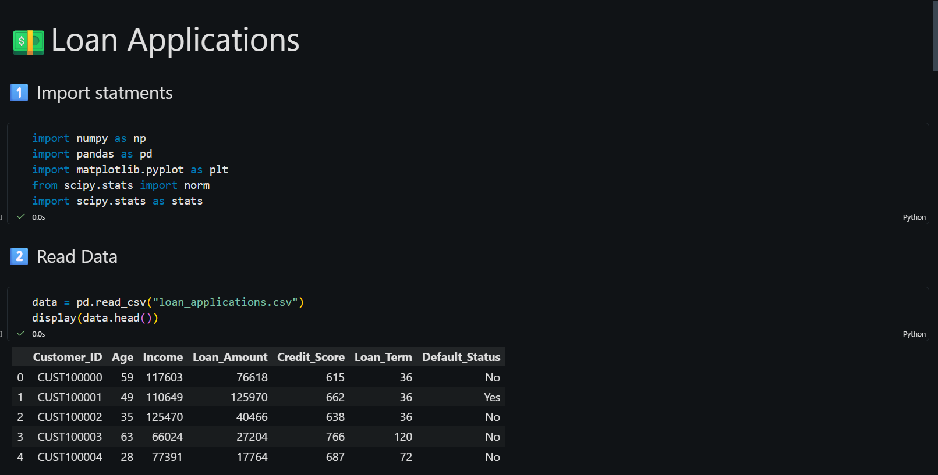
Figure 1: Import Statements & Data Preview (loan_applications.csv)

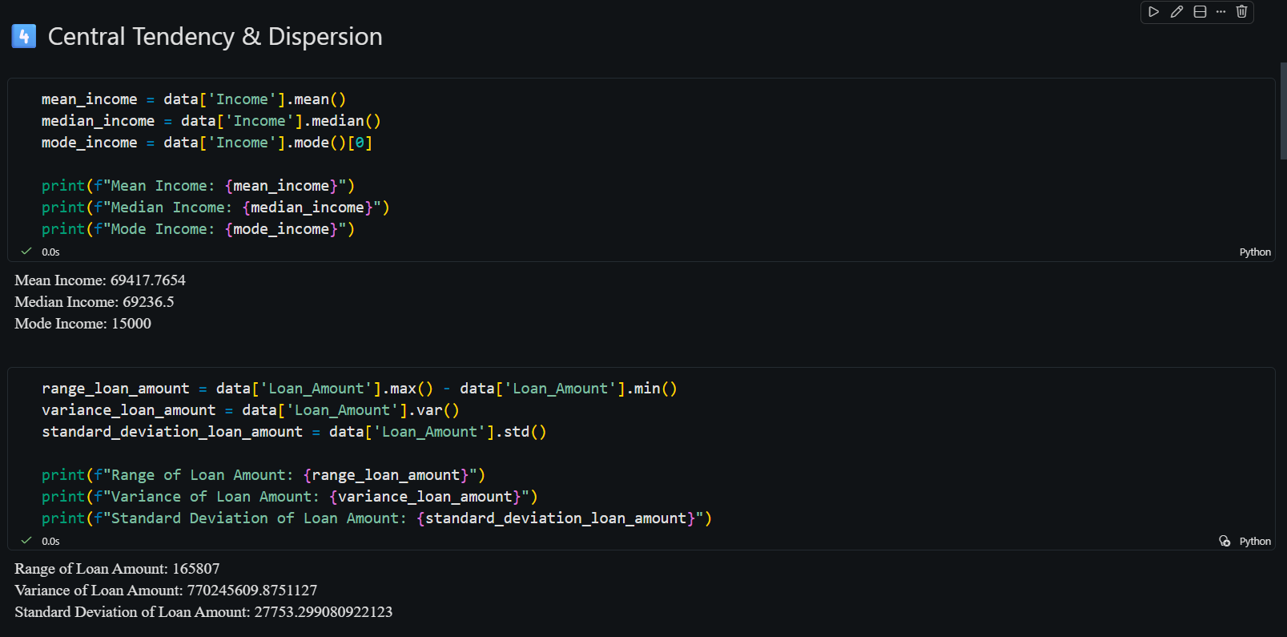
Figure 2: Central Tendency & Dispersion – Mean, Median, Mode, Variance, Std Dev

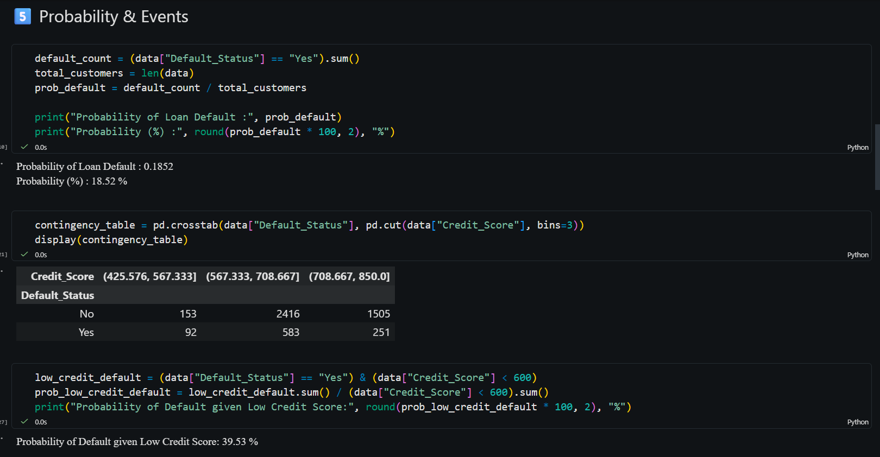
Figure 3: Probability & Events – Default probability, Contingency table, Conditional probability

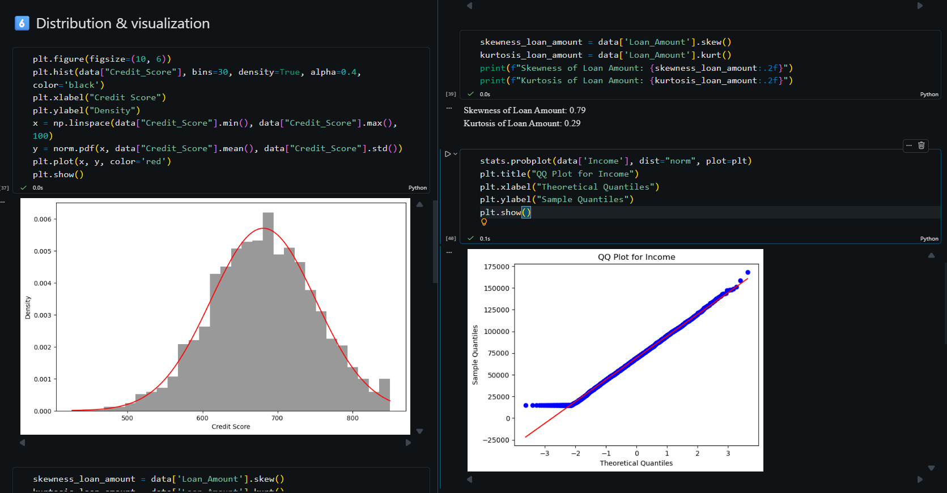
Figure 4: Distribution & Visualization – Credit Score histogram with Normal curve, Skewness, Kurtosis, QQ Plot

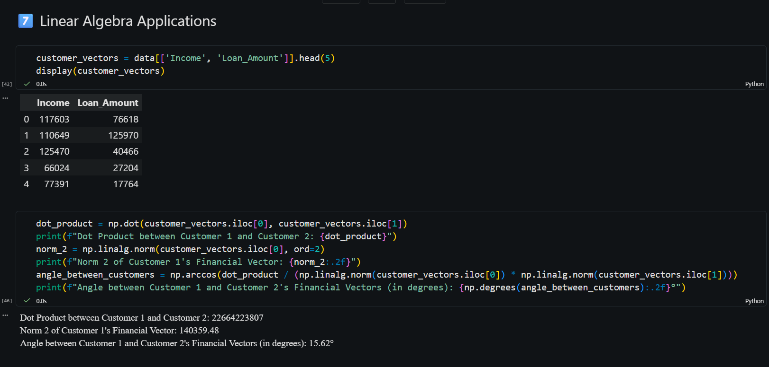
Figure 5: Linear Algebra Applications – Customer vectors, Dot product, Norm, Angle

Key Insights from Data Analysis
Based on the analysis performed in the Jupyter Notebook, the following 5 actionable insights have been identified:

1. Customers with Credit Score < 600 have a 39.53% chance of default — more than double the overall default rate of 18.52%. This indicates that credit score is a strong predictor of default risk, and the bank should apply stricter lending criteria for low-score applicants.

2. The mean and median customer income are nearly identical (≈ ₹69,418 vs ≈ ₹69,237), suggesting a roughly symmetric income distribution. However, the mode income is ₹15,000, revealing a concentration of low-income applicants that may need targeted financial products.

3. Loan amounts show a positive skewness of 0.79, meaning the distribution has a right tail — a significant number of customers borrow amounts much higher than average. The kurtosis of 0.29 (platykurtic) indicates thinner tails and fewer extreme outliers compared to a normal distribution.

4. The angle between Customer 1 and Customer 2's financial vectors (Income, Loan_Amount) is only 15.62°, indicating these two customers have very similar borrowing-to-income profiles. Such vector-based similarity measures can be used for customer segmentation and targeted marketing.

5. The QQ Plot for Income shows data points closely following the theoretical normal line, confirming that customer income is approximately normally distributed. This validates the use of parametric statistical tests (e.g., z-tests, t-tests) for inference on income-related hypotheses.

