# **Desktop_Virtual_Assistant**

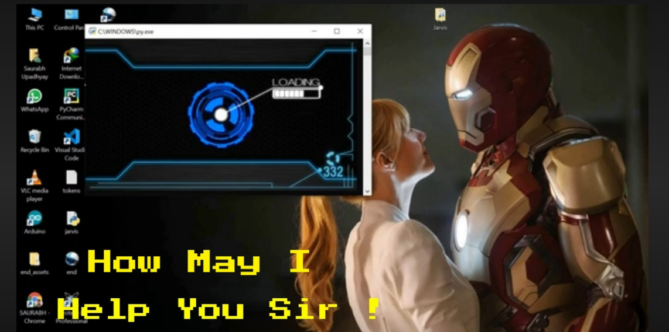

The Desktop Voice Assistant Project is a Python-based application designed to create a seamless and interactive voice-controlled experience for your computer. By harnessing the power of speech recognition and text-to-speech conversion, this project allows users to effortlessly communicate their commands and inquiries to the computer.

**📌Built with**

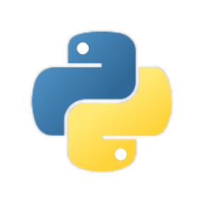

## 📌Features

* Greet user
* Tell about any famous personality (via Wikipedia ) .
* Open any website
* Open college portal and college website (JIIT university).
* Give the current time .
* Plays music
* Open Whatsapp.
* Open Instagram.

## 📌Installation

## Install the pyttsx3(pip install pyttsx3)

## Install the Wikipedia (pip install Wikipedia).

## Install the SpeechRecognition(pip install speechRecognition)

## Install the Webbrowser (pip install webbrowser)

## Install **PyAudio (pip install PyAudio)**

## 📌Author

## 👤 **Priyanshu Mangal**

## LinkedIn :@Priyanshu mangal(www.linkedin.com/in/priyanshu-mangal-b368b9251)

## Github :@priyanshu134