NIP Project — Submission Template
Pega Platform project · This document is your complete submission
Read this before you start:
1. Fill in Section 1 completely. The Pega application name must follow the format NIP-[Project]-[YourName].
2. Create a new Operator in Pega with your full name and log in as that operator before taking any screenshot.
3. When you create your test case, enter YOUR FULL NAME in the Issue Description (Vehicle) or Movie Name (Movie) field.
4. Complete only the section for your chosen project. Delete the other project section.
5. Paste one screenshot per user story (10 total). Follow the screenshot rules in your selected project section.
6. Answer every question in Sections 3 and 4 in your own words.
7. Save the file using this format: ProjectName_FirstName_LastName.docx. Use VehicleService or MovieTicket as the ProjectName. Examples: VehicleService_Ravi_Kumar.docx or MovieTicket_Ravi_Kumar.docx.

Section 1 — Your Details
Full Name | PRIYANSHU AMULANI
Email ID (registered on NIP) | priyanshamulani2096@gmail.com
Phone Number | 9752184719
College Name | LAKSHMI NARAIN COLLEGE OF TECHNOLOGY & SCIENCE
Course (e.g. IT, CS) | CSE - CYBERSECURITY
State | MADHYA PRADESH
Project Chosen (Vehicle Service OR Movie Ticket Booking) | Movie Ticket Booking
Pega Application Name (e.g. NIP-VehicleService-YourName) | NIP-MovieTicket-PriyanshuAmulani
Case Type Name (exact) | Movie Ticket Request
Pega Instance URL | https://4uaaeo0y.pegaacademy.net/prweb/app/movie-ticket-booking/dbQpVsM549jgcQ0KZfxTOR9h29d89lsW*/!STANDARD?pzPostData=667448696
Operator Name (created in Pega with your full name) | NIP-MovieTicket-PriyanshuAmulani

Section 2B — Movie Ticket Booking Management Application
Complete this section only if you selected this project. Delete the other project section before submitting.

Screenshot rules — IMPORTANT before you start:
1. Name your Pega application as: NIP-VehicleService-YourName OR NIP-MovieTicket-YourName
2. Create a new Operator in Pega with your full name (Security → Operators) and log in as that operator.
3. When you create your test case, enter YOUR FULL NAME in the Issue Description (Vehicle) or Movie Name (Movie) field.
4. The logged-in operator name must be visible in every screenshot wherever the Pega interface displays it.
5. The student's full name must be visible in all running-case screenshots.
6. Configuration screenshots must clearly show the relevant application or rule name.
Screenshots that do not show these will not be accepted.

US-001 — Submit Movie Ticket Request
What is expected:
Case created, customer submits Movie Name, Show Date, Show Time, Number of Tickets. Validation applied.
Screenshot — paste your screenshot below this line:
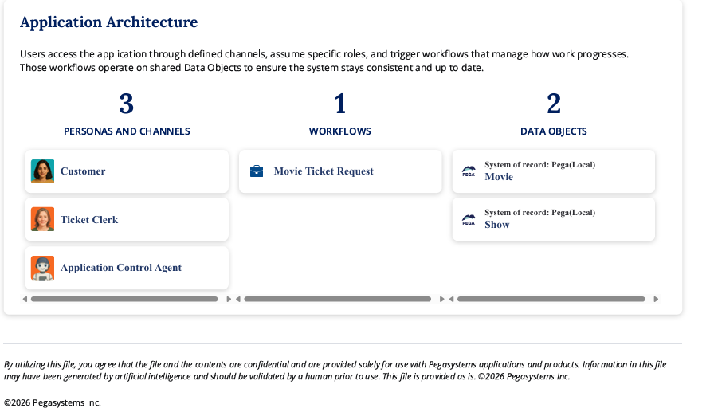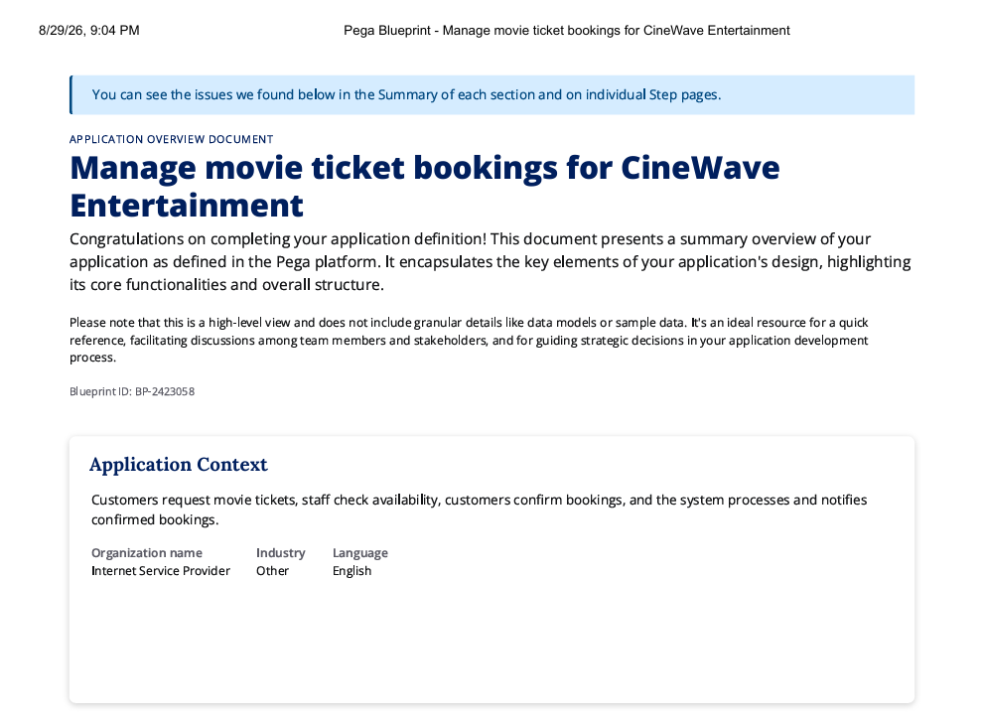

What I built for this (1–2 lines in your own words):
I configured the movie ticket request form to capture Movie Name, Show Date, Show Time and Number of Tickets, with the required validation for the booking request.

US-002 — Check Show Availability
What is expected:
Availability stage. Seat Availability Status and Available Seats Count captured. Booking proceeds only if available.
Screenshot — paste your screenshot below this line:
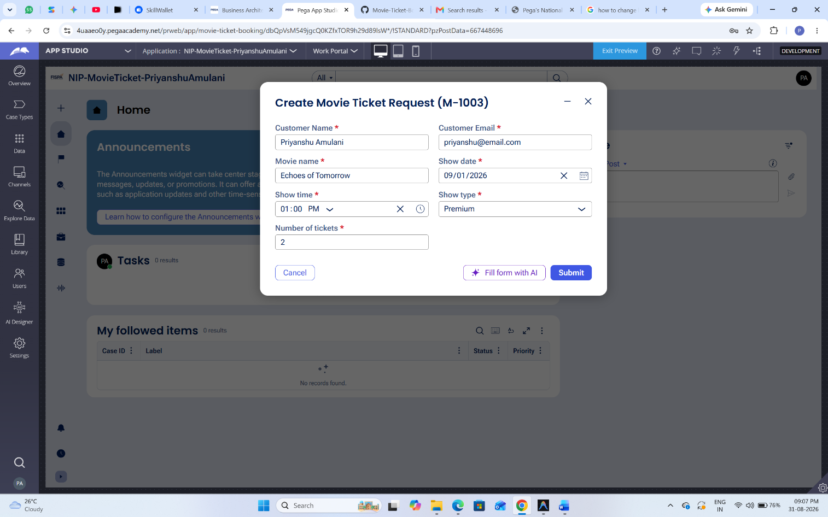

What I built for this (1–2 lines in your own words):
I configured the Availability stage to capture Seat Availability Status and Available Seats Count so the booking can proceed only when seats are available.

US-003 — Calculate Booking Cost
What is expected:
Total Cost calculated automatically from Ticket Price and Number of Tickets using a business rule.
Screenshot — paste your screenshot below this line:
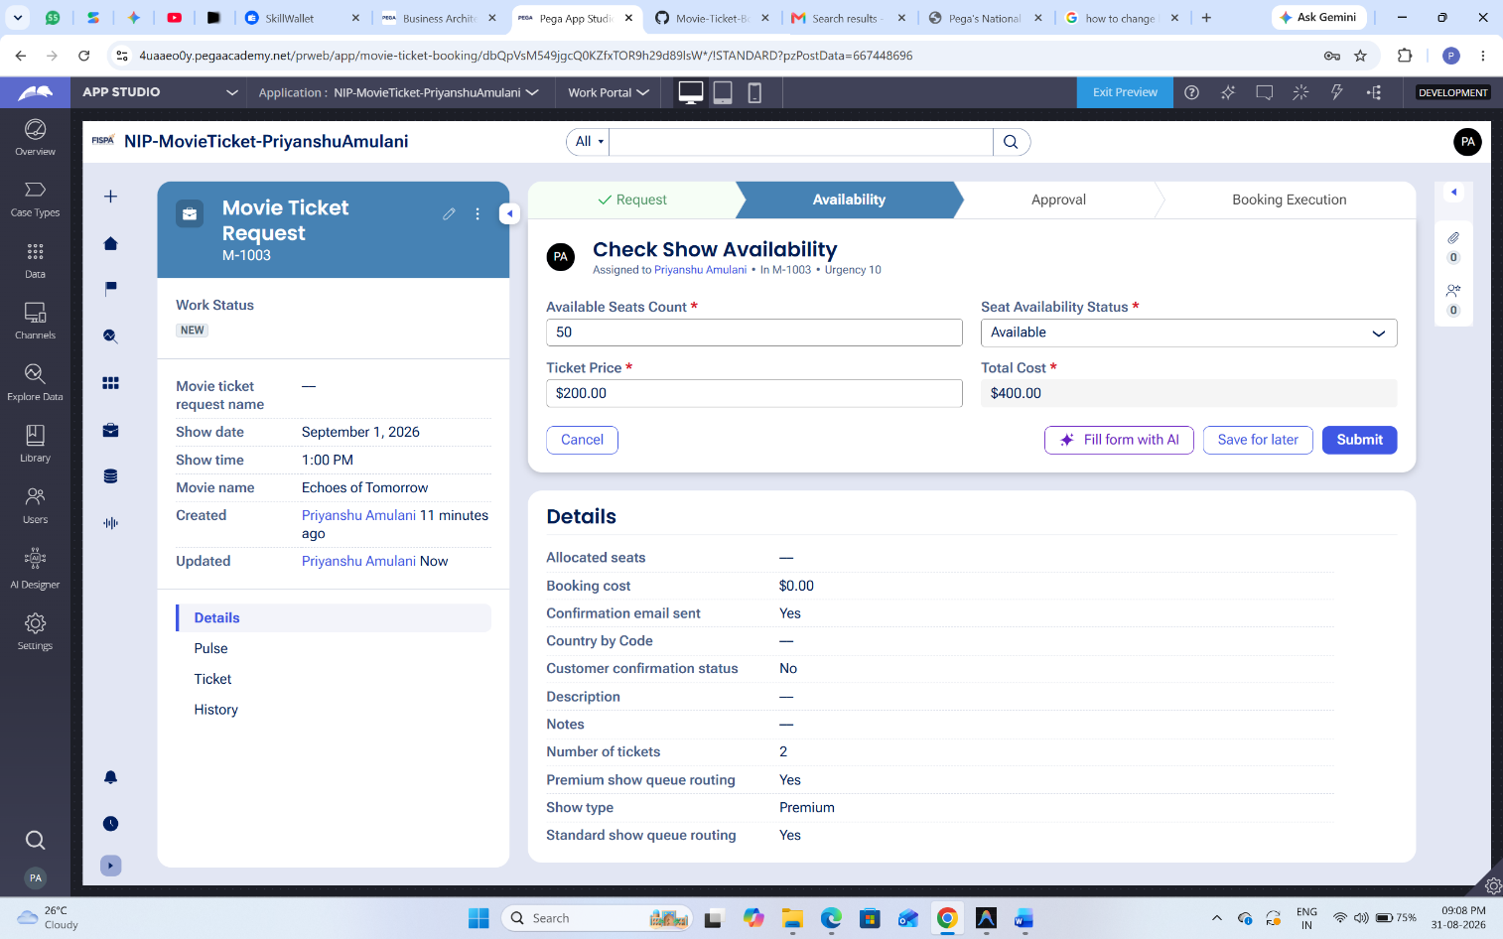

What I built for this (1–2 lines in your own words):
I configured the Total Cost calculation to use the ticket price and number of tickets so the booking amount is calculated automatically.

US-004 — Confirm Booking Request
What is expected:
Approval stage assigned to Customer. Booking Status captured. Flow branches on confirm/cancel.
Screenshot — paste your screenshot below this line:
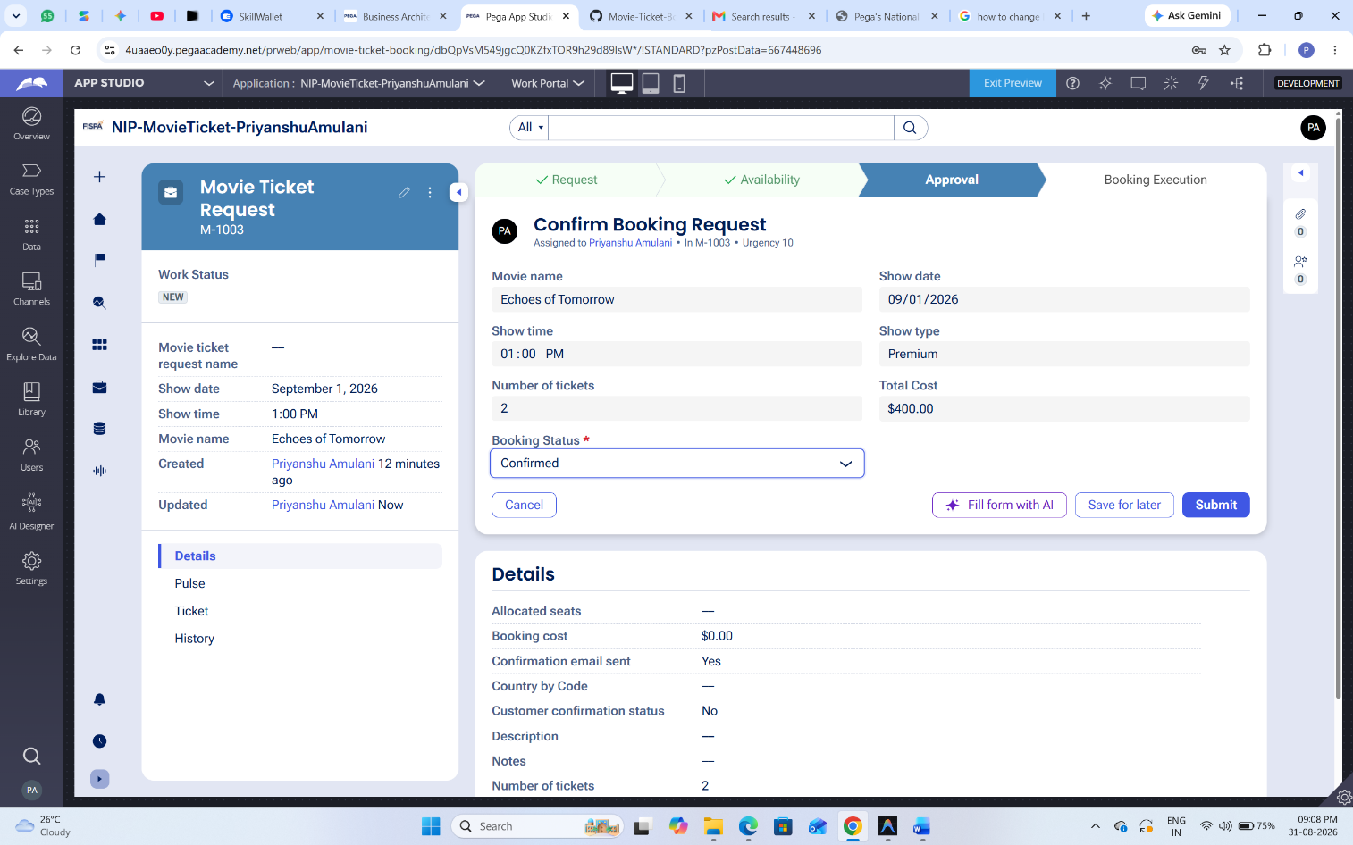

What I built for this (1–2 lines in your own words):
I configured the Approval/Confirmation step for the Customer and captured Booking Status, with the flow able to continue for confirmation or cancel the request.

US-005 — Maintain Movie and Show Data
What is expected:
Reusable Movie and Show data objects created with Movie Name, Genre, Show Date, Show Time, Seat Capacity — linked to case.
Screenshot — paste your screenshot below this line:
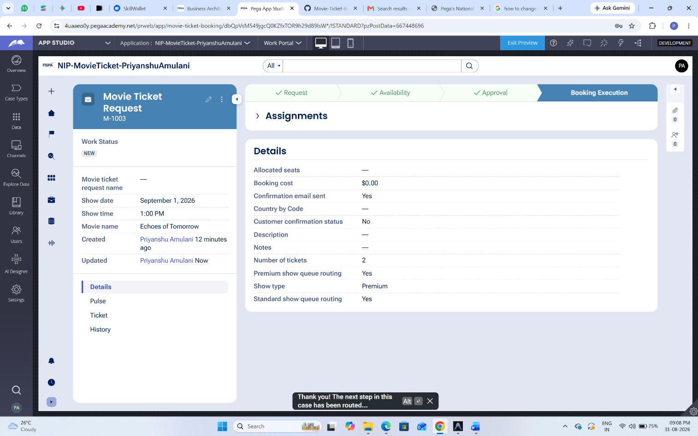

What I built for this (1–2 lines in your own words):
I configured reusable Movie and Show data objects and linked the movie/show information to the movie ticket request.

US-006 — Review Booking Details
What is expected:
Confirmation screen shows Movie Name, Show Timing, Number of Tickets and Total Cost clearly.
Screenshot — paste your screenshot below this line:


What I built for this (1–2 lines in your own words):
I configured the confirmation view to display the movie, show timing, number of tickets and total cost before the booking is completed.

US-007 — Process Ticket Booking
What is expected:
Booking Execution stage. Seat Numbers, Ticket ID and Booking Confirmation Status maintained.
Screenshot — paste your screenshot below this line:


What I built for this (1–2 lines in your own words):
I configured the Booking Execution stage to maintain the allocated Seat Numbers, Ticket ID and Booking Confirmation Status.

US-008 — Notify Booking Confirmation
What is expected:
Correspondence rule triggered on case resolution. Email includes movie, show, seat and cost details.
Screenshot — paste your screenshot below this line:
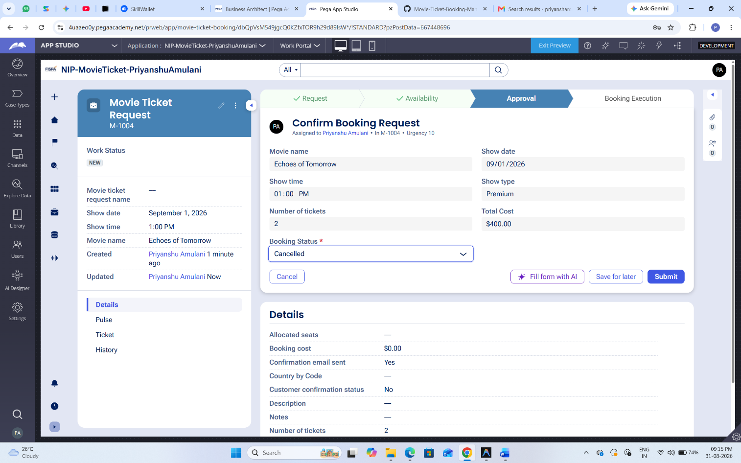

What I built for this (1–2 lines in your own words):
I configured the booking confirmation correspondence so that a confirmation message can contain the movie, show, seat and cost information when the case is resolved.

US-009 — Define Booking SLA
What is expected:
SLA configured on the case type. Goal: 1 day. Deadline: 2 days. Priority increases on breach.
Screenshot — paste your screenshot below this line:
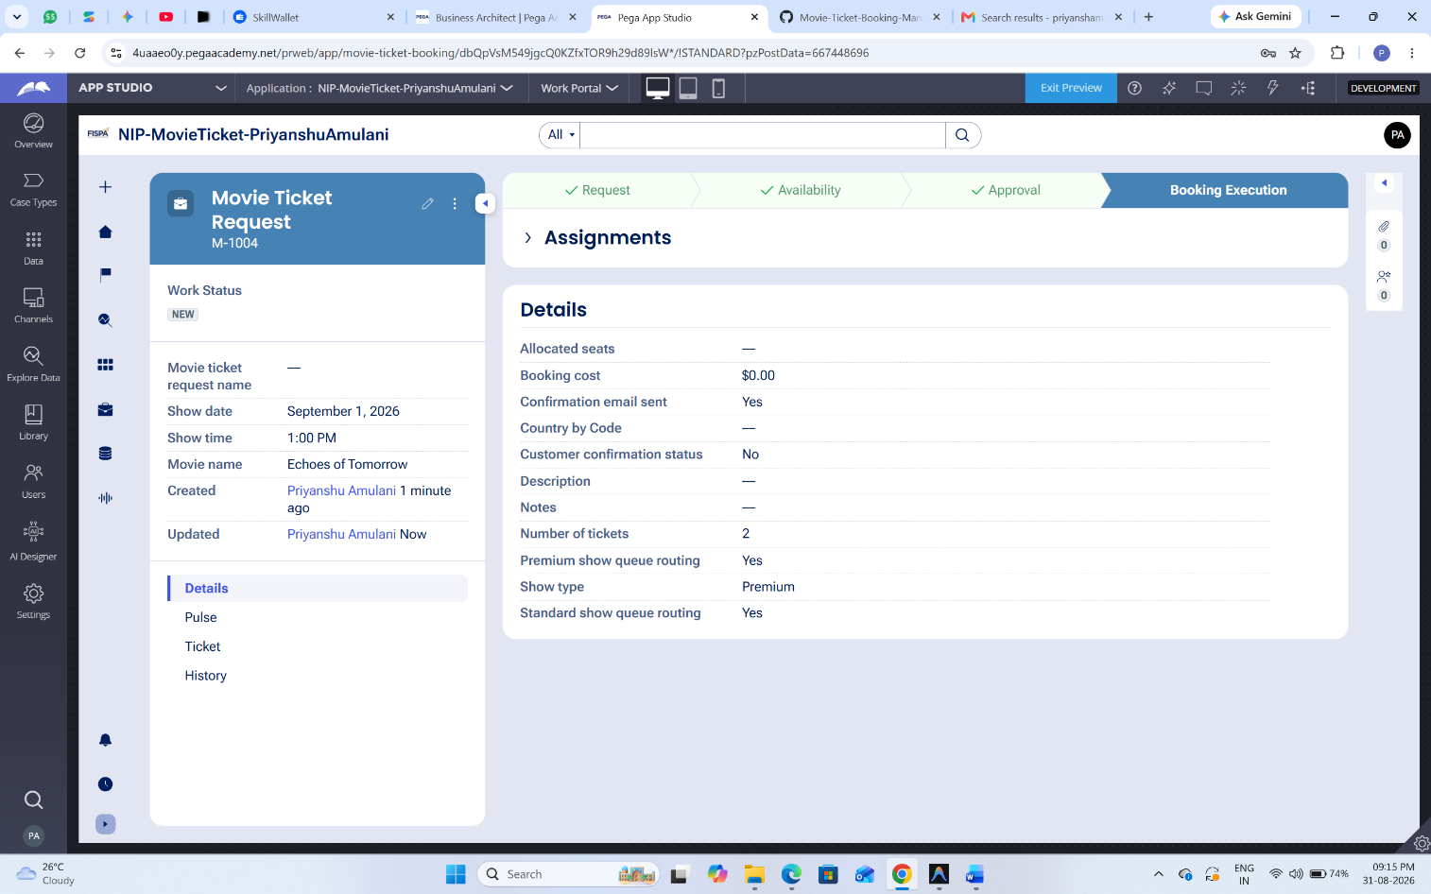

What I built for this (1–2 lines in your own words):
I configured the case completion timing using an SLA with a 1-day goal and 2-day deadline, with higher priority on breach.

US-010 — Route by Show Type
What is expected:
Routing rule or Decision Table routes to PremiumShowQueue or StandardShowQueue based on Show Type property.
Screenshot — paste your screenshot below this line:


What I built for this (1–2 lines in your own words):
I configured routing based on Show Type so Premium and Standard bookings can be sent to their corresponding work queues.

Section 3 — About Your Application
These answers are checked against your screenshots. Write exactly what is in your application.

Q1. List your stages in the order they appear in your case lifecycle.
Stage names in order, separated by commas.
Ticket Request, Availability, Approval, Booking Execution, Closure.

Q2. Name the data object(s) you created and the properties inside them.
Data object name and its properties.
Movie and Show data objects. Movie contains the movie information such as Movie Name and Genre. Show contains Show Date, Show Time and Seat Capacity; the show information is linked to the ticket request. Verify the exact property names in the current Pega data objects before submission.

Q3. What is the exact name and type of the rule you used to calculate Total Cost?
Provide:
• Rule Name
• Rule Type
• Properties used in the calculation
• Formula used
Rule name: VERIFY IN PEGA. Rule type: VERIFY IN PEGA (for example, Declare Expression if that is the rule actually used). Properties used: Ticket Price and Number of Tickets. Formula: Ticket Price × Number of Tickets. Do not submit until the exact rule name/type shown in your application is entered.

Section 4 — Your Understanding
Short, honest and specific answers score well.

Q4. What did Blueprint generate for you, and what did you add or change yourself afterwards?
Be specific about what was already there and what you built or modified on top.
Blueprint generated the initial application structure, including the case lifecycle, stages, forms and basic application structure. I then configured the movie-ticket fields, availability information, booking cost calculation, customer confirmation, booking execution, correspondence, SLA and routing required by the user stories.

Q5. Was there anything Blueprint created that you had to correct or configure further? Describe one example.
A real example from your own work.
Yes. During configuration I encountered an invalid expression in the Confirmation instructions. The text had been treated as an expression and caused a draft-process warning. I removed the invalid instruction/configuration so the warning disappeared.

Q6. Explain your case flow from creation to resolution, in order.
What happens first, who does what, when the case closes.
The customer creates a Movie Ticket Request and enters the movie, show date/time and number of tickets. The Availability stage checks seat availability. The booking cost is calculated from ticket price and ticket quantity. The customer then confirms or cancels the booking. If confirmed, Booking Execution allocates seats and maintains the ticket/confirmation details. The case then reaches Closure and the booking confirmation is sent.

Q7. Pick two design choices you made in your application and explain why you made them.
For each design choice, provide:
• What you implemented
• Why you chose that approach
• What benefit it provides to the application
1) I separated availability checking from customer confirmation so that a booking is confirmed only after availability is checked. This makes the process easier to follow and prevents unavailable bookings from being confirmed. 2) I used work-queue routing for show type so Premium and Standard work can be handled by the appropriate team without manually assigning every case.

Q8. What was the hardest part, and how exactly did you fix it?
Specific and honest. A real challenge scores much better than a generic answer.
The hardest part was configuring the assignment/routing because the Enter Movie Details user action did not expose a routing option in its configuration view. I checked the process/assignment configuration and configured routing where the assignment is available. I also corrected an invalid Confirmation instruction expression; after deleting the invalid expression, the draft warning was removed.

Q9. If the approval step was only needed when Total Cost is above a certain amount, what would you change in your application?
Explain what you would change and where. You do not need to build this.
I would add a condition before the Approval stage that evaluates Total Cost. If Total Cost is above the chosen threshold, the case would enter the Approval step; otherwise it would bypass approval and continue directly to the next stage. The condition would be configured on the case lifecycle/process transition.

Q10. List three exact rule names from your application that you personally created or modified.
Include the rule name and rule type for each one (for example: CalculateTotalCost - Declare Expression).
VERIFY THE EXACT THREE RULE NAMES AND TYPES IN YOUR PEGA APPLICATION BEFORE SUBMITTING. Do not use guessed names. Record them in the format: RuleName — Rule Type. Example only: CalculateTotalCost — Declare Expression, if that is exactly what your application shows.
Q11. List all personas used in your application.
List the persona names exactly as they appear in your application.
Customer, Ticket Clerk, users.
Q12. List all work queues used in your application and explain when each one is used.
For each work queue, provide its exact name and the condition or type of work routed to it.
PremiumShowQueue — used for Premium show bookings. StandardShowQueue — used for Standard show bookings. Verify that these exact work queues exist in your application and that the Show Type routing points to them before submission.
Before You Submit — Check These
Read through once before uploading.
1. Section 1 filled in. Application named as NIP-[Project]-[YourName]. Names match the actual application.
2. New Operator created in Pega with my full name. I logged in as that operator for all screenshots.
3. Only my chosen project section remains — the other project section is deleted.
4. All 10 user story screenshots are pasted and follow the operator, running-case, application, and rule-name evidence requirements.
5. Every question in Sections 3 and 4, including Q10, Q11, and Q12, is answered in my own words.
6. This file is named using the required format: ProjectName_FirstName_LastName.docx (for example, VehicleService_Ravi_Kumar.docx or MovieTicket_Ravi_Kumar.docx) and uploaded as required.

