**APIM**

Transformation policy:

Here we get version and on which platform it is running it is not secure

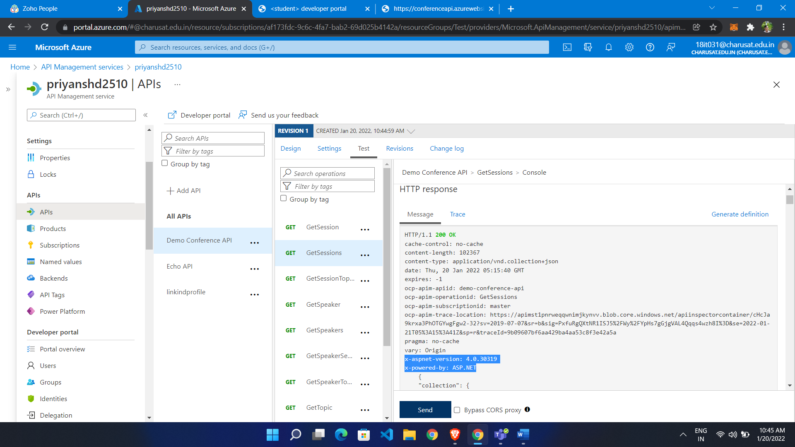

Set header

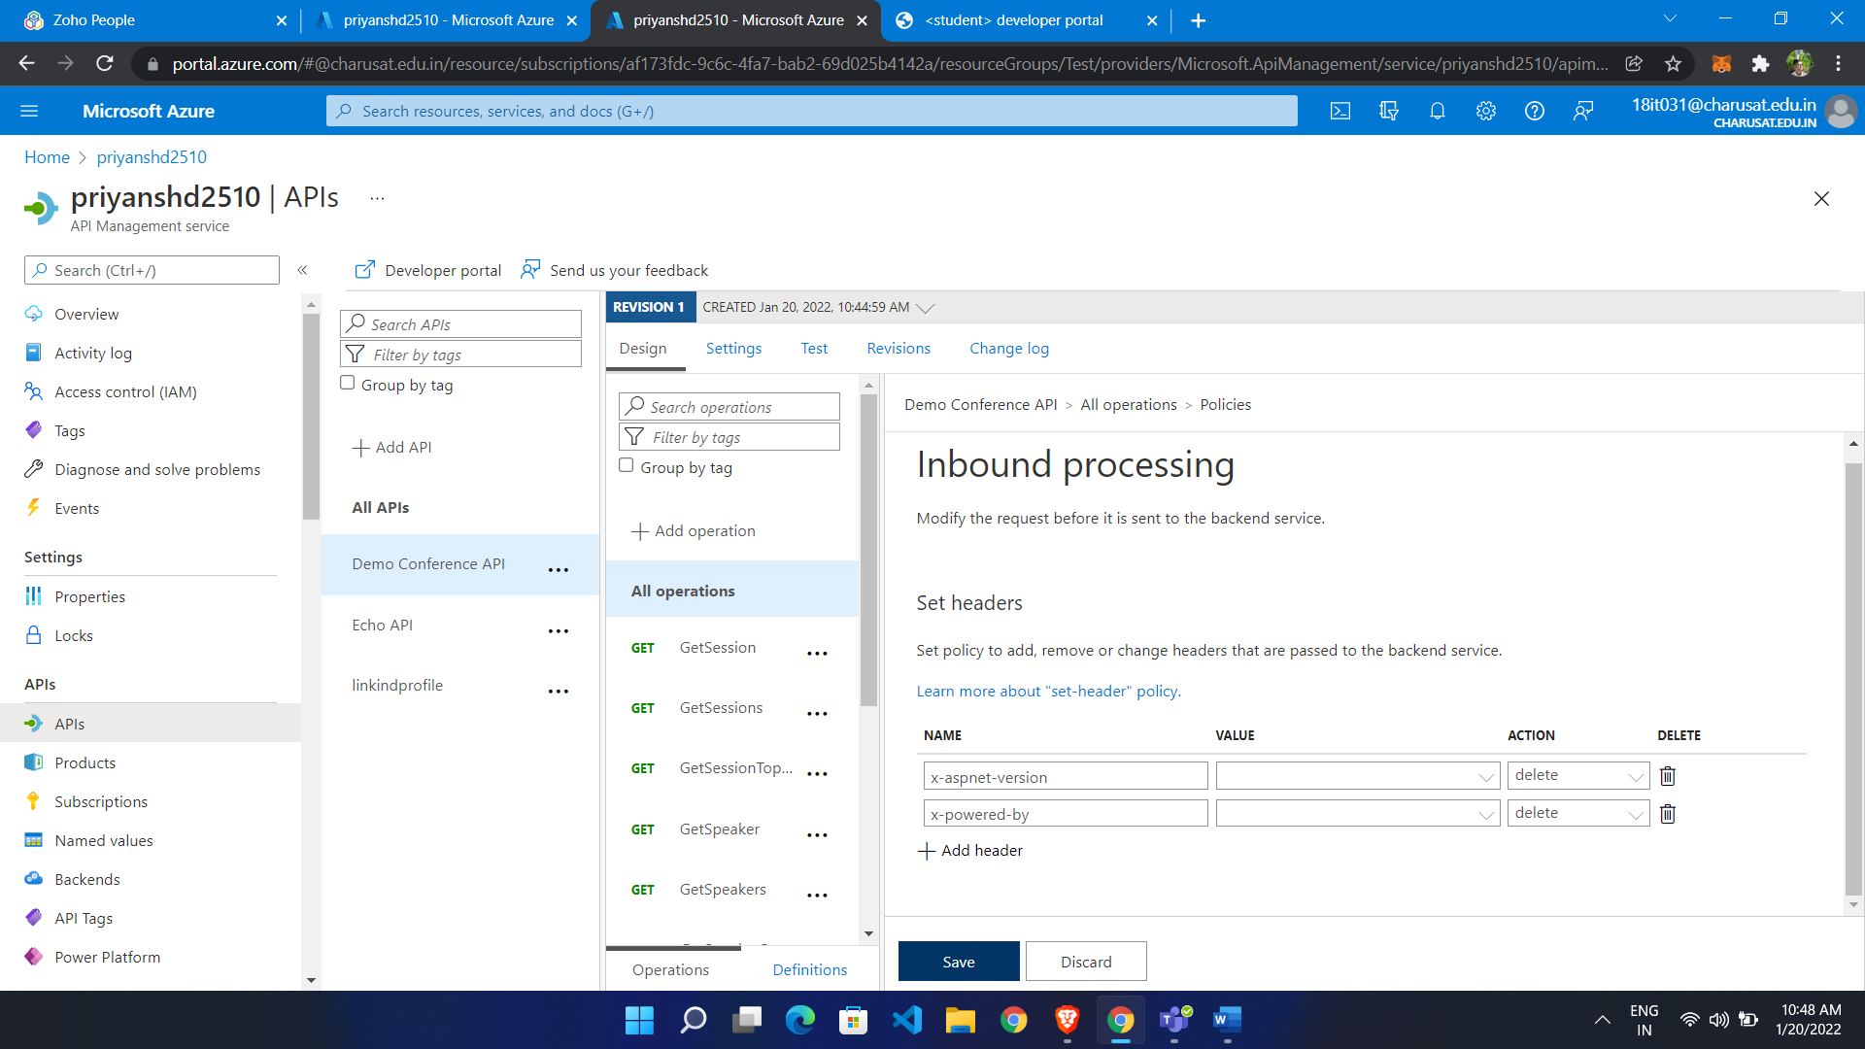

Put it in outbound

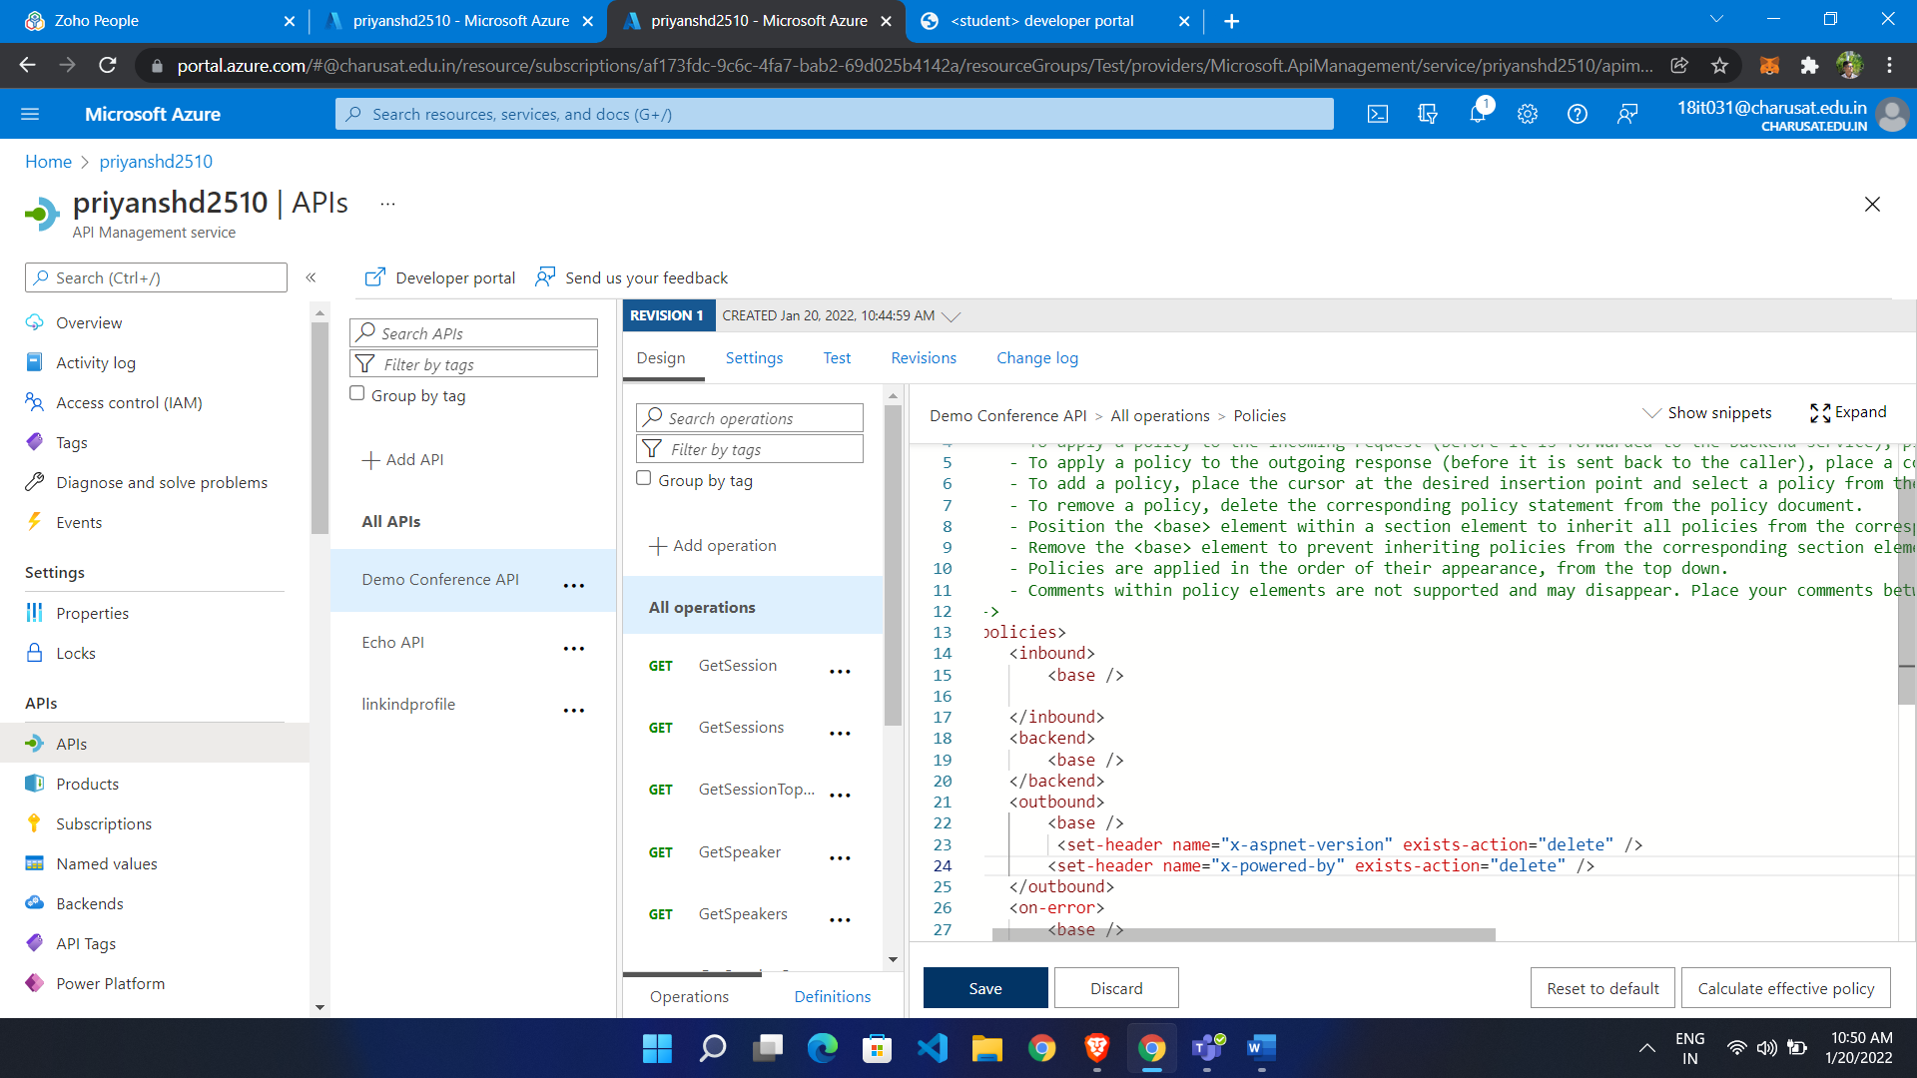

APIM with ARM Template:

|  |
| --- |
| {      "$schema": "https://schema.management.azure.com/schemas/2019-04-01/deploymentTemplate.json#",      "contentVersion": "1.0.0.0",      "metadata": {        "_generator": {          "name": "bicep",          "version": "0.4.1008.15138",          "templateHash": "10451446506799526629"        }      },      "parameters": {        "apiManagementServiceName": {          "type": "string",          "defaultValue": "[format('apiservice{0}', uniqueString(resourceGroup().id))]",          "metadata": {            "description": "The name of the API Management service instance"          }        },        "publisherEmail": {          "type": "string",          "minLength": 1,          "metadata": {            "description": "The email address of the owner of the service"          }        },        "publisherName": {          "type": "string",          "minLength": 1,          "metadata": {            "description": "The name of the owner of the service"          }        },        "sku": {          "type": "string",          "defaultValue": "Developer",          "allowedValues": [            "Developer",            "Standard",            "Premium"          ],          "metadata": {            "description": "The pricing tier of this API Management service"          }        },        "skuCount": {          "type": "int",          "defaultValue": 1,          "allowedValues": [            1,            2          ],          "metadata": {            "description": "The instance size of this API Management service."          }        },        "location": {          "type": "string",          "defaultValue": "[resourceGroup().location]",          "metadata": {            "description": "Location for all resources."          }        }      },      "functions": [],      "resources": [        {          "type": "Microsoft.ApiManagement/service",          "apiVersion": "2020-12-01",          "name": "[parameters('apiManagementServiceName')]",          "location": "[parameters('location')]",          "sku": {            "name": "[parameters('sku')]",            "capacity": "[parameters('skuCount')]"          },          "properties": {            "publisherEmail": "[parameters('publisherEmail')]",            "publisherName": "[parameters('publisherName')]"          }        }      ]    } |

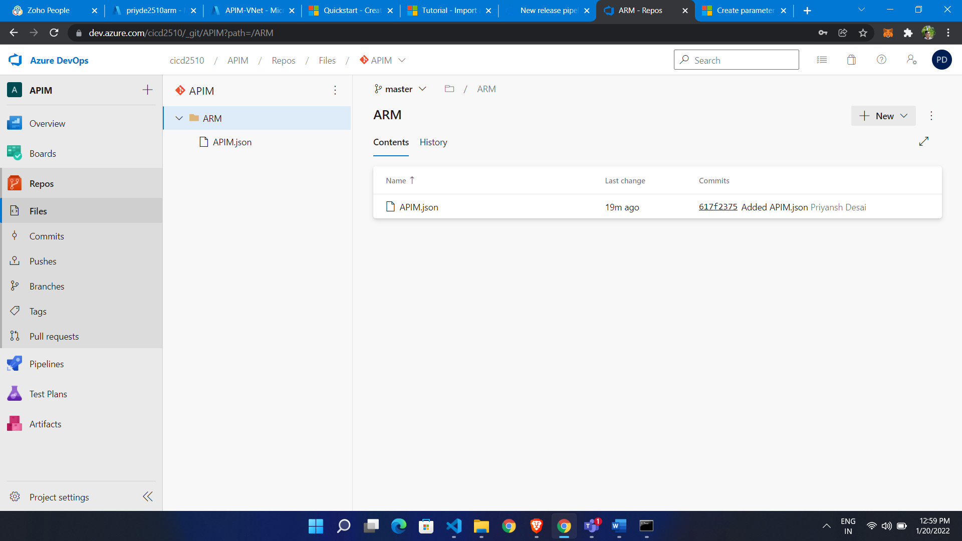

Build pipeline:

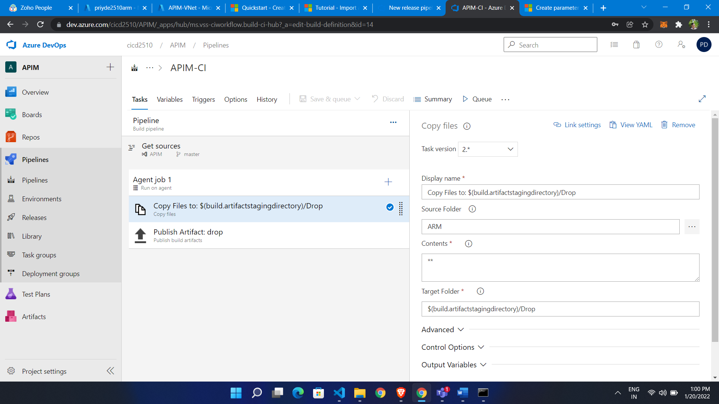

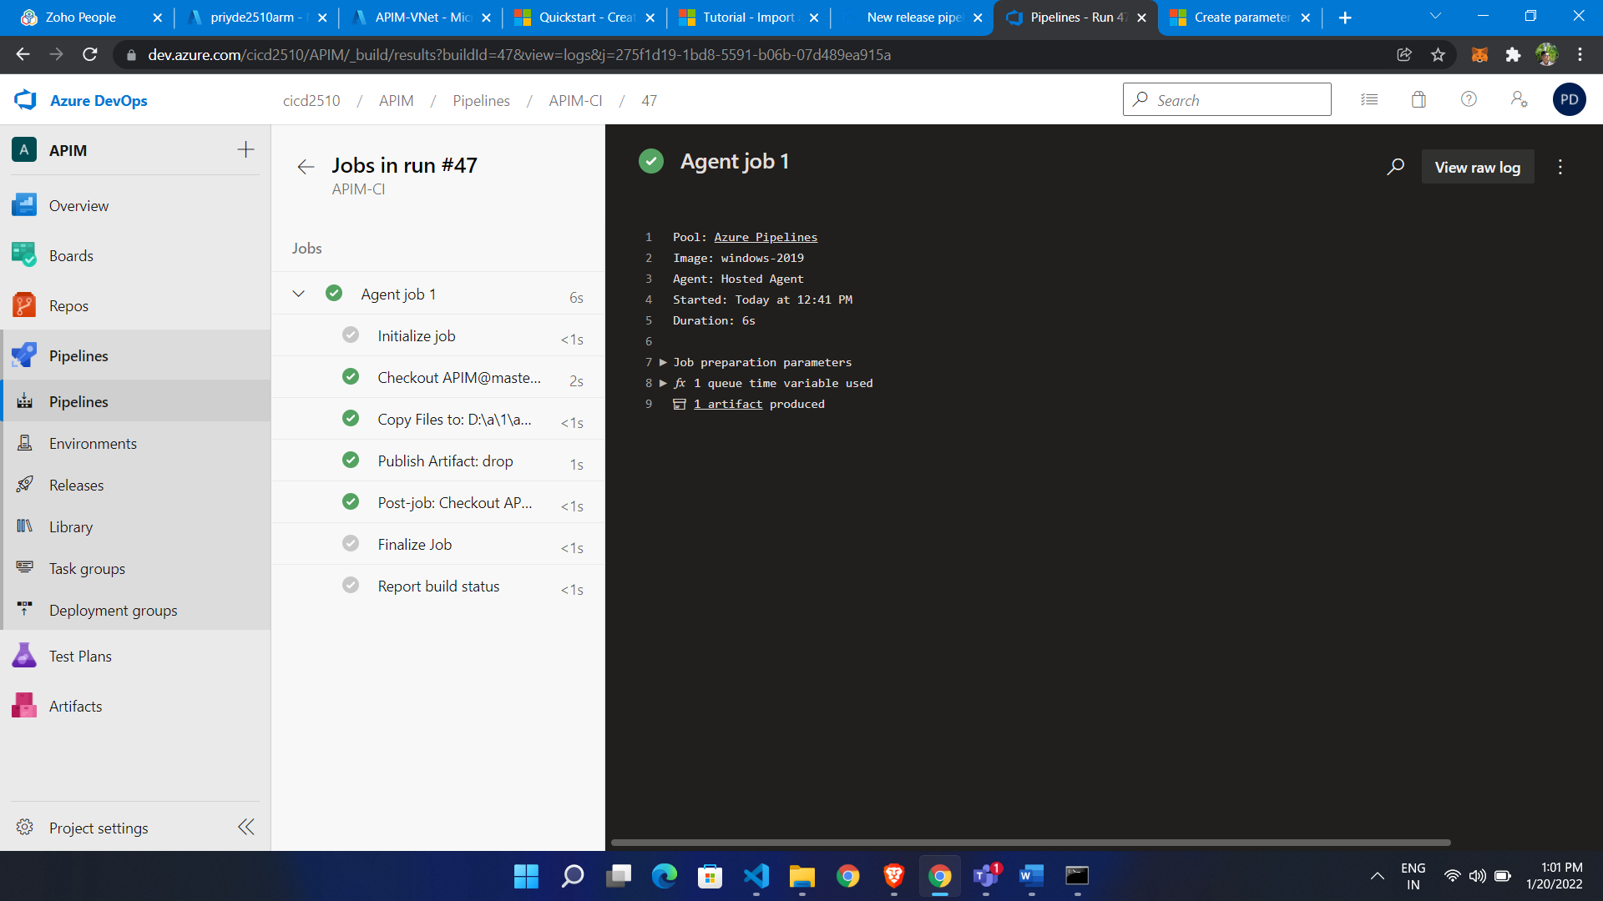

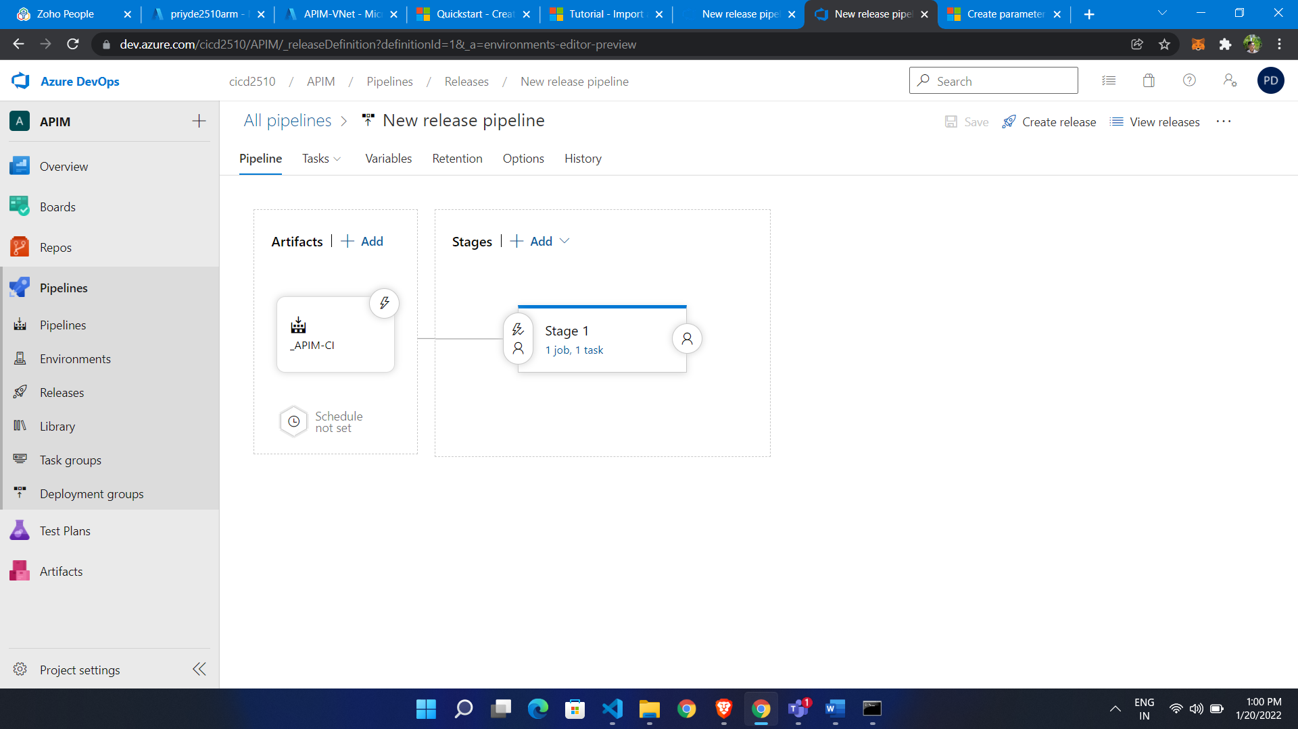

Release pipeline

