**JMeter**

If we take

Thread = 100

Ramp up =100

Loop=1

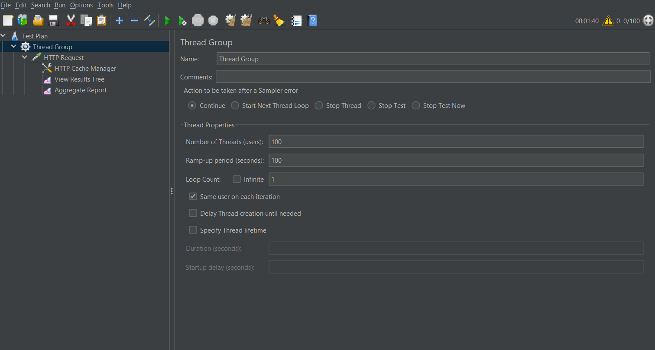

Here each thread will start after 1 sec (100/100) after previous thread begun [ 1user per sec]

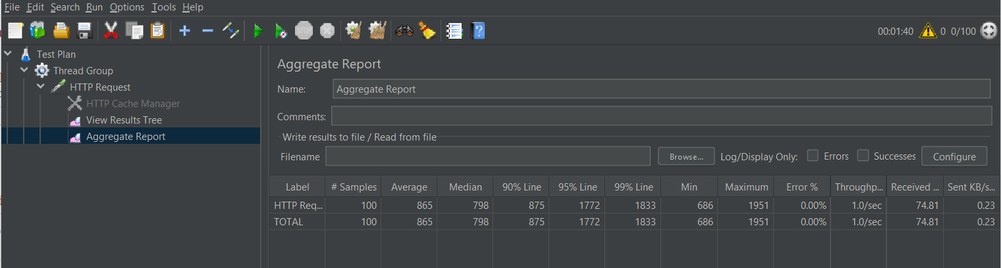

With caching manger

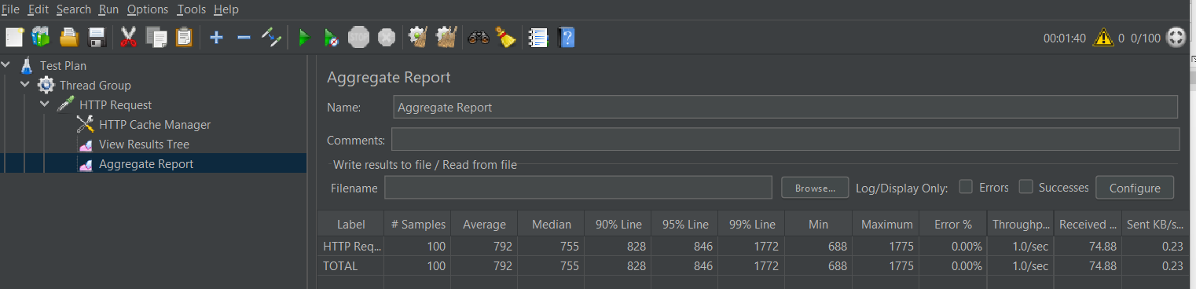

Calculate avg response time

* Sum of all Samplers response times
* Divided by the number of samplers

<https://stackoverflow.com/questions/66352075/calculate-average-response-time-calculation-in-jmeter>

1 user

1 ramp up

100 loop

