**CDN**

Azure CDN is design to send Audio, Video, Images and other file faster and more reliable to customer using servers that are closest to the user

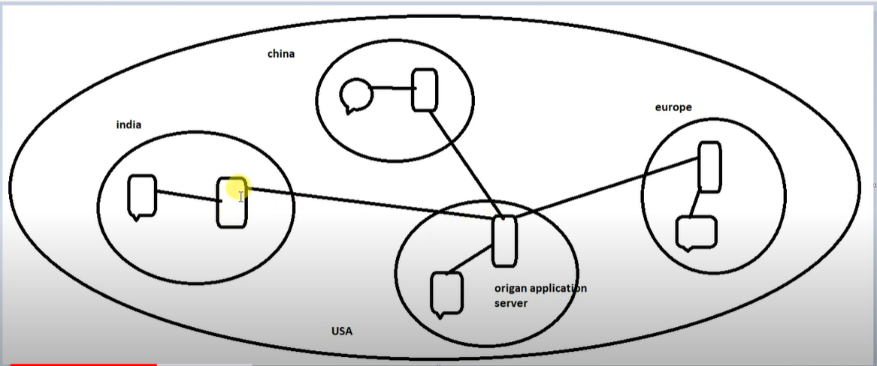

If we have one application in US and we want its in India so send request and get response so in between there is some delay

So in this figure we see that in every region there is one cache server which is connected to origin server so first time any user send request it get response from origin server but it cache In cache server so second time when some one send request it get response from cache server

**Benefit:**

* Low latency and faster delivery of content to the user
* Reduce the load of origin server

**Use Case:**

* Delivery static resource to client
* Stream video content in fast way
* Support some iot solution

**Configuration:**

Make one storage account and create container in it

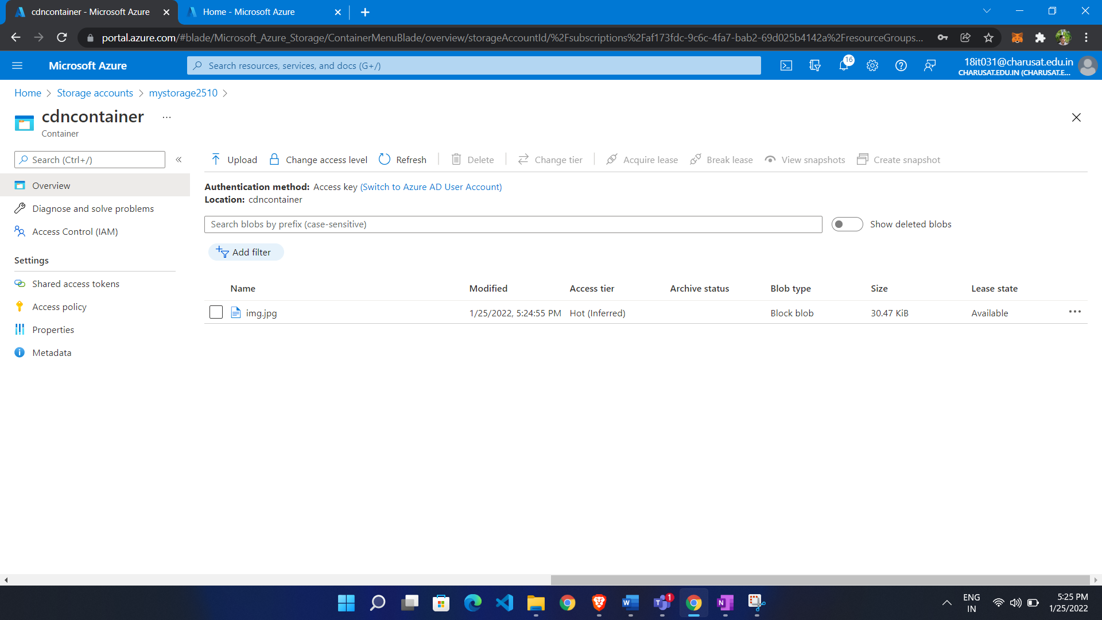

* Search CDN profile
* Click create
* Give name
* Choose region
* Choose pricing tier

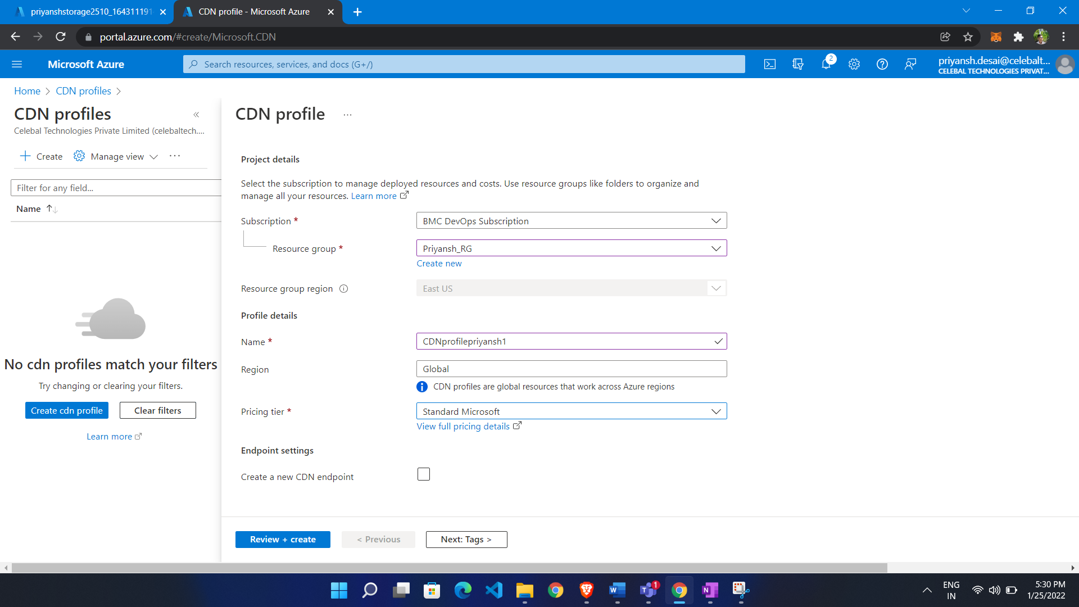

Now we create Endpoint:

* Click add endpoint
* Give name
* Select orogin hostname
* Give path header

