**Tutorial – 1**

1. Write a C program to print “Hello World” on the output screen.

using System;

namespace Tutorial_1

{

class Program

{

static void Main(string[] args)

{

Console.WriteLine("Hello World!");

}

}

}

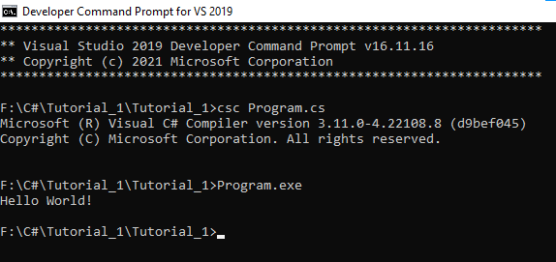**Output:**

1. **Design your profile page as given below.**

using System;

namespace Program2

{

class Program2

{

static void Main(string[] args)

{

string name, dob, address, city, state, country, email;

int pincode;

Console.WriteLine("Enter your name: ");

name = Console.ReadLine();

Console.WriteLine("Enter your Date of Birth: ");

dob = Console.ReadLine();

Console.WriteLine("Enter your Address: ");

address = Console.ReadLine();

Console.WriteLine("Enter your City: ");

city = Console.ReadLine();

Console.WriteLine("Enter your Pincode: ");

pincode = Convert.ToInt32(Console.ReadLine());

Console.WriteLine("Enter your State: ");

state = Console.ReadLine();

Console.WriteLine("Enter your Country: ");

country = Console.ReadLine();

Console.WriteLine("Enter your Email: ");

email = Console.ReadLine();

Console.WriteLine("\n$$$$$$$$$$$$$$$$$$$$$$$$$$$$$$$$$$");

Console.WriteLine("\nName: "+name);

Console.WriteLine("\nDOB: "+dob);

Console.WriteLine("\nAddress: "+address);

Console.WriteLine("\nCity: " + city);

Console.WriteLine("\nPincode: " + pincode);

Console.WriteLine("\nState: " + state);

Console.WriteLine("\nCountry: " + country);

Console.WriteLine("\nEmail: " + email);

Console.WriteLine("\n$$$$$$$$$$$$$$$$$$$$$$$$$$$$$$$$$$");

}

}

}

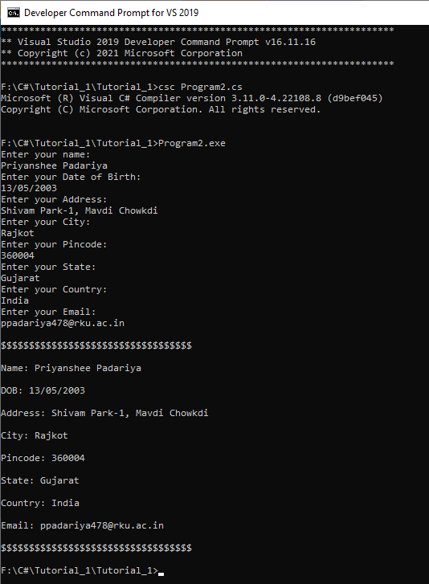**Output:**

1. Find out whether the given input in odd or even.

using System;

namespace Tutorial_1

{

class Program3

{

static void Main()

{

int n;

Console.Write("Enter number:");

n = Convert.ToInt32(Console.ReadLine());

if (n % 2 == 0)

{

Console.WriteLine("\n>>>Given number {0} is Even", n);

}

else

{

Console.WriteLine("\n>>>Given number {0} is Odd", n);

}

}

}

}

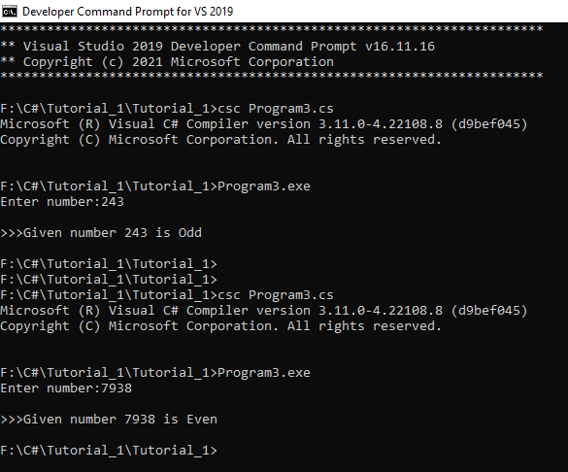**Output:**

1. Rearrange the given code to correct the Program. The resultant program will be to input a number and print whether the given number is odd or even.

namespace ConsoleApplication1

{

    {

        static void Main(string[] args)

        {

            int x;

            Console.WriteLine("Enter Number : ");

            x = Convert.ToInt32(str);

            Console.WriteLine("Number is Even");

            else

            Console.Read();

                           string str = Console.ReadLine();

             if (x % 2 == 0)

            Console.WriteLine("Number is Odd");

        }

    }

}

class Program

using System;

**Rearrange Code:**

using System;

namespace Tutorial_1

{

class Program4

{

static void Main(string[] args)

{

int x;

Console.Write("Enter Number : ");

string str = Console.ReadLine();

x = Convert.ToInt32(str);

if (x % 2 == 0)

Console.WriteLine("Number is Even");

else

Console.WriteLine("Number is Odd");

Console.Read();

}

}

}

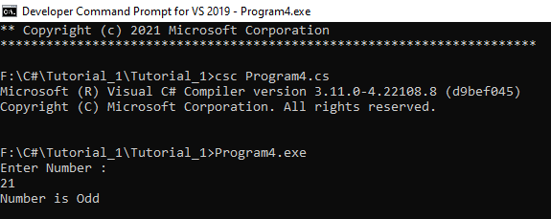**Output:**

1. Write output of the Program. Also write comment for each line for the following code.

using System;

namespace Tutorial_1

{

class Program5

{

static void Main(string[] args)

{

int n;

Double fact = 1; //Because factorial of big integer is big number that crossed integer range

Console.WriteLine("Enter Number : ");

string str = Console.ReadLine(); //Take input from user

n = Convert.ToInt32(str); //Convert String input into Integer

for (int i = 1; i <= n; i++)

{

fact = fact * i; //Factorial of given number

}

Console.WriteLine("Factorial : {0}", fact); //Print Factorial of given number

Console.Read();

}

}

}

**Output:**

Enter Number:

13

Factorial: 6227020800

1. Write Missing statement to get the desired output.

using System;

namespace Tutorial_1

{

class Program6

{

static void Main(string[] args)

{

int a, b, c, result;

String str;

Console.Write("Enter Number 1: ");

//Missing statement is

str = Console.ReadLine();

a = Convert.ToInt32(str);

Console.Write("Enter Number 2: ");

//Missing statement is

str = Console.ReadLine();

b = Convert.ToInt32(str);

Console.Write("Enter Number 3: ");

str = Console.ReadLine();

//Missing statement is

c = Convert.ToInt32(str);

result = Sum(a, b, c);

//Missing statement is

Console.WriteLine("Sum: {0}", result);

Console.Read();

}

static int Sum(int x, int y, int z)

{

int res;

res = x + y + z;

return res;

}

}

}

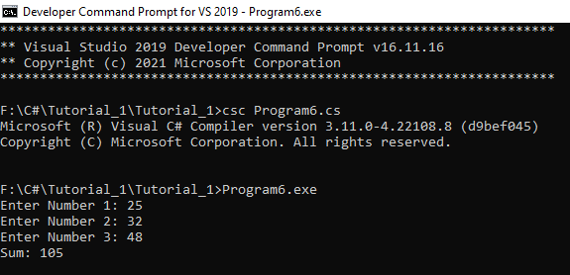**Output:**

1. Predict and Write the output of the given Code.

using System;

namespace While_Loop

{

class Program

{

static void Main(string[] args)

{

int num1, res, i;

Console.WriteLine("Enter a Number: ");

num1 = Convert.ToInt32(Console.ReadLine());

i = 1; //Initialization

//Check whether condition matches or not

while (i <= 10)

{

res = num1 * i;

Console.WriteLine("{0} x {1} = {2}", num1, i, res);

i++;

}

Console.ReadLine();

}

}

}

**Output:**

Enter Number:

8

8 x 1 = 8

8 x 2 = 16

8 x 3 = 24

8 x 4 = 32

8 x 5 = 40

8 x 6 = 48

8 x 7 = 56

8 x 8 = 64

8 x 9 = 72

8 x 10 = 80

1. Write a program to convert given name in upper case.

INPUT: John F Kennedy  
OUTPUT: JOHN F KENNEDY

using System;

namespace Tutorial_1

{

class Program8

{

static void Main(String[] args)

{

string str,u_str;

Console.Write("INPUT: ");

str = Console.ReadLine();

u_str = str.ToUpper();

Console.WriteLine("OUTPUT:" + u_str);

}

}

}

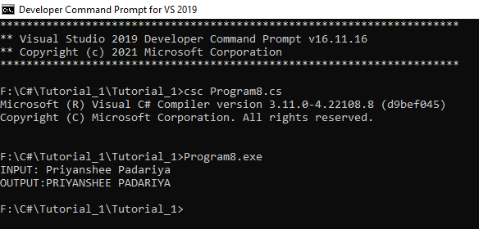**Output:**

1. Write a program to convert given name in toggle case.

INPUT: JoHn F kEnNedy  
OUTPUT: jOhN f KeNneDY

using System;

namespace Tutorial_1

{

class Program9

{

static char check(char s)

{

if (Char.IsUpper(s))

{

return Char.ToLower(s);

}

else

{

return Char.ToUpper(s);

}

}

static void Main(String[] args)

{

Console.Write("\nINPUT: ");

String str = Console.ReadLine();

char[] c = new char[str.Length];

for (int i = 0; i < str.Length; i++)

{

char s = check(str[i]);

c[i]= s;

}

string s_edit = new string(c);

Console.Write("\nOUTPUT: ");

Console.WriteLine(c);

}

}

}

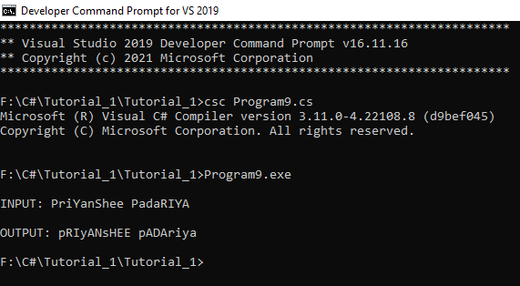**Output:**

1. Write a Program which accepts mobile no as a string from the user and converts the last 5 digits into X.

INPUT: 1234567890  
OUTPUT: 12345XXXXX

using System;

namespace Tutorial_1

{

class Program10

{

static void Main(String[] args)

{

string num,edit_num;

Console.Write("Enter Phone Number:");

num = Console.ReadLine();

char[] numArr = num.ToCharArray();

if(num.Length == 10)

{

for(int i=0; i<10; i++)

{

if (i > 4)

{

numArr[i] = 'X';

}

}

edit_num = new String(numArr);

Console.WriteLine("OUTPUT: " + edit_num);

}

else

{

Console.WriteLine("Invalid Phone Number");

}

}

}

}

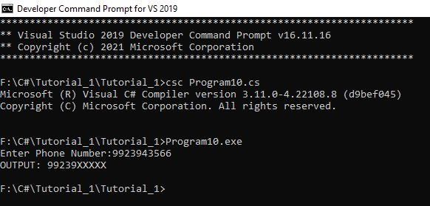**Output:**

1. Write a Program which accepts name and gender from the user. Here, gender may have only 1 character, M or F. Based on the gender prefix the name Mr. & Ms.

Name: Hillary Clinton  
GENDER: F

using System;

namespace Tutorial_1

{

class Program11

{

static void define_g(string n, string g)

{

switch (g)

{

case "M":

case "m":

Console.WriteLine("\n>>>Hello Mr. " + n);

Console.WriteLine("\n");

break;

case "F":

case "f":

Console.WriteLine("\n>>>Hello Ms. " + n);

Console.WriteLine("\n");

break;

}

}

static void Main(String[] args)

{

Console.Write("Enter name: ");

String name = Console.ReadLine();

Console.Write("Enter your Gender(M for Male & F for Female): ");

String gender = Console.ReadLine();

define_g(name, gender);

}

}

}

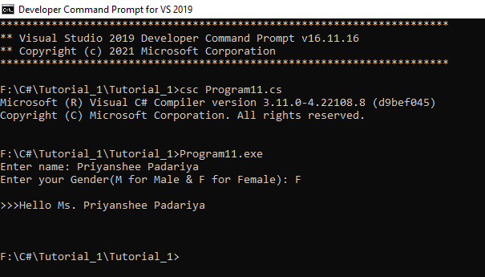**Output:**

1. Write a Program which accepts name from the user and print the same.

INPUT: Winston Churchill  
OUTPUT: Winston Churchill

using System;

namespace Tutorial_1

{

class Program12

{

String str;

string get()

{

Console.Write("INPUT: ");

str = Console.ReadLine();

return str;

}

static void print(String str)

{

Console.WriteLine("OUTPUT: " + str);

}

static void Main(String[] args)

{

Program12 p = new Program12();

String s = p.get();

print(s);

}

}

}

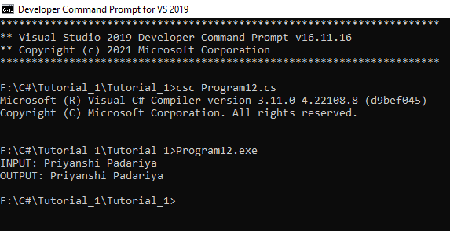**Output:**

1. Write a Program to prints the following series.

0 1 1 2 3 5 8 13 21 34 55

using System;

namespace Tutorial_1

{

class Program13

{

static void Main(String[] args)

{

int n = 0, n1 = 1, n2, num, i;

Console.Write("Enter Number:");

num = Convert.ToInt32(Console.ReadLine());

Console.WriteLine("Fibonacci Series:");

Console.Write(n + " " + n1 + " ");

for (i = 2; i < num; ++i)

{

n2 = n + n1;

Console.Write(n2 + " ");

n = n1;

n1 = n2;

}

Console.WriteLine("\n");

}

}

}

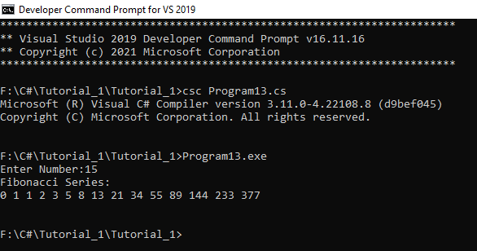**Output:**

1. Write a Program to accepts no from the user and print the same in words.

INPUT: 98732

OUTPUT: Nine Eight Seven Three Two

using System;

namespace Tutorial_1

{

class Program14

{

static void separateDigits(long n)

{

long word,w;

string[] num_words = { "Zero", "One", "Two", "Three", "Four", "Five", "Six", "Seven", "Eight", "Nine" };

if (n < 10)

{

w = n;

Console.Write(num_words[w] + " ");

return;

}

separateDigits(n / 10);

word = n % 10;

Console.Write(num_words[word] + " ");

}

static void Main()

{

long num;

Console.WriteLine("\n--->>Convert Number into Words");

Console.Write("\n->INPUT: ");

num = long.Parse(Console.ReadLine());

Console.Write("->OUTPUT: ");

separateDigits(num);

Console.WriteLine("\n");

}

}

}

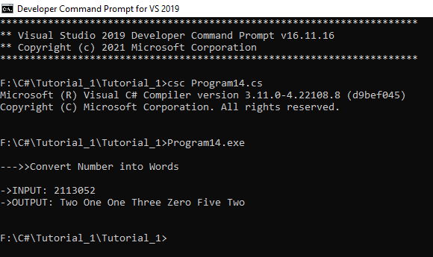**Output:**

1. Write a Program to check whether the given no is Armstrong no or not.

using System;

namespace Tutorial_1

{

class Program15

{

static void Main()

{

int num, n, r, add = 0;

Console.Write("\nEnter number: ");

num = Convert.ToInt32(Console.ReadLine());

n = num;

while (n != 0)

{

r = n % 10;

add += r * r * r;

n = n / 10;

}

if (num == add)

Console.WriteLine("\nGiven number {0} is Armstrong number.\n", num);

else

Console.WriteLine("\nGiven number {0} is not Armstrong number.\n", num);

}

}

}

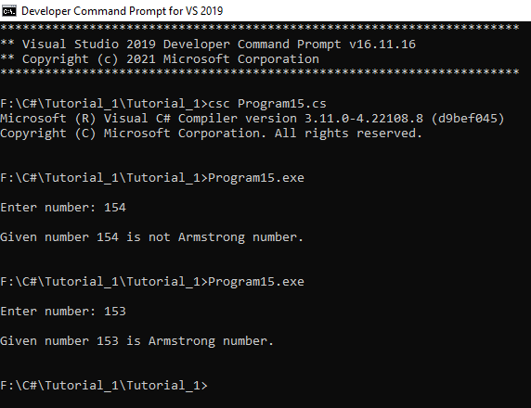**Output:**