**Tutorial – 6**

1. Design an application like follow. Depends on user selection it will display the message as shown. (If gender is Male then Mr. or Female then Miss)

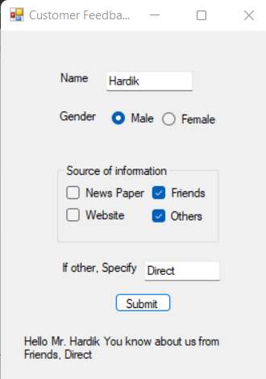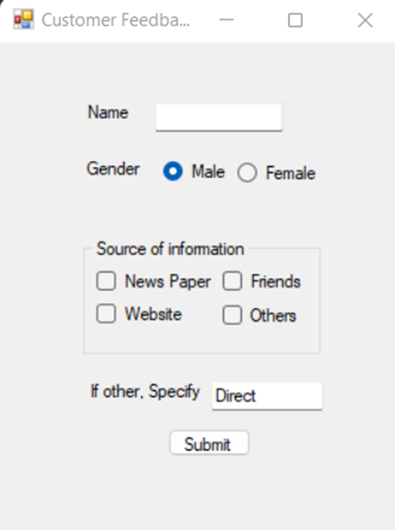

**Output:**

1. Design a form like below. Implement Following functionality to the application.

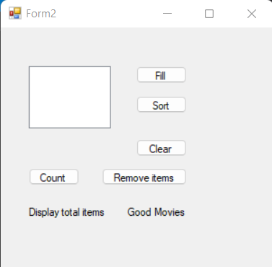

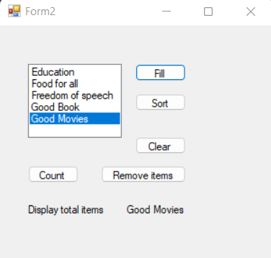**Output:**

1. Design an application which has three textboxes. Implement restricted policy for each textbox to enter data only in numeric form, uppercase, characters

using System;

using System.Collections.Generic;

using System.ComponentModel;

using System.Data;

using System.Drawing;

using System.Linq;

using System.Text;

using System.Threading.Tasks;

using System.Windows.Forms;

namespace Tutorial_6

{

public partial class Form1 : Form

{

public Form1()

{

InitializeComponent();

}

private void txtNum_KeyPress_1(object sender, KeyPressEventArgs e)

{

if (!char.IsControl(e.KeyChar) && !char.IsDigit(e.KeyChar))

{

e.Handled = true;

MessageBox.Show("Please enter only Numeric Text");

}

}

private void txtUppr_KeyPress(object sender, KeyPressEventArgs e)

{

if (!char.IsControl(e.KeyChar) && !char.IsUpper(e.KeyChar))

{

e.Handled = true;

MessageBox.Show("Please enter only Upper Text");

}

}

private void txtLowr_KeyPress(object sender, KeyPressEventArgs e)

{

if (!char.IsControl(e.KeyChar) && !char.IsLower(e.KeyChar))

{

e.Handled = true;

MessageBox.Show("Please enter only Lower Text");

}

}

}

}

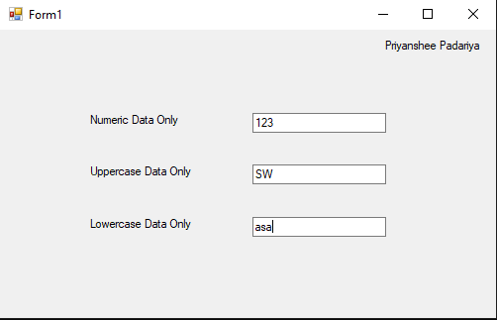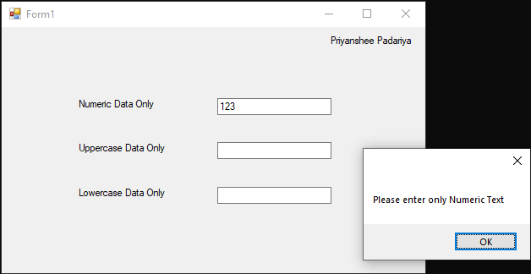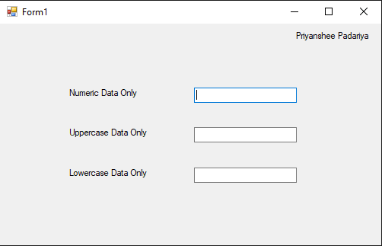**Output:**