**Tutorial – 2**

1. Predict and write output for the following code.

using System;

namespace Tutorial_2

{

class Program

{

static void Main(string[] args)

{

/* local variable definition */

int a = 10;

/* check the boolean condition using if statement */

if (a < 20)

{

/* if condition is true then print the following */

Console.WriteLine("a is less than 20");

}

Console.WriteLine("value of a is : {0}", a);

Console.ReadLine();

}

}

}

**Output:**

a is less than 20

value of a is : 10

1. **Write missing statement to get desire output.**

using System;

using System.Collections.Generic;

using System.Text;

namespace Tutorial_2

{

class Program2

{

static void Main(string[] args)

{

/* local variable definition */

int a = 100;

/* check the boolean condition */

if (a < 20)

{

/* if condition is true then print the following */

Console.WriteLine("a is less than 20");

}

else

{

/* if condition is false then print the following */

//………………………………Missing statement-1……………………………….//

Console.WriteLine("a is not less than 20");

}

//………………………………Missing statement-2……………………………….//

Console.WriteLine("value of a is : {0}",a);

Console.ReadLine();

}

}

}

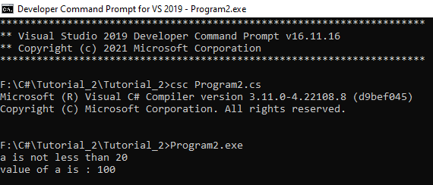**Output:**

1. Correct the following code and write output for the correct code.

using System;

namespace ConsoleApplication1

{

    class Program

    {

        static void Main(string[] args)

        {

            char firstName = "John";

            char lastName = "Doe";

            Console.WriteLine("Name: " + firstName + " " + lastName);

            Console.WriteLine("Please enter a new first name:")

            firstName = Console.ReadLine();

            Console.WriteLine("New name: "  firstName  " "  lastName);

            Console.ReadLine();

        }

    }

}

**Updated Input:**

using System;

namespace Tutorial_2

{

class Program3

{

static void Main(string[] args)

{

string firstName = "John";

string lastName = "Doe";

Console.WriteLine("Name: " + firstName + " " + lastName);

Console.WriteLine("Please enter a new first name:");

firstName = Console.ReadLine();

Console.WriteLine("New name: " + firstName + " " + lastName);

Console.ReadLine();

}

}

}

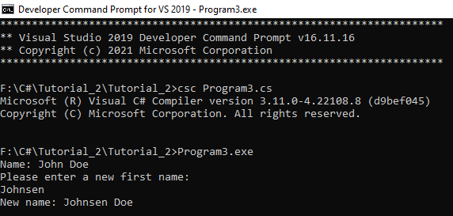**Output:**

1. Input two numbers A and B. Perform different operations using different operators and different data types available in C#. (Note: Follow all the operators and data type to do above task. Use Online help whenever necessary.)

using System;

using System.Collections.Generic;

using System.Text;

namespace Tutorial_2

{

class Program4

{

static void Main(string[] args)

{

int x=10, y=3;

Console.WriteLine("\n----->Arithmetic Operators<-----");

Console.WriteLine("--------------------------------");

Console.Write("->>X:{0}", x);

Console.WriteLine(" ->>Y:{0}", y);

Console.WriteLine("Addition of X and Y: {0}" , x + y);

Console.WriteLine("Subtraction of X and Y: {0}", x - y);

Console.WriteLine("Multiplication of X and Y: {0}", x * y);

Console.WriteLine("Division of X and Y: {0}", x / y);

Console.WriteLine("Modulus of X and Y: {0}", x % y);

Console.WriteLine("Increment of X: {0}", x++);

Console.WriteLine("Decrement of X: {0}", x--);

int a=29;

Console.WriteLine("\n---->Assignment Operators<----");

Console.WriteLine("--------------------------------");

Console.WriteLine("->>A:{0}", a);

Console.WriteLine("A= operator: {0}", a);

Console.WriteLine("A+=3 operator: {0}", a+=3);

Console.WriteLine("A-=3 operator: {0}", a-=3);

Console.WriteLine("A*=3 operator: {0}", a*=3);

Console.WriteLine("A/=3 operator: {0}", a /= 3);

Console.WriteLine("A%=3 operator: {0}", a %= 3);

Console.WriteLine("A&=3 operator: {0}", a &= 3);

Console.WriteLine("A|=3 operator: {0}", a |= 3);

Console.WriteLine("A^=3 operator: {0}", a ^= 3);

Console.WriteLine("A>>=3 operator: {0}", a >>= 3);

Console.WriteLine("A<<=3 operator: {0}", a <<= 3);

int x1 = 20, y1 = 32;

Console.WriteLine("\n----->Comparison Operators<-----");

Console.WriteLine("----------------------------------");

Console.Write("->>X:{0}", x1);

Console.WriteLine(" ->>Y:{0}", y1);

Console.WriteLine("Equal to X and Y: {0}", x1 == y1);

Console.WriteLine("Not equal X and Y: {0}", x1 != y1);

Console.WriteLine("Greater than X and Y: {0}", x1 > y1);

Console.WriteLine("Less than X and Y: {0}", x1 < y1);

Console.WriteLine("Greater than or equal to X and Y: {0}", x1 >= y1);

Console.WriteLine("Less than or equal to X and Y: {0}", x1 <= y1);

int a1 = 5;

Console.WriteLine("\n----->Logical Operators<-----");

Console.WriteLine("-------------------------------");

Console.WriteLine("->>A:{0}", a1);

Console.WriteLine("Logical and operator: {0}", a1 < 5 && a1 < 10);

Console.WriteLine("Logical or operator: {0}", a1 < 5 || a1 < 10);

Console.WriteLine("Logical not operator: {0}", !(a1 < 5 && a1 < 10));

}

}

}

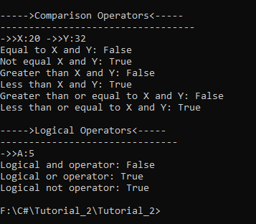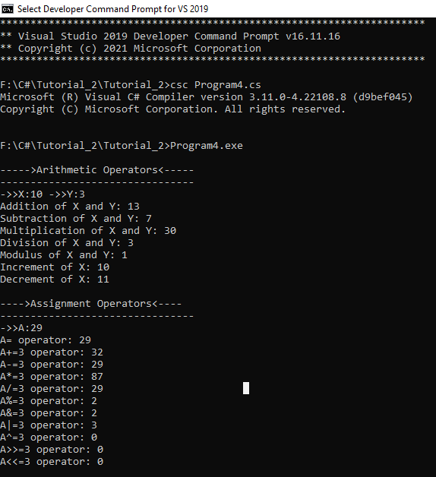**Output:**

1. Rearrange the given code to correct the program. The resultant program will be to enter 5 element into an array and print sum of these elements.

using System;

namespace ConsoleApplication1

{

    class Program

    {

        static void Main(string[] args)

        {

            for (int i = 0; i < 5; i++)

            {

                string str = Console.ReadLine();

            }

            for (int i = 0; i < 5; i++)

            {

                sum = sum + arr[i];

            }

            Console.WriteLine("Sum of Elements : {0}",sum);

            int[] arr = new int[5];

            int sum = 0;

           arr[i] = Convert.ToInt32(str);

           Console.Write("Enter Element {0}: ", i);

            Console.Read();

        }

    }

}

**Rearrange Code:**

using System;

namespace Tutorial_2

{

class Program5

{

static void Main(string[] args)

{

int[] arr = new int[5];

int sum = 0;

for (int i = 0; i < 5; i++)

{

Console.Write("Enter Element {0}: ", i);

string str = Console.ReadLine();

arr[i] = Convert.ToInt32(str);

}

for (int i = 0; i < 5; i++)

{

sum = sum + arr[i];

}

Console.WriteLine("Sum of Elements : {0}", sum);

Console.Read();

}

}

}

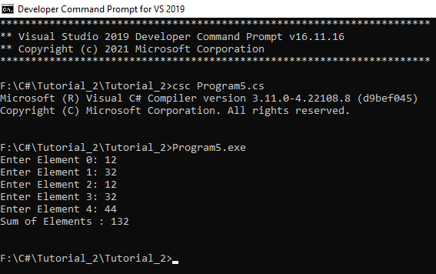**Output:**

1. Write Missing statement to get the desired output.

using System;

using System.Collections.Generic;

using System.Text;

namespace Tutorial_2

{

class Program6

{

public static void Main(string[] args)

{

Console.WriteLine("Hello, World!");

Console.WriteLine("You entered the following {0} command line arguments:", args.Length);

for(int i = 0; i < args.Length; i++)

{

Console.WriteLine(args[i]);

}

//this is

/*foreach (Object obj in args)

{

Console.WriteLine(obj);

}*/

}

}

}

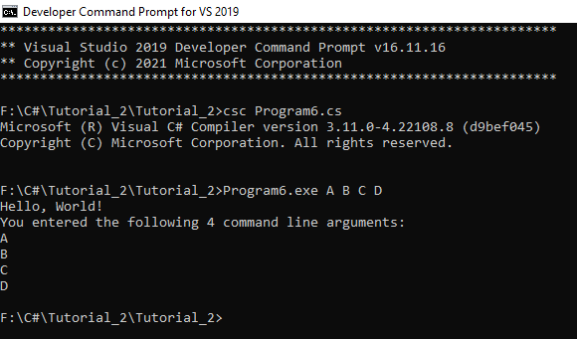**Output:**

1. Predict and Write the output of the given Code.

using System;

namespace CalculatorApplication

{

   class NumberManipulator

   {

      public void swap(ref int x, ref int y)

      {

         int temp;

         temp = x; /* save the value of x */

         x = y;   /* put y into x */

         y = temp; /* put temp into y */

       }

   }

  class TestRef

   {

      static void Main(string[] args)

      {

         NumberManipulator n = new NumberManipulator();

         /* local variable definition */

         int a = 100;

         int b = 200;

         Console.WriteLine("Before swap, value of a : {0}", a);

         Console.WriteLine("Before swap, value of b : {0}", b);

         /* calling a function to swap the values */

         n.swap(ref a, ref b);

         Console.WriteLine("After swap, value of a : {0}", a);

         Console.WriteLine("After swap, value of b : {0}", b);

         Console.ReadLine();

      }

   }

}

**Output:**

Before swap, value of a : 100

Before swap, value of b : 200

After swap, value of a : 200

After swap, value of b : 100

1. Find out error code and correct it. Write the output of the correct code.

using System;

namespace CalculatorApplication

{

   class NumberManipulator

   {

      public int getValues(out int x, out int y, out int z )

      {

          Console.WriteLine("Enter the first value: ");

          x = Convert.ToInt32(Console.ReadLine());

          Console.WriteLine("Enter the second value: ");

          y = Convert.ToInt32(Console.ReadLine());

          sum = “x” + “y” + “z”;

          return “sum”;

      }

   }

 class TestOut

 {

      static void Main(string[] args)

      {

         NumberManipulator n = new NumberManipulator();

         /* local variable definition */

         int a , b, c, sum;

         /* calling a function to get the values */

         sum = n.getValues(out a, out b, out c);

         Console.WriteLine("After method call, value of a : {0}", a);

         Console.WriteLine("After method call, value of b : {0}", b);

         Console.WriteLine("After method call, value of c : {0}", c);

         Console.WriteLine("Sum : {0}", );

      }

   }

}

**Updated Code:**

using System;

using System.Collections.Generic;

using System.Text;

namespace Tutorial_2

{

class NumberManipulator

{

public int getValues(out int x, out int y, out int z)

{

Console.WriteLine("Enter the first value: ");

x = Convert.ToInt32(Console.ReadLine());

Console.WriteLine("Enter the second value: ");

y = Convert.ToInt32(Console.ReadLine());

Console.WriteLine("Enter the third value: ");

z = Convert.ToInt32(Console.ReadLine());

int sum = x + y + z;

return sum;

}

}

class Program8

{

static void Main()

{

NumberManipulator n = new NumberManipulator();

/* local variable definition */

int a, b, c, sum;

/* calling a function to get the values */

sum = n.getValues(out a, out b, out c);

Console.WriteLine("After method call, value of a : {0}", a);

Console.WriteLine("After method call, value of b : {0}", b);

Console.WriteLine("After method call, value of c : {0}", c);

Console.WriteLine("Sum : {0}", sum);

}

}

}

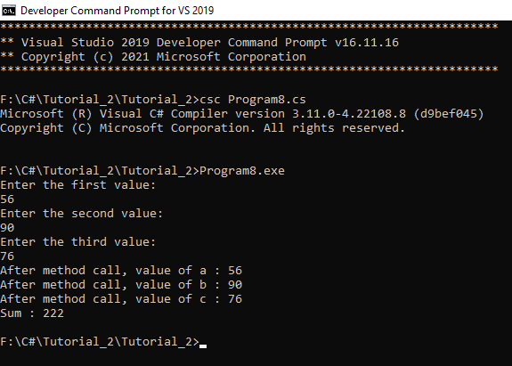**Output:**

1. Given an array A containing 2*N+2 positive numbers, out of which 2*N numbers exist in pairs

whereas the other two number occur exactly once and are distinct. Find the other two numbers.

using System;

namespace Tutorial_2

{

class Program9

{

static void Main()

{

int[] mat = {1, 2, 3, 5, 4, 1, 2, 3};

int[] a= new int[2];

int m, n;

int count = 0,size= mat.Length;

//int[] mat = new int[size];

//for (int i=0; i<size; i++)

//{

// Console.Write("Enter {0} element: ", i + 1);

// mat[i] = Convert.ToInt32(Console.ReadLine());

//}

Console.Write("array[] = ");

for (int i = 0; i < size; i++)

{

Console.Write("{0} ", mat[i]);

}

for (m = 0; m < size; m++)

{

for (n = 0; n < size; n++)

{

if (mat[m] == mat[n] && m!=n)

{

break;

}

}

if (n == size)

{

a[count] = mat[m];

++count;

}

}

Console.WriteLine("\n{0} and {1} occur are exactly once.", a[0], a[1]);

}

}

}

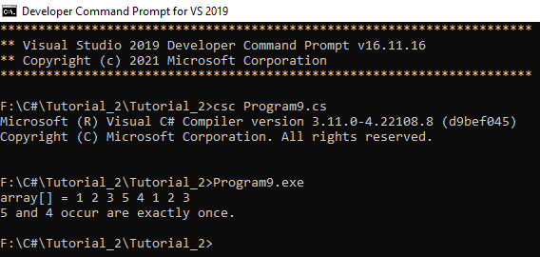**Output:**

1. Given a matrix mat[][] of size N x M, where every row and column are sorted in increasing order,

and a number X is given. The task is to find whether element X is present in the matrix or not.

using System;

using System.Collections.Generic;

using System.Text;

namespace Tutorial_2

{

class Program10

{

static int matSearch(int[,] mat, int n, int m, int X)

{

if (m == 0 || n == 0)

return -1;

for(int i=0; i<n; i++)

{

for (int j = 0; j < n; j++)

{

if (mat[i, j] == X)

{

Console.WriteLine("Element Found at Row {0} of the Column {1}", (i + 1), (j + 1));

return 1;

}

}

}

Console.WriteLine("Element not Found");

return 0;

}

static void Main(String[] args)

{

int[,] mat = { {3,25,12},{31,46,84},{58,67,29} };

int n = 3,m = 3,i,j,x;

Console.WriteLine("-->Matrix: ");

Console.WriteLine("------------------------------");

for (i = 0; i < n; i++)

{

for (j = 0; j < m; j++)

{

Console.Write(mat[i, j] + "\t");

}

Console.WriteLine();

}

Console.Write("Enter number would be find:");

x = Convert.ToInt32(Console.ReadLine());

matSearch(mat, n, m, x);

}

}

}

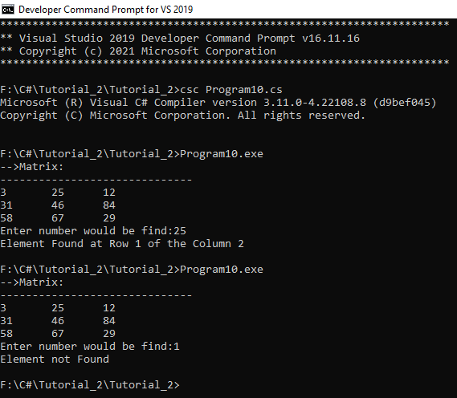**Output:**

1. Write a Program to Find the sum of N elements of an array.

using System;

using System.Collections.Generic;

using System.Text;

namespace Tutorial_2

{

class Program11

{

static void Main()

{

int n, a, sum = 0;

Console.Write("Enter total number of elements: ");

n = Convert.ToInt32(Console.ReadLine());

a = n;

int[] array = new int[n];

for (int i = 0; i < n; i++)

{

Console.Write("Enter Element {0}: ", i + 1);

array[i] = Convert.ToInt32(Console.ReadLine());

sum += array[i];

}

Console.WriteLine("Sum of Elements: " + sum);

}

}

}

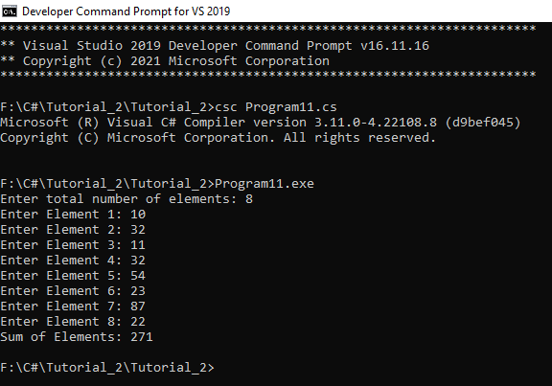**Output:**

1. Write a Program to find the element from an array and print 1 if element is found else print 0.

using System;

namespace Tutorial_2

{

class Program12

{

static void Main()

{

int n, a = 0, f;

Console.Write("Enter total number of elements: ");

n = Convert.ToInt32(Console.ReadLine());

int[] array = new int[n];

for (int i = 0; i < n; i++)

{

Console.Write("Enter Element {0}: ", i + 1);

array[i] = Convert.ToInt32(Console.ReadLine());

}

Console.Write("Enter number to be find: ");

f = Convert.ToInt32(Console.ReadLine());

for (int i = 0; i < n; i++)

{

if(array[i] == f)

{

a = 1;

}

}

Console.WriteLine("Output: {0}",a);

}

}

}

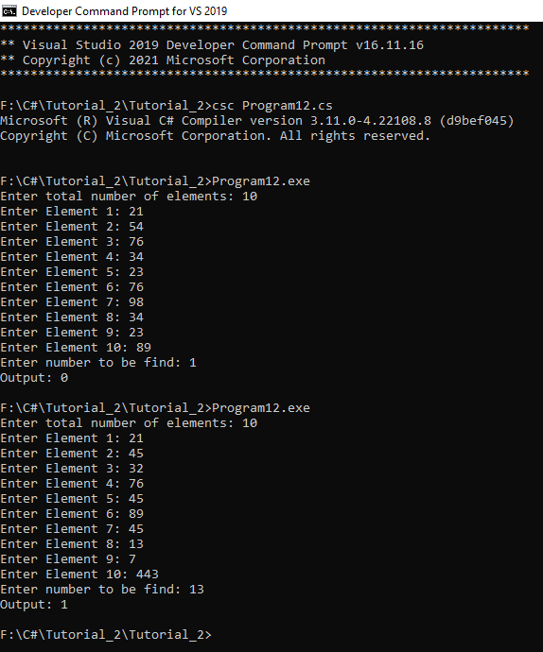**Output:**

1. **Write a Program that will accept the amount and find how many minimum no of notes you required for that. (Using the rupee notes of 1, 2, 5, 10, 20, 50, 100, 200, 500, 2000)**

using System;

using System.Collections.Generic;

using System.Text;

namespace Tutorial_2

{

class Program13

{

public static void countCurrency(int amount)

{

int[] notes = new int[] { 2000, 500, 200, 100, 50, 20, 10, 5, 2, 1 };

int[] noteCounter = new int[10];

for (int i = 0; i < 10; i++)

{

if (amount >= notes[i])

{

noteCounter[i] = amount / notes[i];

amount = amount % notes[i];

}

}

// Print notes

Console.WriteLine("Currency Count ->");

for (int i = 0; i < 10; i++)

{

Console.WriteLine("Notes of Rs." + notes[i] + " = "

+ noteCounter[i]);

}

}

public static void Main()

{

Console.Write("Enter Amount: ");

int amount = Convert.ToInt32(Console.ReadLine());

countCurrency(amount);

}

}

}

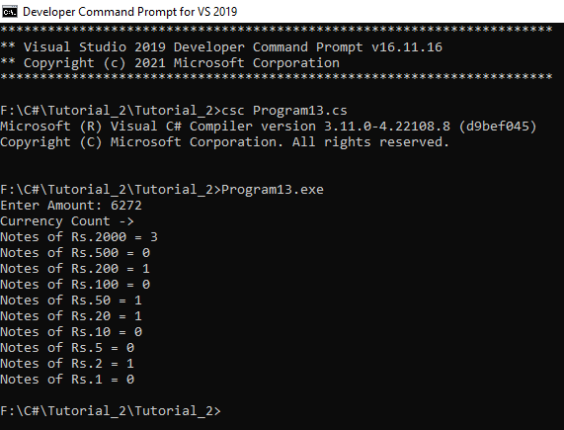**Output:**

1. **Write a Program to find the eligibility of admission for a  professional course based on the following criteria: Marks in Maths >=65 Marks in Phy >=55 Marks in Chem>=50 and Total in all three subjects >=180 or Total in Math and Physics >=140**

using System;

using System.Collections.Generic;

using System.Text;

namespace Tutorial_2

{

class Program14

{

static void Main()

{

int Math, Chem, Phy,PM,PCM;

Console.WriteLine("-------:Find eligibility for admission:-------");

Console.WriteLine("----------------------------------------------");

Console.Write(" Input the marks obtained in Physics: ");

Phy = Convert.ToInt32(Console.ReadLine());

Console.Write(" Input the marks obtained in Chemistry: ");

Chem = Convert.ToInt32(Console.ReadLine());

Console.Write(" Input the marks obtained in Mathematics: ");

Math = Convert.ToInt32(Console.ReadLine());

PM = Phy + Math;

PCM = Phy + Chem + Math;

if (Phy >= 55 && Chem >= 50 && Math >= 65 && (PM>=140 || PCM>=180))

{

Console.WriteLine("----------------------------------------------");

Console.WriteLine("The candidate is eligible for admission.");

}

else

{

Console.WriteLine("----------------------------------------------");

Console.WriteLine("The candidate is not eligible for admission.");

}

}

}

}

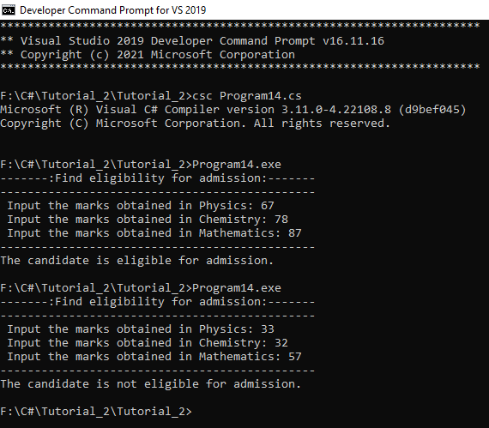**Output:**

1. Write a Program which accepts name from the user and prints the same.

using System;

using System.Collections.Generic;

using System.Text;

namespace Tutorial_2

{

class Program15

{

static void Main()

{

Console.Write("INPUT:");

String str=Console.ReadLine();

Console.WriteLine("OUTPUT:" + str);

}

}

}

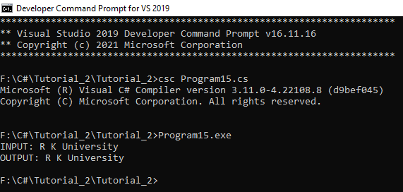**Output:**