**Tutorial – 5**

1. **Design a Form like below. When user Click on OK Button it will print “Welcome to First Windows Application” on Label. When User Click on Cancel button form get closed.**

using System;

using System.Windows.Forms;

namespace Tutorial_5

{

public partial class Form1 : Form

{

public Form1()

{

InitializeComponent();

}

private void button1_Click(object sender, EventArgs e)

{

lblMessage.Text = "Welcome to First WindowsApplication form";

}

private void button2_Click(object sender, EventArgs e)

{

//close form function

this.Close();

}

private void Form1_Load(object sender, EventArgs e)

{

}

}

}

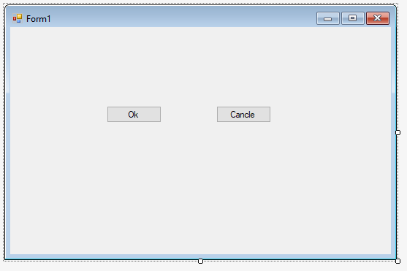**Output:**

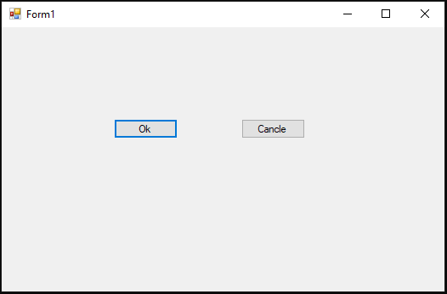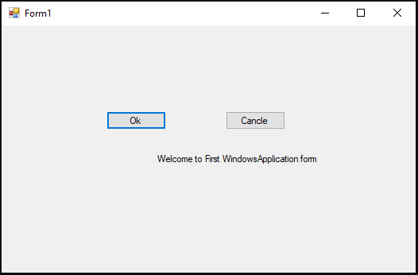

1. **Design a Form like below. When user click on Send Message Button it will display combine message like below on label: “Message of <<Name>> from <<Organization>> with <<comment>>”.**

using System;

using System.Windows.Forms;

namespace Tutorial_5

{

public partial class Form2 : Form

{

public Form2()

{

InitializeComponent();

}

private void btnSend_Click(object sender, EventArgs e)

{

lblrslt.Text = "Message of " + txtName.Text + " from " + txtOrg.Text + " with " + txtComment.Text;

}

private void Form2_Load(object sender, EventArgs e)

{

}

}

}

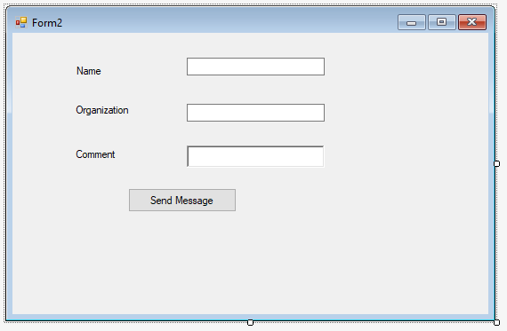

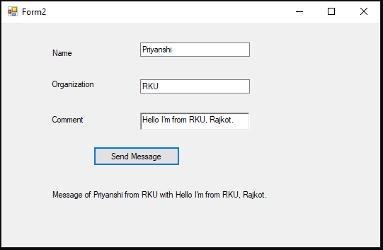**Output:**

1. **Design a form like below. Depends on User’s selection, Background color and ForeColor of Form will change.**

using System;

using System.Drawing;

using System.Windows.Forms;

namespace Tutorial_5

{

public partial class Form3 : Form

{

public Form3()

{

InitializeComponent();

}

private void RBred_CheckedChanged(object sender, EventArgs e)

{

BackColor = Color.Red;

}

private void RByellow_CheckedChanged(object sender, EventArgs e)

{

BackColor = Color.Yellow;

}

private void RBpink_CheckedChanged(object sender, EventArgs e)

{

BackColor = Color.Pink;

}

private void RBwhite_CheckedChanged(object sender, EventArgs e)

{

ForeColor = Color.White;

}

private void RBgreen_CheckedChanged(object sender, EventArgs e)

{

ForeColor = Color.Green;

}

private void RBblue_CheckedChanged(object sender, EventArgs e)

{

ForeColor = Color.Blue;

}

private void Form3_Load(object sender, EventArgs e)

{

}

}

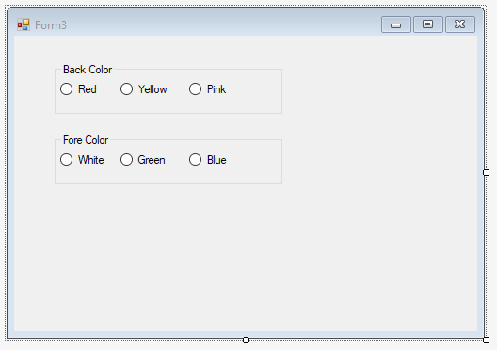}

**Output:**

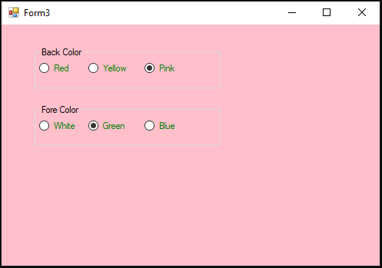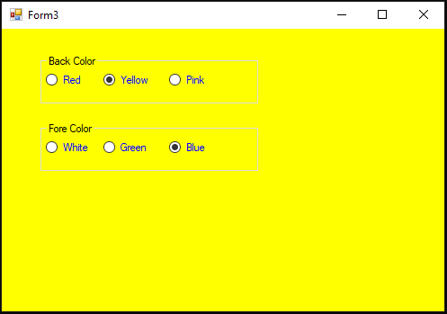

1. **Design a form like below. When user click on Answer button, selected operation performed on given two numbers and answer is displayed on as shown.**

using System;

using System.Windows.Forms;

namespace Tutorial_5

{

public partial class Form4 : Form

{

public Form4()

{

InitializeComponent();

}

private void btnAns_Click(object sender, EventArgs e)

{

Double result;

int a, b;

a = Convert.ToInt32(txtnum1.Text);

b = Convert.ToInt32(txtnum2.Text);

if (rdoAdd.Checked == true)

{

result = a + b;

lblAnswer.Text = txtnum1.Text + " and " + txtnum2.Text + " Addition is " + result;

}

else if (rdoSub.Checked == true)

{

result = a - b;

lblAnswer.Text = txtnum1.Text + " and " + txtnum2.Text + " Subtraction is " + result;

}

else if (rdoMul.Checked == true)

{

result = a * b;

lblAnswer.Text = txtnum1.Text + " and " + txtnum2.Text + " Multiplication is " + result;

}

else if (rdoDiv.Checked == true)

{

result = ((double)a / b);

lblAnswer.Text = txtnum1.Text + " and " + txtnum2.Text + " Divisio is "+ result.ToString("0.000");

}

}

private void Form4_Load(object sender, EventArgs e)

{

}

}

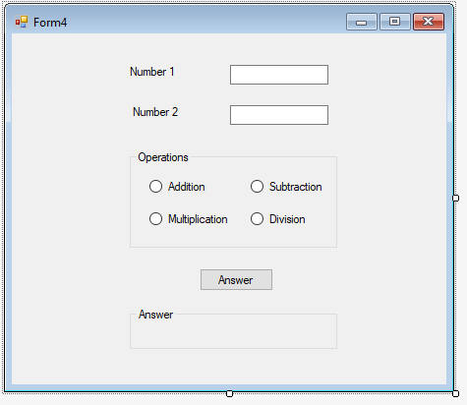}

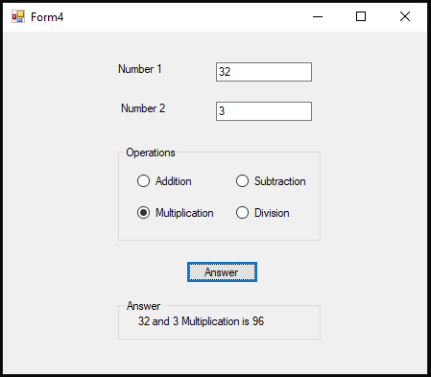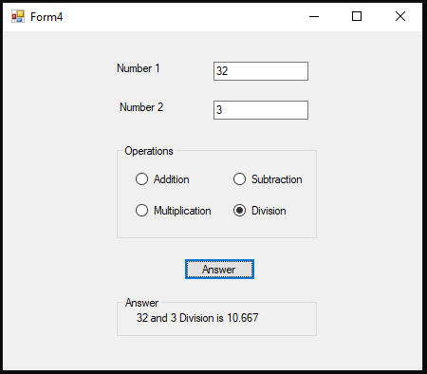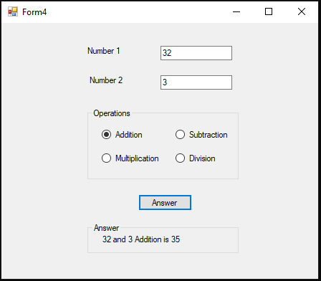**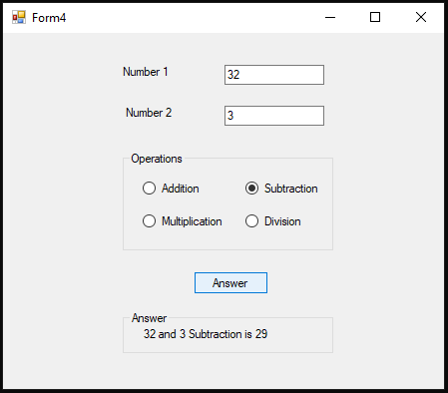Output:**