Name- Priyanshi Nigam
Reg. No.- 23BAI10908

ReactJS Hands-On Lab - Solutions

Lab 1: React Router – TrainersApp
Objectives
- Explain the need and benefits of React Router
- Identify the Components in React Router
- List the types of Router Components
- Parameter passing via url
In this hands-on lab, you will learn how to:
- Implement a Simple Navigation Menu
- Add Basic Routes (install, configure)
- Use Routes in React Applications
Prerequisites
- Node.js
- NPM
- Visual Studio Code
Problem Statement
Cognizant Academy teams want to maintain a list of trainers along with their expertise in a SPA using React as the technology. The trainer data used consists of: T-ID, Name, Phone, Email, Stream and Skills.
Solution
Step 1: Create a new React app named "TrainersApp" and open it in VS Code.
npx create-react-app TrainersApp
cd TrainersApp
code .
Step 2: Add a file trainer.js inside the src folder and define the Trainer class.
src/trainer.js
class Trainer {
constructor(trainerId, name, email, phone, technology, skills) {
this.trainerId = trainerId;
this.name = name;
this.email = email;
this.phone = phone;
this.technology = technology;
this.skills = skills;
}
}

export default Trainer;
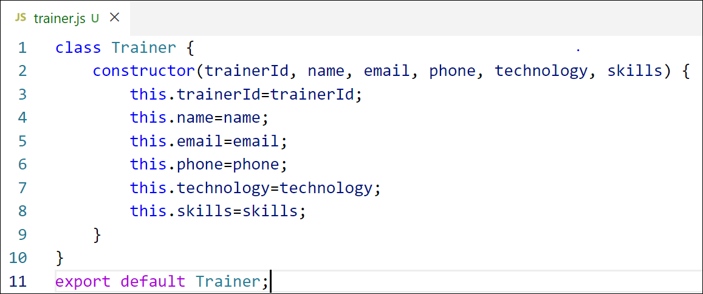
Figure 1: trainer.js
Step 3: Create trainersMock.js containing the mock trainer data.
src/trainersMock.js
import Trainer from "./trainer";
const trainersMock = [
new Trainer('t-syed8',
'Syed Khaleelullah',
'khaleelullah@cognizant.com',
'97676516962',
'.NET',
['C#','SQL Server','React','.NET Core']),
new Trainer('t-jojo',
'Jojo Jose',
'jojo@cognizant.com',
'9897199231',
'Java',
['Java','JSP','Angular','Spring']),
new Trainer('t-elisa',
'Elisa Jones',
'elisa@cognizant.com',
'9871212235',
'Python',
['Python','Django','Angular'])
]
export default trainersMock;
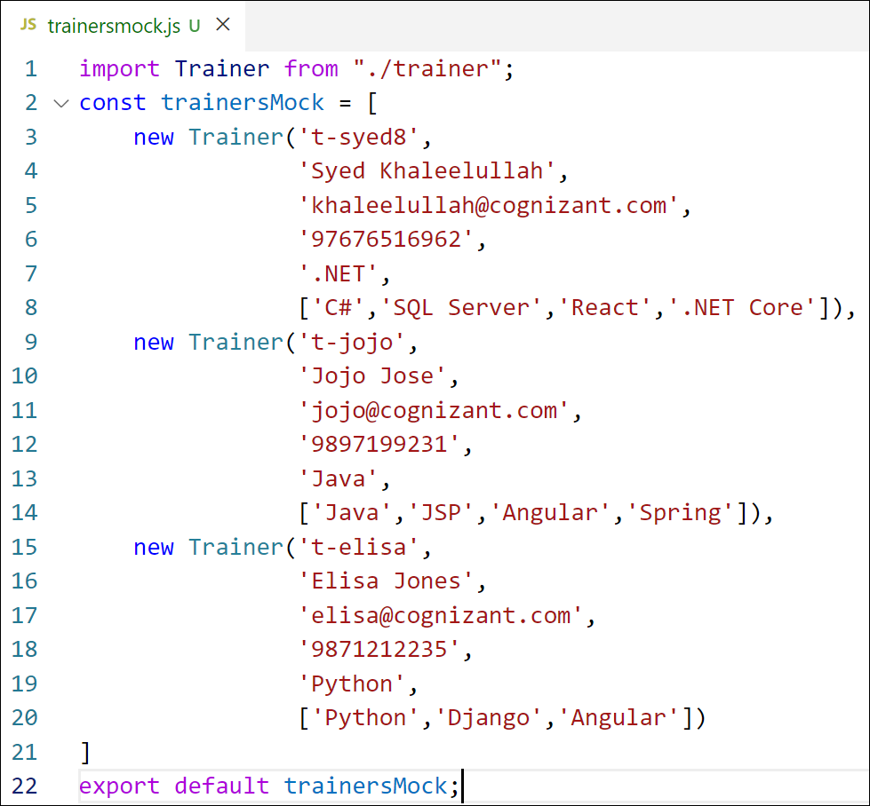
Figure 2: trainersMock.js
Step 4: Install React Router for DOM.
npm install react-router-dom@6
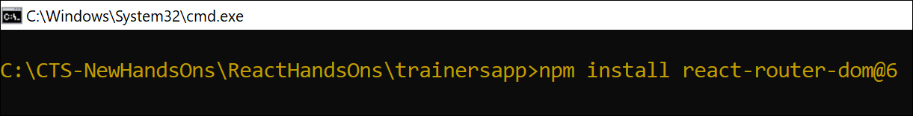
Figure 3: Installing React Router
Step 5: Create the TrainersList component inside TrainerList.js. It receives trainer data as a prop and renders each trainer's name as a clickable link.
src/TrainerList.js
import React from 'react';
import { Link } from 'react-router-dom';

function TrainersList({ trainers }) {
return (
<div>
<h2>Trainers List</h2>
<ul>
{trainers.map((trainer) => (
<li key={trainer.trainerId}>
<Link to={`/trainers/${trainer.trainerId}`}>
{trainer.name}
</Link>
</li>
))}
</ul>
</div>
);
}

export default TrainersList;
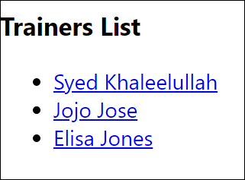
Figure 4: TrainersList component output
Step 6: Create the Home component inside Home.js.
src/Home.js
import React from 'react';

function Home() {
return (
<div>
<h2>Welcome to My Academy trainers page</h2>
</div>
);
}

export default Home;

Figure 5: Home component output
Step 7: Modify the App component to add routing support, using BrowserRouter, Routes, Route and Link from react-router-dom. '/' redirects to Home and '/trainers' redirects to TrainersList.
src/App.js
import React from 'react';
import { BrowserRouter, Routes, Route, Link } from 'react-router-dom';
import Home from './Home';
import TrainersList from './TrainerList';
import TrainerDetails from './TrainerDetails';
import trainersMock from './trainersMock';

function App() {
return (
<BrowserRouter>
<div>
<h1>My Academy Trainers App</h1>
<nav>
<Link to="/">Home</Link> |
<Link to="/trainers">Show Trainers</Link>
</nav>
<Routes>
<Route path="/" element={<Home />} />
<Route path="/trainers"
element={<TrainersList trainers={trainersMock} />} />
<Route path="/trainers/:id"
element={<TrainerDetails />} />
</Routes>
</div>
</BrowserRouter>
);
}

export default App;
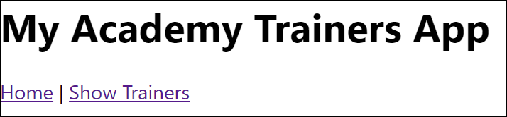
Figure 6: App component navigation layout
Step 8: Create the TrainerDetail component inside TrainerDetails.js. It reads the id parameter from the URL using the useParams hook, looks up the matching trainer and displays the details. The TrainersList component links to this component while passing the id.
src/TrainerDetails.js
import React from 'react';
import { useParams } from 'react-router-dom';
import trainersMock from './trainersMock';

function TrainerDetails() {
const { id } = useParams();
const trainer = trainersMock.find((t) => t.trainerId === id);

if (!trainer) {
return <p>Trainer not found</p>;
}

return (
<div>
<h2>Trainers Details</h2>
<h4>{trainer.name} ({trainer.technology})</h4>
<p>{trainer.email}</p>
<p>{trainer.phone}</p>
<ul>
{trainer.skills.map((skill, index) => (
<li key={index}>{skill}</li>
))}
</ul>
</div>
);
}

export default TrainerDetails;
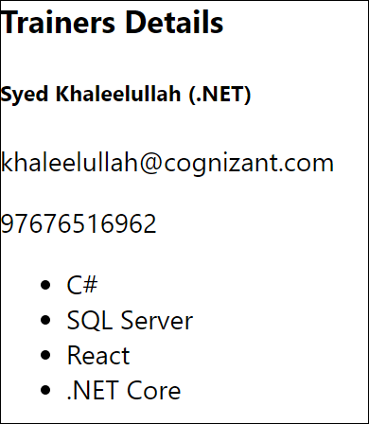
Figure 7: TrainerDetails component output
Step 9: Build and run the application.
npm start
The complete application:
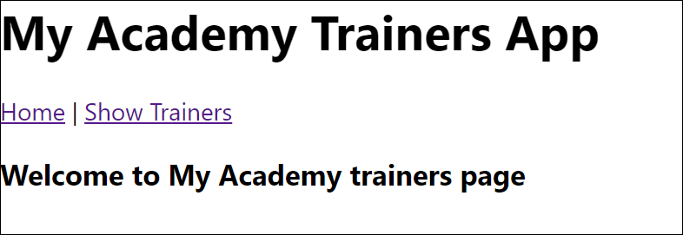
Figure 8: Home page
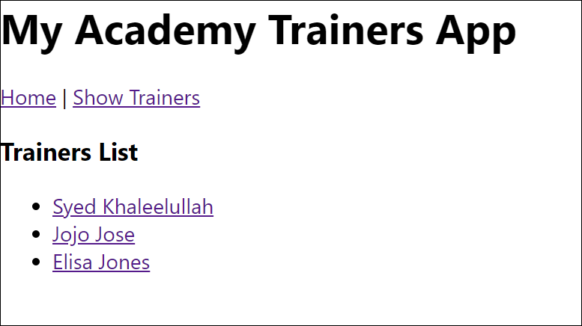
Figure 9: Trainers List page
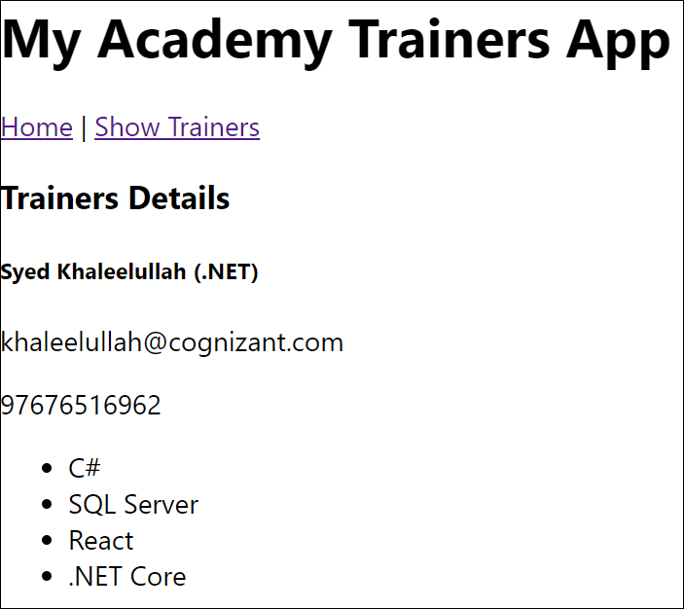
Figure 10: Trainer Details page

Lab 2: Props – ShoppingApp
Objectives
- Define Props
- Explain Default Props
- Identify the differences between State and Props
- Explain reactDOM.render()
In this hands-on lab, you will learn how to:
- Use Props
- Apply reactDOM.render()
Prerequisites
- Node.js
- NPM
- Visual Studio Code
Problem Statement
Create a React Application named "shoppingapp" with a class component named "OnlineShopping" and a component named "Cart".
Solution
Step 1: Create the app and define the Cart component with two props: itemname and price. Cart receives the ordered items as a prop (item) and loops through them using map(), rendering a table row for each item.
npx create-react-app shoppingapp
cd shoppingapp
code .
src/Cart.js
import React from 'react';

class Cart extends React.Component {
render() {
return (
this.props.item.map((item) => {
return (
<tr>
<td> {item.itemname} </td>
<td> {item.price} </td>
</tr>
)
})
);
}
}

export default Cart;
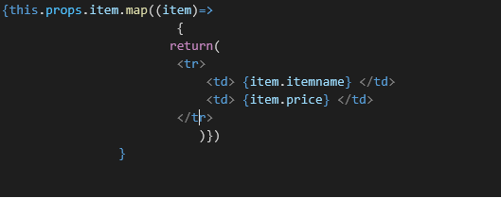
Figure 1: Cart component – rendering rows from props
Step 2: In OnlineShopping, create an array of 5 cart items and pass it to Cart via the item prop.
src/OnlineShopping.js
import React from 'react';
import Cart from './Cart';

export class OnlineShopping extends React.Component {
render() {
const CartInfo = [{itemname:"Laptop", price: 80000},
{itemname:"TV",price:120000},
{itemname:"Washing Machine",price:50000},
{itemname:"Mobile",price:30000},
{itemname:"Fridge",price:70000}];
return (
<div className="mydiv">
<h1>Items Ordered :</h1>
<table>
<thead>
<tr><th>Name</th><th>Price</th></tr>
</thead>
<tbody>
<Cart item={CartInfo} />
</tbody>
</table>
</div>
);
}
}

export default OnlineShopping;
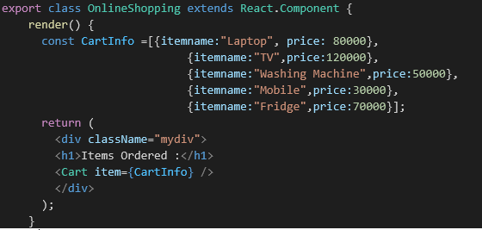
Figure 2: OnlineShopping component
Step 3: Render OnlineShopping from App.js and start the application. Loop through the items and display the data as shown below.
src/App.js
import React from 'react';
import OnlineShopping from './OnlineShopping';

function App() {
return (
<div>
<OnlineShopping />
</div>
);
}

export default App;
npm start
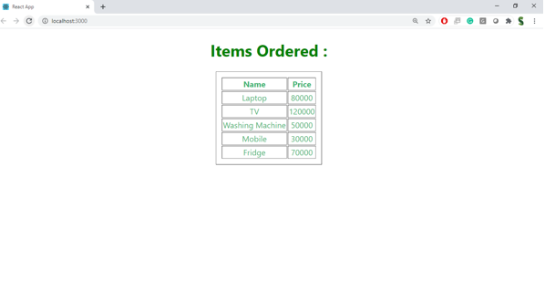
Figure 3: Output – Items Ordered table

Lab 3: State – CounterApp
Objectives
- Explain React State
In this hands-on lab, you will learn how to:
- Use React State object
Prerequisites
- Node.js
- NPM
- Visual Studio Code
Problem Statement
Create a React App "counterapp" with a component named "CountPeople" having two methods: updateEntry(), which displays the number of people who entered the mall, and updateExit(), which displays the number of people who exited the mall. Use a constructor and state to store entrycount and exitcount. The component has two buttons - Login (increments entrycount) and Exit (increments exitcount).
Solution
Step 1: Create the app.
npx create-react-app counterapp
cd counterapp
code .
Step 2: Create the CountPeople component. Initialize entrycount and exitcount to 0 in the constructor using state, then define updateEntry() and updateExit() using setState(), and two buttons that call them on click.
src/CountPeople.js
import React from 'react';

class CountPeople extends React.Component {
constructor() {
super();
this.state = {
entrycount: 0,
exitcount: 0
};
}

updateEntry() {
this.setState((prevState, props) => {
return { entrycount: prevState.entrycount + 1 }
});
}

updateExit() {
this.setState((prevState, props) => {
return { exitcount: prevState.exitcount + 1 }
});
}

render() {
return (
<div>
<button onClick={() => this.updateEntry()}>Login</button>
<span> {this.state.entrycount} People Entered!!!</span>
&nbsp;&nbsp;&nbsp;&nbsp;&nbsp;
<button onClick={() => this.updateExit()}>Exit</button>
<span> {this.state.exitcount} People Left!!!</span>
</div>
);
}
}

export default CountPeople;
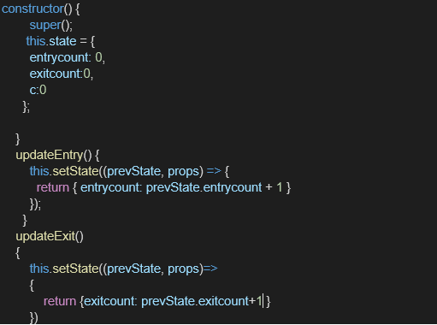
Figure 1: CountPeople component – state and update methods
Step 3: Render CountPeople from App.js and run the application.
src/App.js
import React from 'react';
import CountPeople from './CountPeople';

function App() {
return (
<div>
<CountPeople />
</div>
);
}

export default App;
npm start
The output, after clicking Login twice and Exit once, should be as follows:
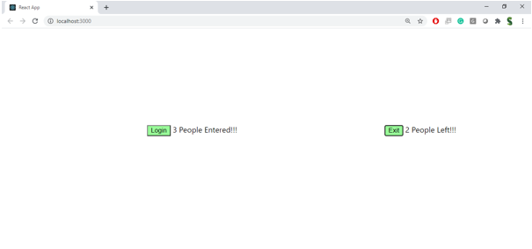
Figure 2: Output – Login/Exit counters
Lab 4: Conditional Rendering, Lists and Keys – bloggerapp
Task:
Create a React app named "bloggerapp" with three components - Book Details, Blog Details and Course Details - implemented using as many forms of conditional rendering as possible.
Approach:
- Store the source data (books, courses, blogs) in a single data.js file.
- BookDetails renders the book list using Array.map().
- CourseDetails uses the ternary operator to decide whether to render the list or a fallback message.
- BlogDetails uses an if-else early return plus the && operator to conditionally render a post and its content.
- App.js composes the three components inside styled divs.
data.js
export const books = [
{ id: 101, bname: 'Master React', price: 670 },
{ id: 102, bname: 'Deep Dive into Angular 11', price: 800 },
{ id: 103, bname: 'Mongo Essentials', price: 450 },
];

export const courses = [
{ id: 1, cname: 'Angular', date: '4/5/2021' },
{ id: 2, cname: 'React', date: '6/3/2021' },
];

export const blogs = [
{ id: 1, title: 'React Learning', author: 'Stephen Biz',
published: true, content: 'Welcome to learning React!' },
{ id: 2, title: 'Installation', author: 'Schwzdenier',
published: true, content: 'You can install React from npm.' },
];
BookDetails.js (conditional rendering with Array.map)
import React from 'react';
import { books } from './data';

function BookDetails() {
const bookdet = (
<ul>
{books.map((book) => (
<div key={book.id}>
<h3>{book.bname}</h3>
<h4>{book.price}</h4>
</div>
))}
</ul>
);
return bookdet;
}

export default BookDetails;
CourseDetails.js (conditional rendering with ternary operator)
import React from 'react';
import { courses } from './data';

function CourseDetails() {
const coursedet =
courses.length > 0 ? (
courses.map((course) => (
<div key={course.id}>
<h3>{course.cname}</h3>
<h4>{course.date}</h4>
</div>
))
) : (
<p>No courses available</p>
);
return <>{coursedet}</>;
}

export default CourseDetails;
BlogDetails.js (conditional rendering with if-else and &&)
import React from 'react';
import { blogs } from './data';

function BlogPost({ blog }) {
if (!blog.published) {
return null;
}
return (
<div>
<h3>{blog.title}</h3>
<h4>{blog.author}</h4>
{blog.content && <p>{blog.content}</p>}
</div>
);
}

function BlogDetails() {
const content = blogs.map((blog) => (
<BlogPost key={blog.id} blog={blog} />
));
return <>{content}</>;
}

export default BlogDetails;
App.js
import React from 'react';
import BookDetails from './BookDetails';
import BlogDetails from './BlogDetails';
import CourseDetails from './CourseDetails';
import './App.css';

function App() {
const bookdet = <BookDetails />;
const content = <BlogDetails />;
const coursedet = <CourseDetails />;
return (
<div>
<div className="st2">
<h1> Book Details</h1>
{bookdet}
</div>
<div className="v1">
<h1> Blog Details</h1>
{content}
</div>
<div className="mystyle1">
<h1> Course Details</h1>
{coursedet}
</div>
</div>
);
}

export default App;
App.css
.st2, .v1, .mystyle1 {
display: inline-block;
width: 30%;
vertical-align: top;
padding: 20px;
border-left: 3px solid green;
}
Output:
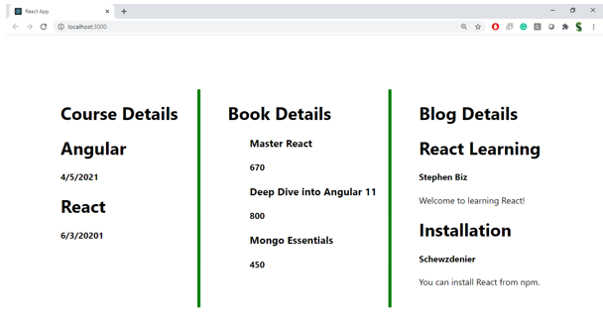
bloggerapp running on localhost:3000

Lab 5: React Context API – Employee Management
Task:
Convert an employee management application (App -> EmployeeList -> EmployeeCard) that currently passes the theme name down through props, so that it instead uses the React Context API.
Steps followed:
- npm install to restore node modules, then npm start to confirm the base app runs.
- Created ThemeContext.js and defined a context with default value 'light'.
- Wrapped the JSX in App.js with ThemeContext.Provider, passing the theme state as the value.
- Removed the theme prop from the EmployeeList and EmployeeCard calls.
- In EmployeeCard.js, consumed the context using useContext() and used it to set the button className.
ThemeContext.js
import { createContext } from 'react';

const ThemeContext = createContext('light');

export default ThemeContext;
App.js
import React, { useState } from 'react';
import ThemeContext from './ThemeContext';
import EmployeeList from './EmployeeList';
import './App.css';

const employees = [
{ id: 1, name: 'Ravi Kumar', designation: 'Software Engineer' },
{ id: 2, name: 'Anita Sharma', designation: 'Project Manager' },
{ id: 3, name: 'John Mathew', designation: 'UI Developer' },
];

function App() {
const [theme, setTheme] = useState('light');
const toggleTheme = () => {
setTheme((prev) => (prev === 'light' ? 'dark' : 'light'));
};
return (
<ThemeContext.Provider value={theme}>
<div className="App">
<h1>Employee Management</h1>
<button onClick={toggleTheme}>Toggle Theme</button>
<EmployeeList employees={employees} />
</div>
</ThemeContext.Provider>
);
}

export default App;
EmployeeList.js
import React from 'react';
import EmployeeCard from './EmployeeCard';

function EmployeeList({ employees }) {
return (
<div className="employee-list">
{employees.map((emp) => (
<EmployeeCard key={emp.id} employee={emp} />
))}
</div>
);
}

export default EmployeeList;
EmployeeCard.js
import React, { useContext } from 'react';
import ThemeContext from './ThemeContext';

function EmployeeCard({ employee }) {
const theme = useContext(ThemeContext);
return (
<div className={theme === 'light' ? 'card-light' : 'card-dark'}>
<h3>{employee.name}</h3>
<p>{employee.designation}</p>
<button className={theme === 'light' ? 'btn-light' : 'btn-dark'}>
View Profile
</button>
</div>
);
}

export default EmployeeCard;
Terminal output:
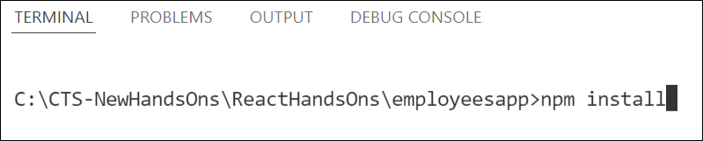
npm install restoring node modules
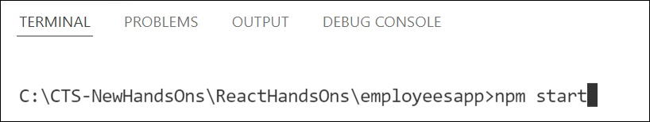
npm start launching the application

Lab 6: React Forms - Controlled Components – ticketraisingapp
Task:
Create a React app named "ticketraisingapp" with a component "ComplaintRegister" that contains a textbox for the employee name and a textarea for the complaint. On submit, a reference number should be generated and shown in an alert box.
Approach:
- The textbox and textarea are controlled components, bound to state with value and onChange.
- handleSubmit prevents the default form action, generates a random reference number, and shows the alert.
ComplaintRegister.js
import React, { useState } from 'react';

function ComplaintRegister() {
const [name, setName] = useState('');
const [complaint, setComplaint] = useState('');

const handleSubmit = (event) => {
event.preventDefault();
const refNumber = Math.floor(Math.random() * 100);
alert(
`Thanks ${name}\nYour Complaint was Submitted\nTransaction ID is: ${refNumber}`
);
setName('');
setComplaint('');
};

return (
<div>
<h1 style={{ color: 'red' }}>Register your complaints here!!!</h1>
<form onSubmit={handleSubmit}>
<label>Name: </label>
<input
type="text"
value={name}
onChange={(e) => setName(e.target.value)}
/>
<br /><br />
<label>Complaint: </label>
<textarea
value={complaint}
onChange={(e) => setComplaint(e.target.value)}
/>
<br /><br />
<button type="submit">Submit</button>
</form>
</div>
);
}

export default ComplaintRegister;
App.js
import React from 'react';
import ComplaintRegister from './ComplaintRegister';

function App() {
return (
<div>
<ComplaintRegister />
</div>
);
}

export default App;
Output:
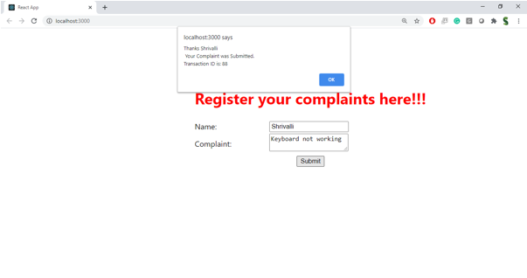
Complaint submitted - reference number shown in the alert box

Lab 7: React Forms Validation – mailregisterapp
Task:
Create a React app named "mailregisterapp" containing a component "Register" with a form that accepts name, email and password, validated as follows:
- Name should have at least 5 characters
- Email should have @ and .
- Password should have at least 8 characters
Validation is triggered on both onChange and onSubmit of the form.
Register.js
import React, { Component } from 'react';

class Register extends Component {
constructor(props) {
super(props);
this.state = {
fullName: '',
email: '',
password: '',
errors: { fullName: '', email: '', password: '' },
};
}

handleChange = (event) => {
const { name, value } = event.target;
this.setState({ [name]: value }, () => {
this.validateField(name, value);
});
};

validateField = (name, value) => {
let errors = { ...this.state.errors };
switch (name) {
case 'fullName':
errors.fullName =
value.length < 5 ? 'Full Name must be 5 characters long!' : '';
break;
case 'email':
const validEmailRegex = /^[^\s@]+@[^\s@]+\.[^\s@]+$/;
errors.email = validEmailRegex.test(value)
? ''
: 'Email is not valid!';
break;
case 'password':
errors.password =
value.length < 8 ? 'Password must be 8 characters long!' : '';
break;
default:
break;
}
this.setState({ errors });
};

validateForm = (errors) => {
let valid = true;
Object.values(errors).forEach((val) => {
if (val.length > 0) valid = false;
});
return valid;
};

handleSubmit = (event) => {
event.preventDefault();
if (this.validateForm(this.state.errors)) {
alert('Valid Form');
} else {
if (this.state.errors.fullName !== '') {
alert(this.state.errors.fullName);
}
if (this.state.errors.email !== '') {
alert(this.state.errors.email);
}
if (this.state.errors.password !== '') {
alert(this.state.errors.password);
}
}
};

render() {
return (
<div>
<h1 style={{ color: 'red' }}>Register Here!!!</h1>
<form onSubmit={this.handleSubmit}>
<label>Name: </label>
<input
type="text"
name="fullName"
value={this.state.fullName}
onChange={this.handleChange}
/>
<br /><br />
<label>Email: </label>
<input
type="text"
name="email"
value={this.state.email}
onChange={this.handleChange}
/>
<br /><br />
<label>Password: </label>
<input
type="password"
name="password"
value={this.state.password}
onChange={this.handleChange}
/>
<br /><br />
<button type="submit">Submit</button>
</form>
</div>
);
}
}

export default Register;
App.js
import React from 'react';
import Register from './Register';

function App() {
return (
<div>
<Register />
</div>
);
}

export default App;
Output:
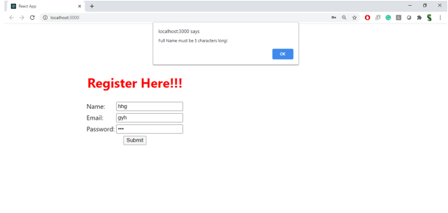
Name validation - must be at least 5 characters
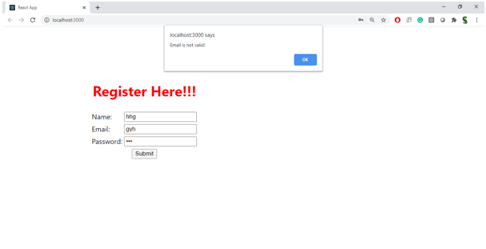
Email validation - must be a valid email address
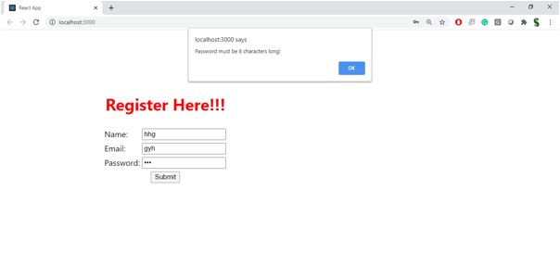
Password validation - must be at least 8 characters

Lab 8: Consuming a REST API from React – fetchuserapp
Task:
Create a React application "fetchuserapp" that retrieves user details from https://api.randomuser.me/ and displays the title, first name and image of the user. The component "Getuser" should invoke the URL inside the asynchronous lifecycle method componentDidMount() using fetch, and display the response in render().
Getuser.js
import React, { Component } from 'react';

class Getuser extends Component {
constructor(props) {
super(props);
this.state = {
person: null,
loading: true,
};
}

async componentDidMount() {
const url = "https://api.randomuser.me/";
const response = await fetch(url);
const data = await response.json();
this.setState({ person: data.results[0], loading: false });
console.log(data.results[0]);
}

render() {
const { person, loading } = this.state;
if (loading) {
return <p>Loading...</p>;
}
return (
<div>
<h1>
{person.name.title} {person.name.first} {person.name.last}
</h1>
<img src={person.picture.large} alt={person.name.first} />
</div>
);
}
}

export default Getuser;
App.js
import React from 'react';
import Getuser from './Getuser';

function App() {
return (
<div>
<Getuser />
</div>
);
}

export default App;
Output:
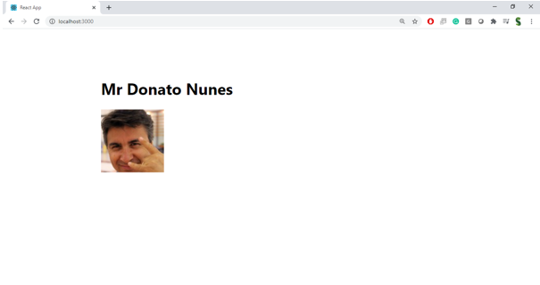
User title, name and image fetched from the REST API

