Version |  |  | Description |  | Created By | Date
1.0 |  |  | First version of the system |  | ANUKRITI VASHISTH,  PRIYANSHTYAGI,  JYOTI, ANUBHAV DAGAR, ARJUN CHAUDHARY | 27-08-2019
General Description
A use case is a methodology used in system analysis to identify, clarify, and organize system requirements. The use case is made up of a set of possible sequences of interactions between systems and users in a particular environment and related to a particular goal. It consists of a group of elements (for example, classes and interfaces) that can be used together in a way that will have an effect larger than the sum of the separate elements combined. The use case should contain all system activities that have significance to the users. A use case can be thought of as a collection of possible scenarios related to a particular goal, indeed, the use case and goal are sometimes considered to be synonymous.
A use case (or set of use cases) has these characteristics:
- Organizes functional requirements
- Models the goals of system/actor (user) interactions
- Records paths (called scenarios) from trigger events to goals
- Describes one main flow of events (also called a basic course of action), and possibly other ones, called exceptional flows of events (also called alternate courses of action)
- Is multi-level, so that one use case can use the functionality of another one.
Use cases can be employed during several stages of software development, such as planning system requirements, validating design, testing software, and creating an outline for online help and user manuals.

Actors <an entity that can interact with a system, invoking some behavior>
- Administrator/Admin
- Job Provider
- Job Seeker

Preconditions <the state(s) the system can be in before this use case starts>
- The System is functioning properly
- The System should be connected to the Internet
- The System should have access to the database
- The Actor should have knowledge of working on internet.
- The Actor must have a valid E-mail id.
Use Case Diagram <a specific sequence of actions and interactions between actors and the system being discussed>
ONLINEJOBPORTAL.COM System(Major) Use Case Diagram

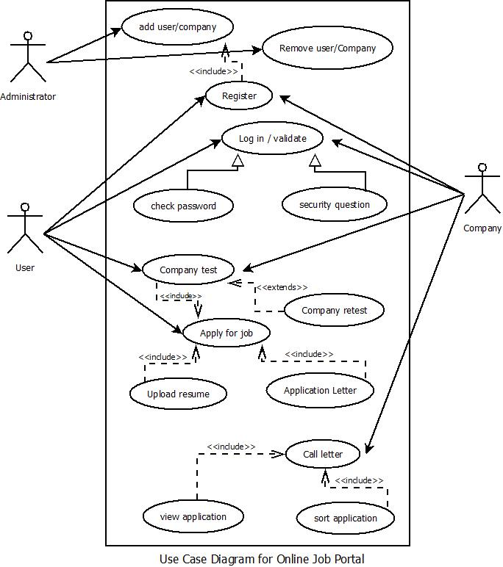

Basic flow of events: <a specific sequence of actions and interactions between actors and the system being discussed (happy path Or basic course of action)>
Line |  | System Actor Action |  | System Response
 |  | Administrator Manages(Deletes User, Modifies User Details) |  | Job seeker, job provider
 |  | Administrator Updates |  | Add company
 |  | Administrator Uploads |  | Remove company
 |  | Administrator do |  | Registration
 |  | Administrator Receives Payments to grant access from |  | job seeker, job provider
 |  | User performs |  | Registration
 |  | User do |  | Login
 |  | User |  | Check password
 |  | User /jobseeker |  | Apply for job
 |  | User |  | Send or upload resume
 |  | Job Provider/company |  | Register
 |  | Job Provider/company |  | Login
 |  | Job Provider/company |  | Security questions
 |  | Job Provider/company |  | Job letter
Exceptional flow of events: <an alternate sequence of actions and interactions between the actors and the system (alternate course of action)>
1 | Administrator Updates for job provider, job seeker. |  |  | News & Updates, Latest jobs, and Job Board.
2 | Administrator manages |  |  | Job seeker, job provider.
3 | Administrator manages(moderate’s comments) |  |  | Comment job provider , job seeker
Post Conditions <the state(s) the system can be in when this use case ends>
The logout operation must enable the logout of the user from the current session.
The feedback provided by the user must be entertained in the system if applicable.
The maintenance of the system must be done regularly to keep the system running.
The system must be monitored regularly in order to avoid slow responsiveness and working of the system.

System Messages <all system generated messages that the system will prompt for the user>
1 | Login-Login successful or Login Failed: Re-enter your username and/or password.
2 | Search-Search Results not found. Please modify your search.
3  4  5  6 | Register-Successfully registered or you are already a member.  Upload-Successfully uploaded or failed to upload or slow internet connection.  Download-Successfully downloaded or failed to download due to slow internet connection.  Online job- You have slow internet connection or job provider is not available or You appear to be offline.
Appendix <List of any supporting documents attached>
- http://searchsoftwarequality.techtarget.com/definition/use-case
- http://en.wikipedia.org/wiki/Use_case
- Fundamentals of Software Engineering – Rajib Mall

