Version |  |  | Description |  | Created By | Date
1.0 |  |  | First Version |  | ANUKRITI VASHISTH,  PRIYANSHTYAGI,  JYOTI, ABUBHAV DAGAR, ARJUN CHAUDHARY | 30-08-2019
General Description
The ER Diagram designed here gives us the basic idea about the functionality of the ONLINEJOBPORTAL.COM, the idea provided helps us in understanding the relations between the tables and what all attributes are needed their as the information, what will be managed by the administrator, what is the functionality of the system and the modules.

ER Diagram
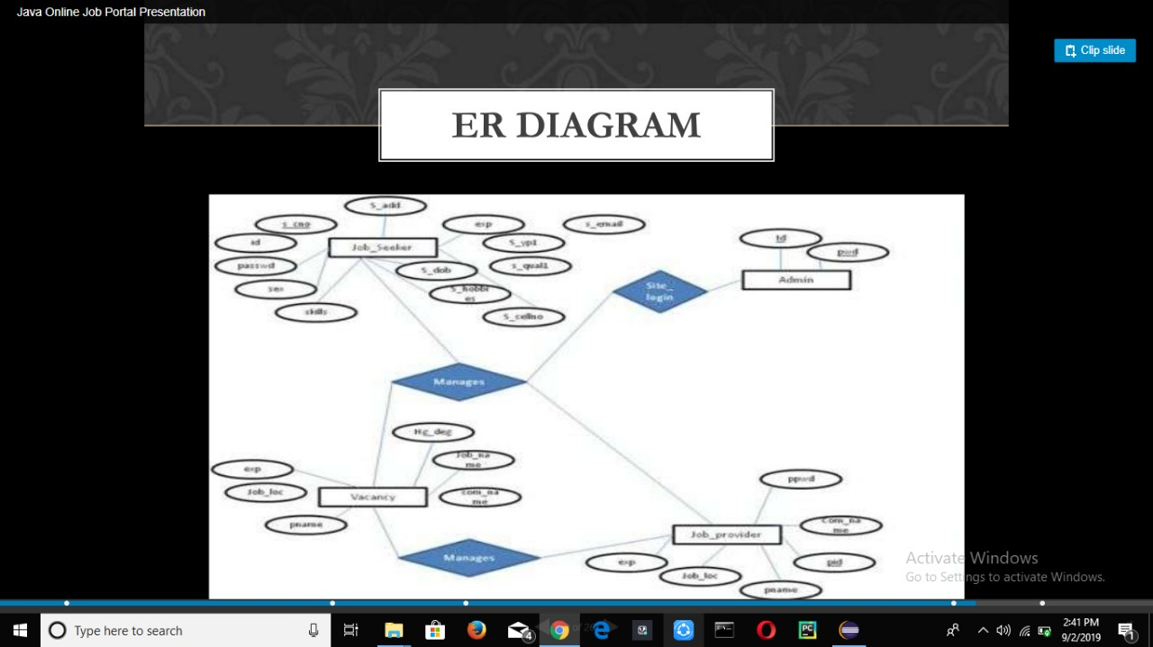

Basic flow of events: <a specific sequence of actions and interactions between actors and the system being discussed (happy path Or basic course of action)>
Line |  | System Actor Action |  | System Response
 |  | Administrator Manages(Deletes User, Modifies User Details, Responses to E-Mail Requests) |  | Student, Tutor, Parent
 |  | Administrator Updates |  | LatestTutors, JobBoard, News, Payment
 |  | Administrator Uploads |  | OnlineMaterials
 |  | Administrator Moderates Comments on |  | Student, Parent, Teacher
 |  | Administrator Receives Payments to grant access from |  | Student, Teacher, Parent
 |  | Student Searches |  | Tutors
 |  | Student Comments on |  | Tutors
 |  | Student Downloads |  | OnlineMaterials
 |  | Student Makes Payments to |  | Admin
 |  | Parents Searches |  | Tutors
 |  | Parents Comment on |  | Tutors
 |  | Parents Download |  | OnlineMaterials
 |  | Parents Makes Payment to |  | Admin
 |  | Tutor adds to his/her batch |  | Student
 |  | Tutor comments on |  | Student/Parent
 |  | Tutor Makes Payment to |  | Admin
 |  | Tutor receive payment from |  | Admin
 |  | Tutor uploads |  | OnlineMaterials
Exceptional flow of events: <an alternate sequence of actions and interactions between the actors and the system (alternate course of action)>
1 | Administrator Updates for Student, Tutor, Parent. |  |  | Payments, News, LatestTutor and JobBoard.
2 | Administrator manages |  |  | Student, Parent and Tutor.
3 | Administrator manages(moderate’s comments) |  |  | CommentParentonTutor, CommentStudent
4 | Administrator receives payment for giving  access to online materials and subscription of teaching period. |  |  | Student, Parent and Tutor.
Post Conditions <the state(s) the system can be in when this use case ends>
- Registration-You are successfully registered to our account page.
- Login-Home page of ACADEMICBUDDY.com (login state) of the (user, administrator, anonymous user).
- Payment-The payment received by the administrator.
- Teaches- The tutor teaches the student added in his/her batch.
5 Logout-The user of the Website is in logout state or out of his/her home page.

System Messages <all system generated messages that the system will prompt for the user>
1 | Login-Login successful or Login Failed: Re-enter your username and password.
2 | Search-Search Results not found. Please modify your search.
3 | Register-Successfully registered or you are already a member.
4 | Uploading-Successfully uploaded or Failed to upload or you have slow Internet Connection.
5 | Download-Successfully downloaded or Failed to download due to slow Internet Connection.
6 | Online teaching-You have slow Internet Connection or Tutor is not available or You appear to be Offline.
User Interface Screens: <a prototype screen for this use case to give proof of concept or detailed level depending on the importance of the screen design to the user>
Screen ID: ACADEMICBUDDY.COM INDEX PAGE

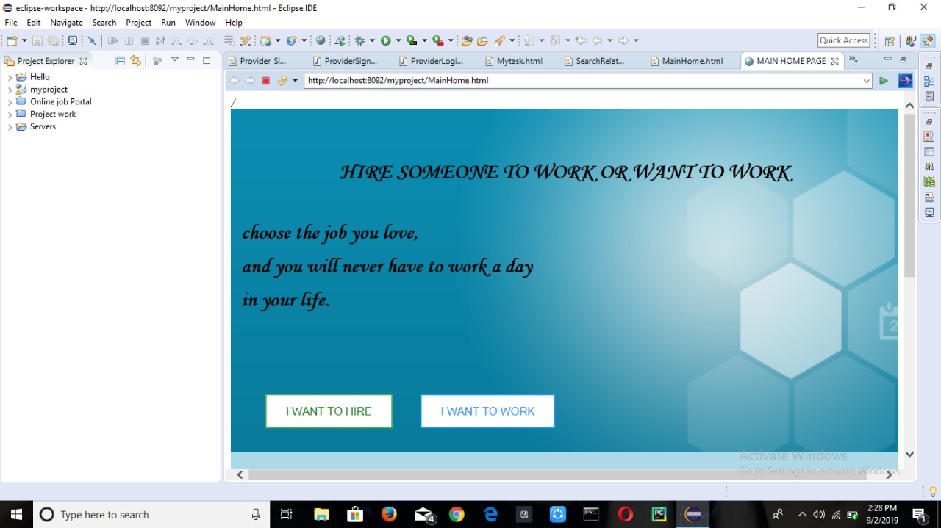

Screen ID:ONLINEJOBPORTAL.COM-SIGN UP PAGE of JOB SEEKER
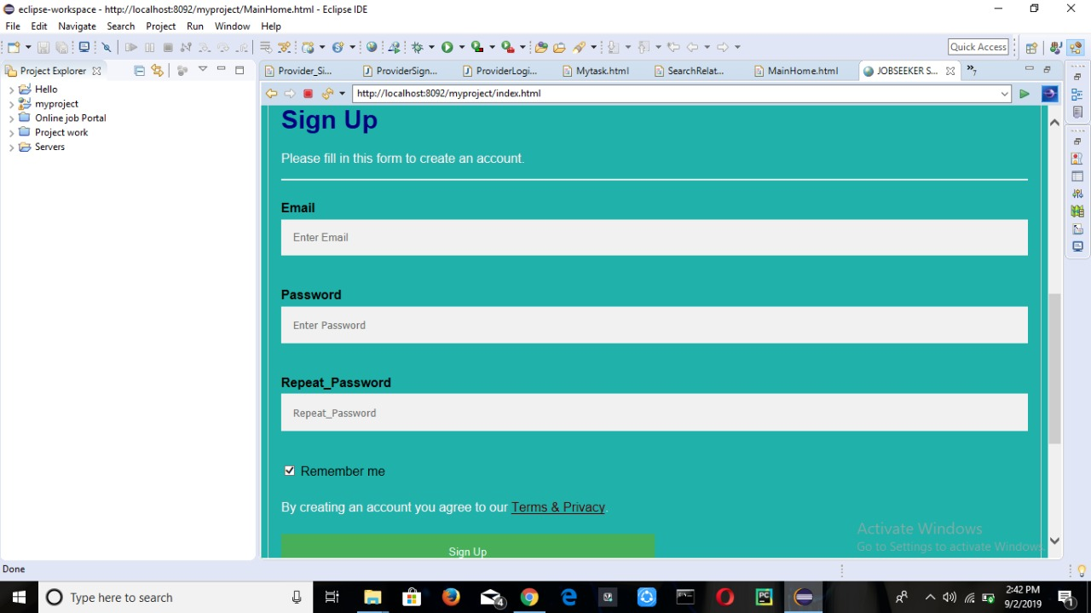

Screen ID: ACADEMICBUDDY.COM – SIGN UP PAGE of JOB PROVIDER

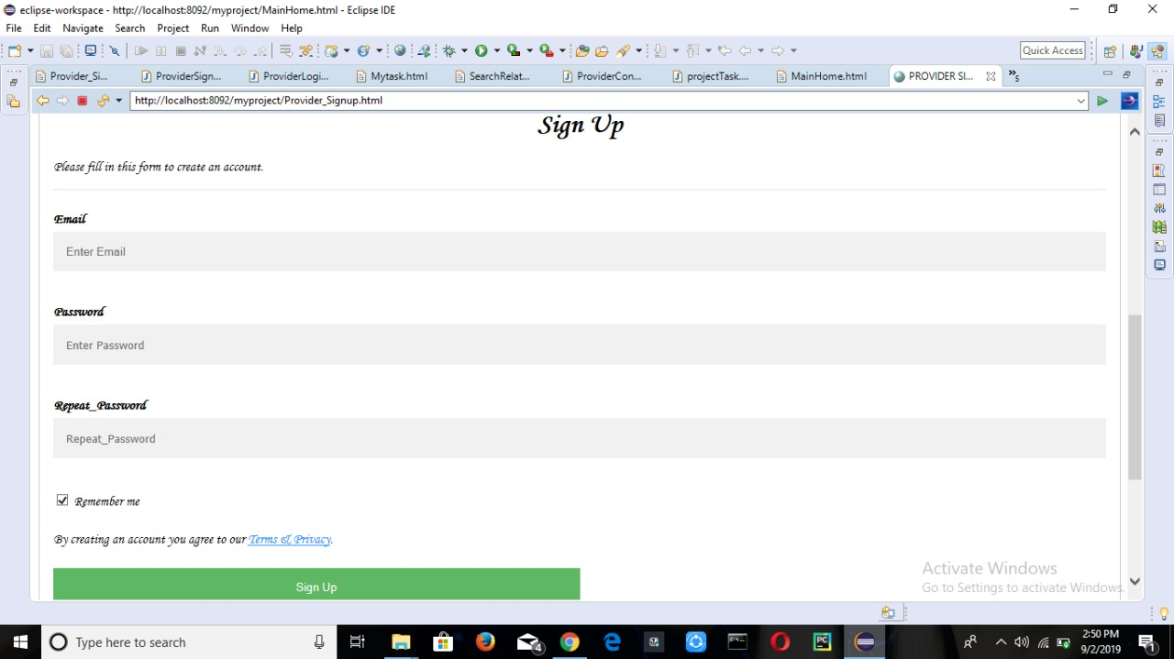

Screen ID: ACADEMICBUDDY.COM – LOGIN PAGE of JOB SEEKER

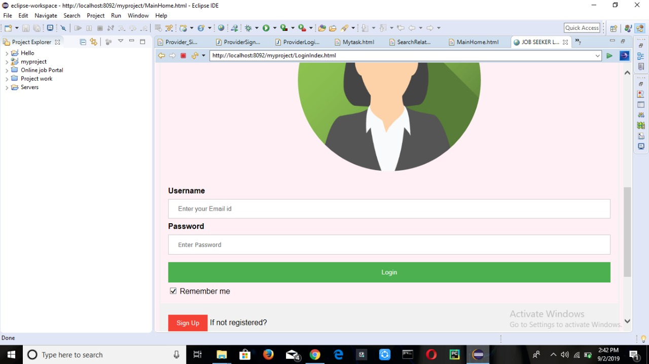

Screen ID: ACADEMICBUDDY.COM – LOGIN PAGE of JOB PROVIDER

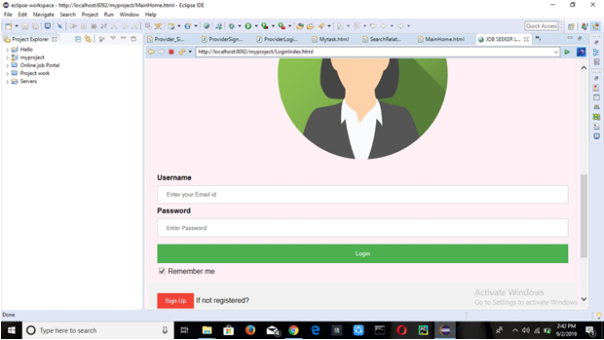

Screen ID: ACADEMICBUDDY.COM – HOME PAGE of JOB SEEKER
