CONFIDENTIAL

Project name: ONLINE JOB PORTAL SYSTEM

Class Design Specification

DOCUMENT VERSION HISTORY

Document Version | Date Issued | Comments
1.0 | 30-08-2019 | First version of the Web Portal

Table of Contents

Table of Contents 2
Class Design
1 Introduction 3
2 Conventions followed 3
3 Class Diagrams 4

Introduction

The class diagram is the main building block of object oriented modelling. It is used both for general conceptual modelling of the systematics of the application, and for detailed modelling translating the models into programming code. Class diagrams can also be used for data modeling. The classes in a class diagram represent both the main objects and or interactions in the application and the objects to be programmed. In the class diagram these classes are represented with boxes which contain three parts:
A class with three sections:
- The upper part holds the name of the class
- The middle part contains the attributes of the class
- The bottom part gives the methods or operations the class can take or undertake

Conventions followed

Hungarian Convention

Class Diagrams

Classes
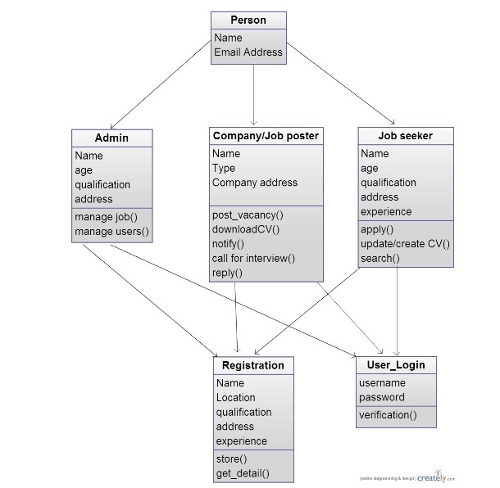

Admin

Class Description :
The Administrator class holds those attributes and functions which may be used for the functioning of the system. The administrator manages Jobseeker, jobprovider. The administrator uploads online materials and moderates comments.

Methods
 | Function | OutPut Parameters | Description
1 | deleteUser(String, String, String) | Int | This function deletes the existing user from the database
2 | login(String, String) | Int | checks for the authentic username and password and provides the login
3 | updateData(String, String, String, String, String) | Int | the administrator make changes in the user details, qualifications, etc
4 | uploadProjects(String, String, String) | Int | the administrator uploads projects which can be accessed online or downloaded and can be used by jobseeker for jobs
6 | update(String) | Int | the administrator keeps the website updated by updating the home page details

Job Seeker

Class Description :
The Jobseeker class contains the attributes and related functionality for the jobseeker.

Methods
 | Function | OutPut Parameters | Description
1 | Sign Up(String, String, String, String, String, String, String, String, String, String, String) | Int | registers the new job seeker in the portal
2 | login(String, String,String) | Int | authenticates the job seeker to login

Employee Home

Class Description :
This class holds the business logic to display the values stored in the database.

Methods
 | Function | OutPut Parameters | Description
1 | displaysJobBoard | displays the JobBoard
2 | displayLatestJobprovider | displays the Latest job providers
3 | displaysHomePageDetails | displays the homepage details

Search Projects

Class Description :
This class holds the business logic to display the values stored in the database.

Methods
 | Function | OutPut Parameters | Description
1 | Searches Projects | displays the list of projects on the searched query

Add JobSeekers

Class Description :
This class holds the business logic to display the values stored in the database.

Methods
 | Function | OutPut Parameters | Description
1 | addJobSeekers(String, String, String, String, String) | Int | enables the jobseekers to get added in the particular project.

Job Provider

Class Description :
The Job Provider class contains the attributes and related functionality for the provider.

Methods
 | Function | OutPut Parameters | Description
1 | register(String, String, String, String, String, String, String, String, String, String, String) | int | registers the new provider in the portal
2 | login(String, String,String) | int | authenticates the provider to login

Search Job

Class Description :
This class holds the business logic to display the values stored in the database.

Methods
 | Function | OutPut Parameters | Description
1 | displaysResults | displays the List of tutors on the searched query

