SOURCE CODE

**Q** **21.** **Write a method removeEvenLength that takes an ArrayList of Strings as a parameter and that removes all of the strings of even length from the list. (Use ArrayList).**

**/* Java program to write a method removeEvenLength that takes an ArrayList of Strings as a parameter and that removes all of the strings of even length from the list. (Use ArrayList).*/**

import java.util.*;

public class Question21 {

    public static void removeEvenLength(ArrayList<String> list) {

        for (int i = 0; i < list.size(); ) {

            if (list.get(i).length() % 2 == 0) {

                list.remove(i);

            } else {

                i++;

            }

        }

    }

    public static void main(String[] args) {

        Scanner scanner = new Scanner(System.in);

        ArrayList<String> words = new ArrayList<>();

        System.out.println("Enter words (type 'done' to finish):");

        while (true) {

            String input = scanner.nextLine().trim();

            if (input.equalsIgnoreCase("done")) break;

            if (!input.isEmpty()) words.add(input);

        }

        removeEvenLength(words);

        if (words.isEmpty()) {

            System.out.println("No words with odd lengths found.");

        } else {

            System.out.println("Words with odd lengths:");

            for (String word : words) {

                System.out.println(word);

            }

        }

        scanner.close();

    }

}

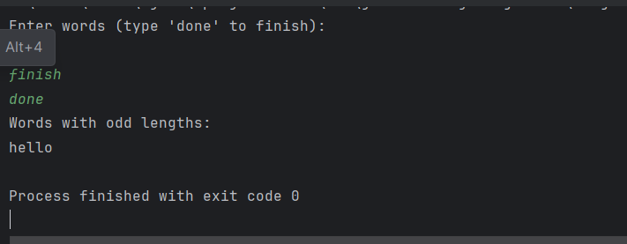

SOURCE CODE

**Q** **22.** **Write a method swapPairs that switches the order of values in an ArrayList of Strings in a pairwise fashion. Your method should switch the order of the first two values, then switch the order of the next two, switch the order of the next two, and so on.**

import java.util.*;

public class Question22 {

    public static void swapPairs(ArrayList<String> list) {

        for (int i = 0; i < list.size() - 1; i += 2) {

            String temp = list.get(i);

            list.set(i, list.get(i + 1));

            list.set(i + 1, temp);

        }

    }

    public static void main(String[] args) {

        Scanner scanner = new Scanner(System.in);

        System.out.println("Enter words separated by spaces:");

        String inputLine = scanner.nextLine().trim();

        ArrayList<String> words = new ArrayList<>(Arrays.asList(inputLine.split("\\s+")));

        swapPairs(words);

        System.out.println("Words after swapping pairs:");

        for (String word : words) {

            System.out.print(word + " ");

        }

        scanner.close();

    }

}

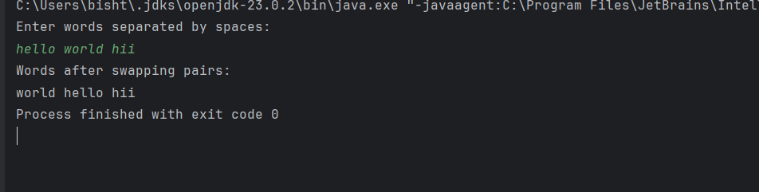

SOURCE CODE

**Q** **23.** **Write a method called alternate that accepts two Lists of integers as its parameters and returns a new List containing alternating elements from the two lists, in the following order:**

**• First element from first list**

**• First element from second list**

**• Second element from first list**

**• Second element from second list**

**• Third element from first list**

**• Third element from second list….**

**/* Write a method called alternate that accepts two Lists of integers as its parameters and returns a new List containing alternating elements from the two lists.*/**

import java.util.*;

public class Question23{

    public static List<Integer> alternate(List<Integer> list1, List<Integer> list2) {

        List<Integer> result = new ArrayList<>();

        int maxLength = Math.max(list1.size(), list2.size());

        for (int i = 0; i < maxLength; i++) {

            if (i < list1.size()) result.add(list1.get(i));

            if (i < list2.size()) result.add(list2.get(i));

        }

        return result;

    }

    public static void main(String[] args) {

        Scanner scanner = new Scanner(System.in);

        List<Integer> list1 = new ArrayList<>();

        List<Integer> list2 = new ArrayList<>();

        System.out.print("Enter the number of elements in the first list: ");

        int n1 = scanner.nextInt();

        System.out.println("Enter " + n1 + " integers for the first list:");

        for (int i = 0; i < n1; i++) {

            list1.add(scanner.nextInt());

        }

        System.out.print("Enter the number of elements in the second list: ");

        int n2 = scanner.nextInt();

        System.out.println("Enter " + n2 + " integers for the second list:");

        for (int i = 0; i < n2; i++) {

            list2.add(scanner.nextInt());

        }

        List<Integer> combined = alternate(list1, list2);

        System.out.println("Alternating list:");

        for (int num : combined) {

            System.out.print(num + " ");

        }

        scanner.close();

    }

}

