**Practical-7**

**Aim:** Build a simple perceptron and classified XOR problem.

Code:

Perceptron.py

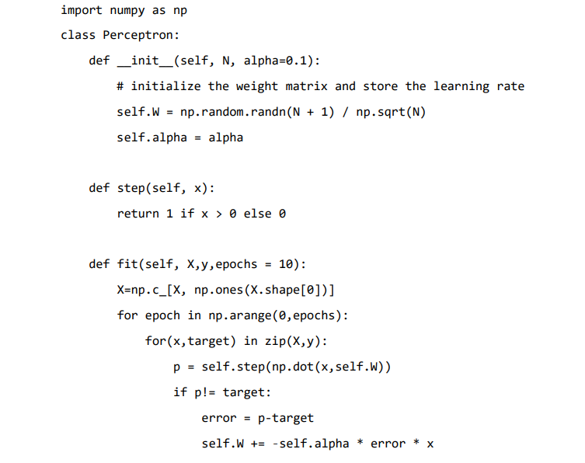

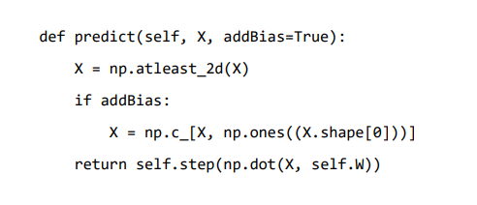

Prac-7.py

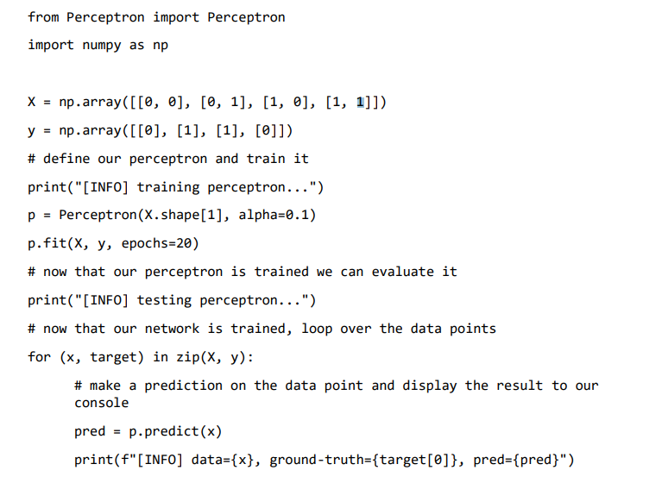

**Output:**

