**Experiment-6**

**Aim:** To observe and analyze the Co-channel and Adjacent Channel Interference for Cellular Mobile Telephone scenario.

**Activities:**

1. To observe the MATLAB Demo Simulink Block (Academic Version) set for the Cochannel and Adjacent Chanel.
2. Understand and Analyze the Significance of the offset, Gain and Interfere block of Simulink DEMO.
3. Observe the BER behavior for the No- Channel Interfere, Single and Multiple Co-channel interfere with Variable of Gain Parameters.
4. Observe and analyze the BER behavior for the No- Channel Interfere, Single and Multiple Adjacent channel interfere with Variable of Gain Parameters.
5. Observe and analyze the BER behavior for the No- Channel Interfere, Single and Multiple Co & Adjacent channel interfere together with Variable of Gain Parameters.

**Theory:**

* Two major types of system-generated interference :
  + Co-Channel Interference (CCI)
  + Adjacent Channel Interference (ACI)
* Co-Channel Interference caused by frequency reuse
  + Many cells in given coverage area use same set of channel frequencies to increase system capacity (*C*)
  + Co-channel cells → cells that share same set of frequencies
  + VC & CC traffic in co-channel cells are interfering sources to neighboring (not adjacent!) co-channel cells
* CCI depends on :
  + *R* : cell radius
  + *D* : distance from BS to center of nearest co-channel cell
* *D / R* ↑ then spatial separation relative to cell coverage area ↑
  + Improved isolation from co-channel RF energy
* 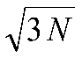*Q = D / R* : co-channel reuse ratio
* For hexagonal cells →  *Q = D / R* *=*
* Signal to Interference ratio → *S / I* (not *S / N* or *SNR*!!)

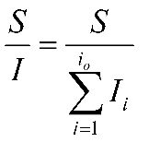

*S* : Rx power from desired signal

*Ii* : Interference power from *ith* co-channel cell

*io* : # of co-channel interfering cells

Average Rx power at distance *d*

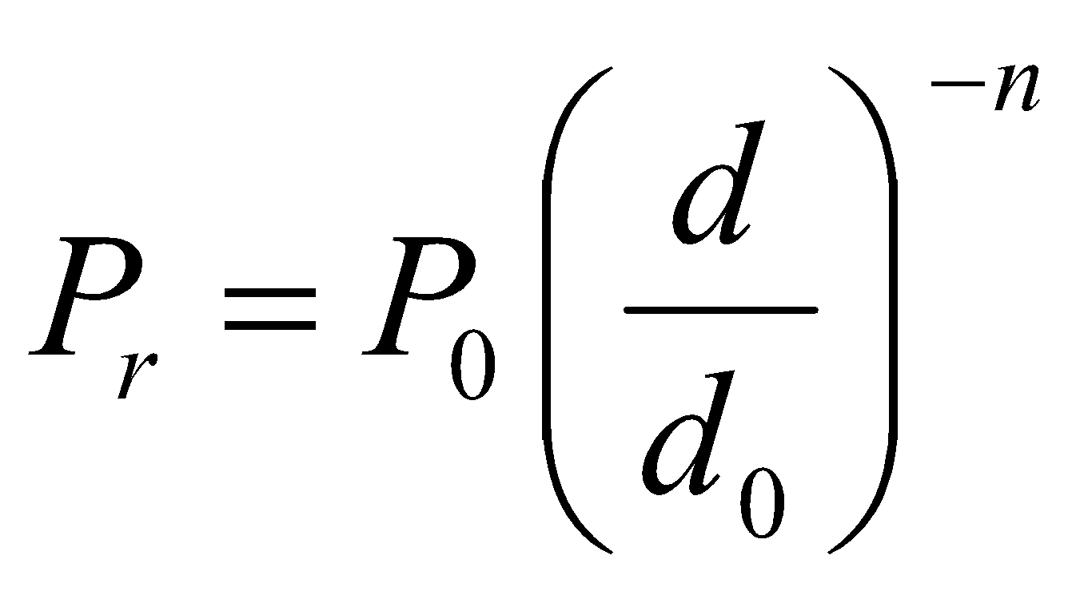

*P*0 : Rx power at close-in reference point

*d*0 : close-in reference distance

*n* : path loss exponent

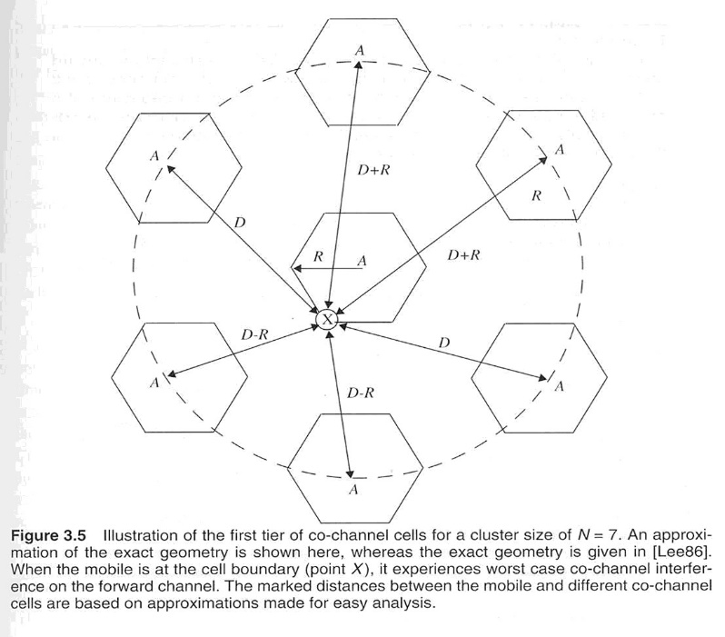

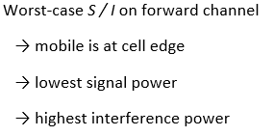

* Adjacent Channel Interference (ACI)
  + Caused by imperfect Rx filters that allow energy from adjacent channels to leak into passband of desired signal

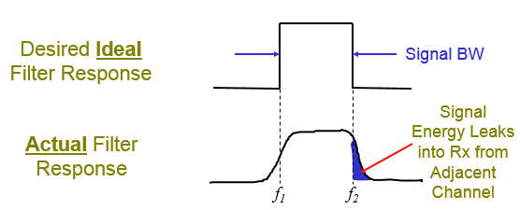

* + ACI can affect both forward & reverse channel links
  + Reverse Link → mobile-to-base
  + Interference @ base station Rx from nearby mobile Tx when desired mobile Tx is far away from base station
* Forward Link → base-to-mobile
  + Interference @ desired mobile Rx from nearby base Tx when secondary mobile Rx is far away from base station
* Near/Far Effect
  + Interfering source (Tx) is near some Rx when other source is far away
* ACI is primarily from mobiles in same cell

Some cell-to-cell ACI does occur as well → secondary source

**Activity A:**

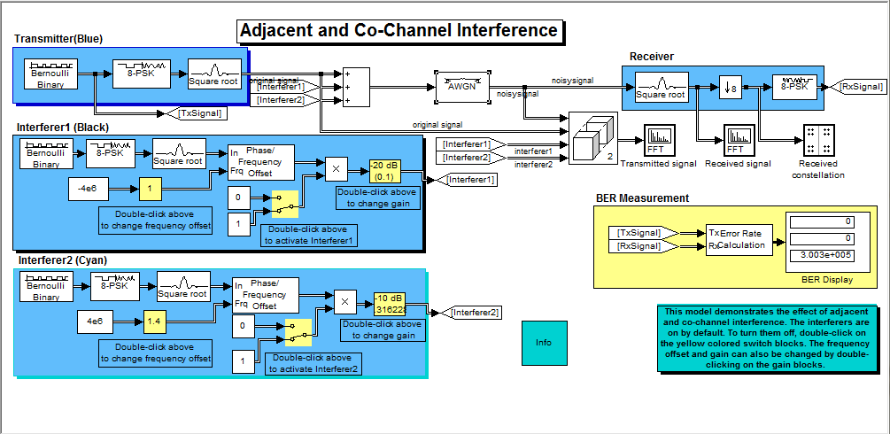

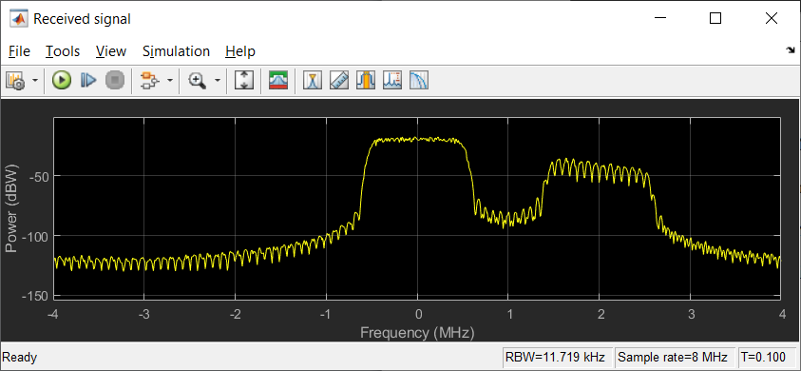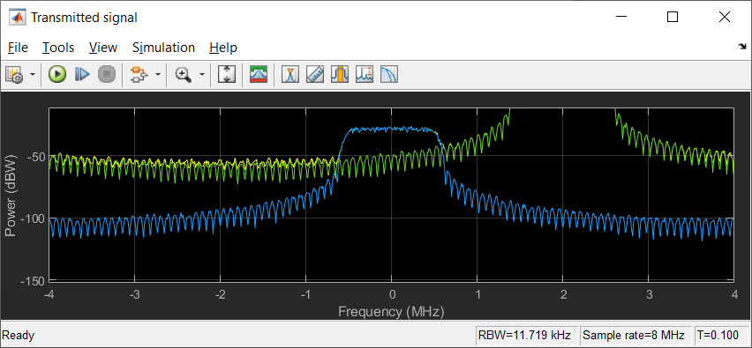

**Activity B:**

**Offset change: - (Before)**

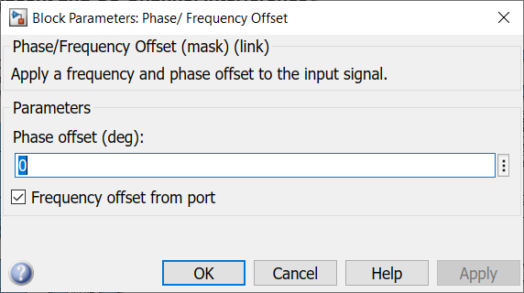

**After changes: - (Offset=3)**

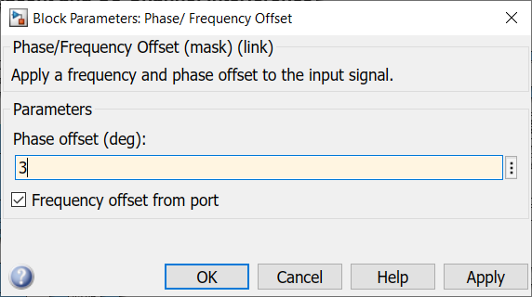

**After changing Frequency: -**

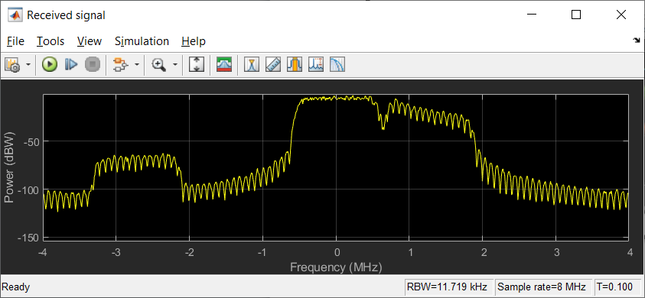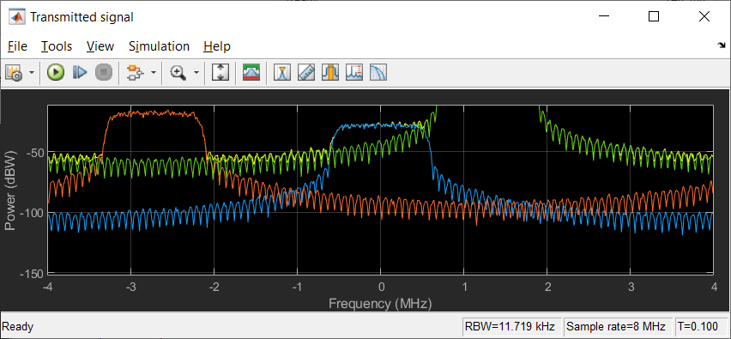

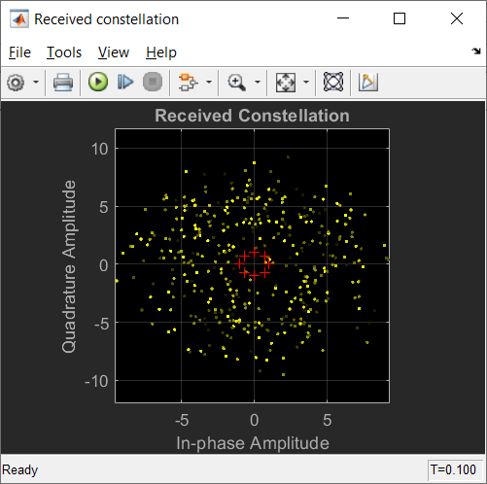

**Changing Gain Parameters:**

After changes the gain of block: -

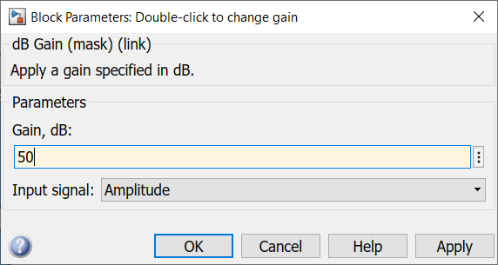

**Activity C:**

* To deactivate an interferer, double-click the switch block that corresponds to that interferer. In the "Received signal" spectrum analyzer, notice the effect of omitting the interfering signal.
* To change the spectral overlap between primary signal and interfering signals, set the "Frequency offsets" parameter of Multiband Combiner block.
* As we decrease the offset, the "Received signal" spectrum analyzer shows the interfering signal slowly moving from the adjacent channel into the frequency band of the original signal and eventually causing co-channel interference.
* The values reported in the BER Display block slowly deteriorate as the offset decreases, because the 8-PSK constellation points become difficult to demodulate correctly.
* To change the power gain of an interfering signal, double-click the dB Gain block and change the Gain parameter.
* 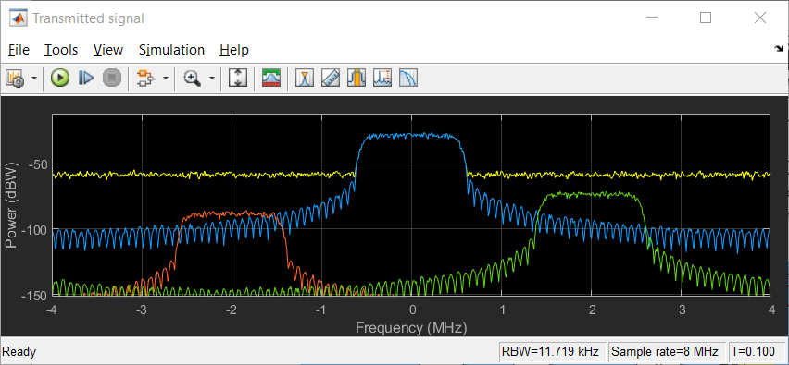Observe the effect on the "Transmitted signal" and the "Received signal" spectrum analyzers. If we decrease the negative dB gain, the BER worsens, especially in the presence of co-channel interference.

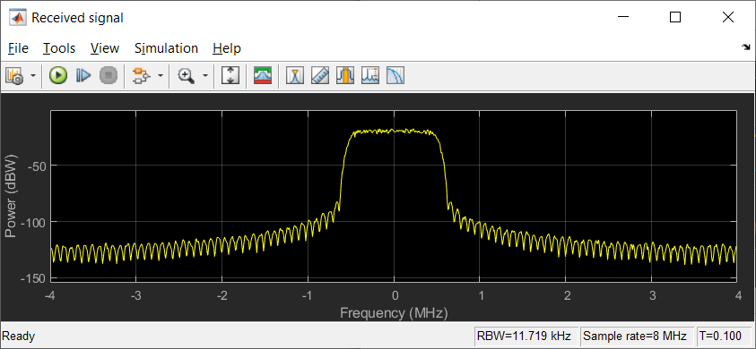

**Channel Frequency change:- (Before changes)**

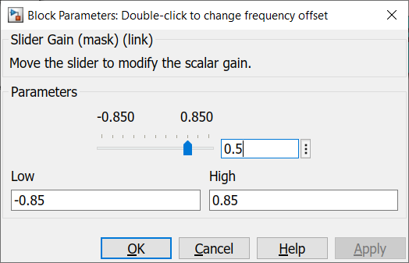

**After changes Frequency:-**

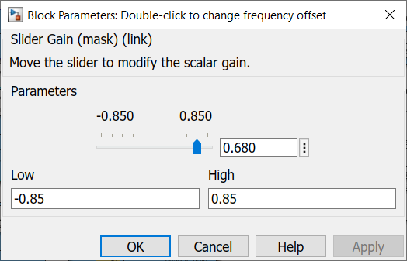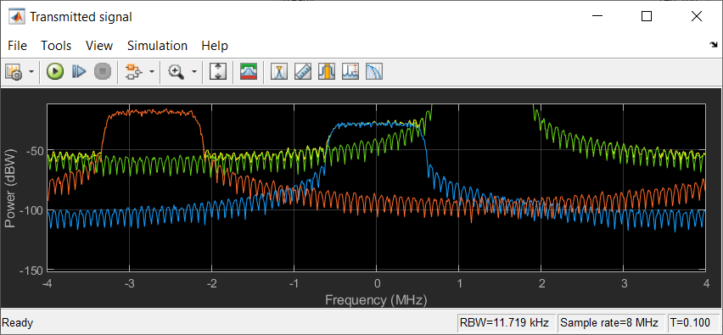

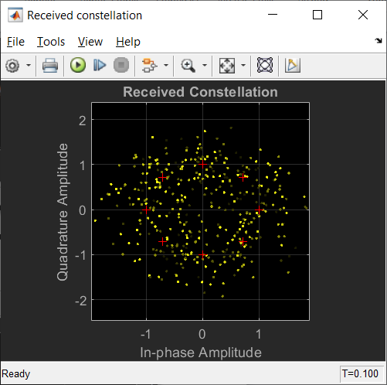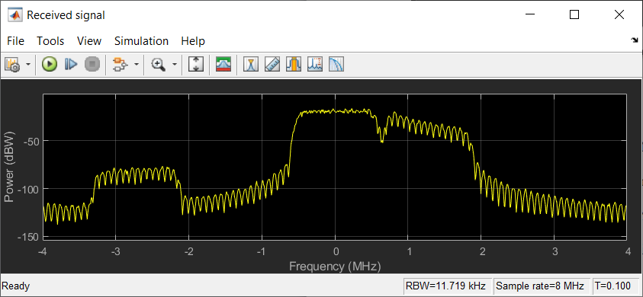

**BER Obserevation:**

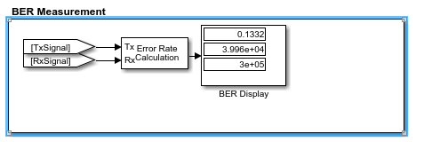

**Activity D:**

Before Change in Gain is:- It is 25db

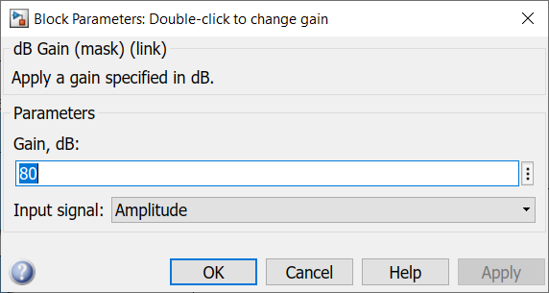After changes in Gain- we make it 80db

When we change in the gain that before time BER is: -

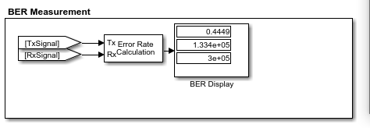**After changes in Gain: -**

**Conclusion:**

Doing above activities, we can study Co-Channel and adjacent channel interference for Cellular Mobile Telephone scenarios more accurately and properly.