**Experiment-12**

**Aim:** To implement concept code of Handoff system for cellular communication.

**Activities:**

1. To Develop and implement Code of Handoff System with consideration of signal strength and time.

1. To Plot the graph of Handoff for Time over Signal Strength of signal.

**Theory:**

In Cellular system a handoff, also known as a handover is a crucial process that allows a mobile device to maintain an ongoing call or data session as it moves from the coverage area of one cell (base station) to another. Handoff are essential to ensure that a mobile device maintains a strong and uninterrupted connection to the cellular network.

Overview of Handoff work in cellular system.

1. **Cellular Network Structure:** Cellular networks are divided into multiple cells, each served by a base station (cell tower). The cells are designed to cover a specific geographic area.
2. **Monitoring Signal Strength:** Mobile devices constantly measure the signal strength and quality from the cell they are currently connected to. This information helps determine when a handoff is needed.
3. **Handoff Trigger:** When a mobile device's signal strength starts to weaken as it moves away from the current cell's coverage area, the network begins to search for a neighboring cell with a stronger signal.
4. **Neighbor Cell Selection:** The network identifies one or more neighboring cells that can provide better signal quality for the mobile device. This process involves evaluating signal strength, interference, and other factors.
5. **Handoff Decision:** Based on the assessment, the network decides to initiate a handoff to a specific target cell. This target cell may be in the same or different frequency bands, depending on the network's design.

There are different types of handoffs, including:

* **Intra-cell Handoff:** This involves transferring a connection to another sector within the same cell. It is typically a soft handoff.
* **Inter-cell Handoff:** This is a handoff between two cells served by different base stations. It can be a soft handoff or a hard handoff.

Handoffs are a fundamental aspect of cellular network operation, ensuring that mobile devices maintain connectivity as they move within the network's coverage area. Effective handoff management is crucial for providing seamless voice and data services to users.

**Code:**

import time import random

import matplotlib.pyplot as plt

class Cell:

def init (self, cell_id, signal_strength): self.cell_id = cell_id self.signal_strength = signal_strength

def get_signal_strength(self): return self.signal_strength

class HandoffSystem:

def init (self, cells, time_threshold): self.cells = cells self.time_threshold = time_threshold self.current_cell = None self.last_handoff_time = time.time() self.handoff_times = []

def handoff(self, current_signal_strength): if self.current_cell is None:

self.current_cell = max(self.cells, key=lambda cell: cell.get_signal_strength())

if current_signal_strength > self.current_cell.get_signal_strength(): self.current_cell = max(self.cells, key=lambda cell: cell.get_signal_strength())

self.last_handoff_time = time.time() self.handoff_times.append((time.time(), self.current_cell))

elif time.time() - self.last_handoff_time > self.time_threshold: self.current_cell = max(self.cells, key=lambda cell: cell.get_signal_strength())

self.last_handoff_time = time.time() self.handoff_times.append((time.time(), self.current_cell))

return self.current_cell

# Generate random time and signal strength data time_data = list(range(1, 21)) signal_strength = [random.randint(-90, -60) for _ in time_data]

# Create cells based on the generated signal strength values

cells = [Cell(f"Cell {i}", signal) for i, signal in enumerate(signal_strength)]

# Create a handoff system with a time threshold of 10 seconds handoff_system = HandoffSystem(cells, 10)

# Initialize lists to store data for the graph time_points = [] signal_strength_points = []

# Simulate handoff decisions based on the generated time and signal strength data for i, current_signal_strength in enumerate(signal_strength):

time_points.append(time_data[i])

current_cell = handoff_system.handoff(current_signal_strength) signal_strength_points.append(current_signal_strength)

print(f"Time: {time_data[i]} seconds, Current Cell: {current_cell.cell_id}")

# Extract handoff times and cells for plotting

handoff_times, handoff_cells = zip(*handoff_system.handoff_times) if handoff_system.handoff_times else ([], [])

# Plot the graph plt.figure(figsize=(10, 6)) plt.plot(time_points, signal_strength_points, marker='o', linestyle='-', color='b') if handoff_times: plt.scatter(handoff_times, handoff_cells, color='red', marker='o', label='Handoff Point') plt.legend(['Signal Strength', 'Handoff Point']) # Explicit legend labels plt.xlabel('Time (seconds)') plt.ylabel('Signal Strength')

plt.title('Handoff for Time over Signal Strength (Generated Data)') plt.grid(True) plt.show()

**Output:**

Time: 1 seconds, Current Cell: Cell 11 Time: 2 seconds, Current Cell: Cell

11 Time: 3 seconds, Current Cell: Cell

11 Time: 4 seconds, Current Cell: Cell

11 Time: 5 seconds, Current Cell: Cell

11 Time: 6 seconds, Current Cell: Cell

11 Time: 7 seconds, Current Cell: Cell

11 Time: 8 seconds, Current Cell: Cell 11 Time: 9 seconds, Current Cell: Cell

11

Time: 10 seconds, Current Cell: Cell 11

Time: 11 seconds, Current Cell: Cell 11

Time: 12 seconds, Current Cell: Cell 11

Time: 13 seconds, Current Cell: Cell 11

Time: 14 seconds, Current Cell: Cell 11

Time: 15 seconds, Current Cell: Cell 11

Time: 16 seconds, Current Cell: Cell 11

Time: 17 seconds, Current Cell: Cell 11

Time: 18 seconds, Current Cell: Cell 11

Time: 19 seconds, Current Cell: Cell 11

Time: 20 seconds, Current Cell: Cell 11

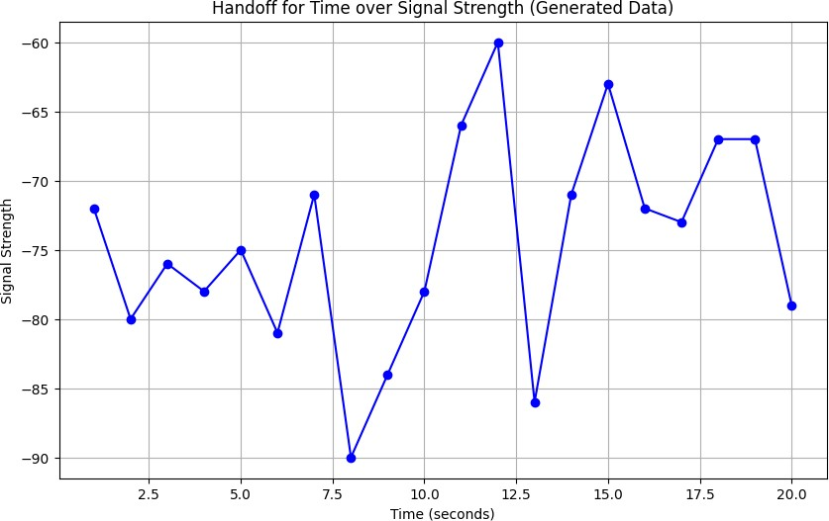

**Conclusion:**

Our Python program simulated cellular handoff systems, emphasizing their role in ensuring uninterrupted mobile connectivity during cell transitions.