**Experiment-5**

**Aim:** To implement analytical calculation program for the Frequency Re-Use ratio for cellular mobile communication.

**Activities:**

1. Write a program to calculate Frequency re-use ratio (FRR) using user specified inputs: Co-channel distance, radius of cell and path loss exponent.
2. Use this FRR to calculate Signal-to-Interference Ratio for the worst case i.e. MS is located at the cell boundary.
3. Also calculate S/I for cell sectoring specified by user.

**Theory:**

Frequency re use implies that in a given area there are several cells that use same frequencies these are called co-channel cells. And the interference of signals from these cells is called co-channel interference.

To reduce co-channel interference, co-channel cells must be physically separated by a minimum distance to provide sufficient isolation due to propagation

When the size of each cell is approximately the same and the BSs transmit the same power, the co-channel interference ratio is independent of the transmitted power and becomes a function of the radius of the cell (R) and the distance between the centers of the nearest co-channel cells (D)

The parameter Q is called the *co-channel reuse ratio* is related to the cluster size

For a hexagonal geometry Q=D/R=√(3N)

A small value of Q provides larger capacity since the cluster size is small whereas a large value of Q improves the transmission quality, due to smaller level of co-channel interference

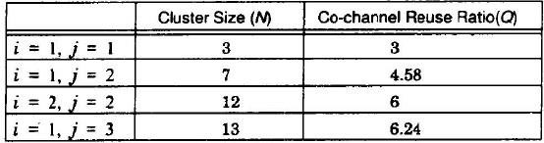

Fig: Co-channel re-use ratio for some values of N

When the transmit power of each BS is equal and path loss exponent is the same throughout the coverage area, SIR for a mobile station can be approximated as



Where,

D/R- co-channel reuse ratio

𝑖0 - number of interfering cells

N- cluster size n- path loss component

Using exact cell geometry layout for a seven-cluster cell, with MS at the cell boundary, the MS is at a distance D-R from the two nearest co-channel interfering cells, and is exactly D and D+R from the other two interfering cells in the first tier

Assuming n=4, the SIR for the worst-case scenario can be approximated as

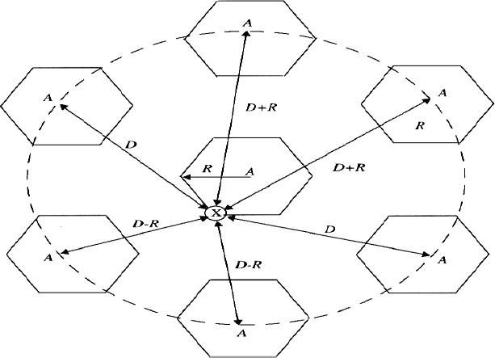

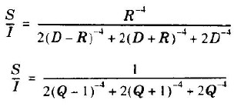

The above S/I is for omnidirectional antennas.

|  |  |
| --- | --- |
| For 60-degree sectoring | 𝑆 1  =  𝐼 (𝑄 − 1)−𝑛 |
| For 120-degree sectoring |  |

𝐼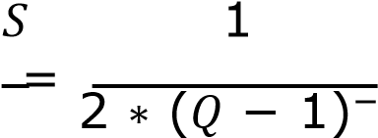𝑛

**Program:**

**a.)** Write a program to calculate Frequency re-use ratio (FRR) using user-specified inputs: Co-channel distance, radius of cell and path loss exponent.

# **Code:** -

D = float(input('Enter the co-channel distance: ')) R = float(input('Enter the radius of the channel: ')) n = float(input('Enter the path loss component: '))

FRR = D / R print('FRR is:', FRR)

# Output: -

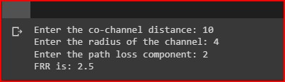

**For calculating different value of N:**

# Code: -

import math

N = int(input('Enter the value of N: '))

R = float(input('Enter the Reuse Distance i0: '))

D1 = math.sqrt(3 * N)

D = D1 * R q = D / R

print('Simple FRR is:', q)

n = float(input('Path Loss Component: '))

1. = [1, 2]
2. = [1, 2, 3]

length_i = len(i) length_j = len(j)

print('Here the S/I ratio is:')

print('i\t j\t N\t Q\t\t SNR')

for p in range(length_i): for q in range(length_j):

N1 = i[p] ** 2 + i[p] * j[q] + j[q] ** 2

Q1 = 3 * N1

Q = math.sqrt(Q1) SNR = Q ** n

print(f'{i[p]}\t {j[q]}\t {N1}\t {Q}\t\t {SNR}')

# Output: -

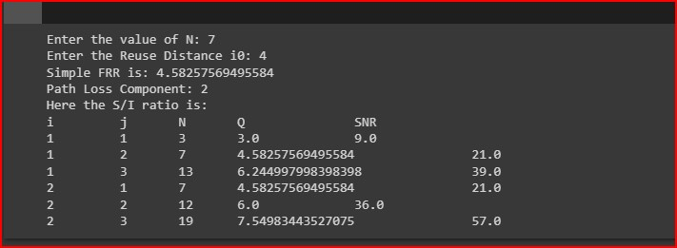

**b.)** Use this FRR to calculate Signal-to-Interference Ratio for the worst case, i.e., MS is located at the cell boundary.

# **Code: -**

import math

D = float(input('Enter the co-channel Distance: ')) R = float(input('Enter the radius of Channel: ')) n = float(input('Enter the path loss Component: '))

Q = D / R

print('FRR is:', Q)

SNR_W1 = 2 * ((Q - 1) ** (-n)) + 2 * ((Q + 1) ** (-n)) + 2 * (Q ** (-n))

SNR_W = 1 / SNR_W1

SNR_W_DB = 10 * math.log10(SNR_W)

print('Worst Case SNR is:', SNR_W)

print('Worst Case SNR is in DB:', SNR_W_DB)

# Output: -

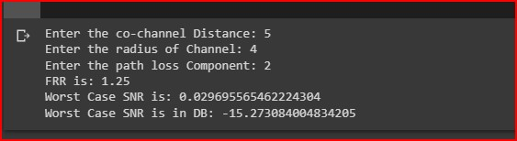

**c.)** Also Calculate S/I for cell sectoring specified by user.

**Code:**

import math

N = [4, 7, 12] n = [2, 3, 4]

theta = [360, 120, 60]

length_N = len(N) length_n = len(n)

length_theta = len(theta)

print('N\t n\t s\t SNR\t ') print('\n') print('\n')

for p in range(length_N): for q in range(length_n): for s in range(length_theta):

Q = math.sqrt(3 * N[p])

if theta[s] == 360:

SNR = ((Q - 1) ** n[q]) * 0.167 elif theta[s] == 120: SNR = ((Q - 1) ** n[q]) * 0.5 else:

continue

print(f'{N[p]}\t {n[q]}\t {theta[s]}\t {SNR}')

**Output: -**

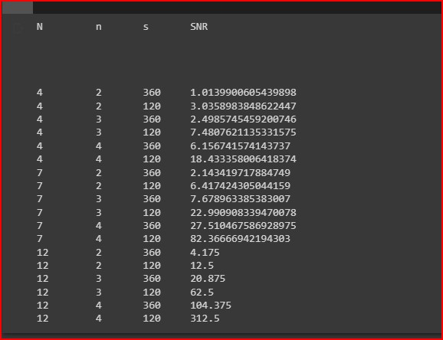

**Conclusion:**

By performing this practical, we calculate frequency reuse ratio for the different value of Co-channel distance, Radius of cell and path loss exponent. Also, we have calculated Signal-to-Interference Ratio for the worst case using FRR. Also calculate S/I for cell sectoring for different value.