
ASSIGMENT : UNIT 2
NAME : PRIYANSHI
ROLL NO : 25010216
COURSE : BTECH CSE(core)
SECTION : A
SUBJECT : COMPUTATIONAL SCIENCE FUNDAMENTALS AND CAREER PATH WAYS
SUBMITTED TO: MR. RAJESH BANDRA

#INTRODUCTION
This assignment is designed to provide practical, hands -on experience with the Linux Operating System.
Linux is an essential skill for computer science and IT professionals due to its inherent flexibility, security, and powerful scripting capabilities. The core objective is to demonstrate proficiency across three key areas:
1) Successfully establishing a Linux environment (Installation)
2) Executing and documenting fundamental shell commands
3) Developing functional Bash shell scripts to automate system administration tasks

#STEP 1
How to download Ubuntu and virtual box and make a machine to operate linux
Step 1: browse download Ubuntu
Step2: download it in the window according to the system
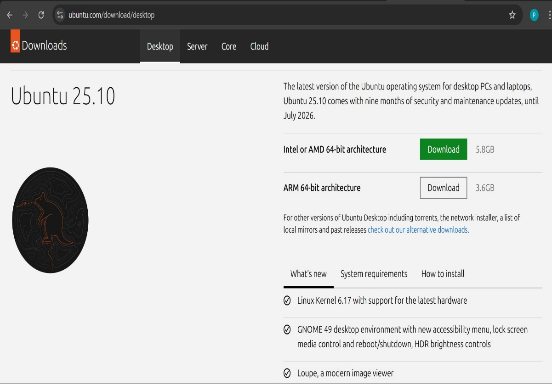
Step 3: browse download virtual box
Step 4: download it in window
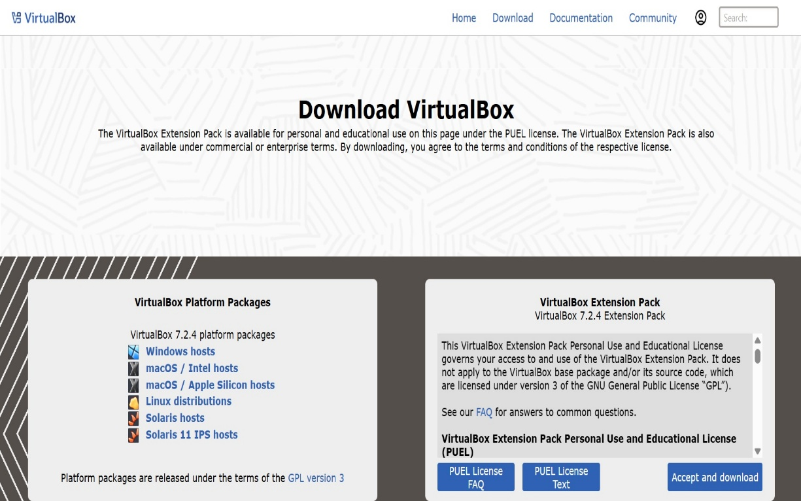
Step 5: open the virtual box manager and click the machine
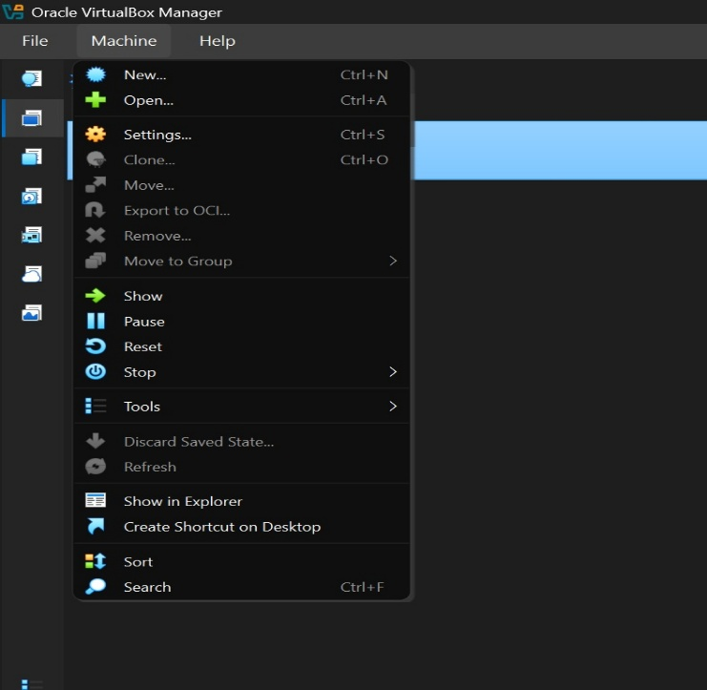
Step 6: select new machine and create a new machine giving it name as Ubuntu
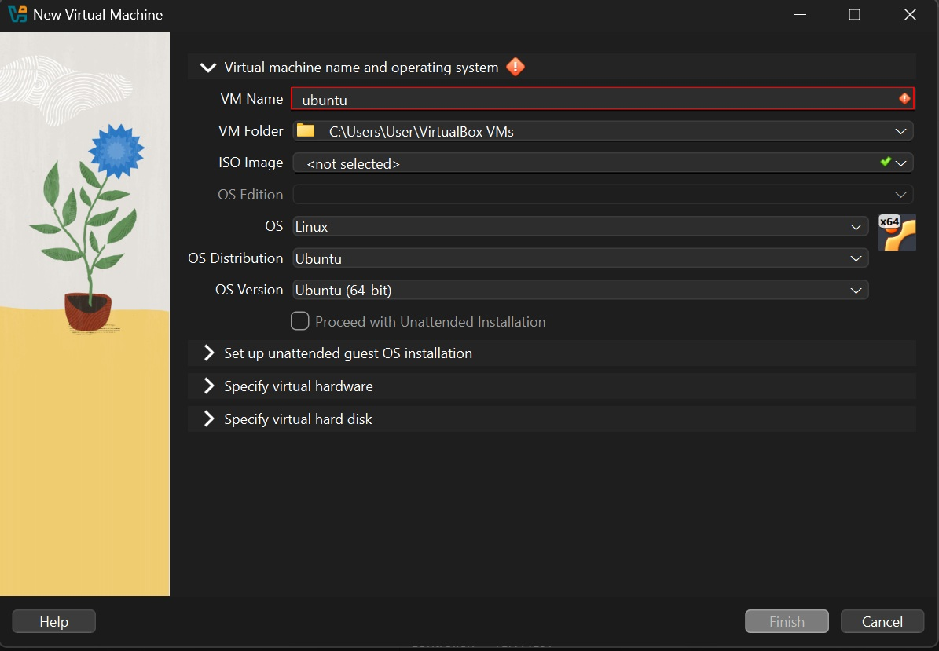
Step 7: click on specify virtual hardware than set up base memory and number and CPUs as follows
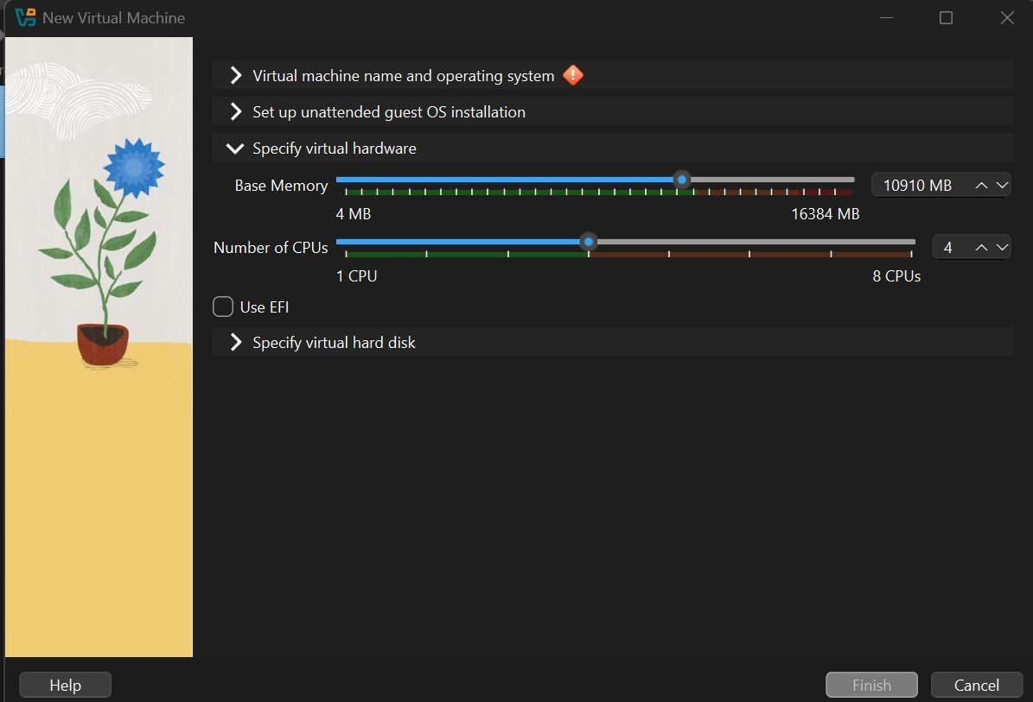
Step 8: add a strong password and click on finish than new machine will be created to start that machine click on start.
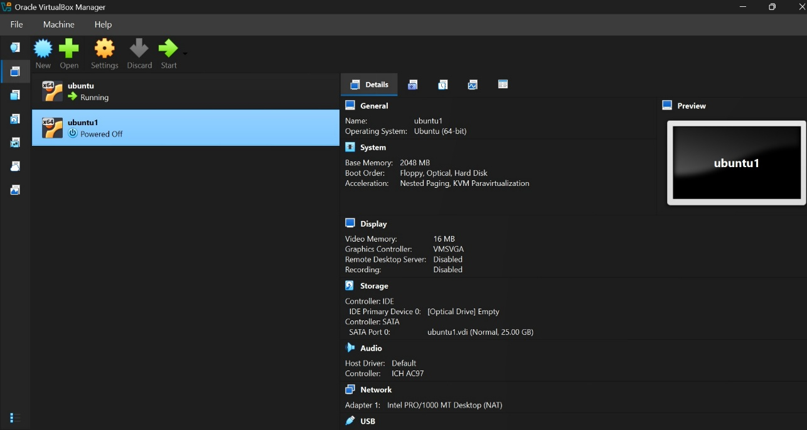S
Step 9: start the machine this would take 20-30 minutes to set up the machine than click and select all the default setting and than start the machine again it will show the interface as follows
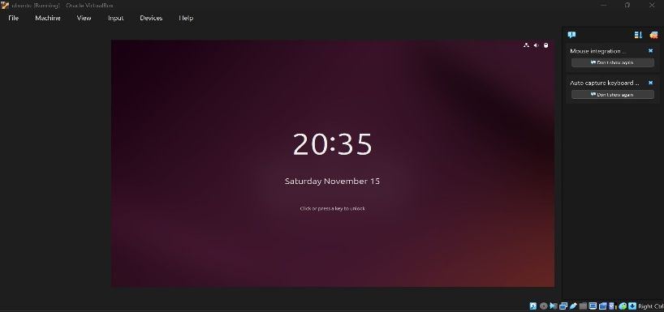
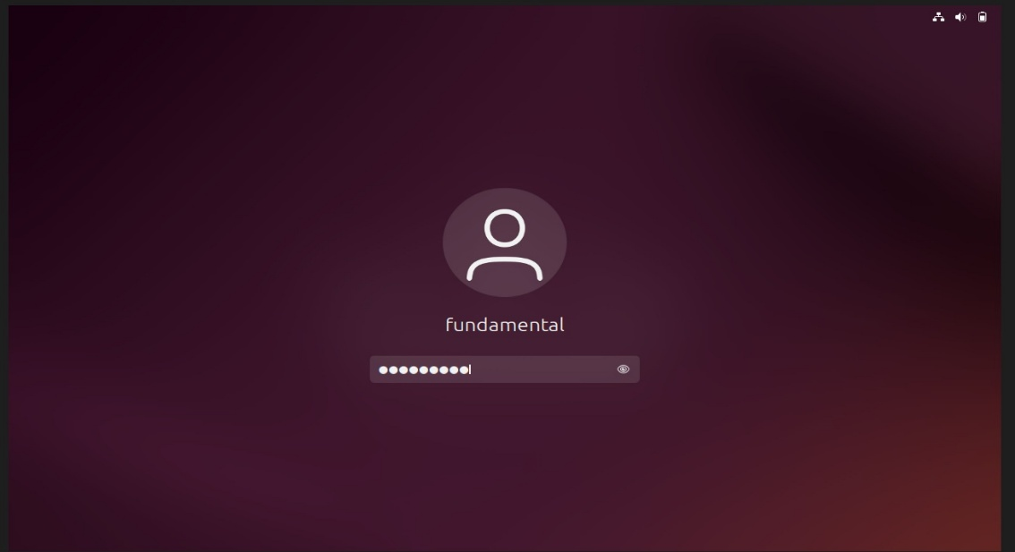
Step 10: add the password that was created in step 8
Step 11: this will appear click on the circle type icon and search terminal and there we can practice all the commands
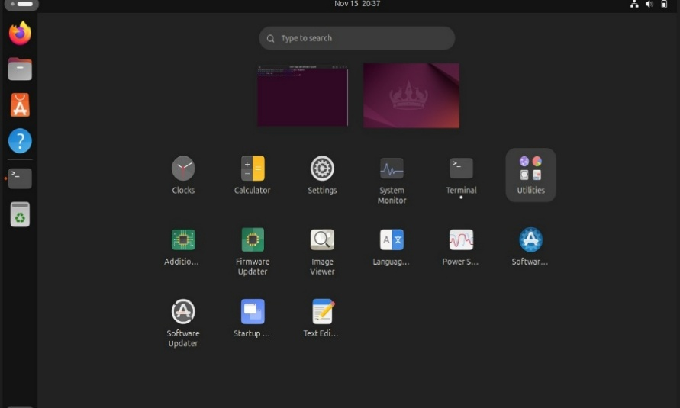


Step 12: here is the terminal
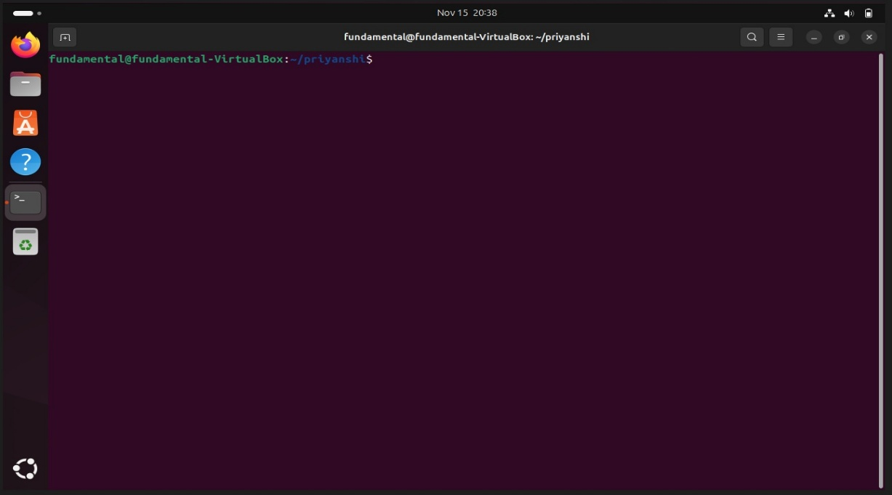
# commands practice
- Ls
- Syntax: ls
- Description: this command is used to list files or folders in current directory
- Use Case: To see all files including hidden
- Implementation:
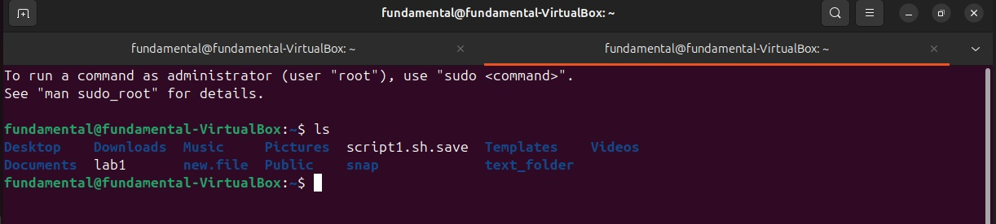
- mkdir
- Syntax: mkdir [directory name]
- Description: it is used to create a new directory or folder
- Use Case: it is useful for organizing files by creating one or multiple directories quickly
- Implementation:
- 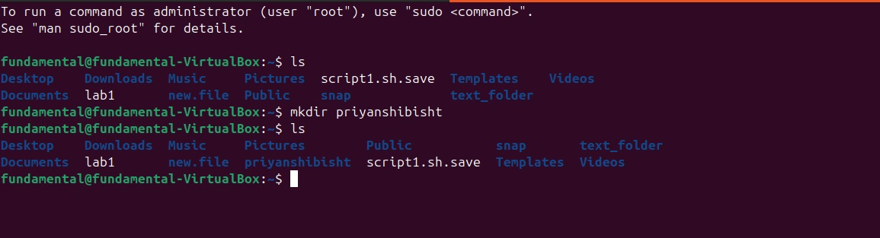
- cd
- Syntax: cd [options] [directory]
- Description: it is used to change the current working directory
- Use Case: It is commonly used whenever you need to navigate to a different directory to access or manage files
- Implementation:
- 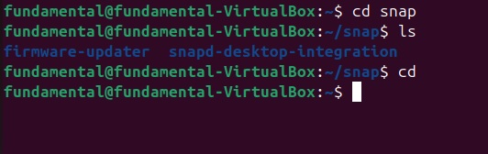
- touch
- Syntax: touch <filename>
- Use Case: it is used to create an empty file or update file timestamp
- Description: create multiple files for practice
- Implementation:
- 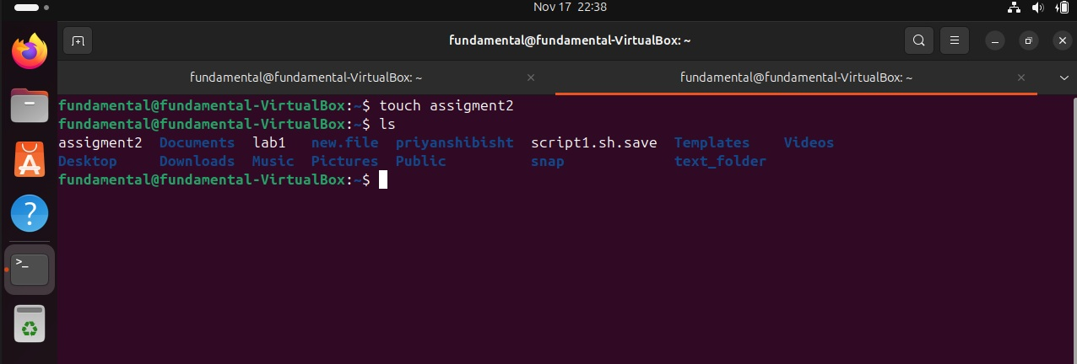
- Echo
- Syntax: echo “text”
- echo “text” > file
- Echo “text” >> file
- Use case: Create a quick file with content
- Description: Prints output to screen or writes/appends text to a file.
- Implementation:
- Mv
- Syntax: mv <source> <destination>
- Use case: Moves or renames files/directories
- Description: The word “mv” stands for “move files” this command in Linux is used to move or rename files and directories
- Implementation:
- 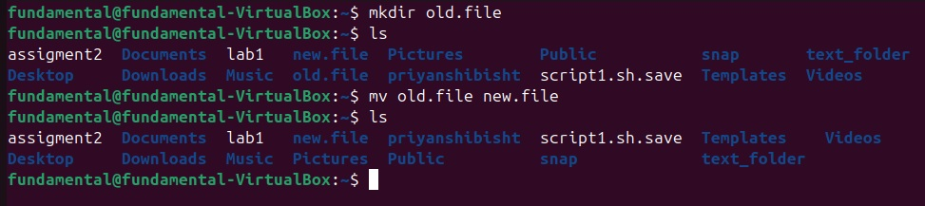
- Cat
- Syntax: : cat [filename], for Combining files :- cat [file1] [file2]
- Use case: The cat command in Linux is used to display the content of the file on the terminal or combine multiple files
- Description: The name cat command means “concatenate”. It is used to display the content of files, concatenate multiple files, and redirect output to create or append to files
- Implementation:
- 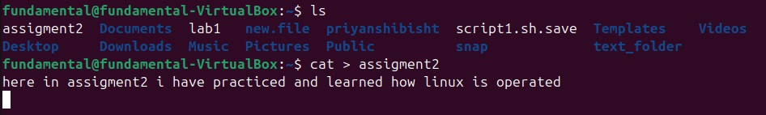
- Cp
- Syntax: cp <source> <destination>
- Use case: Create backup of a config file before editing
- Description: Copies files or folders
- Implementation:
- 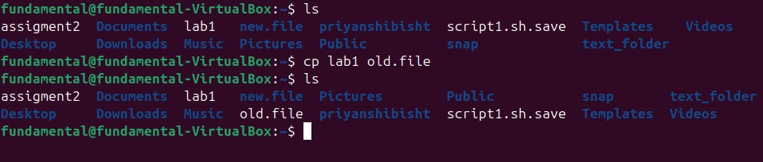
- Cp –r
- Syntax: cp –r <source_ folder> <destination_ folder>
- Use case: Duplicate a folder including subfolders and files
- Description: copies files or folders
- Implementation:
- 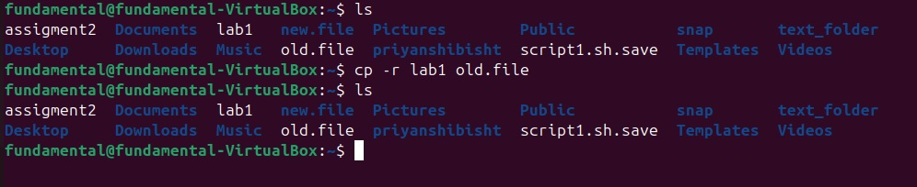
- Rm
- Syntax: rm <filename>
- Use case: Delete a file no longer required
- Description: Deletes a file permanently (no recycle bin)
- Implementation:
- 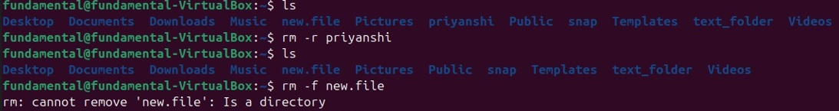
- rm –f
- syntax: rm –f <filename>
- use case: delete a corrupted or permission restricted file
- description : Force deletes file without prompting even if write-protected
- implementation:
- rm –r
- syntax: rm –r <directoryname>
- use case : Remove a node_modules folder or build output directory
- description: deletes folder and all its content recursively
- implementation:
- chmod
- syntax: chmod <mode> <file>
- use case: make a script executable
- description: changes access permissions(read , write, execute)
- implementation:
- 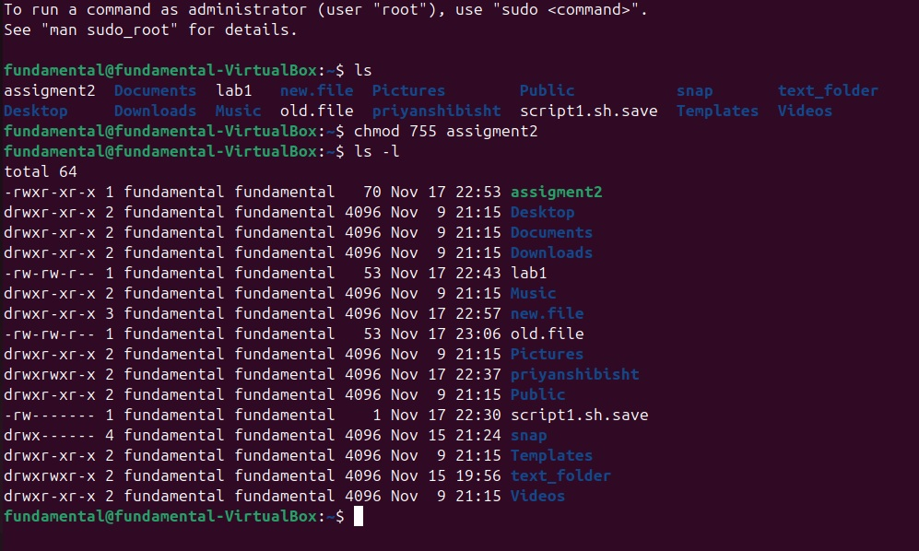
- ps aux
- syntax: ps aux
- use case: to find resource consuming processes
- description: shows full list of running processes with memory , CPU usage and owner
- implementation:
- 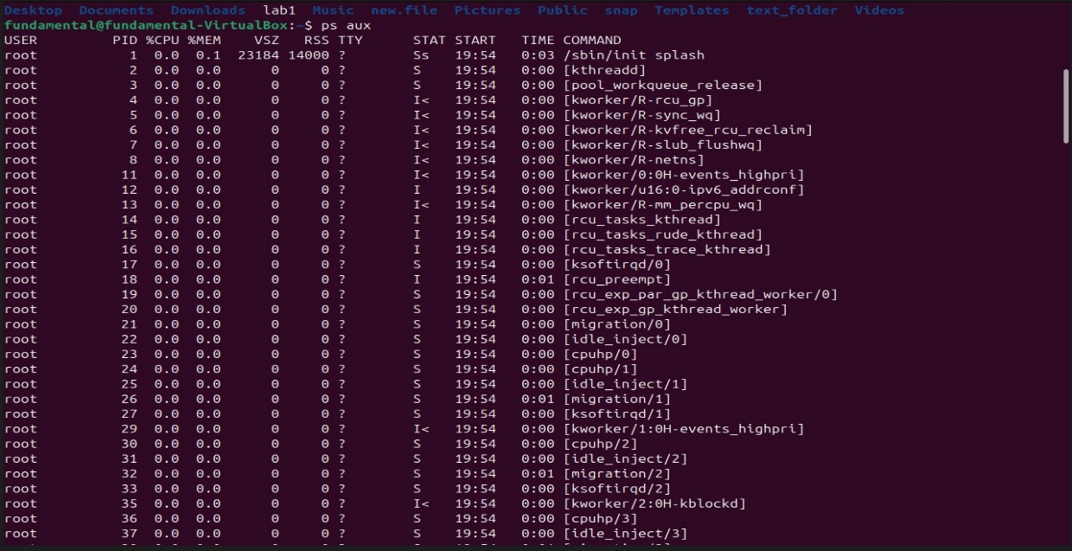
- ps
- syntax: ps
- use case: Check if a program started from where terminal is running
- description: shows only processes related to current terminal session
- implementation:
- top
- syntax: top
- use case: monitor CPU/memory while running apps
- description: displays real time performance statistics
- implementation:
- 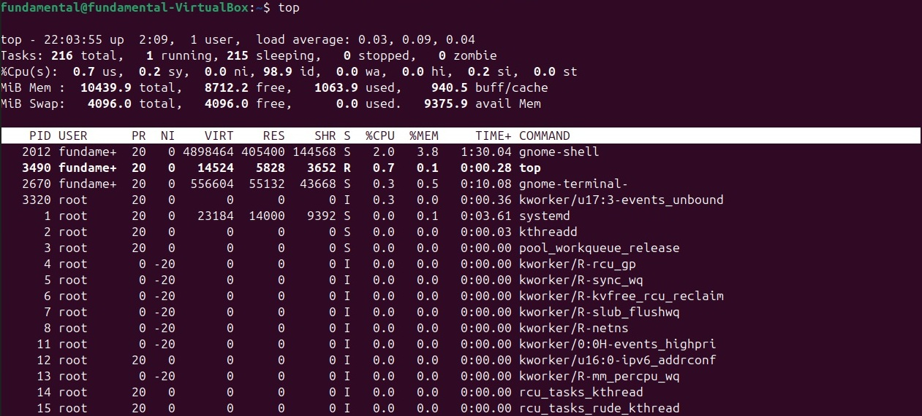
- ping
- syntax: ping <host>
- use case: test internet connections
- description: checks network connectivity and response time
- implementation:
- 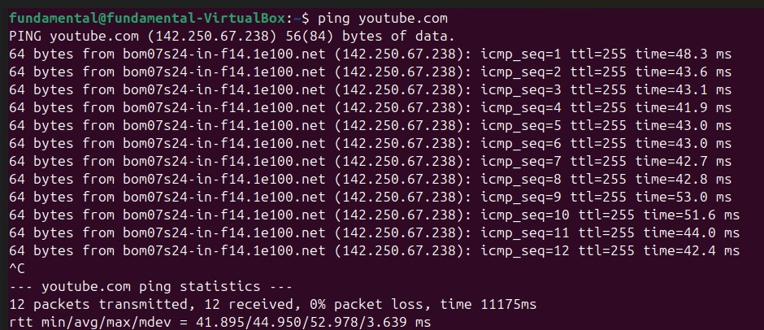
- netstat –a
- syntax: netstat –a
- use case: troubleshoot port conflicts between applications. And check if server app started listening
- description: displays all active connections and listening ports
- implementations:
- 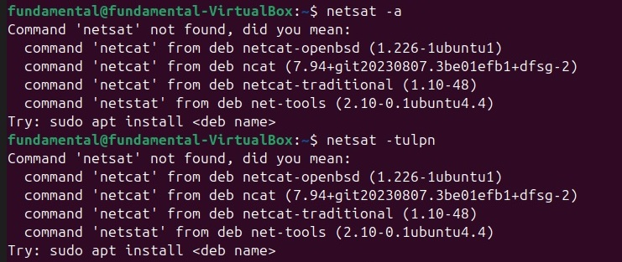
- ip addr
- syntax : ip addr
- use case: find system IP address on LAN
- descriptions: shows IP details of system network interfaces
- implementation:
- 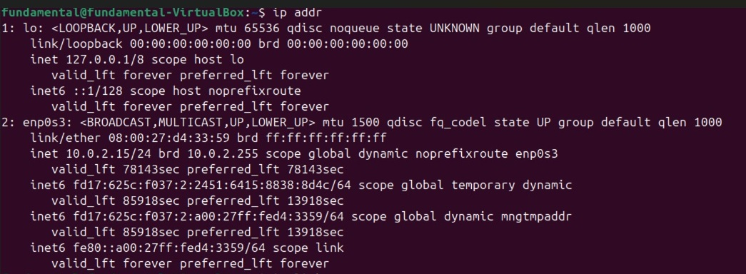
- ip link
- syntax: ip link
ip link set <interface> up/down
- use case: disable Wi-Fi interface temporarily
- description: shows and configures network interfaces
- implementation:
- kill
- syntax: kill [signal] <PID>
- use case: This command is essential for managing and controlling the processes that run on the Linux system
- description : The “kill” command is used to send signals to processes, typically to terminate them.
- Implementation:
- 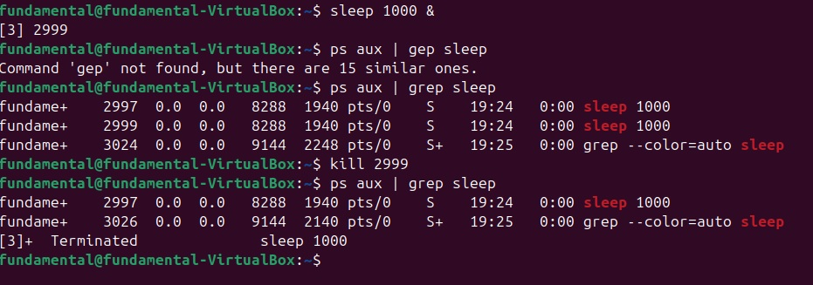

#Scripting
Script 1 : Backup a Directory
Purpose: To create a backup of a specified directory by copying all its contents into a backup folder with a timestamp. This helps in maintaining safe copies of important files
SCRIPT:
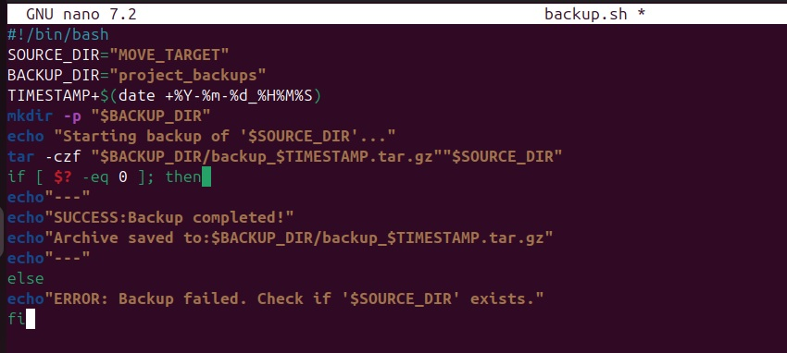
Output:
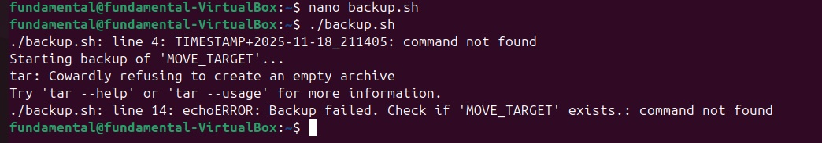

Explanation : This script uses the tar command to combine and compress the files (-c for create, -z for gzip compression, -f for specifying the filename). It uses the date command output to ensure every backup file has a unique name
SCRIPT 2: CPU / Memory Monitoring
Purpose: To log CPU and memory usage at regular intervals into a log file. This is useful for monitoring system performance
Script :
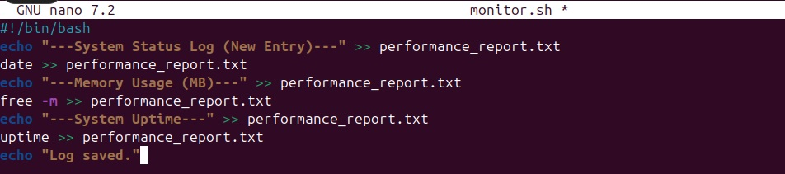
Output :
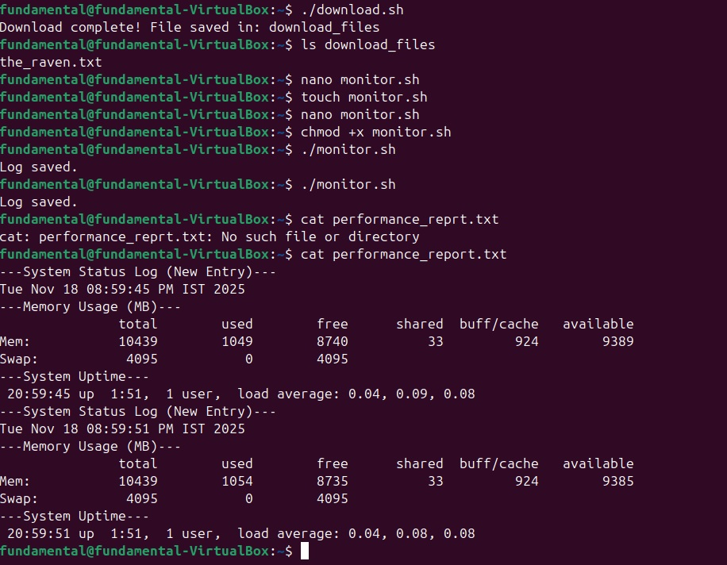
Explanation : This script uses the redirection operator >> to append the output of date, free-m, and uptime commands to the performance_report.txt file without overwriting previous entries

SCRIPT 3 : Automated download task
Purpose : To download a file from the internet using either wget or curl and save it inside a predefined download directory
Script :
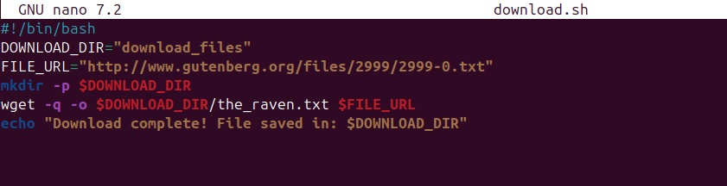

Output :
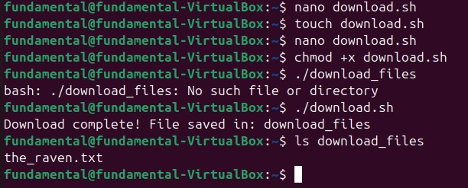
Explanation : The script uses mkdir -p to guarantee the target folder exists. The wget command handles the actual file transfer from the defines URL directly into the download_files folder.
How to upload file and submission of github repositories
To complete this step, I have created a GitHub repository to store all my Linux Shell Scripts, screenshots, and the assignment report. GitHub helps in saving code online and provides version control. 4.1: Repository Creation :
      - I logged into my Github account at(https://github.com)
      - I clicked on “New Repository”
      - I named the repository linux-shell-assignment
      - I selected Public so it can be viewed easily 5. I clicked Create Repository.
      - Here is my github repository link : https://github.com/priyanshi220383-max/linux-CSFCAP-assigment
Uploading Files to github
Inside the repository, I uploaded the required files:
• All three shell scripts
- backup_dir.sh
- monitor_sys.sh
- auto_download.sh
• Screenshots (Linux installation, commands, scripts outputs)
• My assignment report (DOCX/PDF)
REFLECTION
The practical phase of this assignment primarily challenged me to master shell script, where issues like missing spaces in conditional checks required dedicated debugging. This process reinforced the importance of precise automation logic and led me directly to proficiency in essential techniques, including command chaining and output redirection (>>) for creating persistent logs. These skills translate directly into critical real-world functions: the monitor.sh script models essential server health checks (CPU/memory), the backup.sh script ensures data resilience and disaster recovery through timestamped backups, and the download.sh script demonstrates fetching dependencies required for DevOps pipelines. Successfully implementing these scripts confirms a foundational understanding of Linux as a powerful automation platform.

