STUDENT MANAGEMENT SYSTEM
PROJECT DOCUMENTATION

A Python-Based Student Record Management Application

Submitted by
Priyanshi Dubey
Registration no.: 26BAI10873
____________________________
VIT Bhopal University
Academic Project Documentation

TABLE OF CONTENTS
S. No. | Chapter / Section | Page
1 | Introduction | 6
2 | Problem Statement | 6
3 | Objectives | 6
4 | Scope of the Project | 7
5 | Target Users | 7
6 | Functional Requirements | 8
7 | Non-Functional Requirements | 9
8 | System Design and Methodology | 10
9 | Implementation Details | 13
10 | Testing and Results | 27
11 | Challenges Faced | 32
12 | Learning Outcomes | 32
13 | Limitations | 32
14 | Future Enhancements | 33
15 | Conclusion | 33
16 | References | 34

1. Introduction
The Student Management System is a Python-based application developed to simplify and organize the management of student information. Educational institutions handle a large amount of student data, including names, roll numbers, courses, contact details, and other academic information. Managing such information manually can be time-consuming and may result in errors or loss of records.
The proposed system provides a simple and efficient way to perform common student management operations through a computer-based application. The system can support operations such as adding new student records, viewing existing records, searching for students, updating information, and deleting records when required.
The project demonstrates practical implementation of Python programming concepts such as variables, functions, conditional statements, loops, data structures, input validation, and exception handling. It also provides a foundation for developing a more advanced student information management platform.

2. Problem Statement
Managing student records manually becomes difficult as the number of students increases. Traditional methods such as notebooks, registers, or manually maintained files require considerable effort and may lead to duplicate, outdated, or incorrect information.
- Difficulty in maintaining a large number of student records.
- Time-consuming searching and retrieval of records.
- Difficulty updating student information.
- Possibility of human errors and incorrect entries.
- Repetitive manual work.
- Difficulty maintaining consistent and organized records.
- Difficulty retrieving information quickly.
The Student Management System addresses these issues by providing a centralized application for performing basic operations on student records.

3. Objectives
- To create a computerized system for managing student records.
- To provide an easy method for adding new students.
- To display stored student information.
- To provide a search facility for finding student records.
- To allow modification of existing student details.
- To provide an option for deleting records when required.
- To reduce manual effort involved in maintaining student information.
- To minimize errors in record management.
- To demonstrate practical implementation of Python programming concepts.
- To create a foundation that can be extended into a larger student management application.

4. Scope of the Project
The scope of the Student Management System covers the basic operations required for maintaining student records. The system focuses on record creation, viewing, searching, updating, and deletion.
- Adding student information.
- Viewing student records.
- Searching for students.
- Updating student details.
- Deleting student records.
- Validating user input.
- Displaying appropriate success and error messages.

5. Target Users
Target User | Possible Use
Teachers | Maintain and quickly search basic student information.
Administrative Staff | Add, update, search, and manage student records.
Educational Institutions | Use as a basic student record-management solution.
Students | Benefit from organized maintenance of their information.
Learners / Developers | Study Python programming and CRUD-style applications.

6. Functional Requirements
Requirement | Description
Add Student | Allows the user to enter and store student information.
View Students | Displays available student records.
Search Student | Finds a student using an identifier.
Update Student | Modifies information of an existing student.
Delete Student | Removes a student record.
Input Validation | Checks whether entered information is valid.
Exit | Allows the user to safely close the application.

6.1 Add Student
The user enters the required student information and the system creates a new record.

6.2 View Student Records
The system displays stored student information in a readable format.

6.3 Search Student
The search function allows the user to locate a student using an appropriate identifier.

6.4 Update Student
The update operation modifies information belonging to an existing student.

6.5 Delete Student
The delete operation removes a selected student record after identifying the appropriate record.

7. Non-Functional Requirements
Requirement | Description
Usability | Simple interface suitable for users with basic computer knowledge.
Performance | Basic operations should execute without unnecessary delay.
Reliability | The application should behave consistently during normal operation.
Maintainability | Functions and logical structure should make future changes easier.
Portability | Python allows execution on systems with a compatible environment.
Security | Input validation should reduce unintended or invalid operations.

8. System Design and Methodology

8.1 System Workflow
The application follows an input-processing-output workflow.

8.2 Input-Process-Output Model
Stage | Description
Input | Student details and selected operation.
Processing | Python program processes the requested operation.
Storage | Student information is maintained using the selected storage method.
Output | Records or status messages are displayed to the user.

8.3 Development Methodology
- Requirement Analysis – identify required student management operations.
- System Design – plan menu structure, records, and operations.
- Implementation – develop the system using Python.
- Testing – test each operation with different input cases.
- Debugging – identify and correct errors.
- Finalization – perform final verification after corrections.

9. Implementation Details
The Student Management System is implemented using Python. The implementation uses fundamental programming constructs to organize student data and perform management operations.

9.1 Technologies Used
Technology / Concept | Purpose
Python | Main programming language.
Functions | Organize system operations.
Conditional Statements | Decision making.
Loops | Repeated menu execution.
Lists / Dictionaries | Managing student information.
File Handling | Persistent storage where implemented.
Exception Handling | Handling invalid input and runtime errors.

9.2 Main Menu
A typical menu structure is shown below:
===== STUDENT MANAGEMENT SYSTEM =====
1. Add Student
2. View Students
3. Search Student
4. Update Student
5. Delete Student
6. Exit
Enter your choice:

9.3 Add Student Module
The Add Student module collects the required student information and creates a new record.

9.4 View Student Module
The View module retrieves available student records and displays them to the user.

9.5 Search Module
The Search module locates a particular student based on a suitable identifier.

9.6 Update Module
The Update module modifies existing information after locating the relevant student record.

9.7 Delete Module
The Delete module removes a selected student record.

9.8 Error Handling
Error handling is important because users may enter unexpected values. Examples include invalid menu choices, incorrect numerical input, empty fields, or searches for nonexistent records. Python's try-except mechanism can be used to handle runtime input errors.
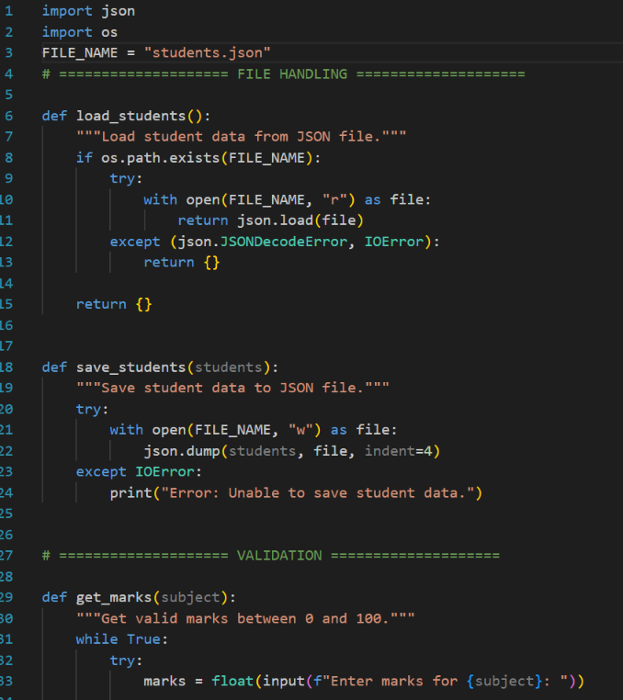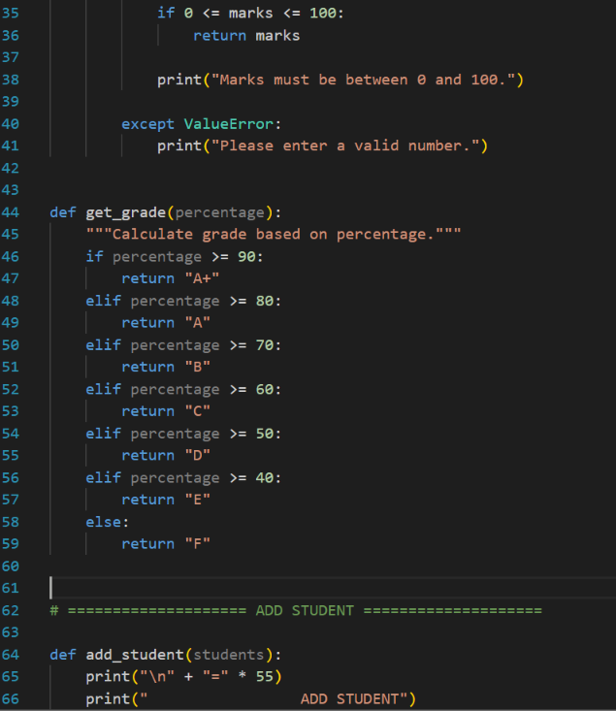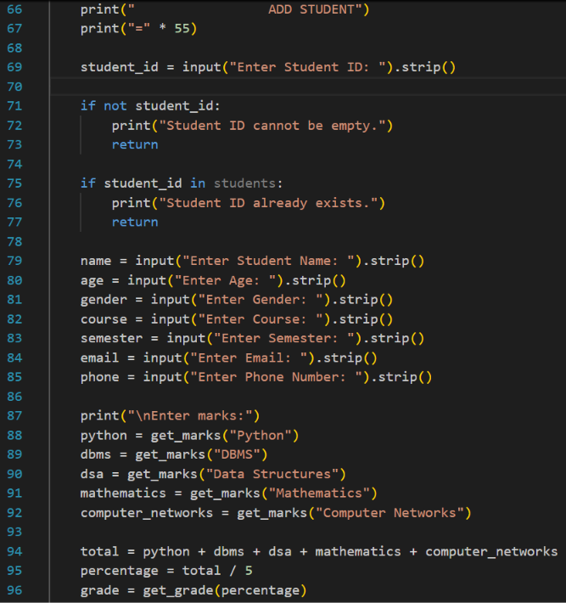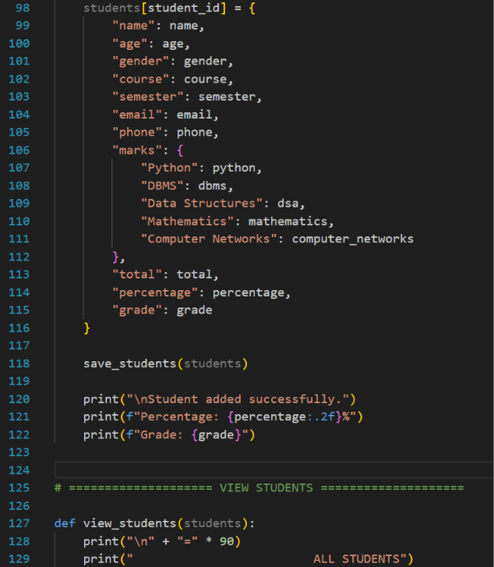
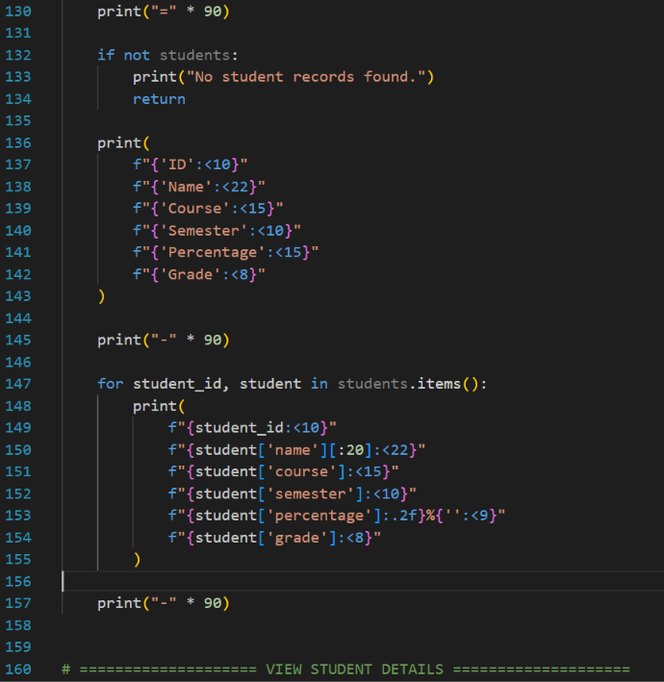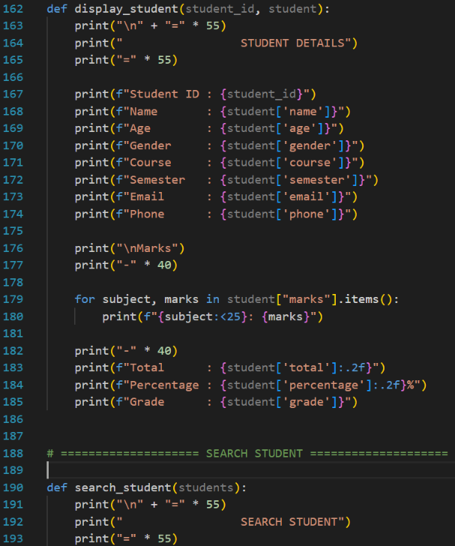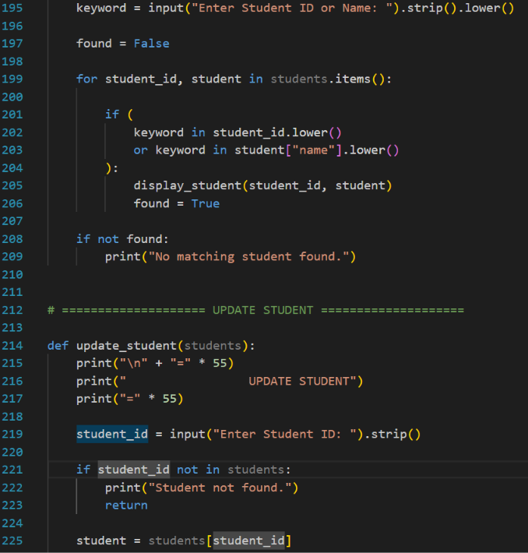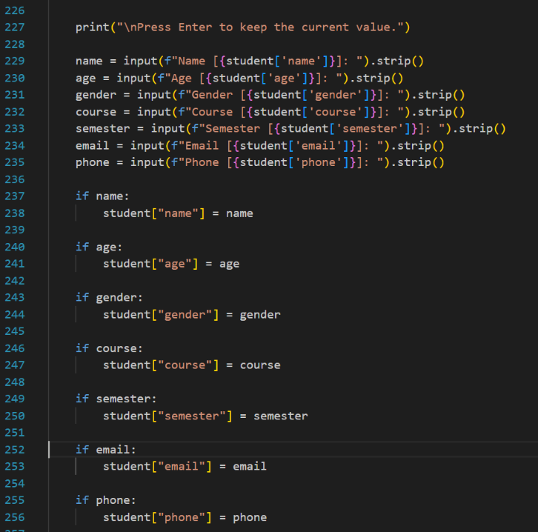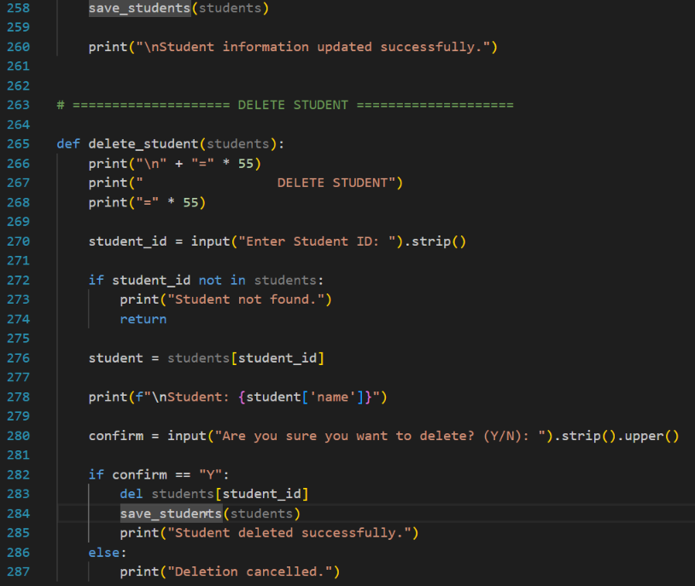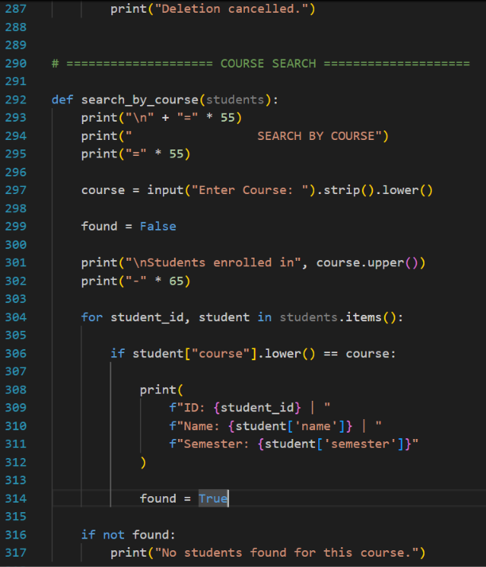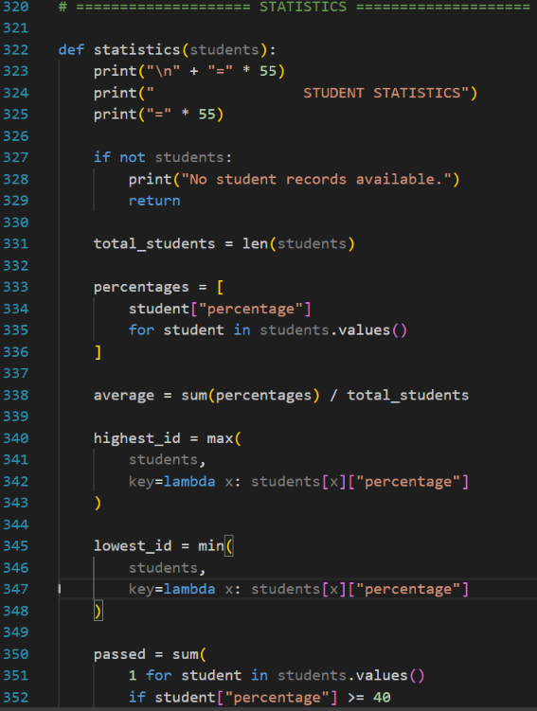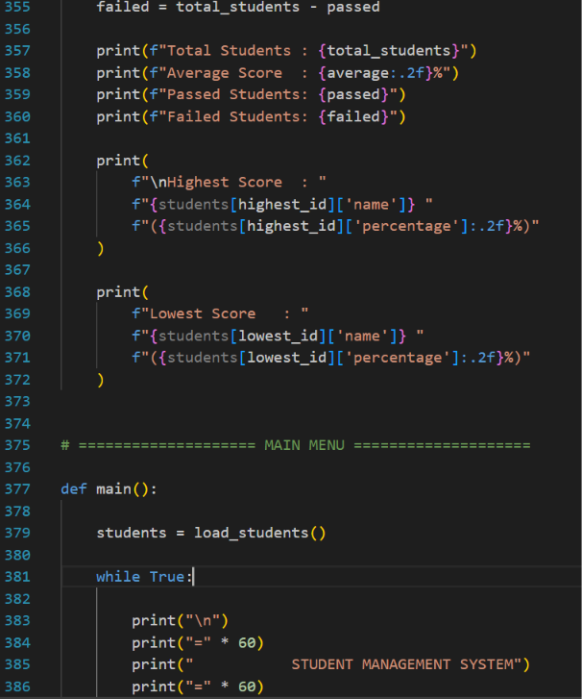
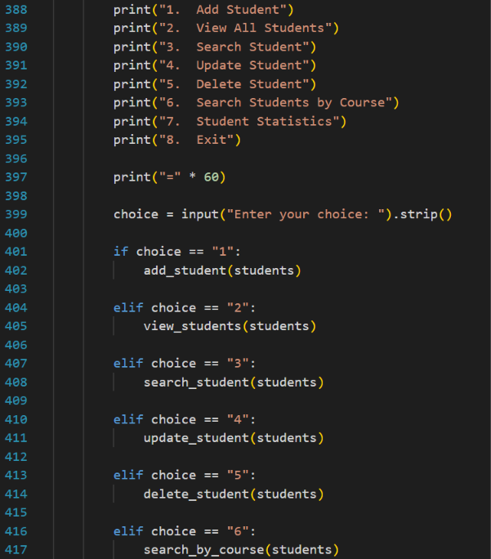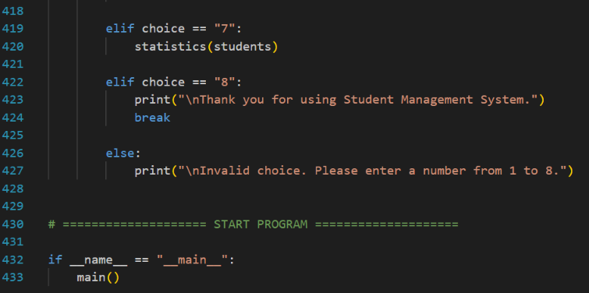

10. Testing and Results
Testing was performed to verify that the Student Management System performs its intended operations correctly. Each major function was considered separately and tested using valid and invalid input scenarios.

10.1 Testing Objectives
- Verify each system function.
- Identify incorrect outputs.
- Check invalid inputs.
- Verify student record operations.
- Ensure the application behaves correctly during normal usage.

10.2 Test Cases
Test ID | Test Case | Input | Expected Result | Status
TC01 | Add student | Valid details | Student added | Pass
TC02 | View records | View option | Records displayed | Pass
TC03 | Search student | Existing ID | Student displayed | Pass
TC04 | Search student | Invalid ID | Not-found message | Pass
TC05 | Update student | Existing ID | Record updated | Pass
TC06 | Delete student | Existing ID | Record deleted | Pass
TC07 | Invalid menu | Invalid option | Error message | Pass
TC08 | Exit | Exit option | Program terminates | Pass

10.3 Final Testing Result
The testing process verifies the major operations of the Student Management System. Valid inputs are expected to produce the intended results, while invalid inputs should be handled through appropriate messages or validation mechanisms. The final results should be updated according to the actual execution of the submitted program
. 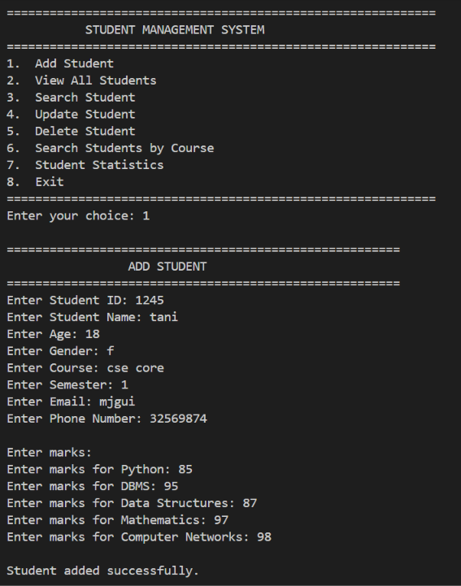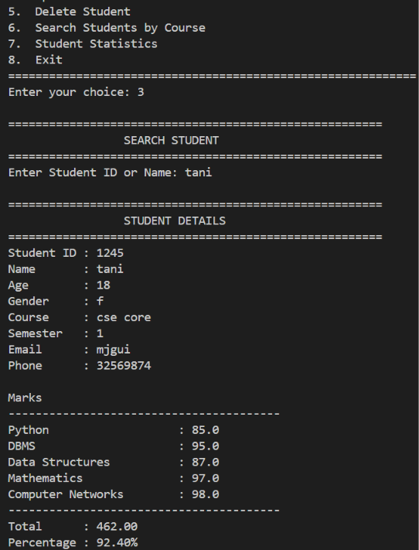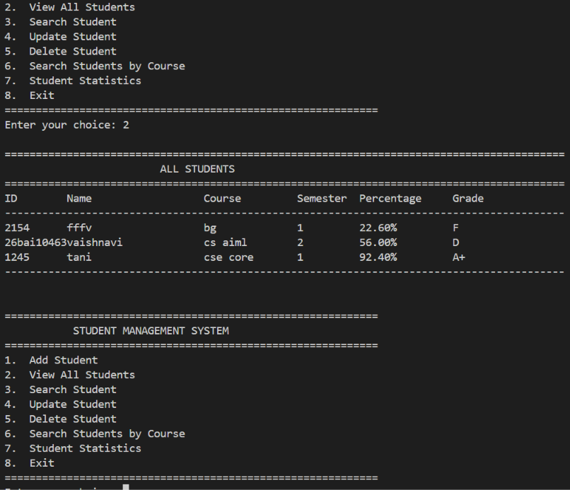

11. Challenges Faced
- Managing multiple student records in an organized structure.
- Validating different types of user input.
- Implementing reliable search functionality.
- Updating and deleting the correct student record.
- Handling unexpected inputs without terminating the program.
- Debugging logical and runtime errors.

12. Learning Outcomes
- Understanding Python programming fundamentals.
- Using functions and modular programming.
- Applying conditional statements and loops.
- Working with lists and dictionaries.
- Handling input and output.
- Using file handling where applicable.
- Applying exception handling.
- Understanding CRUD operations.
- Performing testing and debugging.
- Preparing technical project documentation.

13. Limitations
- The system may have limited user authentication.
- It may not support multiple users simultaneously.
- Advanced database management may not be implemented.
- The interface may be command-line based.
- The system may not provide online access.
- Advanced reporting may not be available.
- Backup and recovery features may be limited.
- Attendance, fees, examinations, and timetable modules may not be included.

14. Future Enhancements
- Develop a graphical user interface using Tkinter, PyQt, or another suitable framework.
- Integrate a database such as SQLite, MySQL, or PostgreSQL.
- Add authentication for authorized users.
- Add attendance management.
- Add examination and result management.
- Add fee management.
- Generate PDF or Excel reports.
- Convert the application into a web-based system.

15. Conclusion
The Student Management System provides a simple and structured approach to managing student information. The project demonstrates how Python programming can be used to create an application capable of performing common student record operations.
The system reduces the effort involved in manually managing records and provides a convenient method for adding, viewing, searching, updating, and deleting student information. The project also provides practical experience in programming, data management, validation, error handling, testing, debugging, and technical documentation.
Although the current system focuses on basic student management, its structure can be extended with database integration, authentication, attendance, examination management, fee management, report generation, and graphical or web-based interfaces.

16. References
- Python Software Foundation – Python Documentation: https://docs.python.org/3/
- Python Software Foundation – Python Tutorial: https://docs.python.org/3/tutorial/
- W3Schools – Python Tutorial: https://www.w3schools.com/python/
- GeeksforGeeks – Python Programming Language: https://www.geeksforgeeks.org/python-programming-language/
- Real Python – Python Programming Tutorials: https://realpython.com/

