Priyanshi Chaturvedi

This project presents a machine learning-based approach to predict whether water is safe for drinking using parameters such as pH, hardness, solids, chloramines, sulfate, and conductivity. A Random Forest Classifier is used to analyze the data and classify water as safe or unsafe. The model provides quick predictions based on user input, demonstrating how artificial intelligence can be applied to solve real-world problems like water quality assessment.
Fundamentalof AI ML
VIT BHOPAL CSA 2001 Name-Priyanshi Chaturvedi Reg No.-25BHI10083

Water Quality Prediction Using Machine Learning

Introduction

Access to clean and safe drinking water is essential for human health and survival. However, due to increasing pollution, industrial waste, and environmental changes, water quality has become a major concern in many regions. Determining whether water is safe for consumption usually requires laboratory testing, which can be time-consuming and not easily accessible to everyone.
With the advancement of technology, machine learning offers a smart and efficient way to analyze data and make predictions. This project focuses on using machine learning techniques to predict water quality based on its chemical properties. By analyzing parameters such as pH, hardness, dissolved solids, chloramines, sulfate, and conductivity, the model can classify water as safe or unsafe for drinking.
The main aim of this project is to demonstrate how artificial intelligence can be applied to solve real-world environmental problems in a simple, fast, and effective manner.

Problem Statement
It is difficult for individuals to determine whether water is safe for consumption without proper testing. There is a need for a quick and efficient system that can predict water potability using measurable parameters.

Objective
The main objectives of this project are:
- To analyze water quality parameters
- To build a machine learning model for prediction
- To classify water as safe or unsafe for drinking
- To provide a simple and user-friendly prediction system

Methodology
  - Data Collection
A dataset containing water quality parameters such as pH, hardness, solids, chloramines, sulfate, and conductivity was used. The dataset was manually created for demonstration purposes.

Data Preprocessing

. Data was stored in CSV format
. Relevant features were selected
. No missing values were present

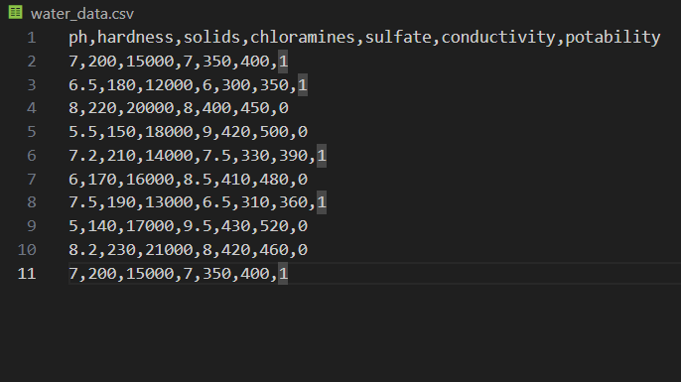

Model Selection

A Random Forest Classifier was used for prediction. This algorithm is suitable for classification problems and provides good accuracy.

Model Training

. The dataset was divided into input features (X) and target variable (y)
. The model was trained using the dataset

Prediction
The user provides input values, and the model predicts whether the water is safe or not.

5. Tools and Technologies Used

. Python
. Pandas
. Scikit-learn
. Visual Studio Code
. GitHub

6.Implementation

The project consists of:
- A dataset file (water_data.csv)
- A Python script (model.py)
The model reads the dataset, trains itself, and takes user input to predict the output.

7. Results
The model successfully predicts whether water is:
- ✅ Safe to drink
- ❌ Not safe to drink
The accuracy of the model is calculated using the dataset and shows satisfactory performance.

8. Challenges Faced

. Understanding how to install and use libraries
. Handling file paths and dataset loading
. Running the program correctly in the terminal
. Debugging errors during execution

9. Conclusion
This project demonstrates how machine learning can be used to solve real-world problems like water quality prediction. The model provides quick predictions based on input parameters and can be further improved with larger datasets.

10. Future Scope

. Use real-world datasets (e.g., from sensors or government data)
. Build a web or mobile application
. Improve accuracy using advanced models
. Add visualization and graphs

11. References
. Scikit-learn documentation
. Python documentation
. Basic machine learning tutorials

CODE-
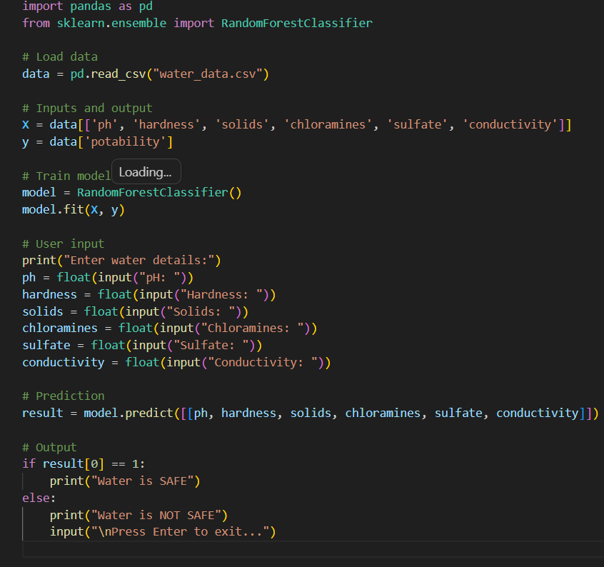OUTPUT-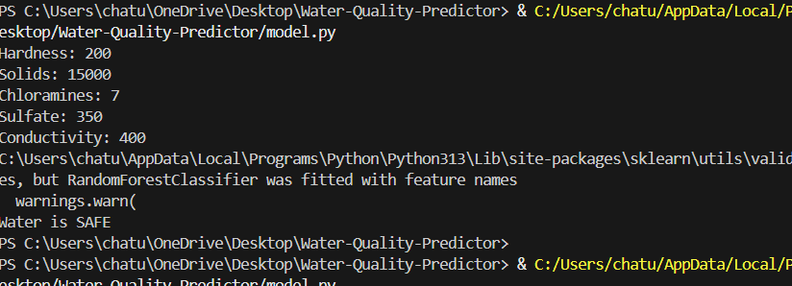

THANKYOU

