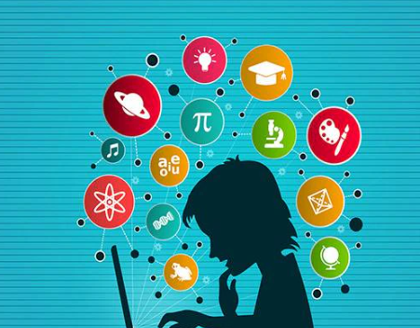  Digital Literacy Project | DIGITAL LITERACY PROJECT  Submitted by:  Priyanshi Chaturvedi  Course:  CSE0001 Digital Literacy  Program:  B.Tech CSE(Health Informatics)  University:  VIT Bhopal  Academic Year:  2025–26

Task 1 : INFOGRAPHIC
For this task, I designed an infographic using Canva on the topic of digital literacy. I included important points like safe internet usage, useful tools for students, and how to behave professionally online.
While making this, I found it interesting to arrange the content in a visual format. It helped me understand how information can be presented in a simple and attractive way.
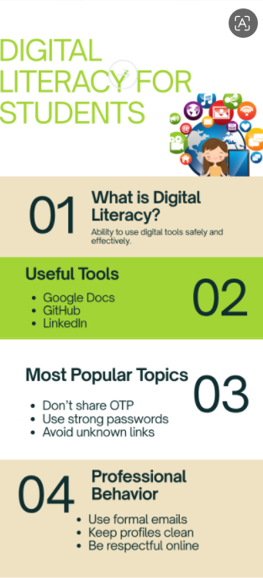Task 2
Task 2
In this task, I created profiles on platforms like GitHub, LinkedIn, and Kaggle. These platforms are useful for building skills and connecting with others.
GitHub is mainly used to store projects, LinkedIn helps in professional networking, and Kaggle is useful for learning data-related skills. This task helped me understand the importance of having an online presence.
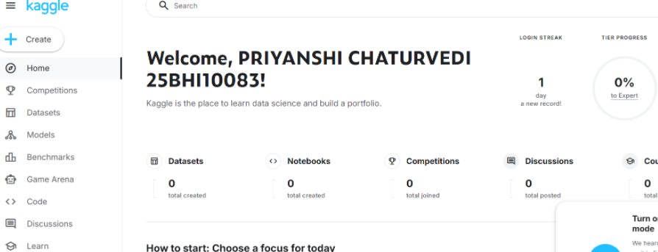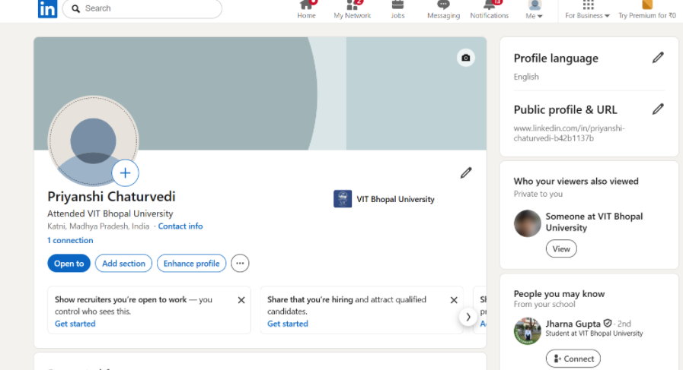

Task 3
For this task, I solved a basic problem on HackerRank, which gave me an idea of how coding platforms work. It was simple but helpful in understanding logic.
I also created a Google Form quiz related to digital literacy. This helped me learn how to design questions and collect responses. Overall, this task was practical and useful.

Task 4
In this task, I practiced writing formal emails. I understood how to use proper subject lines, greetings, and polite language.
I also made a list of do’s and don’ts for social media use. This helped me realize how important it is to communicate responsibly online.
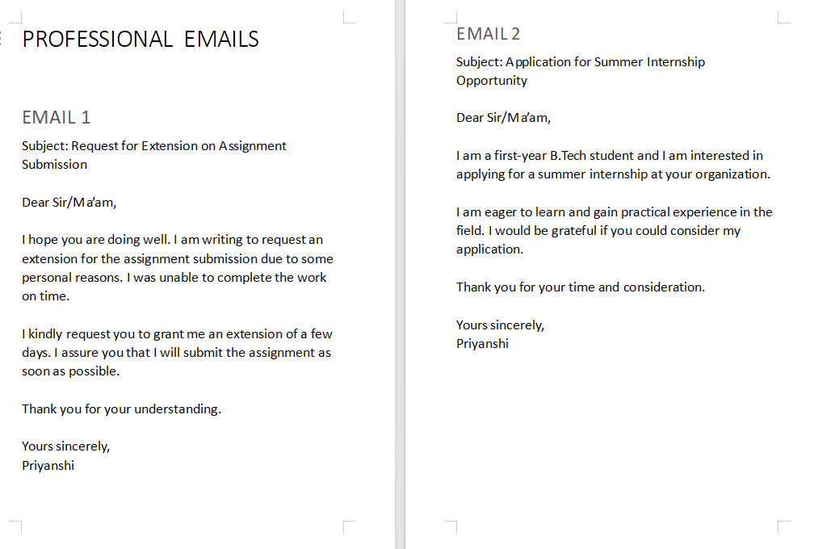

Task 5
In this task, I learned about phishing as a type of cybercrime. I understood how people can be tricked into sharing personal information.
I also created a list of safety tips, which made me more aware of how to stay safe online. This task was very informative.

Conclusion
Overall, this project helped me learn many useful digital skills. I understood how to use different platforms, stay safe online, and communicate professionally. It was a good learning experience.

THANK YOU

