Experiment no. 04

Aim: To set up a Continuous Integration Pipeline using Jenkins/GitHub Act.
LO Mapped: LO3
PART A — Continuous Integration & Jenkins Installation

1.1 Theory
Continuous Integration is a development practice that promotes collaboration, early issue detection, and automated testing to enhance the quality and efficiency of software development.
Jenkins is an open-source automation server that facilitates continuous integration and continuous delivery (CI/CD) of software projects. It helps developers automate various stages of the software development lifecycle, from building and testing to deployment and monitoring. Jenkins supports a wide range of plugins and integrations, making it a versatile tool for automating various tasks in software development.

1.2 Steps to Install Jenkins
- Java Installation: Ensure Java Development Kit (JDK) is installed on your system.

- Download Jenkins: Get the latest Jenkins WAR file from the official website or package manager.
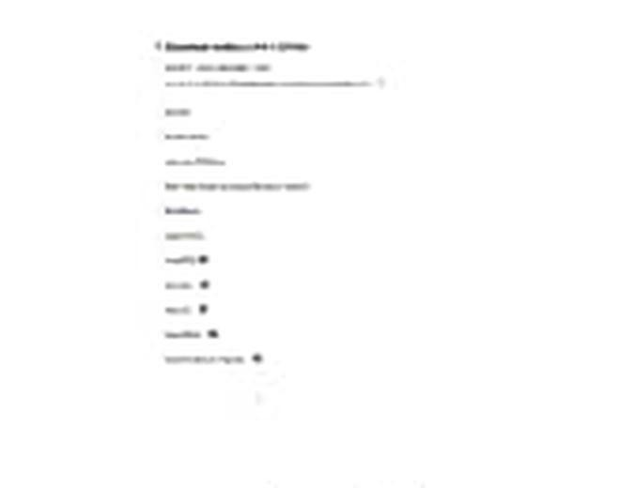
- Launch Terminal: Open a terminal/command prompt on your system. command: java –jar
C:\Users\Asus\Downloads\jenkins.war ––enable–future–java
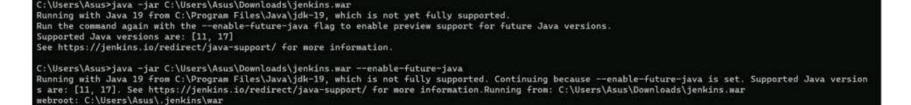
- Navigate to Directory: Use the cd command to navigate to the directory containing the Jenkins WAR file.

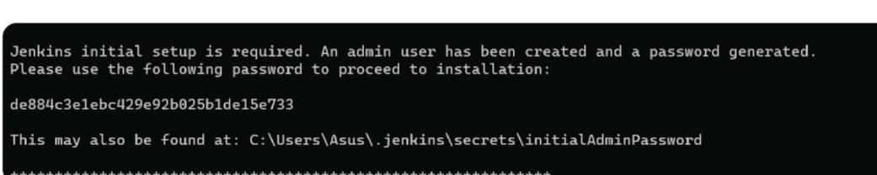
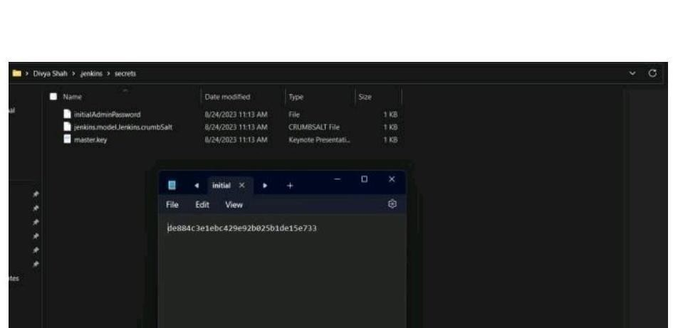
- Start Jenkins: Run the command java -jar jenkins.war to start the Jenkins server.
- Access Web UI: Open a web browser and go to http://localhost:8080 to access the Jenkins setup wizard.


- Unlock Jenkins: Retrieve the initial admin password from the terminal and enter it in the setup wizard.
- Customize Plugins: Choose recommended or custom plugins to install during setup.
- Create Admin User: Set up an admin user account with credentials.
- Jenkins URL: Confirm the Jenkins URL and complete the setup process.
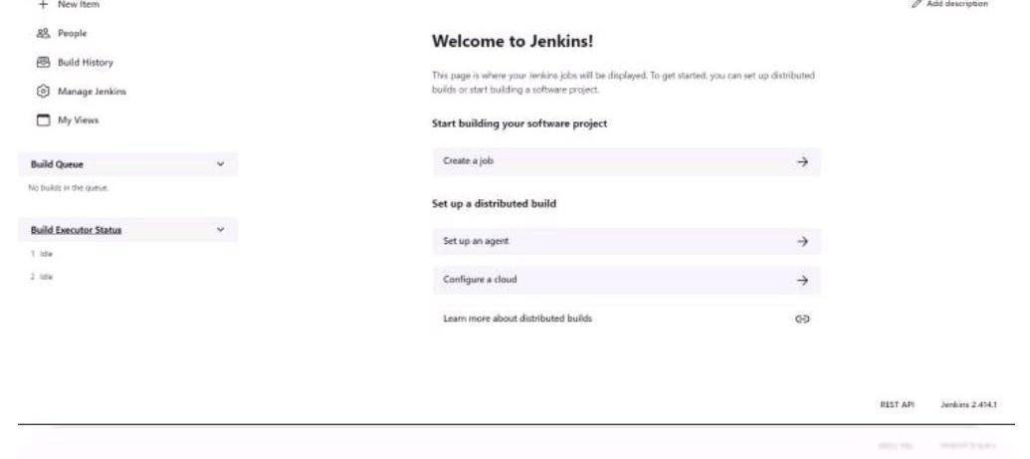
Dashboard: Log in with the admin credentials to access the Jenkins dashboard.



CONCLUSION : By this assignment we learned about Continuous Integration and the way to install Jenkins.

PART B — Building a Pipeline using Jenkins
Aim: To build a pipeline using Jenkins.

2.1 Theory
What is a Pipeline in Jenkins?
A Jenkins Pipeline is a set of automated processes that help developers and DevOps teams build, test, and deploy code in a continuous integration/continuous delivery (CI/CD) environment. In simple terms, it is a workflow that defines how software moves from code to production in an automated and repeatable manner.

Key Benefits of a Jenkins Pipeline
- Automates CI/CD processes
- Provides better visibility into the build process
- Offers version control of build logic (Pipeline as Code)
- Supports complex workflows (parallel execution, conditional logic, etc.)

Types of Jenkins Pipelines
There are two main types of syntax used to define Jenkins pipelines:
1. Declarative Pipeline | 2. Scripted Pipeline
Simpler and more structured syntax  Designed for users who want an easy-to-read format  Introduced later to make pipelines more readable and maintainable  Key Features:  - Uses pipeline {} block  - Organized into stages and steps  - Easier error handling  - Better validation in the Jenkins UI | More flexible and powerful  Written in Groovy-based syntax  Gives full control over the build process  Suitable for advanced users  Key Features:  - Uses node {} block  - Everything is written as code  - Allows complex scripting and logic  - Less user-friendly for beginners

2.2 Declarative Pipeline — Creation
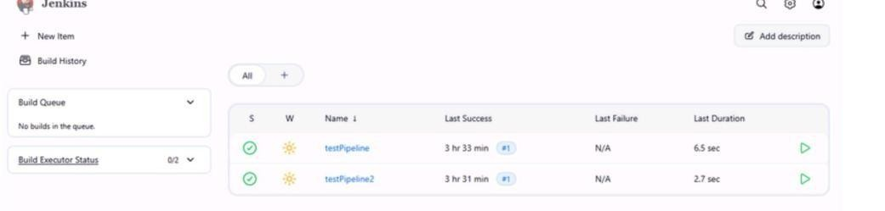

Code
pipeline {

agent any

stages {

stage('Hello') {

steps {

echo ‘
Darshika
2401114
'

}

}

}

}

Output
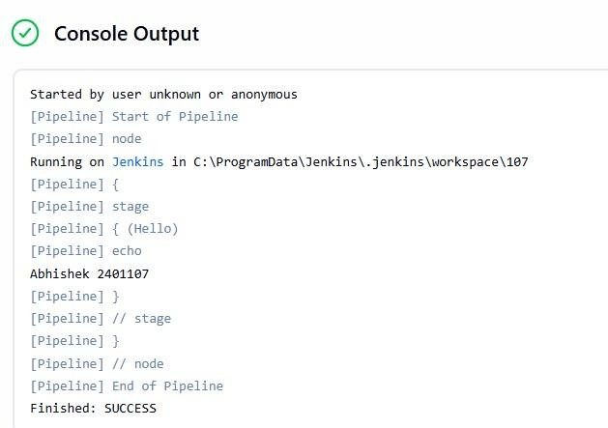

2.3 Scripted Pipeline — Creation
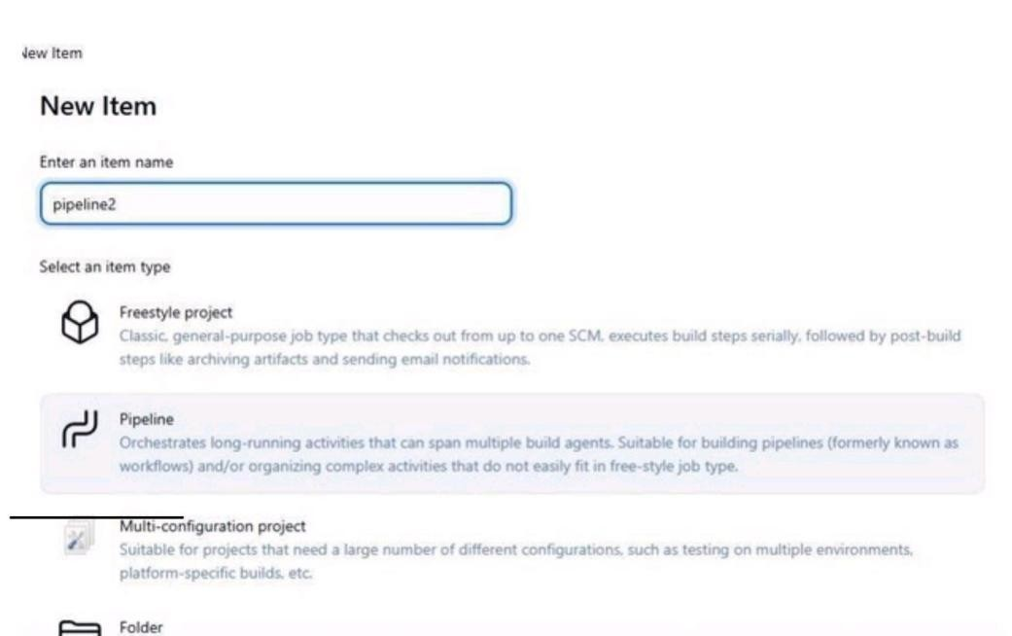
Conclusion:
In this assignment, we learned how to create Jenkins Pipelines to automate the build, test, and deployment process. We explored both Declarative and Scripted pipelines, understanding their structure, benefits, and use cases. By implementing different pipeline examples, we demonstrated how Jenkins enables efficient, repeatable, and reliable CI/CD workflows

