**NAME – PRIYANSHI ASATI**

**SAP ID – 500108525**

**ROLL NO – R2142220982**

**BATCH- 4 (AIML-NON HONS.)**

**PREDICTIVE ANALYTICS LAB- 4**

**Python Library Pandas:**

**Q1.  Loading and Inspecting Data:**

**·         Load various data formats (CSV, Excel, JSON) into Pandas DataFrames.**

**·         Explore DataFrame attributes like shape, columns, dtypes, head, tail, info, describe.**

**·         Practice selecting columns and rows using different methods (indexing, slicing, loc, iloc).**

**CODE:**

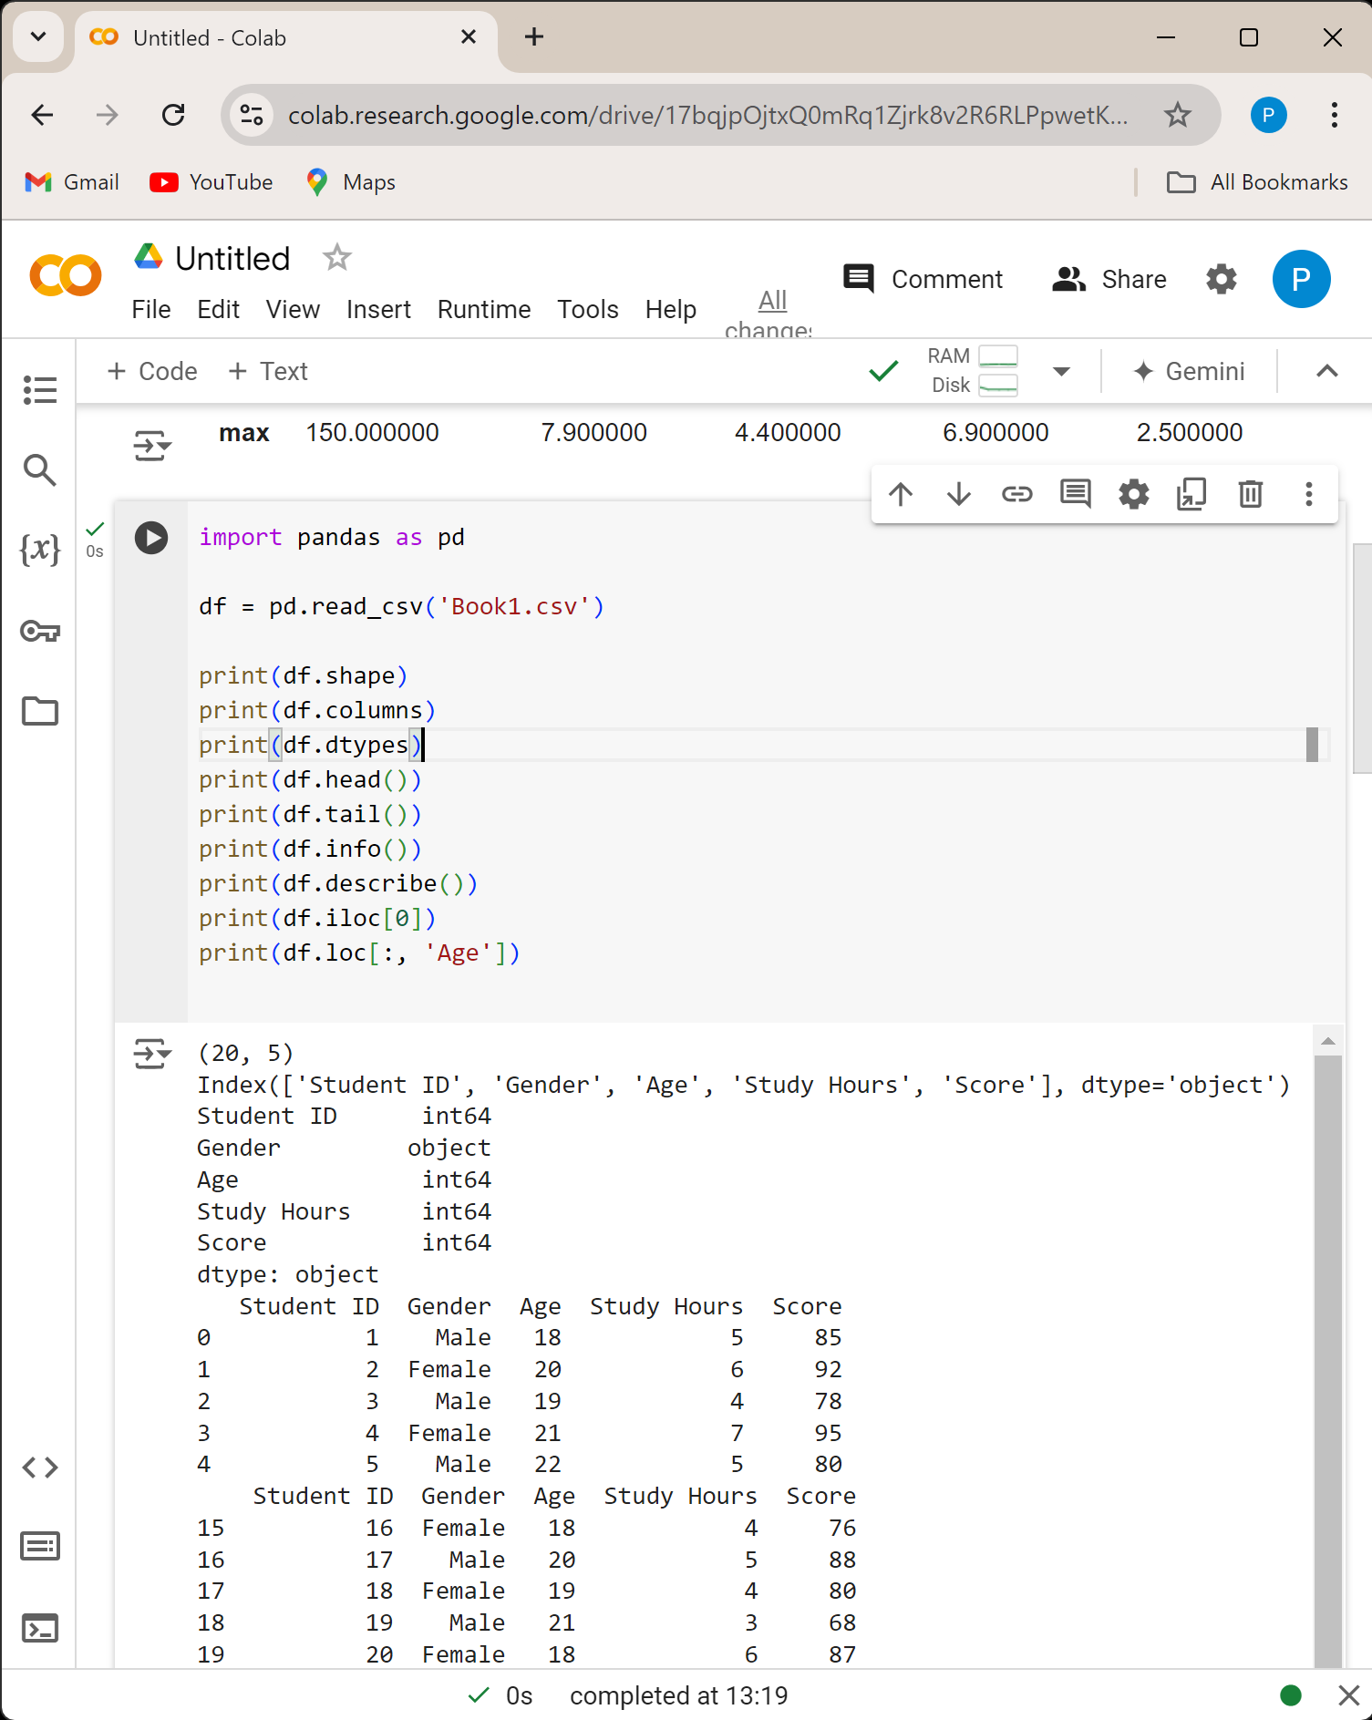

**OUTPUT:**

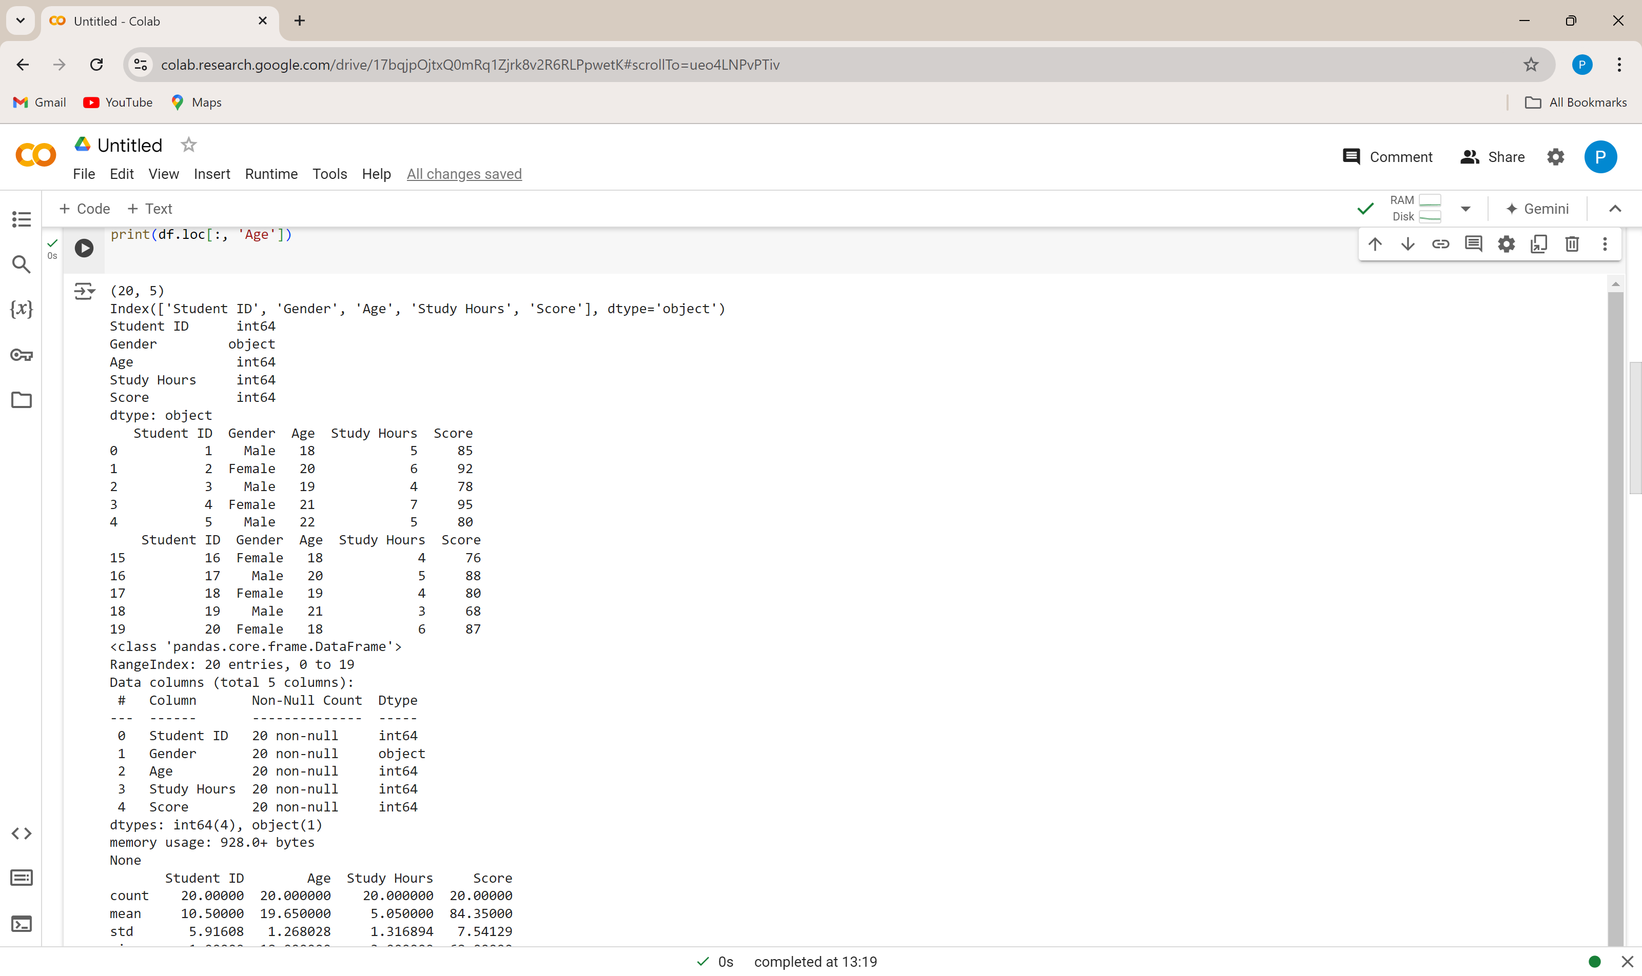

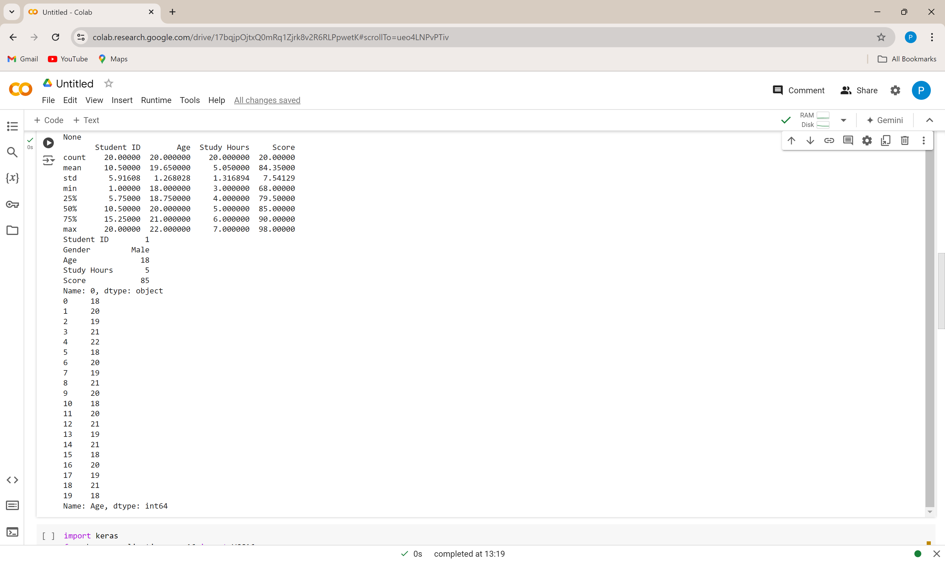

**Q2. Data Cleaning and Preparation**

* **Identify missing values using isnull and isna.**
* **Handle missing values using fillna, dropna, interpolation.**
* **Apply scaling techniques (min-max, z-score) to numerical columns.**
* **Create dummy variables for categorical columns.**

**CODE:**

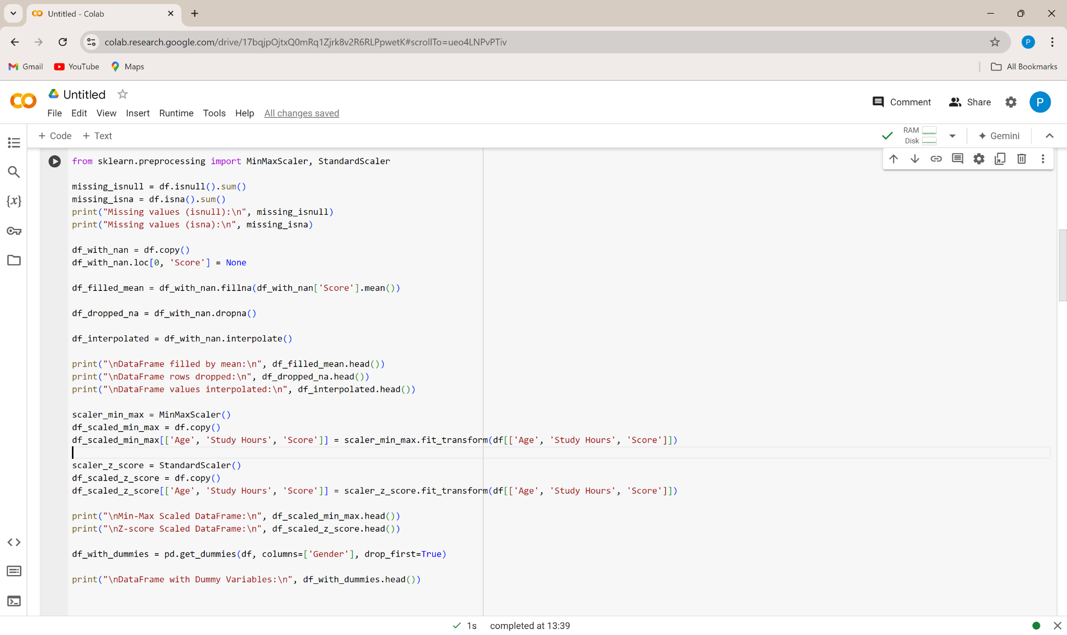

**OUTPUT:**

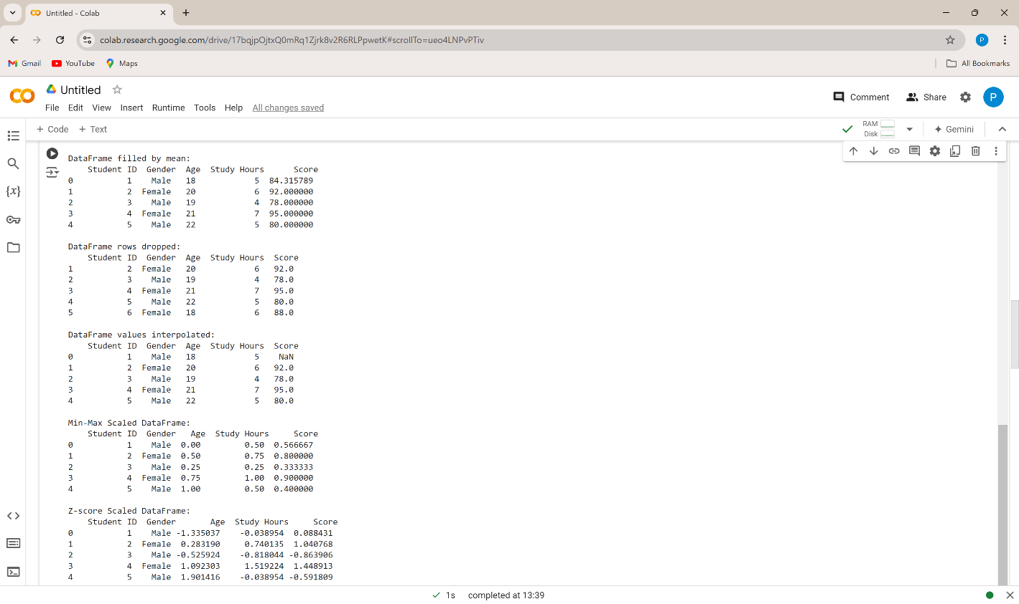

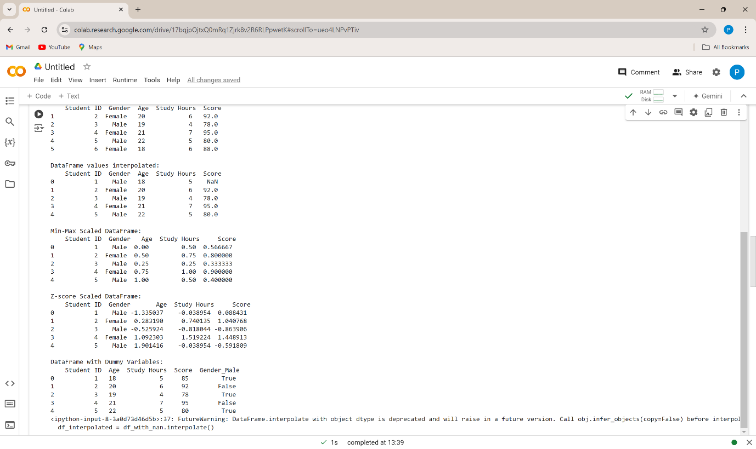

**Q3. Aggregation and Grouping:**

**Calculate summary statistics (mean, median, count, etc.) using groupby.**

**Create pivot tables for data summarization.**

**Combine DataFrames using concat, merge, and join.**

**Practice different join types (inner, outer, left, right).**

**CODE:**

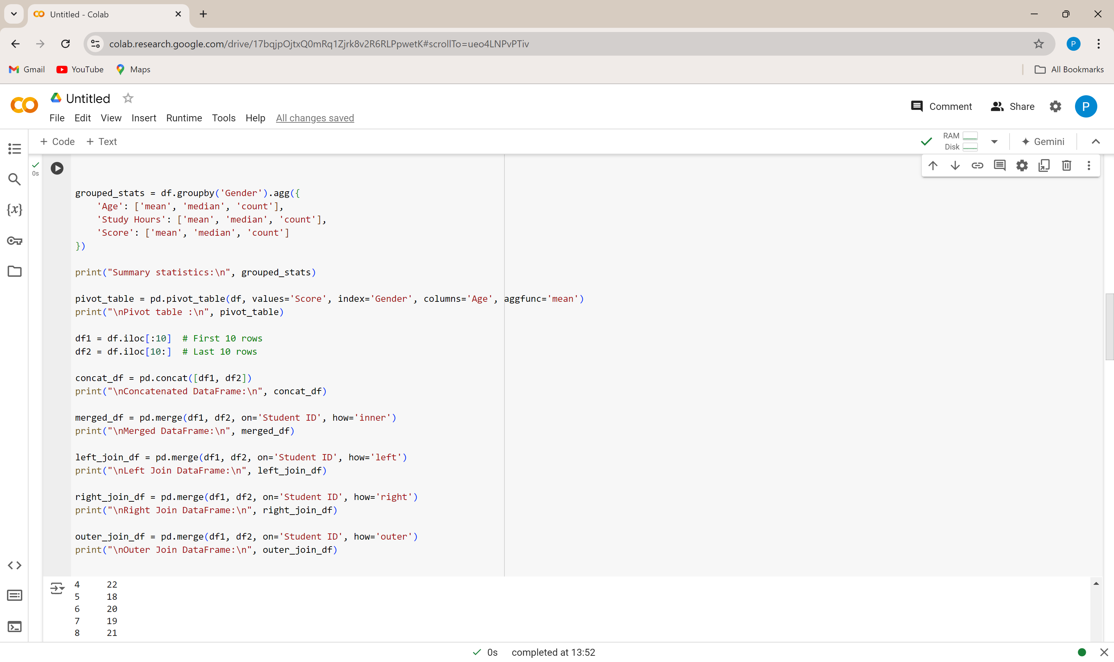

**OUTPUT:**

