1. Test
Hello world, justified body text.
PM2.5 mean = 250.6
- first
- second
- alpha
- beta
print('hello')
Table 1: Smoke test table
A | B
1.5 | p
2.25 | q
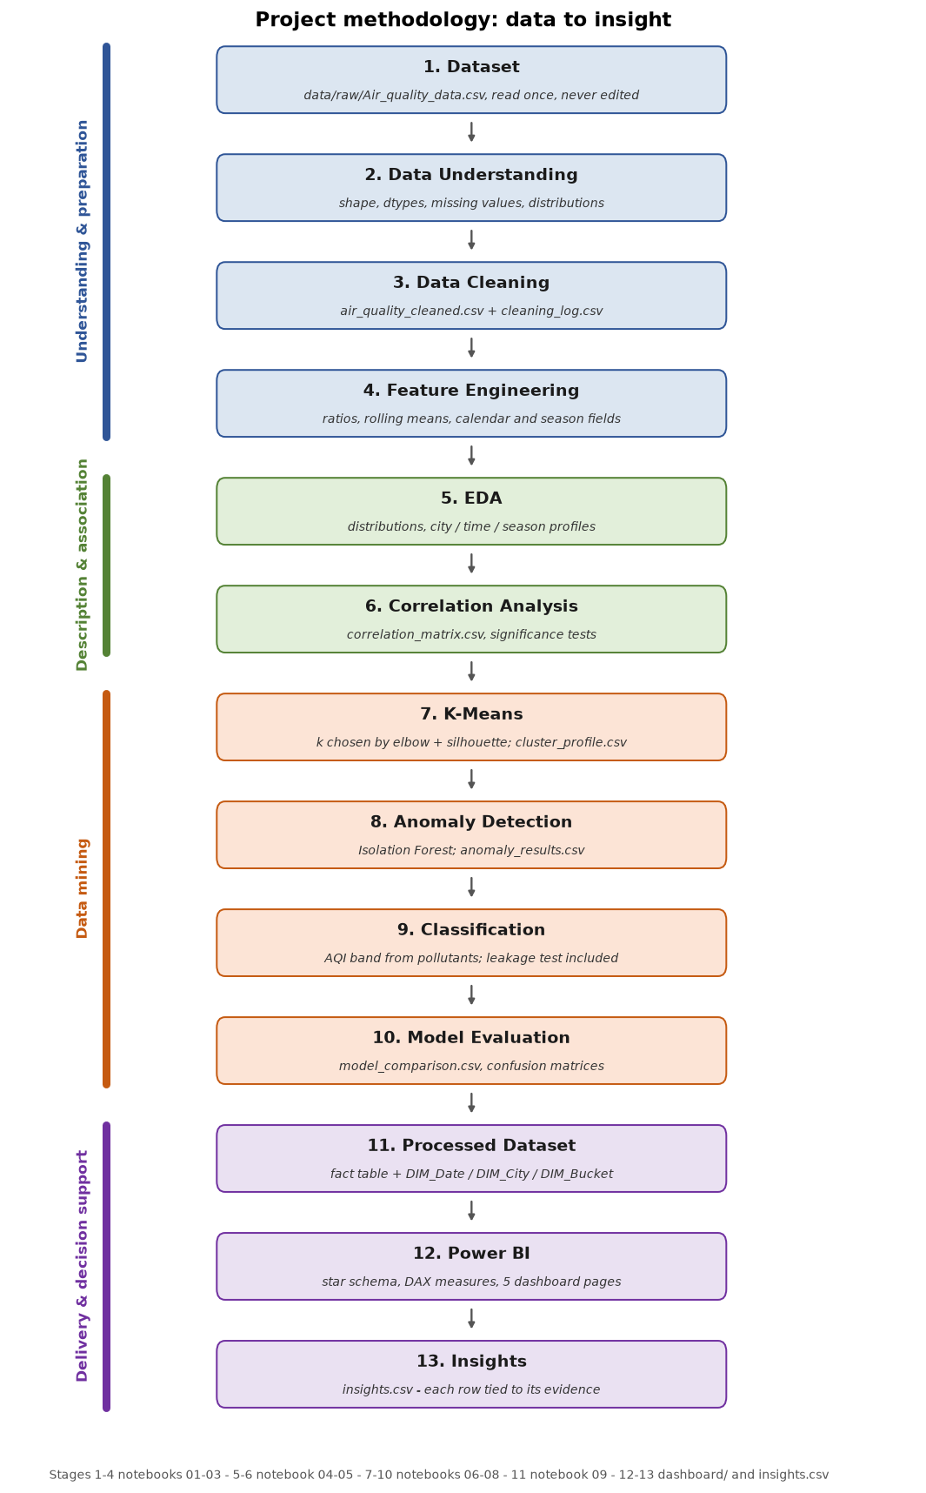
Figure 1: Smoke figure
Contents
1. Test 1

List of Figures
Figure 1: Smoke figure 1

