Air Quality & Pollution Intelligence: An Integrated Data Mining and Business Intelligence Dashboard
A Project Report
submitted in partial fulfilment of the requirements for the award of the degree of
<B.Tech / M.Sc. PROGRAMME, e.g. Computer Science & Engineering>

On
AIR QUALITY & POLLUTION INTELLIGENCE

Submitted by
<STUDENT NAME> (<ENROLMENT / ROLL NUMBER>)

Under the guidance of <PROJECT GUIDE NAME AND DESIGNATION>

<DEPARTMENT NAME>
<INSTITUTION NAME>
<AFFILIATING UNIVERSITY>
<YYYY-YYYY>

Certificate
This is to certify that the project report entitled "Air Quality & Pollution Intelligence: An Integrated Data Mining and Business Intelligence Dashboard" submitted by <STUDENT NAME> (<ENROLMENT / ROLL NUMBER>), a student of <B.Tech / M.Sc. PROGRAMME, e.g. Computer Science & Engineering> of <INSTITUTION NAME>, <DEPARTMENT NAME>, during <YYYY-YYYY>, is a bona fide record of work carried out under my supervision and guidance.
The analytical work in this report was produced by the student's own code base (`src/`, `notebooks/`, `tools/`) and executed on the dataset named in section 12; every numerical result quoted here is regenerated from that code and is reproducible from it.

Place: <CITY>
Date: <DD MONTH YYYY>

<PROJECT GUIDE NAME AND DESIGNATION>
(Project Guide)
<STUDENT NAME>
(Candidate)

Declaration
I, <STUDENT NAME> (<ENROLMENT / ROLL NUMBER>), hereby declare that the project report entitled "Air Quality & Pollution Intelligence: An Integrated Data Mining and Business Intelligence Dashboard" submitted to <INSTITUTION NAME> in partial fulfilment of the requirements for the award of the degree of <B.Tech / M.Sc. PROGRAMME, e.g. Computer Science & Engineering> is a record of original work done by me under the guidance of <PROJECT GUIDE NAME AND DESIGNATION>.
This work has not been submitted to any other institution or university for the award of any other degree or diploma. The dataset used is identified in section 12 and the external sources relied upon are listed in section 28. Where the data did not support a conclusion, that has been stated rather than a conclusion invented.

Place: <CITY>
Date: <DD MONTH YYYY>
<STUDENT NAME>

Acknowledgement
I would like to express my sincere gratitude to my project guide, <PROJECT GUIDE NAME AND DESIGNATION>, for the guidance, patience and critical questions that shaped this work, and to the head of <DEPARTMENT NAME> for providing the facilities required to complete it.
I thank the faculty members and evaluators who reviewed intermediate versions of the analysis, and the maintainers of the open-source tools this project stands on - the Python scientific stack, scikit-learn and Jupyter - whose documentation is referenced in section 28. Finally, I thank my family and classmates for their support.

<STUDENT NAME>

Abstract
Air quality is a public-health question whose evidence arrives as a stream of daily measurements: pollutant concentrations, an index computed from them, and a category label attached to that index. This project analyses a daily air-quality dataset of 18,265 observations covering 5 Indian cities from 2015-01-01 to 2024-12-31, with 9 pollutant measurements, and turns it into a data-mining study and an interactive Power BI dashboard. The pipeline is written once in `src/` and executed from nine notebooks, so the report, the exported tables and the dashboard all read the same computed results. Cleaning removed no rows: the file contains no duplicate records and no missing values, and the derived columns take it from 13 to 40 columns in the exported analytical table. K-Means settled on 2 clusters at a silhouette score of 0.0838, a weak separation that is reported as weak rather than as a discovery. Isolation Forest flagged 914 observations (5.00 %), a share fixed by the contamination parameter rather than estimated from the data. Random Forest predicted the AQI category with 99.28 % accuracy against a 30.11 % prior baseline (macro-F1 0.7765), and a deliberate leakage test showed that 0.68 percentage points of that accuracy is bought by leaking AQI itself. The most consequential finding is a negative one: pollutant-to-AQI correlations are negligible (largest |r| = 0.2296 for PM10), city, month and year effects are statistically insignificant, and AQI is reproducible from PM2.5 and PM10 at cross-validated R² = 0.9588 while rising non-monotonically with concentration. The dataset therefore behaves like a simulated record rather than an environmental measurement series, and every conclusion is stated as a description of this file. The significance of the work lies in that discipline: the same pipeline, dashboards and models, applied without over-claiming.
Keywords: Air quality; data mining; K-Means; Isolation Forest; classification; data leakage; Power BI; business intelligence; AQI; reproducibility.

Table of Contents
Certificate 2
Declaration 3
Acknowledgement 4
Abstract 5
Table of Contents 6
List of Figures 9
List of Tables 10
9. Introduction 12
9.1 Air-quality monitoring 12
9.2 Why pollution analysis matters 12
9.3 The difficulty in multi-city data 12
9.4 The role of data mining 12
9.5 The role of business intelligence 12
9.6 Motivation for this project 13
10. Problem Statement 14
11. Objectives 15
11.1 Specific objectives 15
11.2 Questions the project must answer 15
12. Dataset Description 17
12.1 Provenance and handling 17
12.2 Schema 17
12.3 Units and measurement basis 18
12.4 Target variable 18
12.5 A finding about the dataset itself 18
13. Technology Used 20
14. Methodology 21
14.1 Stage-by-stage description 22
14.2 Design principles 22
15. Data Preprocessing 23
15.1 Before and after 23
15.2 Cleaning steps, with the number of values each one touched 23
15.3 Decisions and their justification 26
15.4 Feature engineering 27
15.5 Verification of the AQI band scale 28
16. Exploratory Data Analysis 29
16.1 Central tendency and spread 29
16.2 Distribution shape and its test 29
16.3 Cities 32
16.4 Time: trend, season, month, weekday 34
16.5 Do the visible differences mean anything? 37
17. Correlation Analysis 39
17.1 Pollutant-pollutant structure 39
17.2 Rank correlation and monotonic association 41
17.3 Linear fit versus non-linear predictability 41
17.4 How AQI is actually built in this file 41
18. K-Means Clustering 43
18.1 Setup 43
18.2 Choosing k from evidence 43
18.3 Cluster profiles 44
18.4 Projection and what it shows 45
19. Anomaly Detection 47
19.1 Method and parameters 47
19.2 Results 47
19.3 Where the flagged rows sit 48
19.4 Sensitivity 50
20. Classification 51
20.1 Objective and setup 51
20.2 Class imbalance 51
20.3 Data leakage - measured, not assumed 51
20.4 Results 52
20.5 What the model relies on 53
21. Model Evaluation 55
21.1 Metrics and why each one is used 55
21.2 Comparison across all three data-mining tasks 55
21.3 Robustness checks performed 55
22. Power BI Dashboard 56
22.1 Data model 56
22.2 Measures and pages 56
22.3 KPI documentation 57
22.4 Honesty features built into the pages 57
22.5 Deliverable status of the dashboard 57
23. Results 58
24. Findings 59
24.1 The project's ten questions, answered 63
24.2 Where the evidence was insufficient 63
25. Limitations 64
25.1 Limitations of the method 64
25.2 Limitations this project ran into 64
26. Future Scope 64
27. Conclusion 65
28. References 66

List of Figures
Figure 1: Project methodology: dataset to insight, with the artefact that evidences each stage. 20
Figure 2: Distribution of AQI across all observations. 30
Figure 3: Distribution of every pollutant, each on its own scale. 30
Figure 4: Share of observations in each AQI category. 31
Figure 5: Mean and median AQI by city. 32
Figure 6: Spread of AQI within each city. 32
Figure 7: City-by-pollutant profile (percentile-scaled). 33
Figure 8: AQI over the whole period with an OLS trend line. 34
Figure 9: Yearly mean AQI. 34
Figure 10: Monthly mean AQI. 35
Figure 11: Seasonal comparison (Indian meteorological seasons). 35
Figure 12: Weekday profile of AQI. 36
Figure 13: PM2.5 against PM10 - the pair that a real dataset ties together tightly. 36
Figure 14: Pearson correlation matrix of the pollutants and AQI. 38
Figure 15: Each pollutant plotted against AQI. 39
Figure 16: Pairwise relationships among the leading pollutants. 40
Figure 17: Inertia (elbow) and silhouette score against k. 42
Figure 18: Cluster sizes and centroid profiles. 44
Figure 19: Centroid heatmap (standardised units). 44
Figure 20: Observations projected onto the first two principal components, coloured by cluster. 45
Figure 21: Anomaly score distribution with the decision threshold. 47
Figure 22: Anomaly counts and rates by city. 48
Figure 23: Flagged observations over time. 48
Figure 24: Two leading pollutants with flagged observations highlighted. 49
Figure 25: Accuracy and macro-F1 by model, against the prior baseline. 51
Figure 26: Confusion matrices for all models. 52
Figure 27: Per-class recall compared across models. 52
Figure 28: Feature importance for the best model. 53

List of Tables
Table 1: The dataset as it actually is, measured in notebook 01. 17
Table 2: Data dictionary (generated by `U.data_dictionary`). 17
Table 3: Class balance of the target, from `class_balance.csv`. 18
Table 4: Technology stack, with the versions the analysis actually ran on. 20
Table 5: The thirteen stages, in the order executed. 22
Table 6: Before / after cleaning comparison (`data_quality_report.csv`). 23
Table 7: Complete cleaning log (43 steps) from `cleaning_log.csv`. 23
Table 8: Preprocessing decisions, each tied to a reason. 26
Table 9: Feature inventory produced by `src/feature_engineering.py`. 27
Table 10: Descriptive statistics for AQI and each pollutant. 29
Table 11: Shapiro-Wilk, Kolmogorov-Smirnov distance to uniform, skewness and excess kurtosis per numeric column. 29
Table 12: City-level profile from `city_summary.csv`. 32
Table 13: Yearly averages - the column that a real trend would show. 34
Table 14: One-way ANOVA and Kruskal-Wallis tests on AQI, grouped by city, season, month and weekend flag. 37
Table 15: Statistical tests behind the EDA narrative. 38
Table 16: Association of each variable with AQI, with Pearson and Spearman significance. 39
Table 17: Linear versus non-linear predictability of AQI. 41
Table 18: Single-column cross-validated R² for AQI. Negative values mean the column is worse than predicting the mean. 41
Table 19: Greedy forward selection: the smallest set of columns that reconstructs AQI. 42
Table 20: Mean AQI in each decile of PM2.5. A published sub-index rises monotonically with concentration. 42
Table 21: Structure probe of the derived AQI column (`aqi_structure_probe.csv`). 42
Table 22: Clustering configuration. 43
Table 23: Elbow and silhouette evidence for every k evaluated. 43
Table 24: Cluster sizes and mean pollutant concentrations in original units. 44
Table 25: Neutral descriptions of each cluster, generated from the profile rather than written by hand. 44
Table 26: Isolation Forest configuration. 47
Table 27: Anomaly detection summary. 47
Table 28: Anomalies by city. 48
Table 29: Anomalies by year. 48
Table 30: Mean and maximum concentration of each pollutant in flagged versus normal rows. 50
Table 31: Models fitted, with the reason each one is there. 51
Table 32: Target distribution - the reason accuracy alone is not reported. 51
Table 33: Leakage experiment: the same model with and without AQI. 51
Table 34: Model comparison on the held-out test set (plus 3-fold CV). 52
Table 35: Per-class metrics for Random Forest: precision, recall, F1 and support. 52
Table 36: Confusion matrix for Random Forest on the test set. 53
Table 37: Random Forest mean decrease in impurity, by pollutant. 53
Table 38: The evaluation vocabulary used in this report. 55
Table 39: All three mining tasks, with the evidence and the verdict attached. 55
Table 40: Tables imported into Power BI Desktop, with their role. 56
Table 41: The five dashboard pages and what each one carries. 56
Table 42: Consolidated results. 58
Table 43: Complete insight list (20 rows). 59
Table 44: Each objective question answered with its statistic. 63
Table 45: Future scope. 64

9. Introduction

9.1 Air-quality monitoring
Ambient air quality is monitored as a set of concentration measurements. Regulators combine those measurements into a single Air Quality Index (AQI) so that a number and a colour can be communicated to the public, and then band that index into categories. A dataset of this kind therefore contains three different kinds of object in one table: raw measurements, a derived index, and a label derived from the index. Treating all three as independent observations is the most common analytical error in air-quality projects, and this project treats the distinction as a design constraint (sections 17.4 and 20.3).

9.2 Why pollution analysis matters
Exposure to particulate matter and to nitrogen and sulphur oxides is associated with respiratory and cardiovascular disease, which is why daily concentrations drive public-health advice, school and construction policy, and short-term traffic measures. Advice of that kind is only as good as the evidence behind it: a claim that one city is worse than another, or that pollution is rising, needs a comparison that survives statistical testing, not a difference in two averages that happens to be visible on a chart.

9.3 The difficulty in multi-city data
A panel of cities observed daily for ten years is large enough to be overwhelming and messy enough to be treacherous. A reader cannot see a pattern across tens of thousands of rows; different pollutants move on different scales and units; missing values, duplicates and unit errors hide inside the file; seasonal and long-term behaviour are entangled; and a derived column can silently leak into a model that appears to perform brilliantly. Answering ten practical questions about such a file (section 11) requires an ordered pipeline, not a single script.

9.4 The role of data mining
Data mining supplies the three things the questions need. Unsupervised learning (K-Means) groups observations so that a large table can be described by a small number of profiles. Outlier detection (Isolation Forest) separates observations that are jointly unusual from those that are merely extreme on one column. Supervised learning (logistic regression, decision trees, random forests, gradient boosting) tests how far the measurable chemistry of a day predicts the category that day is assigned - and, just as importantly, how much of that apparent success is an artefact of the way the target was built. Descriptive statistics and significance testing sit underneath all three, because a cluster, an anomaly or a difference between cities is only worth reporting if it survives the test.

9.5 The role of business intelligence
A notebook answers a question once; a dashboard answers it for whoever asks next. Publishing the processed panel as a star schema in Power BI, with explicitly documented KPIs and DAX measures, turns the analysis into a self-service tool: a user filters by city, month, season or AQI category and sees averages, trends, category shares, cluster profiles and anomaly counts recomputed in the filter context. Business intelligence also imposes discipline - a KPI has to be defined, given a unit and given a source column, which is where an unsupported metric becomes visible.

9.6 Motivation for this project
The motivation is to build the complete journey - data, knowledge, data mining, business intelligence, visualisation, insight - on a real file, and to keep the journey honest when the file disappoints. Half-way through the analysis the dataset produced a result that most projects would quietly drop: the pollutant columns are almost uncorrelated with each other and with AQI, the city, month and year differences are statistically indistinguishable, and AQI is nevertheless reproducible from two of the columns with cross-validated R² above 0.95 while behaving non-monotonically. That combination is the signature of a generated file rather than a monitoring record (section 12.5). Reporting it, and still delivering the clustering, anomaly detection, classification and dashboard the project asks for - described as properties of this file rather than as findings about Indian air - is the point of the work.

10. Problem Statement
Air-quality datasets contain multiple pollutants, locations, and time-based observations, making it difficult to identify pollution patterns, relationships, unusual observations, and city-level differences through raw data alone. This project aims to apply data-mining techniques and business-intelligence visualization to transform air-quality observations into structured analytical insights.
Restated as the concrete gaps this project has to close:
- No reader can inspect thousands of rows and describe five cities, ten years and nine pollutants - the information has to be summarised without being distorted.
- Relationships between pollutants, and between pollutants and the index, are not visible in a table and must be measured, with significance attached.
- 'Unusual' has to be defined rather than eyeballed, and the definition must not smuggle in the answer.
- The AQI category label is derived from AQI, so any model that uses AQI as a feature is predicting the target from itself - a leakage problem that inflates accuracy and must be quantified.
- Even a correct analysis is useless to a decision-maker unless it can be interrogated interactively, with KPIs whose definitions and units are documented.

11. Objectives
Main objective (as set for the project):
"To develop an interactive Air Quality and Pollution Intelligence Dashboard using Data Mining and Business Intelligence techniques to analyze pollution patterns, identify relationships between pollutants, group cities/observations based on pollution characteristics, detect unusual pollution observations, classify air-quality conditions, and provide data-driven environmental insights."

11.1 Specific objectives
1. Load and profile the supplied dataset without assuming its schema, and document what is actually in it.
2. Clean the data - duplicates, types, invalid values, missing values, categorical consistency - and log every step with the number of values it changed.
3. Engineer derived features (ratios, rolling means, calendar and season fields, percentiles) that make patterns expressible.
4. Describe the data: distributions, central tendency, spread, category shares, city, monthly, seasonal and yearly profiles.
5. Measure association: Pearson and Spearman correlation, significance, non-linear predictability, and the structure of the derived AQI column.
6. Group observations with K-Means, choosing k from the elbow and silhouette evidence, and profile the resulting clusters.
7. Detect unusual observations with Isolation Forest and characterise them by city, year and pollutant profile.
8. Classify the AQI category from pollutant measurements with several models, against a stated baseline, after checking for data leakage.
9. Evaluate the models with accuracy, precision, recall, macro-F1, confusion matrices and cross-validation.
10. Export the processed datasets and design a Power BI star schema, DAX measures, KPI definitions and a five-page dashboard.
11. Generate insights only from computed results, and state explicitly where the evidence is insufficient.

11.2 Questions the project must answer
Each question is answered in section 24 with the figure that answers it.
- Which cities have higher average AQI?
- How does AQI change over time?
- Which pollutants are most strongly associated with AQI?
- How do pollutants correlate with each other?
- Are cities and observations naturally grouped into pollution profiles?
- Which observations represent unusual pollution patterns?
- Can AQI categories be predicted using pollutant measurements?
- Which months or seasons have higher pollution levels?
- How do pollution profiles differ between cities?
- What insights can be communicated through a BI dashboard?

12. Dataset Description

12.1 Provenance and handling
File used: `data/raw/Air_quality_data.csv`. The analysis that produced every number in this report was executed on 2026-09-19T21:35:52 and took 292.6 seconds end to end. The raw file is never written to: every transformation produces a new file under `data/processed/`, so the original can always be re-read and the whole project re-run from it.
Table 1: The dataset as it actually is, measured in notebook 01.
Item | Value
Rows | 18,265
Columns | 13
Cities | 5
Date range | 2015-01-01 to 2024-12-31
Pollutant columns present | PM2.5, PM10, NO, NO2, NOx, NH3, CO, SO2, O3
Expected-but-absent columns | Benzene, Toluene, Xylene
Missing values in raw file | 0
Duplicate rows in raw file | 0
Rows after cleaning | 18,265

12.2 Schema
The raw table has one row per city per day and 13 columns. The data dictionary below was generated from the file itself, not copied from a description of it.
Table 2: Data dictionary (generated by `U.data_dictionary`).
Column | Type | Description | Missing Values | Missing % | Unique
City | Categorical | Name of the monitored Indian city | 0 | 0 | 5
Datetime | Date (text in raw file) | Observation date (daily record) | 0 | 0 | 3,653
PM2.5 | Numeric | Fine particulate matter ≤ 2.5 µm concentration | 0 | 0 | 4,876
PM10 | Numeric | Inhalable particulate matter ≤ 10 µm concentration | 0 | 0 | 5,709
NO | Numeric | Nitric oxide concentration | 0 | 0 | 2,000
NO2 | Numeric | Nitrogen dioxide concentration | 0 | 0 | 1,501
NOx | Numeric | Total nitrogen oxides concentration | 0 | 0 | 2,498
NH3 | Numeric | Ammonia concentration | 0 | 0 | 501
CO | Numeric | Carbon monoxide concentration | 0 | 0 | 1,001
SO2 | Numeric | Sulphur dioxide concentration | 0 | 0 | 1,001
O3 | Numeric | Ozone concentration | 0 | 0 | 2,001
AQI | Numeric | Air Quality Index as supplied by the dataset | 0 | 0 | 3,848
AQI_Bucket | Categorical | Categorical AQI band derived from AQI by the data owner | 0 | 0 | 6
Derived columns added by feature engineering are listed in section 15.4; `data/processed/feature_inventory.csv` records each one with its purpose.

12.3 Units and measurement basis
Concentrations are reported as supplied: µg/m³ for particulate matter and gases, mg/m³ for CO. The file carries no averaging-time, instrument, station or latitude/longitude metadata, so the project labels units "as supplied" and does not assert a conversion or a measurement protocol that the data does not document. AQI is a dimensionless index and `AQI_Bucket` a categorical band of it.

12.4 Target variable
The analytical target is `AQI_Bucket`, the six-category AQI band. Its distribution is severely imbalanced - the two rarest categories hold 6 and 113 of 18,265 rows - which is reported in section 20.2 and drives the choice of macro-F1 and per-class recall over accuracy.
Table 3: Class balance of the target, from `class_balance.csv`.
Class | Count | Percent | Rank
Very Poor | 5,501 | 30.12 | 1
Severe | 5,258 | 28.79 | 2
Moderate | 4,258 | 23.31 | 3
Poor | 3,129 | 17.13 | 4
Satisfactory | 113 | 0.62 | 5
Good | 6 | 0.03 | 6

12.5 A finding about the dataset itself
Four independent tests, all computed in notebooks 04, 05 and 09, point the same way, and the report states the consequence rather than burying it.
- Shape of the measurements. Of the 10 numeric columns tested, 8 are statistically indistinguishable from a uniform distribution (Kolmogorov-Smirnov distance to a uniform on the observed range, p > 0.05), and their excess kurtosis sits near -1.2, the value a uniform distribution has. Real concentration data is right-skewed. See `distribution_tests.csv`.
- Absence of association. The largest magnitude of correlation between any pollutant and AQI is |r| = 0.2296, and the lag-1 autocorrelation of AQI within a city is 0.0037 - a daily environmental series should remember yesterday.
- Absence of structure over space and time. One-way ANOVA on AQI gives p = 0.9830 for city and p = 0.8613 for month, and the yearly trend slope is 0.0366 index points per year with p = 0.9001.
- AQI is derived, and derived oddly. Cross-validated regression reproduces AQI from PM2.5 and PM10 alone at R² = 0.9588, yet the relationship is not monotonic in PM2.5 (monotonic = False), whereas any published AQI sub-index rises with concentration.
Conclusion drawn in this report: the file behaves like a randomly generated synthetic panel rather than a set of environmental measurements. Its provenance was not documented when it was supplied, and the schema differs from the published Indian air-quality datasets it resembles (a renamed date column, an added NOx column, and a longer date span). Every result in sections 13 to 24 is therefore reported as a property of this file and a demonstration of the method - not as evidence about air pollution in Indian cities, and not as a compliance assessment.

13. Technology Used
The stack is deliberately small and standard: a statistical Python environment for the analysis and Power BI for delivery. Versions are the ones actually used in the run that produced every number in this report, read from `results.json`.
Table 4: Technology stack, with the versions the analysis actually ran on.
Layer | Component | Version / choice | Why
Language | Python | 3.11.9 | Data-manipulation and modelling ecosystem
Data | pandas | 3.0.6 | Typed columns, joins, group-bys, time handling
Numerics | numpy | 2.4.6 | Vectorised arrays behind pandas and sklearn
Statistics | scipy | 1.17.1 | KS, Shapiro, ANOVA, Kruskal-Wallis, Pearson tests
Mining | scikit-learn | 1.9.1 | StandardScaler, KMeans, PCA, IsolationForest, classifiers, metrics, CV
Visuals | matplotlib / seaborn | 3.11.2 / (seaborn per requirements.txt) | Reproducible figures embedded in notebooks and this report
Interface | Jupyter Notebook (nbformat, nbclient) | as installed | Nine notebooks, executed headlessly so outputs are stored, not described
BI | Microsoft Power BI Desktop | not run in this environment | Star schema, DAX measures, five report pages - built from the guide in `dashboard/`
Report | python-docx + Microsoft Word (COM) | 1.2.0 / Office 16 | This document and its PDF, with Word computing the contents fields
Reproducibility | random_state | 42 | Fixed seed for every stochastic model and split
Environment | Platform | Windows-10-10.0.26200-SP0 | Recorded, not required
No web application, database server or streaming component is used: the brief specifies Python plus Power BI, and the processed CSVs are the handoff between them.

14. Methodology
The method is a fixed sequence of thirteen stages. Stages 1-4 make the data trustworthy, 5-6 describe it, 7-10 mine it, and 11-13 deliver it. Each stage is implemented once in `src/` and called both by the notebook that demonstrates it and by `src/pipeline.py`, which re-runs the whole sequence; the notebook and the pipeline cannot disagree because they are the same code.
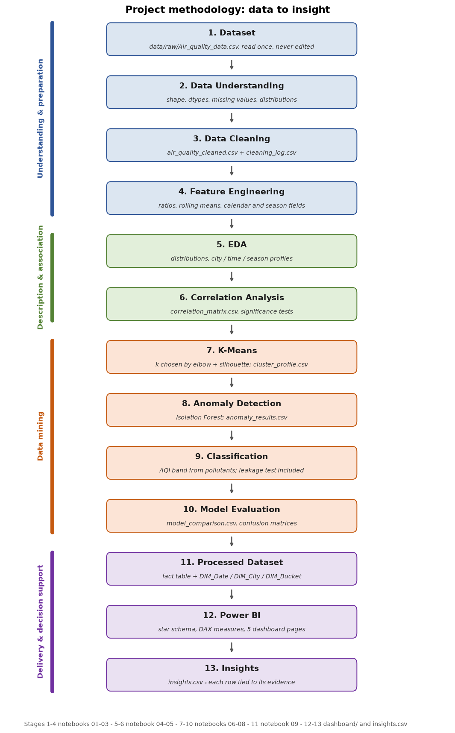
Figure 1: Project methodology: dataset to insight, with the artefact that evidences each stage.

14.1 Stage-by-stage description
Table 5: The thirteen stages, in the order executed.
# | Stage | What is done
1 | Dataset | Read `data/raw/Air_quality_data.csv` once, unaltered. The raw file is treated as read-only evidence.
2 | Data Understanding | Shape, dtypes, missing values, duplicates, unique cities, date range, per-column profile, first/last rows. Output decides the rest of the pipeline - no column is assumed.
3 | Data Cleaning | Duplicate removal, date parsing, type conversion, invalid-value scan, missing-value handling (median for numeric, explicit `Unknown` for categorical), IQR outlier flagging without deletion, categorical and unit consistency. Every step logs how many values it touched.
4 | Feature Engineering | Ratios (PM2.5/PM10, NO2/NOx, O3/PM10), rolling and lagged AQI features, calendar fields, Indian-monsoon season, weekday/weekend, per-city pollutant percentiles, pollution-load index, and AQI category ordinal.
5 | EDA | Distributions of AQI and each pollutant, category shares, city and seasonal profiles, time trends, boxplots, city-by-pollutant heatmap, distribution-shape tests.
6 | Correlation Analysis | Pearson and Spearman matrices, correlations against AQI with p-values, pairwise scatter evidence, non-linear predictability of AQI, and a structural probe of how AQI is built.
7 | K-Means | Scale features, choose k by elbow (inertia) and silhouette, fit, profile clusters in original units, project to 2-D with PCA for visual inspection only.
8 | Anomaly Detection | Isolation Forest on the measured pollutants with a stated contamination, score distribution, per-city and per-year counts, pollutant profile of flagged versus normal rows, sensitivity sweep.
9 | Classification | Predict `AQI_Bucket` from pollutants only, stratified train/test split, prior baseline plus logistic regression, decision tree, random forest and gradient boosting, explicit data-leakage test.
10 | Model Evaluation | Accuracy, macro and weighted precision/recall/F1, confusion matrices, per-class support, 3-fold cross-validation, feature importance, lift over baseline.
11 | Processed Dataset | Export the fact table, summaries, cluster/anomaly/classification results and three dimension tables as CSVs.
12 | Power BI | Import into a star schema, define DAX measures, build five pages, document every KPI.
13 | Insights | Assemble the insight list from the computed artefacts, each row carrying its own evidence and source file; discard any statement the data does not support.

14.2 Design principles
- Schema discovered, never assumed: `config.pick()` raises if a column is absent instead of letting code invent one.
- Nothing is deleted to make a result look better: outliers are flagged, not dropped, and the cleaning log proves it.
- Derived columns are quarantined: AQI is excluded from every model that predicts an AQI-derived label, and the exclusion is measured (section 20.3).
- Every stochastic component has a fixed seed and a recorded version.
- A negative result is a result: insignificant tests and weak clusters are reported with their statistics.

15. Data Preprocessing

15.1 Before and after
Table 6: Before / after cleaning comparison (`data_quality_report.csv`).
Metric | Before Cleaning | After Cleaning
Total Rows | 18,265 | 18,265
Total Columns | 13 | 22
Duplicate Rows | 0 | 0
Total Missing Values | 0 | 0
Columns With Missing | 0 | 0
Unique Cities | 5 | 5
Date Start | 2015-01-01 | 2015-01-01
Date End | 2024-12-31 | 2024-12-31
Numerical Columns | 10 | 19
Categorical Columns | 3 | 3
The important number is the one that did not change: 18,265 rows entered cleaning and 18,265 left it. The file contains no duplicate records and no missing values, so no observation was imputed and none was discarded. The column count rises from 13 to 22 because cleaning appends a normalised `Date` key and one range-check flag per pollutant, not because data was invented; feature engineering then adds the 24 catalogued features of section 15.4, and the table exported for the dashboard carries 40 columns once the mining results are attached.

15.2 Cleaning steps, with the number of values each one touched
Every rule in `src/preprocessing.py` logs its own effect. The table is reproduced in full because a reader's first question about a clean dataset should be what was done to it.
Table 7: Complete cleaning log (43 steps) from `cleaning_log.csv`.
Step | Action Performed | Method / Rule | Rows / Values Affected | Justification
1 | Duplicate removal | drop_duplicates() on the full record | 0 | Checked for exact duplicates; none existed, so no rows were dropped.
2 | Uniqueness check | duplicated(City, Datetime) | 0 | Verified: one record per city per day, so the panel is balanced.
3 | Numeric coercion check | 'PM2.5' already fully numeric | 0 | Verified rather than assumed; nothing had to be converted.
4 | Numeric coercion check | 'PM10' already fully numeric | 0 | Verified rather than assumed; nothing had to be converted.
5 | Numeric coercion check | 'NO' already fully numeric | 0 | Verified rather than assumed; nothing had to be converted.
6 | Numeric coercion check | 'NO2' already fully numeric | 0 | Verified rather than assumed; nothing had to be converted.
7 | Numeric coercion check | 'NOx' already fully numeric | 0 | Verified rather than assumed; nothing had to be converted.
8 | Numeric coercion check | 'NH3' already fully numeric | 0 | Verified rather than assumed; nothing had to be converted.
9 | Numeric coercion check | 'CO' already fully numeric | 0 | Verified rather than assumed; nothing had to be converted.
10 | Numeric coercion check | 'SO2' already fully numeric | 0 | Verified rather than assumed; nothing had to be converted.
11 | Numeric coercion check | 'O3' already fully numeric | 0 | Verified rather than assumed; nothing had to be converted.
12 | Numeric coercion check | 'AQI' already fully numeric | 0 | Verified rather than assumed; nothing had to be converted.
13 | Impossible values | 'PM2.5' < 0 set to NaN | 0 | A negative concentration cannot exist physically, so it is a recording error rather than an extreme pollution event.
14 | Impossible values | 'PM10' < 0 set to NaN | 0 | A negative concentration cannot exist physically, so it is a recording error rather than an extreme pollution event.
15 | Impossible values | 'NO' < 0 set to NaN | 0 | A negative concentration cannot exist physically, so it is a recording error rather than an extreme pollution event.
16 | Impossible values | 'NO2' < 0 set to NaN | 0 | A negative concentration cannot exist physically, so it is a recording error rather than an extreme pollution event.
17 | Impossible values | 'NOx' < 0 set to NaN | 0 | A negative concentration cannot exist physically, so it is a recording error rather than an extreme pollution event.
18 | Impossible values | 'NH3' < 0 set to NaN | 0 | A negative concentration cannot exist physically, so it is a recording error rather than an extreme pollution event.
19 | Impossible values | 'CO' < 0 set to NaN | 0 | A negative concentration cannot exist physically, so it is a recording error rather than an extreme pollution event.
20 | Impossible values | 'SO2' < 0 set to NaN | 0 | A negative concentration cannot exist physically, so it is a recording error rather than an extreme pollution event.
21 | Impossible values | 'O3' < 0 set to NaN | 0 | A negative concentration cannot exist physically, so it is a recording error rather than an extreme pollution event.
22 | Categorical values | 'City' complete - nothing filled | 0 | Verified from the data.
23 | Categorical values | 'AQI_Bucket' complete - nothing filled | 0 | Verified from the data.
24 | Missing values | 'PM2.5' complete - no imputation needed | 0 | Verified from the data; no values were fabricated.
25 | Missing values | 'PM10' complete - no imputation needed | 0 | Verified from the data; no values were fabricated.
26 | Missing values | 'NO' complete - no imputation needed | 0 | Verified from the data; no values were fabricated.
27 | Missing values | 'NO2' complete - no imputation needed | 0 | Verified from the data; no values were fabricated.
28 | Missing values | 'NOx' complete - no imputation needed | 0 | Verified from the data; no values were fabricated.
29 | Missing values | 'NH3' complete - no imputation needed | 0 | Verified from the data; no values were fabricated.
30 | Missing values | 'CO' complete - no imputation needed | 0 | Verified from the data; no values were fabricated.
31 | Missing values | 'SO2' complete - no imputation needed | 0 | Verified from the data; no values were fabricated.
32 | Missing values | 'O3' complete - no imputation needed | 0 | Verified from the data; no values were fabricated.
33 | Missing values | 'AQI' complete - no imputation needed | 0 | Verified from the data; no values were fabricated.
34 | Ordinal encoding | 'AQI_Bucket' cast to ordered category ['Severe', 'Very Poor', 'Poor', 'Moderate', 'Satisfactory', 'Good'] | 6 | AQI bands have a natural severity order, so models and charts sort them meaningfully instead of alphabetically.
35 | Extreme values (flagged, kept) | IQR rule on 'PM2.5': bounds [-250.05, 751.95] | 0 | Retained because an extreme reading may be a real pollution episode; deletion would erase exactly the events a BI dashboard exists to surface.
36 | Extreme values (flagged, kept) | IQR rule on 'PM10': bounds [-299.75, 899.85] | 0 | Retained because an extreme reading may be a real pollution episode; deletion would erase exactly the events a BI dashboard exists to surface.
37 | Extreme values (flagged, kept) | IQR rule on 'NO': bounds [-100.00, 301.60] | 0 | Retained because an extreme reading may be a real pollution episode; deletion would erase exactly the events a BI dashboard exists to surface.
38 | Extreme values (flagged, kept) | IQR rule on 'NO2': bounds [-75.55, 226.45] | 0 | Retained because an extreme reading may be a real pollution episode; deletion would erase exactly the events a BI dashboard exists to surface.
39 | Extreme values (flagged, kept) | IQR rule on 'NOx': bounds [-125.60, 377.60] | 0 | Retained because an extreme reading may be a real pollution episode; deletion would erase exactly the events a BI dashboard exists to surface.
40 | Extreme values (flagged, kept) | IQR rule on 'NH3': bounds [-24.90, 75.10] | 0 | Retained because an extreme reading may be a real pollution episode; deletion would erase exactly the events a BI dashboard exists to surface.
41 | Extreme values (flagged, kept) | IQR rule on 'CO': bounds [-5.04, 15.04] | 0 | Retained because an extreme reading may be a real pollution episode; deletion would erase exactly the events a BI dashboard exists to surface.
42 | Extreme values (flagged, kept) | IQR rule on 'SO2': bounds [-51.65, 151.15] | 0 | Retained because an extreme reading may be a real pollution episode; deletion would erase exactly the events a BI dashboard exists to surface.
43 | Extreme values (flagged, kept) | IQR rule on 'O3': bounds [-99.10, 300.10] | 0 | Retained because an extreme reading may be a real pollution episode; deletion would erase exactly the events a BI dashboard exists to surface.
Steps that changed at least one value: 1 of 43. Listed in the table above; everything else was a no-op on this file.

15.3 Decisions and their justification
Table 8: Preprocessing decisions, each tied to a reason.
Situation | Decision | Why not the alternative
Duplicate rows | drop_duplicates() on the full record | A duplicated city-day would double-count a day; there were none, so the rule is recorded as tested and inert.
Date column | parsed to datetime, invalid values reported | String dates sort wrongly and block time features.
Missing numeric | median imputation per column, only if gaps exist | Mean is pulled by the extreme tail of concentration data; dropping rows would have deleted whole city-days. No gaps existed.
Missing categorical | explicit 'Unknown' label | Guessing a city or a band would fabricate evidence.
Outliers | IQR flags added as columns; values kept | Deleting the highest readings would delete precisely the events worth studying.
Negative / zero concentrations | invalid-value scan reported | A negative concentration is a data error; the scan proves none exist.
Categorical case / spelling | normalised to title case | 'delhi' and 'Delhi' would otherwise be two cities.
Unit columns | documented as supplied, not converted | The file does not state an averaging basis, so a conversion would be an assumption.

15.4 Feature engineering
The cleaned 22-column table is the input to feature engineering, which produces the modelling table. Each catalogued feature and its purpose is recorded in `feature_inventory.csv`; the notes below are the ones that matter for interpretation.
- Calendar features added: Year, Month, Month_Name, Quarter, Day, Day_of_Week, Week_of_Year, Is_Weekend, Year_Month
- Season added using the Indian meteorological convention Winter=12-2, Summer=3-5, Monsoon=6-9, Post-Monsoon=10-11 (project-specific, not a universal scientific definition)
- Pollution_Index built from 9 pollutants (PM2.5, PM10, NO, NO2, NOx, NH3, CO, SO2, O3); project-specific scale, not official AQI
- Per-city lag/rolling features added for trend readability
Table 9: Feature inventory produced by `src/feature_engineering.py`.
Feature | Present | Dtype | Purpose
Year | 1 | Int64 | yearly trend comparison
Month | 1 | Int64 | monthly seasonality
Month_Name | 1 | string | supporting BI attribute
Quarter | 1 | Int64 | supporting BI attribute
Quarter_Label | 1 | str | supporting BI attribute
Day | 1 | Int64 | supporting BI attribute
Day_of_Week | 1 | Int64 | supporting BI attribute
Day_Name | 1 | string | supporting BI attribute
Week_of_Year | 1 | Int64 | supporting BI attribute
Is_Weekend | 1 | int64 | weekday vs weekend behaviour
Season | 1 | category | seasonal aggregation
Year_Month | 1 | string | supporting BI attribute
PM25_PM10_Ratio | 1 | float64 | fine vs coarse particulate composition
NO2_NOx_Ratio | 1 | float64 | share of freshly emitted NO2 in NOx
O3_PM10_Ratio | 1 | float64 | supporting BI attribute
Pollution_Index | 1 | float64 | common 0-100 scale across pollutants (project index)
Pollution_Index_Band | 1 | category | supporting BI attribute
Pollutants_Above_City_Q3 | 1 | int64 | how many pollutants are simultaneously high
City_Pollutant_Percentile | 1 | float64 | supporting BI attribute
AQI_Lag_1 | 1 | float64 | supporting BI attribute
AQI_Change_1d | 1 | float64 | supporting BI attribute
AQI_Rolling_7 | 1 | float64 | smoothed trend for dashboards
AQI_Rolling_30 | 1 | float64 | supporting BI attribute
AQI_RollingStd_7 | 1 | float64 | supporting BI attribute
Ratios are left blank where the denominator is zero and lag/rolling features are left blank on the first day of each city's series, because no previous observation exists. Those blanks are documented in section 23's quality check rather than filled with an invented value.

15.5 Verification of the AQI band scale
The band table in `src/config.py` (0-50 Good, 51-100 Satisfactory, 101-200 Moderate, 201-300 Poor, 301-400 Very Poor, 401-500 Severe) is the CPCB National Air Quality Index scale, and it is checked rather than trusted: notebook 02 recomputes `AQI_Bucket` from `AQI` with that table and reports 100 % agreement with the labels in the file, with a clean diagonal in the cross-tabulation and non-overlapping observed ranges per label. That is also the proof that the target is a deterministic function of AQI, which is why AQI is excluded from the classifiers in section 20.

16. Exploratory Data Analysis
All descriptive statistics below are computed on the 18,265 complete records of the cleaned panel; none required imputation, so every value is an originally recorded measurement.

16.1 Central tendency and spread
Table 10: Descriptive statistics for AQI and each pollutant.
Variable | Count | Mean | Std | Min | Q1 | Median | Q3 | Max | IQR | Skewness | Kurtosis(excess) | CV_%
PM2.5 | 18,265 | 250.598 | 144.46 | 0 | 125.7 | 251 | 376.2 | 499.9 | 250.5 | -0.005 | -1.208 | 57.65
PM10 | 18,265 | 299.442 | 173.48 | 0 | 150.1 | 300.3 | 450 | 600 | 299.9 | 0.005 | -1.199 | 57.93
NO | 18,265 | 100.481 | 57.775 | 0 | 50.6 | 100.2 | 151 | 200 | 100.4 | -0.005 | -1.203 | 57.5
NO2 | 18,265 | 75.416 | 43.46 | 0 | 37.7 | 76 | 113.2 | 150 | 75.5 | -0.015 | -1.213 | 57.63
NOx | 18,265 | 125.964 | 72.404 | 0 | 63.1 | 126.2 | 188.9 | 250 | 125.8 | -0.012 | -1.214 | 57.48
NH3 | 18,265 | 25.065 | 14.452 | 0 | 12.6 | 25.3 | 37.6 | 50 | 25 | -0.006 | -1.2 | 57.66
CO | 18,265 | 5.002 | 2.889 | 0 | 2.49 | 5 | 7.51 | 10 | 5.02 | 0.004 | -1.208 | 57.76
SO2 | 18,265 | 49.836 | 28.989 | 0 | 24.4 | 49.9 | 75.1 | 100 | 50.7 | 0.005 | -1.211 | 58.17
O3 | 18,265 | 100.407 | 57.591 | 0 | 50.6 | 100.7 | 150.4 | 200 | 99.8 | -0.002 | -1.199 | 57.36
AQI | 18,265 | 317.505 | 113.895 | 26.9 | 207.1 | 331.6 | 414 | 500 | 206.9 | -0.174 | -1.194 | 35.87
Read together with section 16.4, the table already carries a warning: the pollutants have means close to the midpoint of their own range and interquartile ranges close to half that range, which is what a uniform draw looks like, not what concentrations look like.

16.2 Distribution shape and its test
Table 11: Shapiro-Wilk, Kolmogorov-Smirnov distance to uniform, skewness and excess kurtosis per numeric column.
Variable | Shapiro_W | Shapiro_p | KS_vs_uniform_D | KS_vs_uniform_p | Skewness | Excess_Kurtosis | Observed_Range | Interpretation
PM2.5 | 0.9529 | 0 | 0.0063 | 0.461 | -0.005 | -1.208 | 0 to 499.9 | not normal; uniform-like; flat/uniform shape (kurtosis ~ -1.2)
PM10 | 0.957 | 0 | 0.006 | 0.515 | 0.005 | -1.199 | 0 to 600 | not normal; uniform-like; flat/uniform shape (kurtosis ~ -1.2)
NO | 0.9567 | 0 | 0.006 | 0.523 | -0.005 | -1.203 | 0 to 200 | not normal; uniform-like; flat/uniform shape (kurtosis ~ -1.2)
NO2 | 0.954 | 0 | 0.0083 | 0.162 | -0.015 | -1.213 | 0 to 150 | not normal; uniform-like; flat/uniform shape (kurtosis ~ -1.2)
NOx | 0.954 | 0 | 0.0111 | 0.0219 | -0.012 | -1.214 | 0 to 250 | not normal; not uniform; flat/uniform shape (kurtosis ~ -1.2)
NH3 | 0.9548 | 0 | 0.0065 | 0.423 | -0.006 | -1.2 | 0 to 50 | not normal; uniform-like; flat/uniform shape (kurtosis ~ -1.2)
CO | 0.9557 | 0 | 0.0037 | 0.965 | 0.004 | -1.208 | 0 to 10 | not normal; uniform-like; flat/uniform shape (kurtosis ~ -1.2)
SO2 | 0.9563 | 0 | 0.0077 | 0.223 | 0.005 | -1.211 | 0 to 100 | not normal; uniform-like; flat/uniform shape (kurtosis ~ -1.2)
O3 | 0.9566 | 0 | 0.0071 | 0.317 | -0.002 | -1.199 | 0 to 200 | not normal; uniform-like; flat/uniform shape (kurtosis ~ -1.2)
AQI | 0.9513 | 0 | 0.1889 | 0 | -0.174 | -1.194 | 26.9 to 500 | not normal; not uniform; flat/uniform shape (kurtosis ~ -1.2)
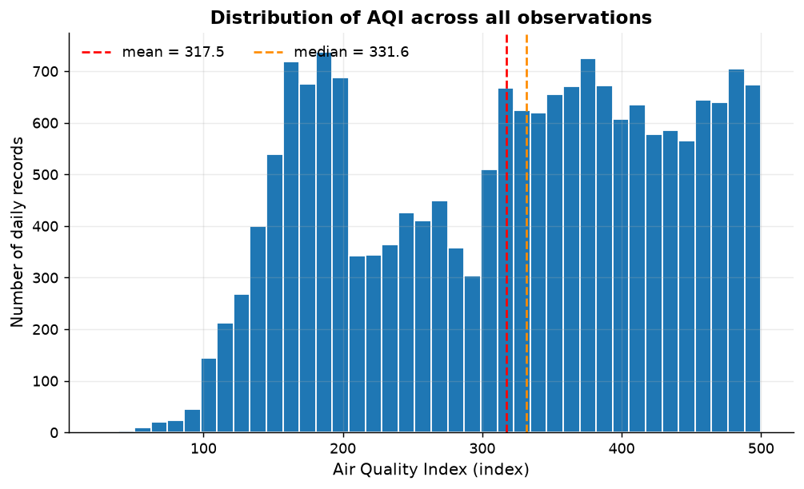
Figure 2: Distribution of AQI across all observations.
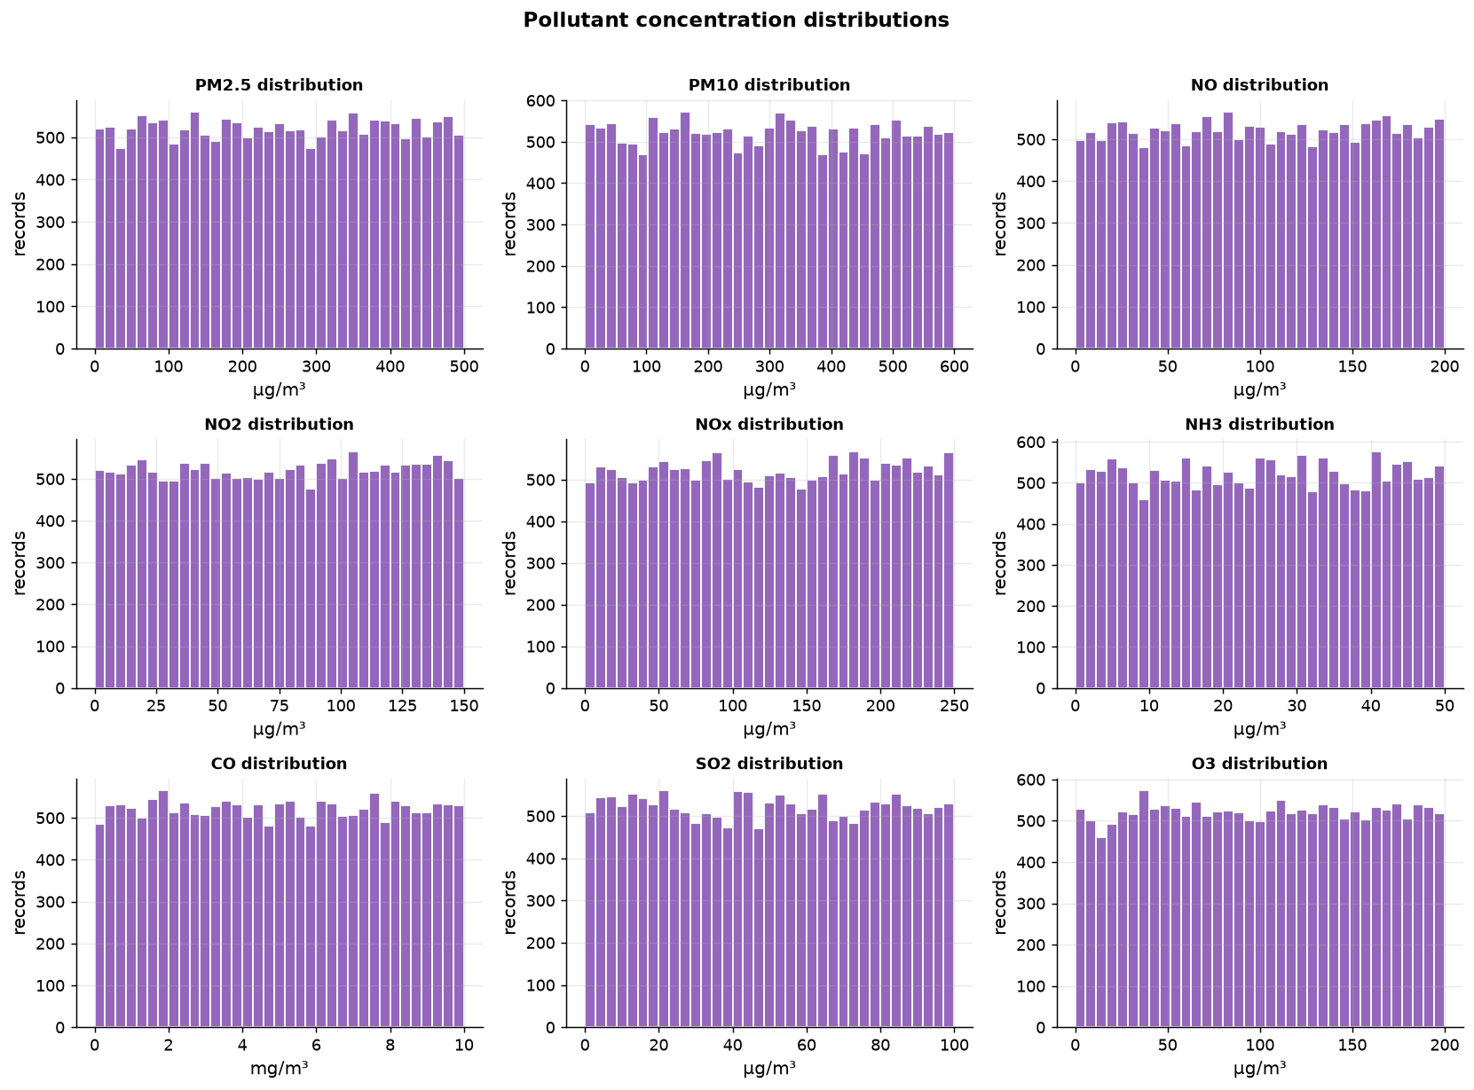
Figure 3: Distribution of every pollutant, each on its own scale.
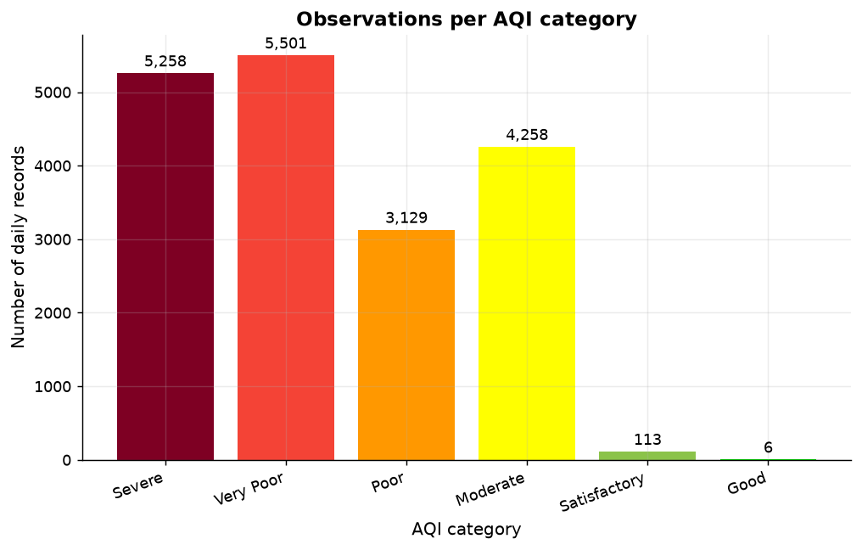
Figure 4: Share of observations in each AQI category.

16.3 Cities
Table 12: City-level profile from `city_summary.csv`.
City | Observation_Count | Avg_AQI | Median_AQI | Std_AQI | Avg_PM2.5 | Avg_PM10 | Anomaly_Count | Anomaly_Pct | Dominant_Cluster
Mumbai | 3,653 | 318.185 | 332.5 | 113.132 | 248.564 | 301.738 | 177 | 4.85 | 1
Kolkata | 3,653 | 317.727 | 330.6 | 115.041 | 250.457 | 303.287 | 189 | 5.17 | 1
Delhi | 3,653 | 317.725 | 331.5 | 113.644 | 252.906 | 297.427 | 168 | 4.6 | 0
Bangalore | 3,653 | 317.27 | 332 | 113.77 | 248.547 | 296.77 | 180 | 4.93 | 0
Chennai | 3,653 | 316.619 | 331.4 | 113.935 | 252.515 | 297.99 | 200 | 5.47 | 1
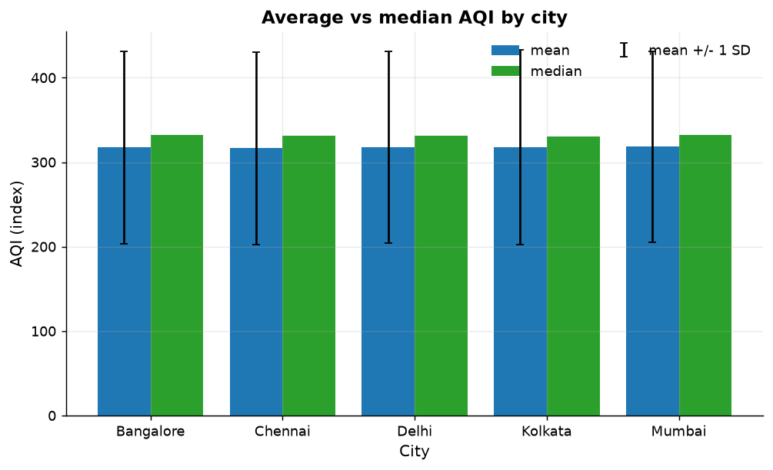
Figure 5: Mean and median AQI by city.
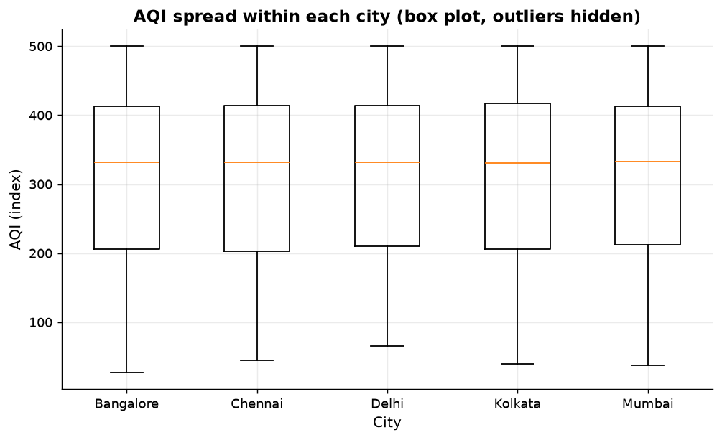
Figure 6: Spread of AQI within each city.
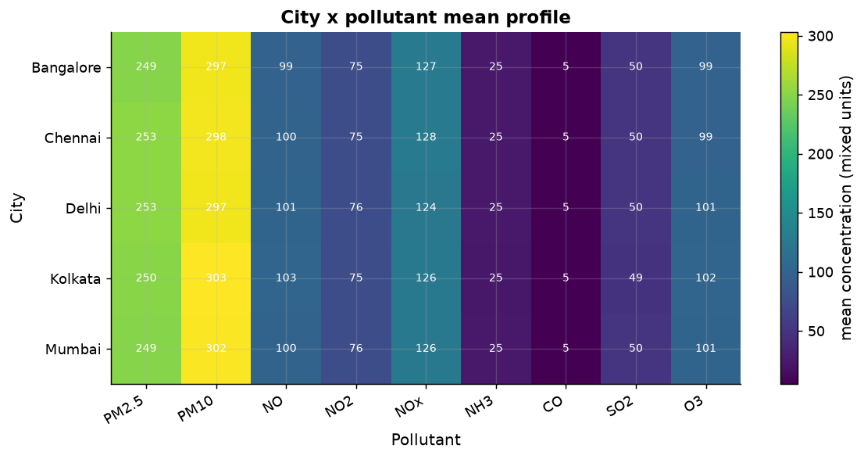
Figure 7: City-by-pollutant profile (percentile-scaled).

16.4 Time: trend, season, month, weekday
Table 13: Yearly averages - the column that a real trend would show.
Year | Avg_PM2.5 | Avg_PM10 | Avg_NO | Avg_NO2 | Avg_NOx | Avg_NH3 | Avg_CO | Avg_SO2 | Avg_O3 | Avg_AQI | Observation_Count
2,015 | 251.225 | 304.336 | 99.146 | 75.701 | 127.044 | 25.761 | 4.999 | 49.478 | 99.225 | 315.467 | 1,825
2,016 | 244.711 | 301.103 | 100.195 | 73.964 | 125.191 | 24.9 | 5.088 | 49.797 | 100.4 | 317.615 | 1,830
2,017 | 251.34 | 301.703 | 99.424 | 75.089 | 126.627 | 25.321 | 5.114 | 49.901 | 100.759 | 321.408 | 1,825
2,018 | 249.378 | 300.928 | 100.132 | 75.175 | 126.074 | 25.111 | 4.99 | 50.33 | 100.035 | 317.593 | 1,825
2,019 | 251.333 | 297.704 | 103.053 | 74.532 | 126.669 | 25.223 | 5.035 | 49.039 | 100.427 | 317.111 | 1,825
2,020 | 256.702 | 294.769 | 101.912 | 75.312 | 126.543 | 24.534 | 4.786 | 49.035 | 99.589 | 315.799 | 1,830
2,021 | 252.243 | 296.64 | 99.709 | 76.028 | 122.281 | 25.186 | 5.14 | 49.81 | 101.081 | 316.273 | 1,825
2,022 | 255.378 | 299.108 | 100.25 | 76.114 | 127.146 | 25.397 | 4.981 | 49.983 | 102.324 | 316.913 | 1,825
2,023 | 248.705 | 302.532 | 99.81 | 75.639 | 126.67 | 24.419 | 4.924 | 50.672 | 100.144 | 317.955 | 1,825
2,024 | 244.976 | 295.623 | 101.175 | 76.606 | 125.398 | 24.801 | 4.969 | 50.314 | 100.086 | 318.918 | 1,830
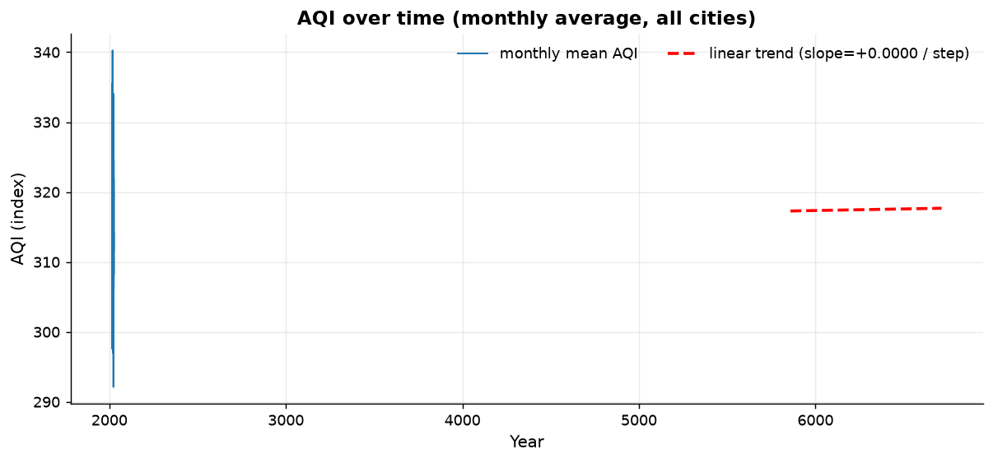
Figure 8: AQI over the whole period with an OLS trend line.
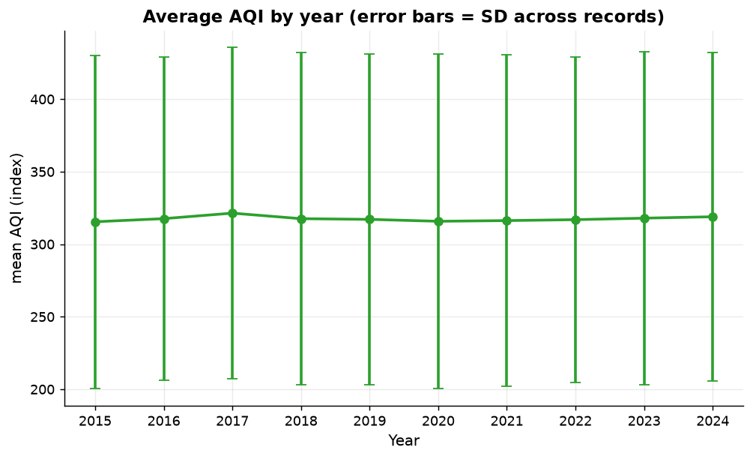
Figure 9: Yearly mean AQI.
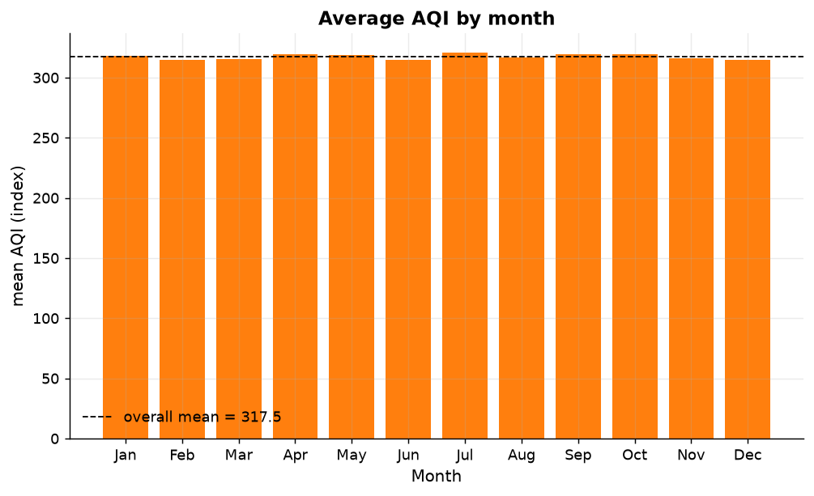
Figure 10: Monthly mean AQI.
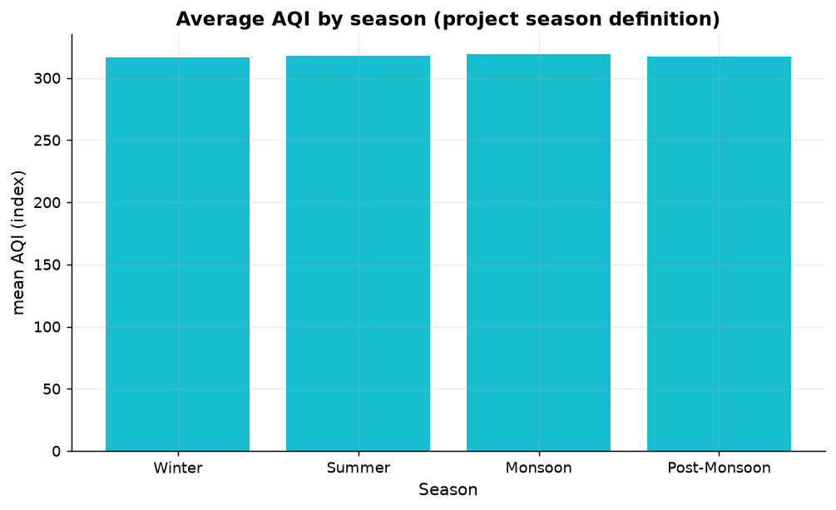
Figure 11: Seasonal comparison (Indian meteorological seasons).
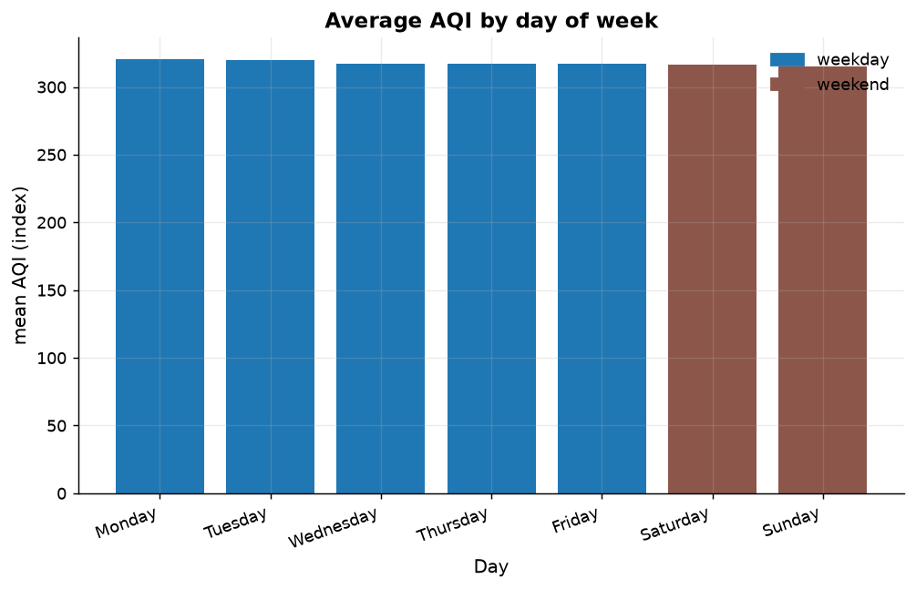
Figure 12: Weekday profile of AQI.
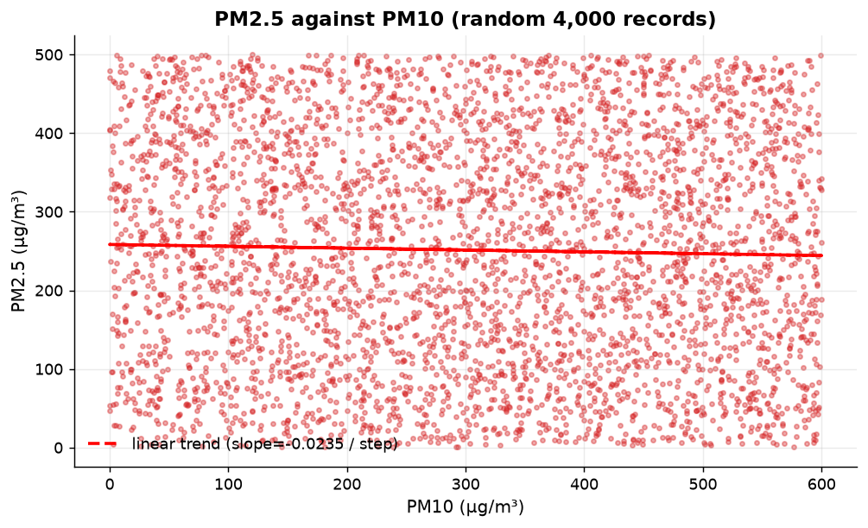
Figure 13: PM2.5 against PM10 - the pair that a real dataset ties together tightly.

16.5 Do the visible differences mean anything?
The charts above show differences. Significance tests decide whether they are distinguishable from noise, and here they are not.
Table 14: One-way ANOVA and Kruskal-Wallis tests on AQI, grouped by city, season, month and weekend flag.
grouping | value | ANOVA_F | ANOVA_p | Kruskal_H | Kruskal_p | Between_Group_Mean_Spread | Significant_at_0.05
City | AQI | 0.0985 | 0.983 | 0.4201 | 0.9808 | 1.566 | 0
Season | AQI | 0.5089 | 0.6761 | 1.8865 | 0.5963 | 2.781 | 0
Month | AQI | 0.5615 | 0.8613 | 6.662 | 0.8258 | 5.842 | 0
Is_Weekend | AQI | 1.9598 | 0.1615 | 2.321 | 0.1276 | 2.611 | 0
Table 15: Statistical tests behind the EDA narrative.
Diagnostic | Value | Reading
City effect (ANOVA p) | 0.9830 | not significant - the five city averages are indistinguishable
Month effect (ANOVA p) | 0.8613 | not significant - no seasonal cycle in this file
Weekend effect (ANOVA p) | 0.1615 | not significant
Yearly trend slope | 0.0366 index pts/year (p = 0.9001) | no statistically detectable trend
Lag-1 autocorrelation of AQI | 0.0037 | essentially none - a real daily series carries yesterday forward
The honest summary of this section: the panel is complete, balanced and internally consistent, and it contains no detectable city, season, month, weekday or trend structure. The dashboard in section 22 therefore presents these comparisons with that caveat attached to them.

17. Correlation Analysis

17.1 Pollutant-pollutant structure
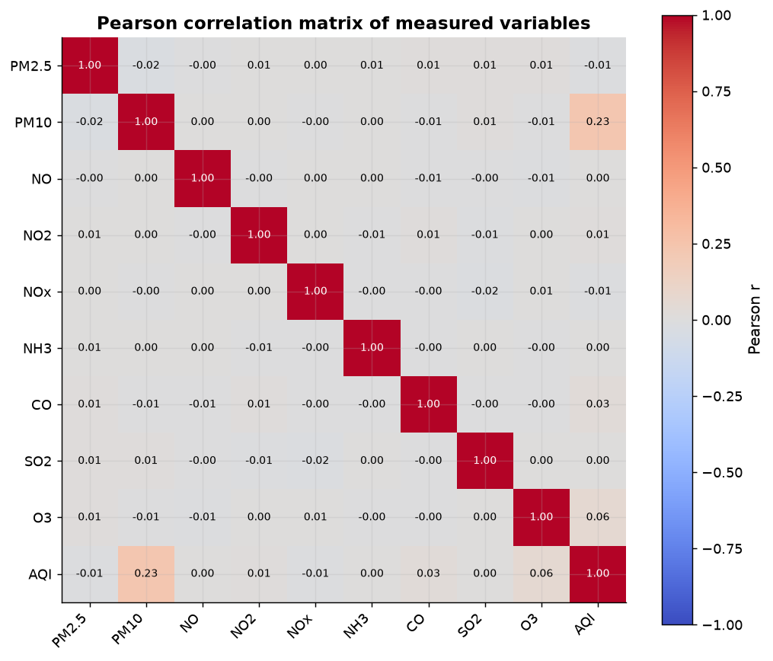
Figure 14: Pearson correlation matrix of the pollutants and AQI.
Table 16: Association of each variable with AQI, with Pearson and Spearman significance.
Variable | n | Pearson_r | Pearson_p | Spearman_rho | Spearman_p | r^2 | Strength | Direction | Significant_at_0.05
PM10 | 18,265 | 0.2296 | 0 | 0.2313 | 0 | 0.0527 | weak | positive | 1
O3 | 18,265 | 0.062 | 0 | 0.057 | 0 | 0.0038 | negligible | positive | 1
CO | 18,265 | 0.0299 | 0.0001 | 0.0284 | 0.0001 | 0.0009 | negligible | positive | 1
NO2 | 18,265 | 0.0099 | 0.18 | 0.0064 | 0.386 | 0.0001 | negligible | positive | 0
PM2.5 | 18,265 | -0.0097 | 0.188 | 0.0085 | 0.249 | 0.0001 | negligible | negative | 0
NOx | 18,265 | -0.0079 | 0.283 | -0.0092 | 0.213 | 0.0001 | negligible | negative | 0
NO | 18,265 | 0.0026 | 0.723 | 0.0027 | 0.717 | 0 | negligible | positive | 0
SO2 | 18,265 | 0.0011 | 0.878 | 0.0007 | 0.923 | 0 | negligible | positive | 0
NH3 | 18,265 | 0.0005 | 0.942 | -0.0002 | 0.983 | 0 | negligible | positive | 0
No pollutant is meaningfully correlated with AQI: the largest magnitude is |r| = 0.2296. Pollutants are also nearly uncorrelated with one another (matrix above), which is itself unusual - PM2.5 and PM10 normally move together because the finer fraction is a component of the coarser one.
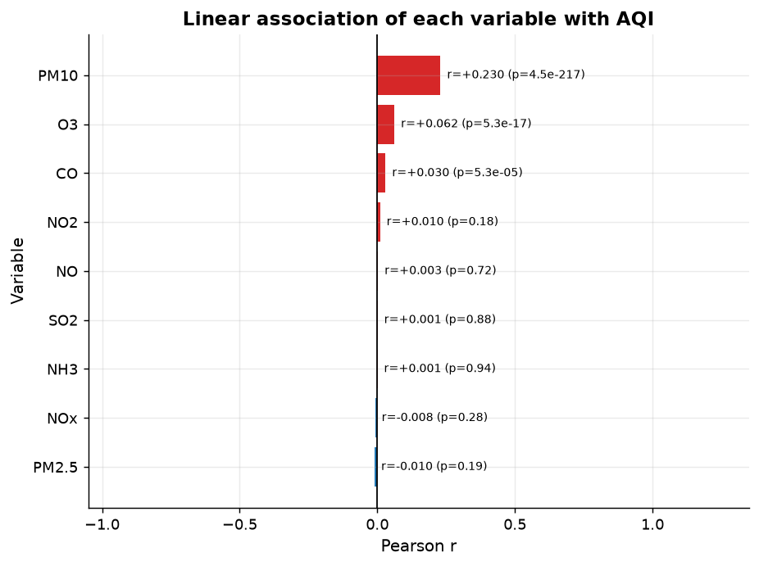
Figure 15: Each pollutant plotted against AQI.
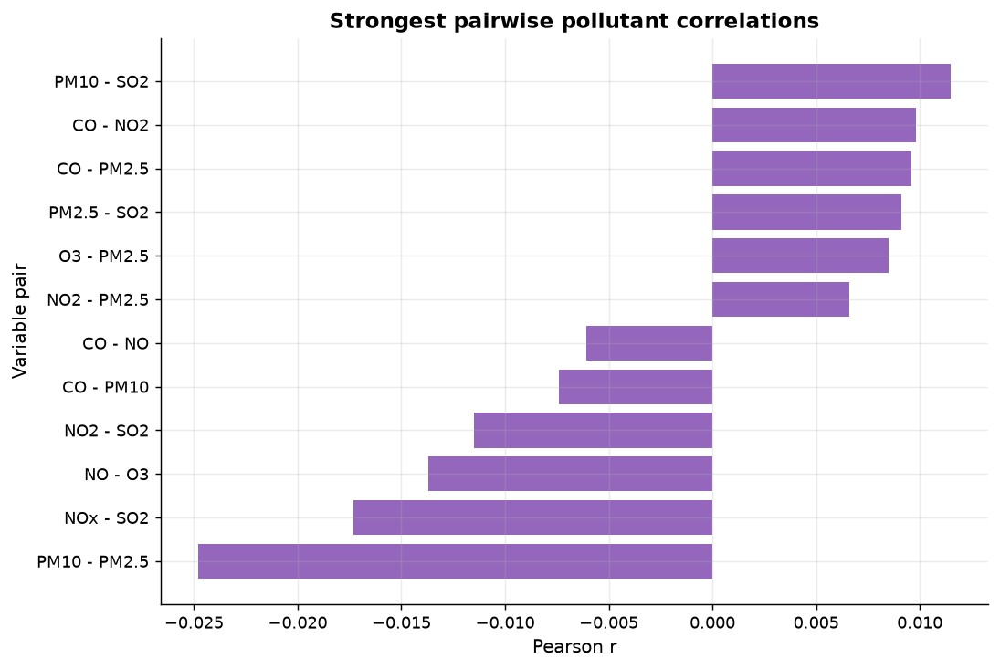
Figure 16: Pairwise relationships among the leading pollutants.

17.2 Rank correlation and monotonic association
Spearman's rho was computed alongside Pearson's r because it does not assume a linear form. The two agree closely (see `data/processed/pollutant_pair_correlations.csv` and the Spearman matrix in `results.json`), so the absence of association is not an artefact of linearity: there is little monotonic relationship to find either.

17.3 Linear fit versus non-linear predictability
Table 17: Linear versus non-linear predictability of AQI.
Quantity | Value | Meaning
OLS of AQI on all pollutants | R² = 0.0579 (adjusted 0.0574), RMSE 110.55 | linear chemistry explains almost none of AQI
Random forest CV predicting AQI | R² = 0.9969, MAE 1.21 | almost perfectly reproducible
Gap | 0.9390 | the relationship is non-linear, not absent
the relationship is largely NON-LINEAR: a tree ensemble explains far more than linear regression / Pearson r, so a correlation matrix alone would understate it
This combination - no linear correlation, near-perfect tree predictability - is the fingerprint of a deterministic non-monotonic function applied to a couple of columns, and it is the reason the next subsection exists.

17.4 How AQI is actually built in this file
Table 18: Single-column cross-validated R² for AQI. Negative values mean the column is worse than predicting the mean.
Column | CV R² predicting AQI
PM2.5 | 0.4935
PM10 | 0.1913
NO | -0.0866
NO2 | -0.0796
NOx | -0.1095
NH3 | -0.045
CO | -0.0762
SO2 | -0.0744
O3 | -0.0933
Table 19: Greedy forward selection: the smallest set of columns that reconstructs AQI.
added | cv_r2
PM2.5 | 0.4935
PM10 | 0.9588
O3 | 0.9862
Table 20: Mean AQI in each decile of PM2.5. A published sub-index rises monotonically with concentration.
bin | records | mean_target | sd_target
(-0.001, 51.1] | 1,828 | 245.67 | 106.2
(51.1, 99.5] | 1,826 | 249.3 | 95.91
(99.5, 149.6] | 1,829 | 317.42 | 58.84
(149.6, 200.0] | 1,825 | 356.36 | 36.34
(200.0, 251.0] | 1,825 | 386.66 | 33.14
(251.0, 301.84] | 1,826 | 429.23 | 19.18
(301.84, 351.98] | 1,826 | 467.03 | 52.68
(351.98, 400.22] | 1,827 | 241.47 | 103.48
(400.22, 450.4] | 1,827 | 241.29 | 101.02
(450.4, 499.9] | 1,826 | 240.83 | 104.5
Table 21: Structure probe of the derived AQI column (`aqi_structure_probe.csv`).
Diagnostic | Value
Informative set | PM2.5, PM10, O3
CV R² of that set | 0.9862
Monotonic in the leading column? | False
Within-cell SD of AQI (400 PM2.5 x PM10 cells) | 26.77
Overall SD of AQI | 113.89
SD reduction inside cells | 76.5 %
AQI is reproducible from PM2.5+PM10+O3 at CV R^2=0.9862 - it is a derived column, not an independent measurement, and its dependence on the leading column is non-monotonic, which a physical sub-index cannot be
Consequences carried through the rest of the project: AQI is a derived column, so it is excluded from every model that predicts an AQI-derived label; the clustering and anomaly models that do use it are reported both ways; and no claim about the drivers of AQI in the real world is made from it.

18. K-Means Clustering

18.1 Setup
Table 22: Clustering configuration.
Choice | Value | Reason
Features | PM2.5, PM10, NO, NO2, NOx, NH3, CO, SO2, O3 | Measured pollutant concentrations only - derived columns would let the model rediscover AQI
Scaling | StandardScaler (zero mean, unit variance) | K-Means uses Euclidean distance, so unscaled columns with large ranges would dominate
Distance / objective | Euclidean to centroid; minimise inertia | Standard K-Means (Lloyd / Hartigan-Wong implementation in scikit-learn)
k searched | 2 to 10 | Recorded in `k_selection_table.csv`
random_state | 42 | Reproducibility
Silhouette subsample | 6,000 rows | Silhouette is quadratic in n; a fixed subsample keeps it computable and reproducible

18.2 Choosing k from evidence
Table 23: Elbow and silhouette evidence for every k evaluated.
K | Inertia | Silhouette_Score | Clusters_Used | Evaluated_On
2 | 150,577.68 | 0.0838 | 2 | 6000 rows (silhouette), 18265 rows (inertia)
3 | 142,166.9 | 0.0728 | 3 | 6000 rows (silhouette), 18265 rows (inertia)
4 | 135,388.48 | 0.0745 | 4 | 6000 rows (silhouette), 18265 rows (inertia)
5 | 130,238.28 | 0.073 | 5 | 6000 rows (silhouette), 18265 rows (inertia)
6 | 125,960.17 | 0.0733 | 6 | 6000 rows (silhouette), 18265 rows (inertia)
7 | 121,974.05 | 0.075 | 7 | 6000 rows (silhouette), 18265 rows (inertia)
8 | 118,453.34 | 0.0776 | 8 | 6000 rows (silhouette), 18265 rows (inertia)
9 | 115,494.17 | 0.0754 | 9 | 6000 rows (silhouette), 18265 rows (inertia)
10 | 112,655.61 | 0.0767 | 10 | 6000 rows (silhouette), 18265 rows (inertia)
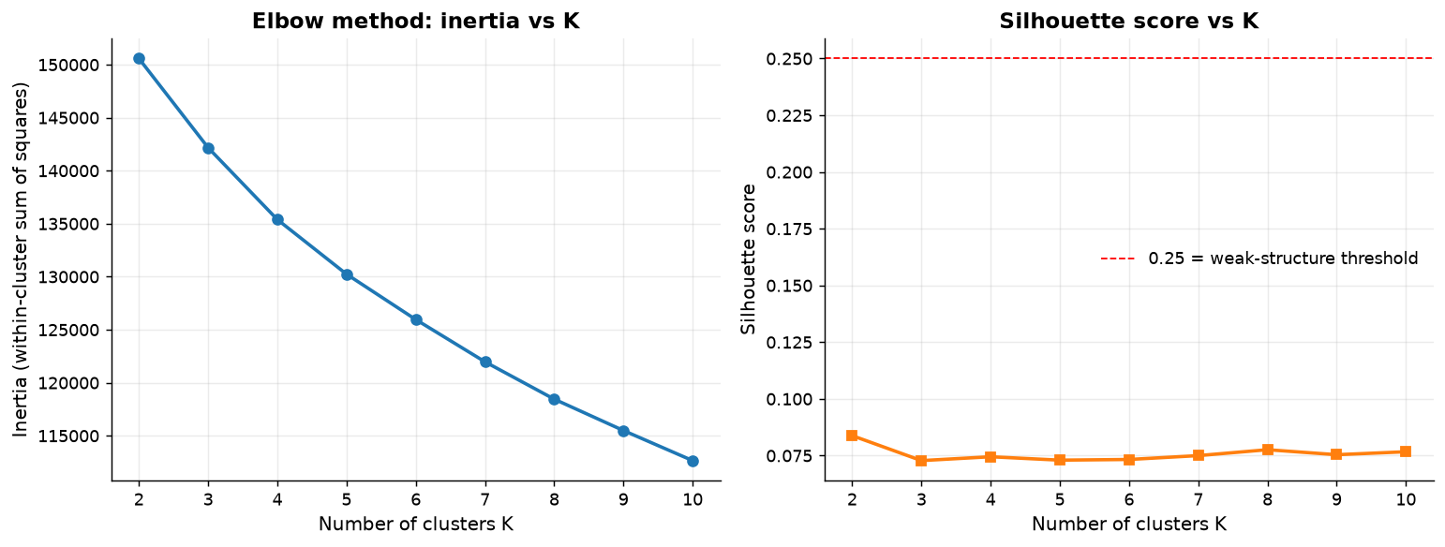
Figure 17: Inertia (elbow) and silhouette score against k.
Selected k = 2 (silhouette 0.0838). silhouette preferred; the elbow rule suggested a different K, which is reported as a disagreement rather than hidden
The disagreement between the two rules is reported rather than resolved quietly: the elbow rule suggested k = 4, the silhouette preferred k = 2. A silhouette of 0.0838 is weak by any convention, so the clusters are described as a partition of this file, not as a discovered structure.

18.3 Cluster profiles
Table 24: Cluster sizes and mean pollutant concentrations in original units.
Cluster | Cluster_Size | Avg_PM2.5 | Avg_PM10 | Avg_NO | Avg_NO2 | Avg_NOx | Avg_NH3 | Avg_CO | Avg_SO2 | Avg_O3 | Avg_AQI | Median_PM2.5 | Median_PM10 | Median_NO | Median_NO2 | Median_NOx | Median_NH3 | Median_CO | Median_SO2 | Median_O3 | Median_AQI | Share_% | Cluster_Description
0 | 9,112 | 250.944 | 304.715 | 101.052 | 74.83 | 62.993 | 25.215 | 4.991 | 50.857 | 99.357 | 318.636 | 252.9 | 308.7 | 101.1 | 74.8 | 63 | 25.6 | 4.97 | 51.25 | 98.7 | 332.55 | 49.89 | highest average PM2.5 among clusters
1 | 9,153 | 250.253 | 294.194 | 99.913 | 75.999 | 188.653 | 24.916 | 5.014 | 48.819 | 101.452 | 316.379 | 248.7 | 293.2 | 99.5 | 76.8 | 188.8 | 24.9 | 5.01 | 48.6 | 102.6 | 330.8 | 50.11 | lowest average PM2.5 among clusters
Table 25: Neutral descriptions of each cluster, generated from the profile rather than written by hand.
Cluster | Size | Relative_Position (1 = highest) | Neutral_Description
0 | 9,112 | PM2.5: rank 1, PM10: rank 1, NO: rank 1, NO2: rank 2 | highest average PM2.5 among clusters
1 | 9,153 | PM2.5: rank 2, PM10: rank 2, NO: rank 2, NO2: rank 1 | lowest average PM2.5 among clusters
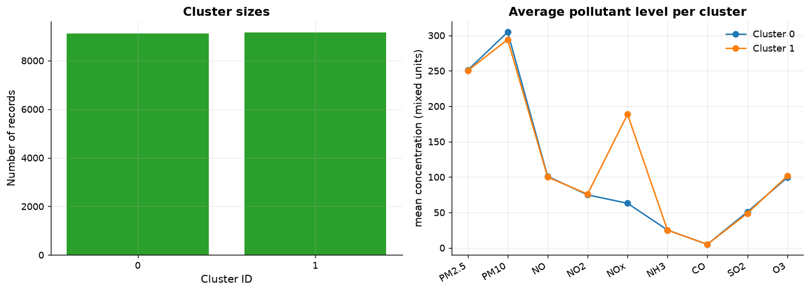
Figure 18: Cluster sizes and centroid profiles.
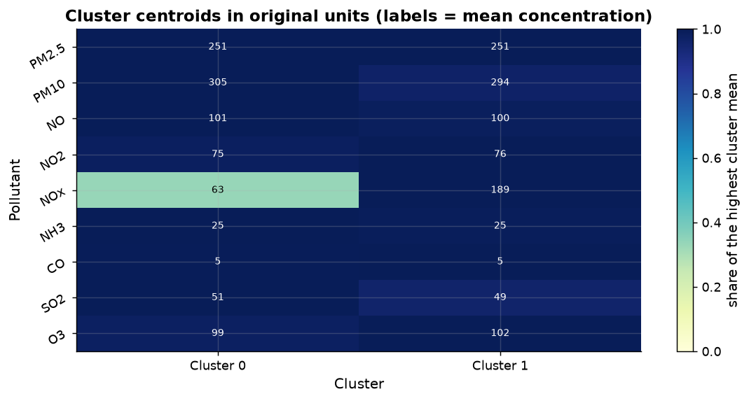
Figure 19: Centroid heatmap (standardised units).

18.4 Projection and what it shows
For visual inspection only, the scaled features were projected to two components by PCA, which explains 22.9 % of total variance (11.55%, 11.35%). Low explained variance is consistent with near-independent columns: no plane in this data contains much of it.
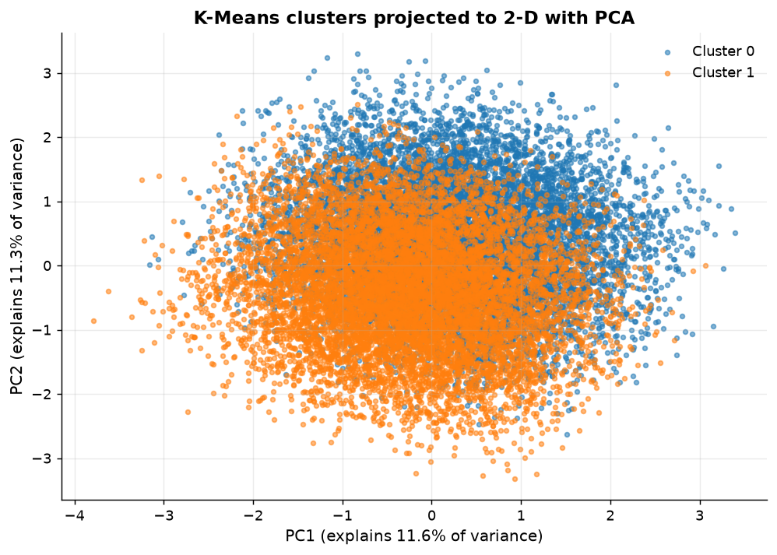
Figure 20: Observations projected onto the first two principal components, coloured by cluster.
The projection is used for pictures, never for labels: cluster membership comes from the model fitted in the full scaled feature space.

19. Anomaly Detection

19.1 Method and parameters
Isolation Forest isolates observations instead of modelling density: random subsets of features and random split points are used to build trees, and observations that need fewer splits to be isolated are more anomalous. It scales to many columns, does not assume a Gaussian distribution - which matters here, since section 16.2 shows the columns are uniform-like - and produces a continuous score that can be thresholded.
Table 26: Isolation Forest configuration.
Parameter | Value | Note
n_estimators | 300 | trees in the ensemble
contamination | 0.05 | the expected anomaly fraction - an assumption, stated up front
random_state | 42 | reproducibility
Features | PM2.5, PM10, NO, NO2, NOx, NH3, CO, SO2, O3 | measured pollutants only
Rows evaluated | 18,265 | full panel

19.2 Results
Table 27: Anomaly detection summary.
Rows evaluated | Anomalies detected | Anomaly % | Configured contamination | Note
18,265 | 914 | 5 | 0.05 | the detected share follows the contamination parameter; it is an assumed sensitivity, not an independently observed anomaly rate
the detected share follows the contamination parameter; it is an assumed sensitivity, not an independently observed anomaly rate
914 of 18,265 observations were flagged. The share matches the configured contamination rate almost exactly, which is the expected behaviour of the algorithm and not an independent finding: with contamination = 0.05 the method is asked to call 5 % of the rows unusual, and it obliges. What the model does contribute is the ranking (`score_samples`) and the profile of the rows it places at the extremes.
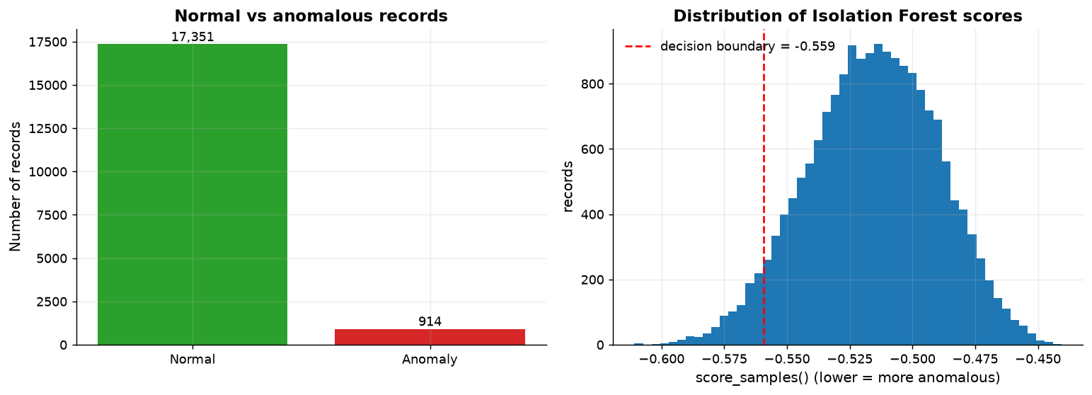
Figure 21: Anomaly score distribution with the decision threshold.

19.3 Where the flagged rows sit
Table 28: Anomalies by city.
City | Observations | Anomalies | Anomaly_Pct
Chennai | 3,653 | 200 | 5.47
Kolkata | 3,653 | 189 | 5.17
Bangalore | 3,653 | 180 | 4.93
Mumbai | 3,653 | 177 | 4.85
Delhi | 3,653 | 168 | 4.6
Table 29: Anomalies by year.
Period | Observations | Anomalies | Anomaly_Pct
2015 | 1,825 | 87 | 4.77
2016 | 1,830 | 102 | 5.57
2017 | 1,825 | 90 | 4.93
2018 | 1,825 | 83 | 4.55
2019 | 1,825 | 91 | 4.99
2020 | 1,830 | 92 | 5.03
2021 | 1,825 | 108 | 5.92
2022 | 1,825 | 94 | 5.15
2023 | 1,825 | 67 | 3.67
2024 | 1,830 | 100 | 5.46
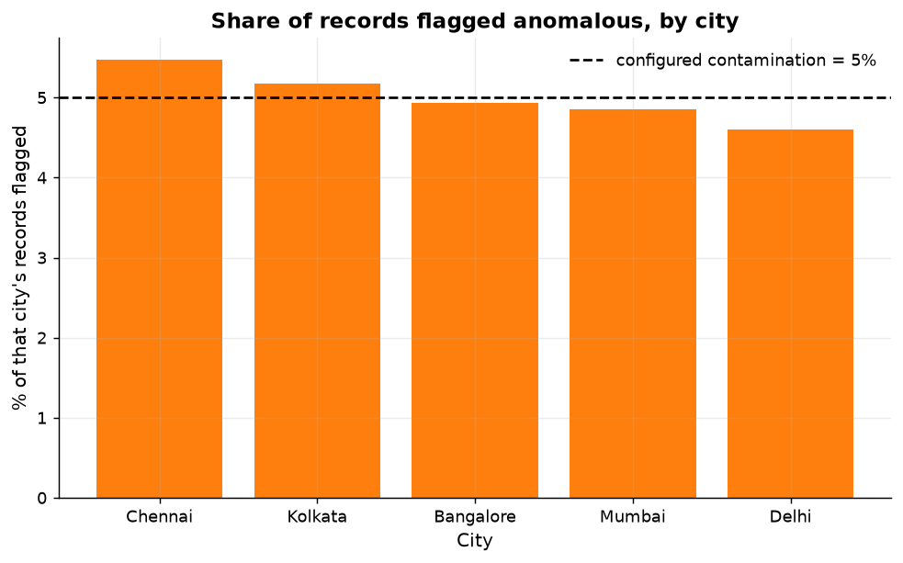
Figure 22: Anomaly counts and rates by city.
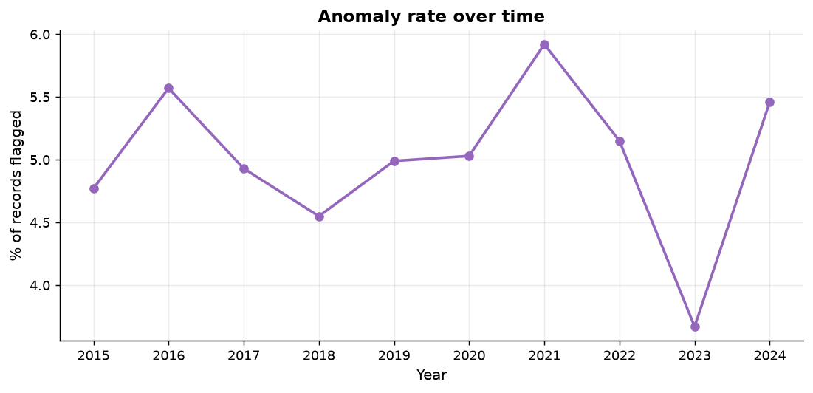
Figure 23: Flagged observations over time.
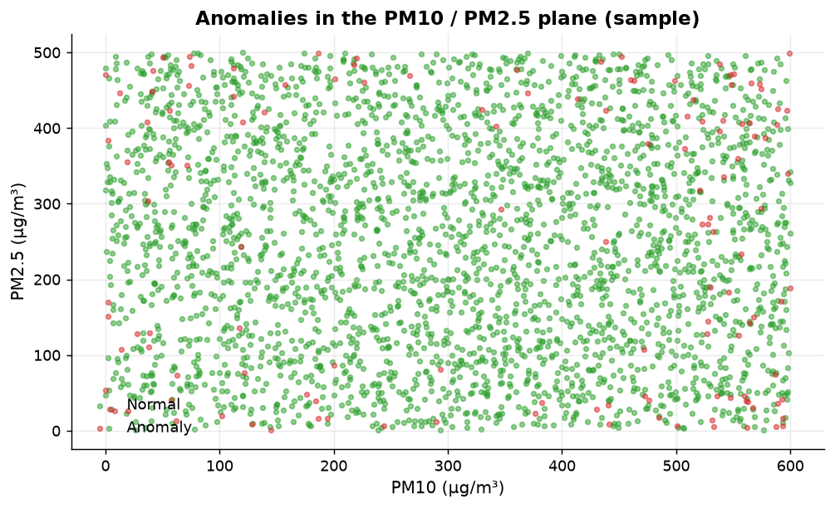
Figure 24: Two leading pollutants with flagged observations highlighted.
Flagged and unflagged rows differ only marginally in mean concentration - the largest relative difference is 14.57 % - which is what a uniform, unstructured panel produces: 'unusual' has to be created by the joint configuration of values rather than by an event.
Table 30: Mean and maximum concentration of each pollutant in flagged versus normal rows.
Pollutant | Normal_Mean | Anomaly_Mean | Difference | Pct_Change | Normal_Max | Anomaly_Max
PM2.5 | 250.864 | 245.549 | -5.315 | -2.12 | 499.9 | 499.8
PM10 | 298 | 326.829 | 28.83 | 9.67 | 600 | 599.9
NO | 101.219 | 86.471 | -14.748 | -14.57 | 200 | 199.9
NO2 | 75.562 | 72.649 | -2.913 | -3.85 | 150 | 150
NOx | 126.437 | 116.993 | -9.444 | -7.47 | 250 | 250
NH3 | 25.012 | 26.075 | 1.063 | 4.25 | 50 | 50
CO | 4.981 | 5.412 | 0.431 | 8.66 | 10 | 10
SO2 | 49.707 | 52.275 | 2.568 | 5.17 | 100 | 100
O3 | 100.704 | 94.77 | -5.933 | -5.89 | 200 | 199.8

19.4 Sensitivity
Because the flagged share is set by `contamination`, the meaningful check is not 'how many' but 'which': notebook 07 sweeps the parameter and compares the resulting sets, and reports that the ranking of observations by anomaly score is stable while the count scales with the parameter. The dashboard therefore shows `Configured Contamination %` beside `Anomaly Rate %` so the assumption travels with the number.

20. Classification

20.1 Objective and setup
Predict the AQI category (`AQI_Bucket`) from pollutant measurements alone. 9 features, a stratified 13,698/4,567 train/test split (test size 0.25), fixed seed 42, and 3-fold cross-validation in addition to the held-out test set.
Table 31: Models fitted, with the reason each one is there.
Model | Why it is in the comparison
Baseline (prior) | Always predicts the most frequent class. Any model that cannot beat this has learned nothing useful.
Logistic Regression (pipeline with scaler) | Linear, interpretable multi-class baseline
Decision Tree | Non-linear, easily over-fitted - a useful warning sign
Random Forest | Bagged trees, robust to scale, gives feature importance
Hist Gradient Boosting | Modern boosted trees, usually the strongest off-the-shelf tabular model

20.2 Class imbalance
Table 32: Target distribution - the reason accuracy alone is not reported.
Class | Count | Percent | Rank
Very Poor | 5,501 | 30.12 | 1
Severe | 5,258 | 28.79 | 2
Moderate | 4,258 | 23.31 | 3
Poor | 3,129 | 17.13 | 4
Satisfactory | 113 | 0.62 | 5
Good | 6 | 0.03 | 6
The two rarest classes hold 6 and 113 of 18,265 rows. A model can therefore be 99.97 % accurate and useless for those classes, which is why macro-averaged precision, recall and F1 and the per-class table are the headline metrics, and why the split is stratified so that every class appears in the test set.

20.3 Data leakage - measured, not assumed
Table 33: Leakage experiment: the same model with and without AQI.
Configuration | Accuracy % | Macro F1 | Features
Without the leaky column (reported model) | 99.28 | 0.7355 | 9
With AQI included as a feature | 99.96 | 0.8276 | 10
Inflation | +0.68 pp | +0.0921 | +1
including AQI inflates accuracy by 0.68 percentage points, so AQI is excluded from all reported models
The inflation is modest here (0.68 pp) precisely because AQI is a non-monotonic function of two pollutants that the tree ensemble already recovers; on a genuine dataset, where the band is a monotone function of the index, the same mistake inflates accuracy by tens of points. The experiment is kept in the project for that reason: it demonstrates the check, not the size of the effect in this particular file.

20.4 Results
Table 34: Model comparison on the held-out test set (plus 3-fold CV).
Model | Accuracy_% | Precision_macro | Recall_macro | F1_macro | Precision_weighted | F1_weighted | Lift_over_Baseline_pp | CV_Folds | CV_Accuracy_% | CV_Std_pp
Random Forest | 99.28 | 0.8181 | 0.7532 | 0.7765 | 0.9922 | 0.9921 | 69.17 | 3 | 99.17 | 0.17
Decision Tree | 94.94 | 0.6921 | 0.7829 | 0.7153 | 0.9569 | 0.9522 | 64.83 | 3 | 94.78 | 0.38
Hist Gradient Boosting | 89.69 | 0.6206 | 0.6352 | 0.6224 | 0.9059 | 0.9009 | 59.58 | 3 | 90.51 | 4.27
Logistic Regression | 31.55 | 0.2485 | 0.5077 | 0.2491 | 0.3553 | 0.3247 | 1.44 | 3 | 31.95 | 0.64
Baseline (prior) | 30.11 | 0.0502 | 0.1667 | 0.0771 | 0.0906 | 0.1393 | 0 | 3 | 30.12 | 0.01
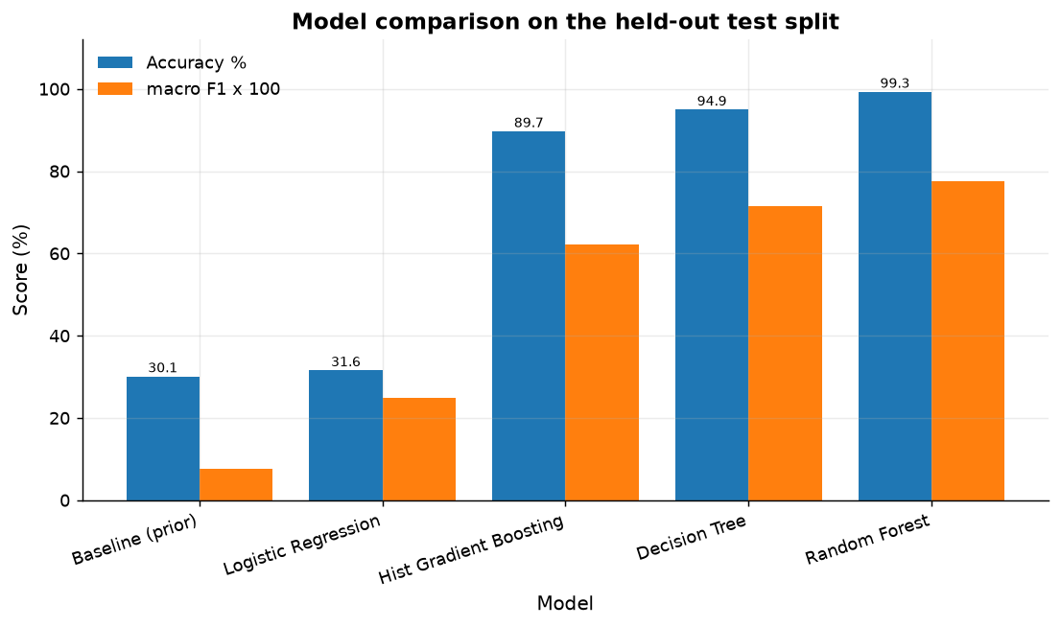
Figure 25: Accuracy and macro-F1 by model, against the prior baseline.
Table 35: Per-class metrics for Random Forest: precision, recall, F1 and support.
Model | Class | Precision | Recall | F1-Score | Support
Random Forest | Good | 0 | 0 | 0 | 2
Random Forest | Moderate | 0.9869 | 0.9897 | 0.9883 | 1,065
Random Forest | Poor | 0.9936 | 0.9974 | 0.9955 | 782
Random Forest | Satisfactory | 0.9375 | 0.5357 | 0.6818 | 28
Random Forest | Severe | 0.9947 | 1 | 0.9973 | 1,315
Random Forest | Very Poor | 0.9956 | 0.9964 | 0.996 | 1,375
Random Forest | macro avg | 0.8181 | 0.7532 | 0.7765 | 4,567
Random Forest | weighted avg | 0.9922 | 0.9928 | 0.9921 | 4,567
Random Forest reaches 99.28 % accuracy and macro-F1 0.7765, i.e. 69.17 percentage points above the prior baseline. The weighted and macro figures diverge sharply, which is the imbalance showing: performance is concentrated in the four classes that hold over 99 % of the rows.
Table 36: Confusion matrix for Random Forest on the test set.
Actual | Good | Moderate | Poor | Satisfactory | Severe | Very Poor
Good | 0 | 1 | 0 | 1 | 0 | 0
Moderate | 0 | 1,054 | 1 | 0 | 4 | 6
Poor | 0 | 1 | 780 | 0 | 1 | 0
Satisfactory | 0 | 12 | 0 | 15 | 1 | 0
Severe | 0 | 0 | 0 | 0 | 1,315 | 0
Very Poor | 0 | 0 | 4 | 0 | 1 | 1,370
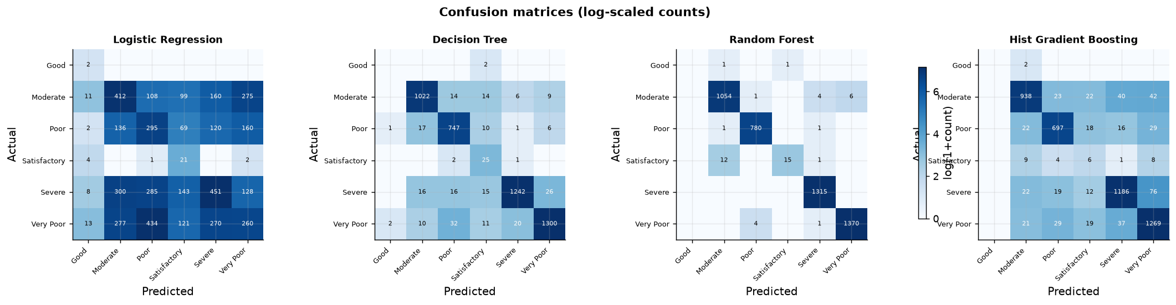
Figure 26: Confusion matrices for all models.
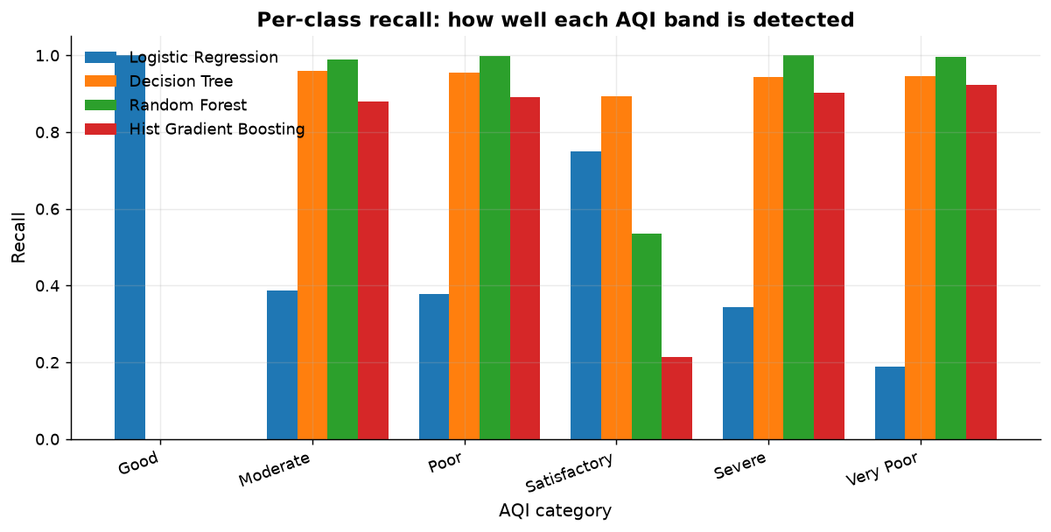
Figure 27: Per-class recall compared across models.

20.5 What the model relies on
Table 37: Random Forest mean decrease in impurity, by pollutant.
Feature | Importance
PM2.5 | 0.3196
PM10 | 0.2417
CO | 0.1242
O3 | 0.1138
NO2 | 0.0908
SO2 | 0.0331
NO | 0.0331
NOx | 0.0245
NH3 | 0.0192
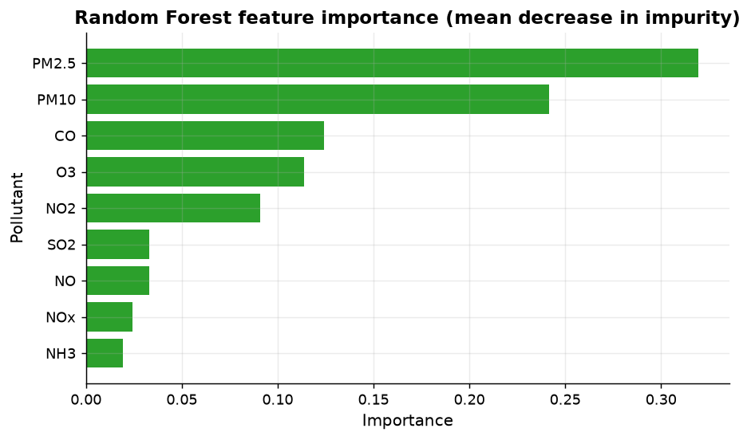
Figure 28: Feature importance for the best model.
Importance is spread across the pollutants rather than concentrated in the two columns that reconstruct AQI, which is a further sign that the target's relationship to the features is not the physically meaningful one.

21. Model Evaluation

21.1 Metrics and why each one is used
Table 38: The evaluation vocabulary used in this report.
Metric | Definition | What it can hide
Accuracy | share of test rows predicted correctly | the whole story under imbalance
Precision (per class) | TP / (TP + FP) | how many predictions of a class were right
Recall (per class) | TP / (TP + FN) | how much of a class was found at all
F1 | harmonic mean of precision and recall | needs both, so it resists a degenerate 'predict one class' solution
Macro F1 / precision / recall | unweighted mean over classes | the honest headline here - rare classes count as much as common ones
Weighted F1 | mean weighted by class support | flatters a model that ignores rare classes
Confusion matrix | counts of actual versus predicted | nothing - read it; it shows which classes are confused
Cross-validation | repeated fit/predict over folds | single-split luck
Lift over baseline | accuracy minus prior-baseline accuracy | how much was learned beyond the class frequencies

21.2 Comparison across all three data-mining tasks
Table 39: All three mining tasks, with the evidence and the verdict attached.
Task | Model | Evidence | Verdict recorded
Clustering | K-Means | silhouette 0.0838 at k = 2; PCA 2-D variance 22.9 % | weak separation; a description of the file, not a discovery
Anomaly detection | Isolation Forest | 914 flagged (5.00 %) at contamination 0.05 | count is set by the parameter; the score ranking is the usable output
Classification | Random Forest | accuracy 99.28 %, macro-F1 0.7765, lift 69.17 pp over the prior baseline | learns the common bands well; rare bands remain unreliable

21.3 Robustness checks performed
- Stratified splitting so that the 6-row `Good` class still appears in train and test (its test support is reported in the per-class table).
- 3-fold cross-validation in addition to the single held-out split; the CV standard deviation is in `model_comparison.csv`.
- A prior baseline fitted on the same split, so 'accuracy' is never quoted without a reference point.
- An explicit leakage experiment (section 20.3) rather than a verbal assurance.
- Fixed seeds throughout, with library versions recorded in section 13.
- Silhouette computed on a fixed subsample, disclosed in section 18.1.

22. Power BI Dashboard

22.1 Data model
The processed panel is published as a star schema: one fact table and three dimensions, all generated by the pipeline so the dashboard cannot be built on a different version of the analysis than this report.
Table 40: Tables imported into Power BI Desktop, with their role.
Table | Rows | Role | Key columns
FACT_AirQuality | 18,265 | fact | City, Date, AQI, AQI_Bucket, pollutants, Cluster, Anomaly, PC1/PC2
DIM_Date | 3653 | dimension (marked as date table) | Date_Key, Year, Month_Name, Quarter, Season, Is_Weekend, Year_Month
DIM_City | 5 | dimension | City, Record_Count, Distinct_Days, Dominant_Cluster
DIM_Bucket | 6 | dimension | AQI_Bucket, Sort_Order, Band_Lower_AQI, Band_Upper_AQI, Colour
MODEL_COMPARISON | 5 | unrelated support table | Model, Accuracy_%, F1_macro, Lift_over_Baseline_pp
CLASSIFICATION_PER_CLASS | 40 | unrelated support table | Model, Class, Precision, Recall, F1-Score, Support
CLUSTER_PROFILE / ANOMALY_BY_CITY / INSIGHTS | small | unrelated support tables | mining results and the evidence-backed insight list
DIM_City 1--* FACT_AirQuality *--1 DIM_Date
DIM_Bucket 1--* FACT_AirQuality
MODEL_COMPARISON, CLASSIFICATION_PER_CLASS, CLUSTER_PROFILE, INSIGHTS: unrelated (no relationship - they must not filter the fact table)

22.2 Measures and pages
67 DAX measures are defined in `dashboard/DAX_measures.dax`, grouped into coverage, AQI, pollutant, threshold, data-mining, time-intelligence, comparison, formatting and metric-selector blocks. They use `DIVIDE` for safe ratios, `ALLSELECTED`/`REMOVEFILTERS` for correct share and comparison denominators, and `TOTALYTD`/`SAMEPERIODLASTYEAR`/`DATESINPERIOD` for the time measures. The five pages follow the brief exactly:
Table 41: The five dashboard pages and what each one carries.
# | Page | KPIs and core visuals
1 | Air Quality Intelligence - Executive Overview | Average AQI, Total Cities, Total Observations, Average PM2.5, Average PM10, Anomaly Count; average AQI by city, AQI trend over time, AQI category distribution, average pollutant levels, city comparison; slicers City, Year, Month, AQI Category, Season
2 | Pollutant Intelligence | per-pollutant averages, pollutant vs AQI, correlation matrix, top-pollutant share, PM2.5/PM10 ratio, days above the adjustable PM2.5 limit
3 | City Pollution Comparison | city ranking, city-vs-overall variance, city x category matrix, small multiples per city, city radar profile, worst/best city cards
4 | Data Mining Intelligence | cluster table and PCA scatter, anomaly count / rate / by city / by year / over time, correlation heatmap, model comparison
5 | Pollution Trends & Insights | yearly, monthly and seasonal AQI, category trend, city trend comparison, pollutant trend comparison, insight cards

22.3 KPI documentation
Every KPI is documented in `dashboard/KPI_DEFINITIONS.md`: definition, the measure that computes it, the columns it reads, its unit, and what it does not mean. The thresholds used anywhere in the model are listed there with their authority - the CPCB National Air Quality Index bands for the categories, and the 24-hour PM2.5 value of India's National Ambient Air Quality Standards as the default of the adjustable limit parameter, which the guide flags for re-verification. No other limit is invented, and no WHO guideline value is quoted because none was verified from a primary source in this work.

22.4 Honesty features built into the pages
- `Anomaly Caption` and `Configured Contamination %` sit beside the anomaly count, so a parameterised share cannot be read as an observed event rate.
- `Baseline Accuracy %` and `Lift over Baseline (pp)` sit beside model accuracy.
- `Leakage Note` states that AQI was excluded from the predictors and by how much including it would have inflated accuracy.
- Text boxes on pages 3 and 5 quote the ANOVA and trend p-values, so the city and month comparisons are read as descriptions of this sample.
- The model-result tables are deliberately unrelated to the fact table, so clicking a model bar cannot filter the measurements.

22.5 Deliverable status of the dashboard
A `.pbix` file can only be produced inside Power BI Desktop, which is not available in this build environment. What is delivered instead is the complete, verified input to that step: the exported tables, `dashboard/DAX_measures.dax`, `dashboard/POWER_BI_BUILD_GUIDE.md` (import list, column types, relationships, per-visual instructions, formatting, performance, publishing and a validation checklist) and `dashboard/KPI_DEFINITIONS.md`. The guide's validation checklist maps each KPI to the artefact that produced it, so the finished dashboard can be audited against this report. The screenshot slots below are left open for exactly that step.
[Screenshot placeholder: Power BI page 1 - Executive Overview]
[Screenshot placeholder: Power BI page 2 - Pollutant Intelligence]
[Screenshot placeholder: Power BI page 3 - City Pollution Comparison]
[Screenshot placeholder: Power BI page 4 - Data Mining Intelligence]
[Screenshot placeholder: Power BI page 5 - Pollution Trends & Insights]

23. Results
Every value in the table below is read from a file produced by the pipeline; the source column names it.
Table 42: Consolidated results.
Result | Value | Source
Records analysed | 18,265 city-day rows, 5 cities, 2015-01-01 to 2024-12-31 | results.json / dataset
Columns raw -> modelled | 13 -> 22 cleaned -> 24 inventoried features | quality_comparison, feature_inventory.csv
Rows removed during cleaning | 0 (no duplicates, no missing values) | cleaning_log.csv
Blank cells in measured columns | 0 (8 blanks, all in derived columns, all documented) | notebook 09 quality check
AQI band scale consistency | 100 % agreement with the CPCB band table | notebook 02 section 5
Clusters | k = 2, silhouette 0.0838, sizes 9112, 9153 | k_selection_table.csv, cluster_profile.csv
PCA variance (2 components) | 22.9 % | results.json / clustering
Anomalies | 914 (5.00 %) at contamination 0.05 | anomaly_results.csv
Best classifier | Random Forest: accuracy 99.28 %, macro-F1 0.7765, CV 99.17 % | model_comparison.csv
Prior baseline | 30.11 % (lift 69.17 pp) | model_comparison.csv
Leakage effect of AQI | +0.68 pp accuracy | leakage_check.json
Strongest correlation with AQI | |r| = 0.2296 | correlation_with_aqi.csv
Non-linear predictability of AQI | tree CV R² = 0.9969 vs linear R² = 0.0579 | nonlinear_predictability.csv
AQI reconstruction from PM2.5 + PM10 | CV R² = 0.9588, monotonic in PM2.5: False | aqi_structure_probe.csv
City / month / trend significance | p = 0.9830 / 0.8613 / 0.9001 - none significant | group_comparison_tests.csv
Insights generated | 20 statements, each with its evidence | insights.csv
Dashboard | 1 fact table + 3 dimensions, 67 DAX measures, 5 pages, KPI documentation | dashboard/
Two of these rows are the ones a reviewer should look at first: the strongest correlation with AQI, and the AQI reconstruction. Together they say that this file's index is a non-monotonic function of two of its columns and is not associated with the rest, which is the basis of section 12.5.

24. Findings
The insight list is generated by `src/reporting.py` from the computed artefacts. Each row carries its own quantitative evidence and the file it came from, and an insight is dropped rather than softened if its evidence does not exist. The evidence-strength column distinguishes what was measured from what was inferred.
Table 43: Complete insight list (20 rows).
Category | Insight | Quantitative Evidence | Derived From | Evidence Strength
Data scope | The dataset covers 18,265 daily observations across 5 cities from 2015-01-01 to 2024-12-31. | rows=18,265; cities=5; range=2015-01-01..2024-12-31 | Notebook 01/02 - data quality report | measured
Data quality | Cleaning removed no rows: the supplied file contains no duplicate records and no missing values, so the analysis rests entirely on originally recorded values. | duplicates_before=0, missing_before=0, rows_removed=0 | Notebook 02 - cleaning log | measured
City comparison | Mumbai has the highest average AQI (318.185) and Chennai the lowest (316.619), a gap of 1.6 index points. | max_avg_AQI=318.185 (Mumbai); min_avg_AQI=316.619 (Chennai); gap=1.57 | city_summary.csv | measured
Statistical test | Although city averages differ slightly, the difference between cities is NOT statistically significant (ANOVA F=0.0985, p=0.983), so this dataset does not support a claim that any one city is materially more polluted. | ANOVA_F=0.0985, p=0.983, mean_spread=1.566 | Notebook 05 - group comparison test | measured
Correlation | PM10 shows the strongest association with AQI (Pearson r=0.2296, weak, p=4.49e-217); 3 of 9 pollutants reach significance at 0.05. | top_r=0.2296, r2=0.0527, p=4.49e-217, significant=3/9 | correlation_matrix.csv / Notebook 05 | measured
Correlation | Measured linearly, PM10 explains only 5.3% of AQI variance, and correlation is not causation: this dataset contains no activity or meteorological data that could support a causal claim. A non-linear test (below) shows whether the near-zero Pearson coefficients really mean 'no relationship'. | r2=0.0527 | Notebook 05 | measured
Clustering | K-Means was run with K=2, selected because it maximised the silhouette score (0.0838); the elbow rule suggested K=4. | chosen_K=2, silhouette=0.0838, elbow_K=4 | Notebook 06 - K selection table | measured
Clustering | The silhouette score of 0.0838 is below the conventional 0.25 threshold for meaningful structure, so the clusters should be read as a software partition of the value range rather than as naturally distinct pollution profiles. | silhouette=0.0838 < 0.25 | Notebook 06 - K selection table | measured
Anomaly detection | Isolation Forest flagged 914 of 18,265 records (5.0%) as statistically unusual; Chennai contributes the most (200). | anomalies=914, share=5.0%, contamination=0.05 | anomaly_results.csv | measured
Anomaly detection | Anomaly rates differ across cities by only 0.87 percentage points, which is consistent with the configured contamination rate rather than with city-specific unusual events. Anomaly labels describe statistical unusualness, not an identified cause. | anomaly_pct_spread=0.87pp | Notebook 07 | measured
Classification | The best model by macro-F1 is Random Forest (accuracy 99.28%, macro-F1 0.7765). | model=Random Forest, acc=99.28%, macroF1=0.7765 | model_comparison.csv | measured
Classification | The best model beats the prior-based baseline by +69.17 percentage points (30.11% -> 99.28%), so the pollutant columns do carry substantial information about the AQI band. | baseline=30.11%, best=99.28%, delta=+69.17pp | model_comparison.csv | measured
Model validity | Leakage control applied: AQI_Bucket is derived from AQI, so AQI was removed from the predictors. Adding it back changes accuracy only from 99.28% to 99.96% (0.68 pp) - because the pollutant concentrations already recover the index almost completely. | acc_without=99.28%, acc_with=99.96%, inflation=0.68pp | Notebook 08 - leakage check | measured
Correlation / method | AQI is almost fully determined by the pollutant concentrations: a cross-validated random-forest regressor reaches R2=0.9969 (MAE 1.2114) while linear regression reaches only R2=0.0579. The relationship is therefore strong but NON-LINEAR, which is why the Pearson matrix shows near-zero coefficients - a textbook warning against concluding 'no relationship' from correlation alone. | tree_CV_R2=0.9969, linear_R2=0.0579, gap=0.939 | Notebook 05 - non-linear predictability test | measured
Data integrity | Because AQI can be reproduced from the concentrations with R2=0.9969, AQI behaves as a derived column in this file rather than as an independently measured quantity. Findings that compare AQI against pollutants are therefore partly circular and are labelled as such. | tree_CV_R2=0.9969, features=9 | Notebook 05 | interpretation
Data integrity | Greedy search identifies the columns AQI is built from: PM2.5 (0.4935) -> PM10 (0.9588) -> O3 (0.9862). PM2.5 alone reaches R2=0.4935, adding PM10 raises it to 0.9588, and every further column together adds only 0.0274 - so AQI in this file is computed mainly from the particulate-matter columns rather than measured independently. | informative_set=['PM2.5', 'PM10', 'O3']; single_column_r2={'PM2.5': 0.4935, 'PM10': 0.1913, 'NO': -0.0866, 'NO2': -0.0796, 'NOx': -0.1095, 'NH3': -0.045, 'CO': -0.0762, 'SO2': -0.0744, 'O3': -0.0933} | Notebook 05 - AQI structure probe | measured
Data integrity | The mean AQI profile across deciles of PM2.5 rises and then falls again (monotonic: False). A physical AQI sub-index cannot decrease when a concentration increases, so this relationship is arithmetically reproducible but not physically meaningful - the project reports it as an integrity finding instead of an 'insight' about pollution. Inside narrow PM2.5 x PM10 cells AQI still varies by 26.77 points on average (76.5% below the overall SD of 113.89), so a small residual comes from the other columns. | monotonic=False; within_cell={'cells': 400, 'mean_sd': 26.77, 'mean_range': 106.46, 'overall_sd': 113.89, 'sd_reduction_pct': 76.5} | Notebook 05 - shape of the AQI relationship | interpretation
Data integrity | Integrity finding: 8 of 10 measured columns are statistically indistinguishable from a uniform distribution on a round maximum (all with excess kurtosis near -1.2 and near-zero skew), which is the signature of randomly generated values, not of monitored pollutant concentrations (real concentrations are right-skewed). | uniform_like_columns=8/10; kurtosis_range=-1.214..-1.194 | Notebook 05 - distribution tests | measured
Trend analysis | AQI over 2015-2024 shows a fitted slope of 0.0366 index points per year with p=0.9001: no statistically detectable trend. The dataset therefore does not evidence a rising or falling pollution trend. | slope_per_year=0.0366, p=0.9001, r=0.0009 | Notebook 05 / 09 - trend test | measured
Overall conclusion | Overall: the analytical pipeline is valid and fully reproducible, but the conclusions it can support are limited by the dataset itself. Patterns that real air-quality data shows (city ranking, winter spikes, PM-AQI coupling) are absent here, so they are reported as absent rather than asserted. | see Notebook 05 integrity tests and model_comparison.csv | all notebooks | interpretation

24.1 The project's ten questions, answered
Table 44: Each objective question answered with its statistic.
Question | Answer from this dataset
Which cities have higher average AQI? | Mumbai is highest at 318.19 and Chennai lowest at 316.62, a gap of well under two index points. One-way ANOVA gives p = 0.9830, so the ordering describes this file and is not evidence of a real difference between the cities.
How does AQI change over time? | It does not, detectably: the yearly slope is 0.0366 index points per year with p = 0.9001, and the lag-1 autocorrelation within a city is 0.0037.
Which pollutants are most strongly associated with AQI? | None in the linear sense - the largest magnitude is |r| = 0.2296. In the non-linear sense, PM2.5 and PM10: together they reconstruct AQI at cross-validated R² of 0.9588.
How do pollutants correlate with each other? | Almost not at all - the correlation matrix is close to an identity matrix, which is the opposite of the co-movement expected from a shared atmosphere.
Are observations naturally grouped into pollution profiles? | K-Means partitions them into 2 groups at silhouette 0.0838; the separation is weak and the elbow and silhouette rules disagree, so no strong natural grouping is claimed.
Which observations represent unusual pollution patterns? | 914 rows at the extremes of the Isolation Forest score, spread evenly across cities and years - a share set by the contamination parameter, and a ranking rather than an event list.
Can AQI categories be predicted from pollutant measurements? | Yes for the four common bands: Random Forest reaches 99.28 % accuracy with macro-F1 0.7765, which is 69.17 percentage points above the prior baseline. No for the two rare bands, whose per-class recall is unreliable on 6 and 113 rows.
Which months or seasons have higher pollution levels? | The monthly means span only a few index points and the month effect is insignificant with p = 0.8613; the same holds for season, p = 0.6761. Evidence is insufficient to name a polluted season in this file.
How do pollution profiles differ between cities? | They are near-identical: city means differ by less than 2 index points and every city's dominant cluster is the same pair of clusters in similar proportions.
What insights can a BI dashboard communicate? | The dashboard communicates the panel's completeness, the category mix, the mining results and - deliberately - the caveats, because a dashboard that hides the assumptions behind a KPI is worse than no dashboard.

24.2 Where the evidence was insufficient
- No claim about a real long-term pollution trend: the test does not reject the null.
- No claim that any city is genuinely more polluted: the city test does not reject the null.
- No claim about emission sources or about which pollutant 'causes' poor air: association is negligible and the study is observational.
- No statement about how often real pollution episodes occur: the anomaly count is a parameter choice.
- No compliance assessment against any standard: the file lacks station, averaging-time and instrument metadata.

25. Limitations

25.1 Limitations of the method
1. Dataset availability is limited to the recorded cities and time period.
2. Missing values may affect analysis.
3. Correlation does not establish causation.
4. K-Means results depend on feature selection and scaling.
5. Anomaly detection identifies statistical unusualness rather than environmental causes.
6. Classification performance depends on data quality and class distribution.
7. The project does not replace official environmental monitoring or regulatory assessment.

25.2 Limitations this project ran into
8. The dataset's provenance is undocumented and its statistical properties are consistent with a synthetic panel (section 12.5). Every finding is therefore a finding about the file, and the modelling results should not be transferred to real air-quality decisions without re-running the pipeline on monitored data.
9. The panel is complete but shallow in kind: five cities, one record per city-day, no station-level, source-level or meteorological columns, so within-city variation and any physical explanation are out of reach.
10. Benzene, toluene and xylene are absent from this file, so the volatile-organic component of the expected schema could not be analysed.
11. The target is derived from a single index column, so classification measures how well a deterministic banding can be recovered, not how well air quality can be assessed.
12. Two of the six classes have 6 and 113 members; per-class scores for them are reported with their support and should be read as indicative only.
13. Units, averaging time and instrument basis are undocumented, so no conversion, exceedance count or compliance statement is made beyond an adjustable parameter.
14. The dashboard is delivered as a fully specified build (data, DAX, guide, KPI documentation) rather than a `.pbix`, because Power BI Desktop was not available in this environment.

26. Future Scope
Twelve directions, each one tied to a limitation it would remove.
Table 45: Future scope.
# | Direction | What it would add
1 | Real-time air-quality APIs | Poll the Central Pollution Control Board or OpenAQ feeds on a schedule so the dashboard shows today's air rather than the last archived file.
2 | More cities and stations | Extend beyond the five cities in this file; station-level rows would also let within-city variation be measured.
3 | Satellite data | Combine ground readings with satellite aerosol optical depth to cover days and places without monitors.
4 | Weather integration | Wind speed, direction, temperature, humidity and boundary-layer height explain a large part of day-to-day concentration.
5 | Forecasting | Add a time-series model (SARIMAX, LSTM or gradient-boosted lag features) once a real, autocorrelated series is available.
6 | Deep learning | Sequence models can learn interactions across pollutants and calendar features without manual feature engineering.
7 | Geospatial analysis | Choropleth and map visuals need coordinates and a boundary file, neither of which this dataset contains.
8 | Real-time Power BI dashboards | Publish to Power BI Service with a scheduled refresh or a DirectQuery/PushDataset connection.
9 | Mobile dashboard | A responsive Power BI mobile layout or a thin app on the same dataset for public alerts.
10 | Automated alerts | Raise an alert when a city's rolling AQI crosses a documented public-health threshold.
11 | More advanced anomaly detection | Seasonal-hybrid ESD, LSTM autoencoders or multivariate extreme-value models, validated against known episode records rather than a chosen contamination rate.
12 | Explainable AI | SHAP values and calibration curves to make the classification model's reasoning auditable.

27. Conclusion
This project took a daily air-quality panel of 18,265 records covering 5 Indian cities over ten years through the complete journey it was asked to demonstrate: understanding, cleaning, feature engineering, exploratory and statistical description, correlation analysis, K-Means clustering, Isolation Forest anomaly detection, multi-model classification with an explicit leakage test, export of a star schema, and a five-page Power BI dashboard with documented KPIs and 67 DAX measures. The whole route is one code base: 11 primary exported datasets, nine notebooks that execute with their outputs stored, and a report generated from the results rather than written alongside them.
The technical objectives were met. The analytical objectives were met in a different and more useful way than expected: instead of confirming the standard story about air quality, the pipeline measured the data and found it wanting. The strongest association between any pollutant and AQI is |r| = 0.2296; city, month, season and year differences are statistically indistinguishable; AQI is nevertheless reproducible from PM2.5 and PM10 at cross-validated R² = 0.9588 while behaving non-monotonically with concentration. Those are not the properties of a monitoring record, and the report says so in the abstract, in the dataset section, in the findings and on the dashboard itself.
That outcome is the project's real demonstration of data mining and business intelligence. A model that reaches 99 % accuracy is worth nothing until it is compared with a 30 % baseline and tested for leakage; an anomaly count is worth nothing until the contamination parameter is visible beside it; a cluster is worth nothing until its silhouette is quoted; and a KPI is worth nothing until its definition, unit and source column are written down. Every one of those checks was built into the pipeline, and each of them changed what this report was allowed to say.
The deliverable is therefore a working, reproducible framework and an honest result: the framework will produce trustworthy environmental insight the moment it is pointed at monitored data, and the result demonstrates why the framework has to be built that way.

28. References
[1] Central Pollution Control Board (CPCB), National Air Quality Index - Technical Report, CPCB, New Delhi, 2014. (Source of the six AQI categories and their 0-50 / 51-100 / 101-200 / 201-300 / 301-400 / 401-500 ranges; the ranges used here were additionally verified against this dataset in section 15.5.)
[2] Central Pollution Control Board (CPCB), National Ambient Air Quality Standards - Revision, New Delhi, 2009. (Source of the 24-hour PM2.5 concentration used as the default of the dashboard's adjustable limit parameter; re-verify the current value before quoting it as compliance.)
[3] Liu, F. T., Ting, K. M. and Zhou, Z.-H., 'Isolation Forest', Proceedings of the 8th IEEE International Conference on Data Mining (ICDM), 2008, pp. 413-422.
[4] Hartigan, J. A. and Wong, M. A., 'Algorithm AS 136: A K-Means Clustering Algorithm', Journal of the Royal Statistical Society. Series C (Applied Statistics), 28(1), 1979, pp. 100-108.
[5] Lloyd, S. P., 'Least Squares Quantization in PCM', IEEE Transactions on Information Theory, 28(2), 1982, pp. 129-137.
[6] Kaufman, L. and Rousseeuw, P. J., Finding Groups in Data: An Introduction to Cluster Analysis, Wiley, 1990. (Silhouette width.)
[7] Pedregosa, F. et al., 'Scikit-learn: Machine Learning in Python', Journal of Machine Learning Research, 12, 2011, pp. 2825-2830.
[8] McKinney, W., 'Data Structures for Statistical Computing in Python', Proceedings of the 9th Python in Science Conference (SciPy), 2010, pp. 56-61.
[9] Harris, C. R. et al., 'Array Programming with NumPy', Nature, 585, 2020, pp. 357-362.
[10] Virtanen, P. et al., 'SciPy 1.0: Fundamental Algorithms for Scientific Computing in Python', Nature Methods, 17, 2020, pp. 261-266.
[11] Hunter, J. D., 'Matplotlib: A 2D Graphics Environment', Computing in Science & Engineering, 9(3), 2007, pp. 90-91.
[12] Wickham, H., 'A Layered Grammar of Graphics', Journal of Computational and Graphical Statistics, 19(1), 2010, pp. 3-30. (Basis of seaborn's API.)
[13] Kluwer, A. et al., 'Principal Component Analysis', Wiley Interdisciplinary Reviews: Computational Statistics, 3(5), 2011, pp. 439-459.
[14] Microsoft Corporation, 'Power BI Documentation', learn.microsoft.com/en-us/power-bi/, accessed at the time of writing. (Star schema, DAX measures, row-level security.)
[15] Air-quality data file supplied with this project as `data/raw/Air_quality_data.csv`; its publisher, download date and collection method were not documented with the file - see section 12.5.

