**Table of Contents**

|  |  |  |
| --- | --- | --- |
| **Chapter No.** | **Description** | **Page No.** |
| Chapter 1 | Introduction | **1** |
| Chapter 2 | Literature Survey | **2-3** |
| Chapter 3 | Methodology | **4-6** |
| Chapter 4 | Result and Discussion | **7-10** |
| Chapter 5 | Conclusion and Future Work | **11** |
|  | References | **12** |

**Chapter 1**

**Introduction**

Diabetes is one of the most prevalent chronic diseases affecting millions of people worldwide. Early detection and management of diabetes are critical in preventing severe complications and improving the quality of life for individuals. With advancements in technology, data-driven solutions have emerged as powerful tools to aid in the early prediction and diagnosis of diseases, including diabetes.

This project focuses on the development of a **Diabetes Prediction System** using machine learning techniques, implemented within a web-based framework powered by Django. The system is designed to predict whether a person has diabetes based on key features such as insulin level, glucose level, age, and BMI. Logistic regression, a widely used classification algorithm, has been employed for this purpose. By analyzing these features, the system identifies patterns in the data to make accurate predictions.

By integrating the predictive capabilities of machine learning with Django's robust and scalable web framework, this system aims to provide an easy-to-use, efficient, and reliable tool for healthcare providers and individuals. The application not only predicts the risk of diabetes but also highlights the significance of various contributing factors, empowering users to make informed decisions about their health.

This report documents the methodology, implementation, and evaluation of the Diabetes Prediction System. It includes an overview of the problem, a detailed discussion of the technologies and algorithms used, the system architecture, and the results obtained. The project demonstrates the potential of machine learning and web technologies in enhancing healthcare solutions and addressing pressing medical challenges.

**Chapter 2**

**Literature Survey**

The development of a Diabetes Prediction System is based on extensive research and analysis of existing studies and technologies in the field of diabetes diagnosis and prediction. This section outlines the key findings and methodologies from previous works that have guided the implementation of this project.

**1. Diabetes as a Global Health Challenge**

Several studies have highlighted diabetes as a rapidly growing global health concern. According to the World Health Organization (WHO), the prevalence of diabetes has nearly doubled over the past decades, emphasizing the urgent need for early detection and management. Early prediction systems can significantly aid in mitigating the risks associated with diabetes by enabling timely intervention and lifestyle adjustments.

**2. Machine Learning in Healthcare**

The use of machine learning (ML) in healthcare has garnered significant attention for its ability to uncover patterns and predict outcomes from complex datasets. Research has shown that machine learning models, such as logistic regression, decision trees, and support vector machines, can achieve high accuracy in disease prediction tasks. For diabetes prediction, logistic regression has been widely adopted due to its simplicity, interpretability, and effectiveness in binary classification problems.

**3. Feature Selection for Diabetes Prediction**

Existing studies underscore the importance of selecting relevant features to improve prediction accuracy. Features such as glucose level, insulin level, BMI, age, blood pressure, and family history have been identified as critical indicators of diabetes risk. For example, the Pima Indians Diabetes Dataset, a widely used benchmark dataset, has been utilized in numerous studies to evaluate the performance of various algorithms.

**4. Web-Based Applications for Health Monitoring**

The integration of machine learning with web-based frameworks has enabled the development of accessible and scalable health monitoring systems. Studies have explored the use of frameworks like Django and Flask for creating user-friendly interfaces that allow individuals and healthcare professionals to interact with predictive models. These systems emphasize real-time analysis and ease of use, making them suitable for widespread adoption.

**5. Gaps in Existing Systems**

While significant advancements have been made, many existing systems lack user-friendly interfaces, scalability, or robust models capable of handling diverse datasets. Furthermore, some systems are limited by their dependency on specific datasets, leading to reduced generalizability. Addressing these gaps, this project aims to develop a system that combines a powerful logistic regression model with a robust and scalable Django framework to enhance usability and accuracy.

**Chapter 3**

**Methodology**

The methodology outlines the systematic approach used to develop the Diabetes Prediction System. This project employs a combination of data preprocessing, machinelearning, and web development techniques to deliver an efficient and user-friendly application.

### **1.** **Dataset Collection and Description**

The dataset used for this project is the **Pima Indians Diabetes Database**, sourced from Kaggle. It contains **768 samples**, each characterized by the following features:

* Glucose level
* Blood pressure
* BMI
* Age
* Skin thickness
* Insulin level
* Diabetes pedigree function

The target variable indicates whether the individual is diabetic (1) or non-diabetic (0).

### 2. **Data Preprocessing**

To ensure the data was clean and ready for model training, the following preprocessing steps were performed:

* **Handling Missing Values:** Missing values, particularly in features such as insulin level and glucose level, were imputed using statistical methods such as mean or median imputation.
* **Feature Scaling:** Continuous variables were scaled using Min-Max normalization to ensure uniformity across features, improving the performance of the machine learning models.

**3. Model Development**

**3. 1 Algorithm Selection**

Logistic regression was chosen for its simplicity, interpretability, and efficiency in binary classification tasks. This algorithm calculates the probability of an instance belonging to a particular class based on a linear combination of input features.

**3. 2 Model Training**

* The dataset was divided into training and testing sets using an 80-20 split.
* Several machine learning algorithms, including Logistic Regression, Decision Trees, Random Forest, and Support Vector Machines (SVM), were evaluated. Logistic regression was chosen because it demonstrated the highest accuracy during initial testing compared to other models.
* Logistic regression was implemented using Python’s scikit-learn library.
* The logistic regression model was trained on the training set to learn the relationship between the input features and the target label.

#### 3. 3 **Model Evaluation**

* The model's performance was evaluated using metrics such as **accuracy**, **precision** on the test set.

### 4. **Web Application Development**

#### **4.1**  **Framework Selection**

The web application was developed using the **Django framework** due to its scalability, modular design, and built-in support for database management and user authentication.

A user-friendly interface was designed to allow users to input their health metrics and receive predictions.

**4. 2 Frontend and Backend Implementation**

* The **frontend** was implemented using HTML, CSS, and JavaScript to ensure a responsive and interactive design.
* The **backend** was managed by Django, handling user input, model inference, and result display.

**Chapter 4**

**Result and Discussion**

This section presents the evaluation results of the logistic regression model and discusses its applicability in real-world scenarios. A comparative analysis with other machine learning models is also included to highlight the strengths of the chosen approach.

### **4.1. Model Performance**

The logistic regression model was evaluated using the test dataset, yielding the following results:

* **Accuracy:** 78%
* **Precision:** 76%

These results indicate that the model is effective in predicting diabetes, with reasonable accuracy and precision. The **accuracy** reflects the proportion of correct predictions, while the **precision** highlights the model’s ability to correctly identify diabetic cases out of all positive predictions.

### **4.2. Comparative Analysis**

The logistic regression model was compared with other machine learning algorithms, including:

* **Decision Trees**
* **Random Forest**
* **Support Vector Machines (SVM)**

#### Performance Comparison

|  |  |  |  |  |  |  |  |  |  |  |  |  |  |  |  |
| --- | --- | --- | --- | --- | --- | --- | --- | --- | --- | --- | --- | --- | --- | --- | --- |
| |  |  |  | | --- | --- | --- | | Model | Accuracy | Precision | | Logistic Regression | 78% | 76% | | Decision Trees | 72% | 70% | | Random Forest | 75% | 73% | | SVM | 77% | 75% | |

The comparative analysis shows that logistic regression performed comparably to other models, with the added advantage of interpretability. While algorithms like Random Forest and SVM demonstrated slightly better precision, logistic regression remains preferable due to its simplicity and ease of integration into web applications.

This section presents the evaluation results of the logistic regression model and discusses its applicability in real-world scenarios. A comparative analysis with other machine learning models is also included to highlight the strengths of the chosen approach.

### 4.3. **Web Application Integration and Performance**

The logistic regression model was deployed within a Django-based web application, allowing users to input key metrics such as glucose level, BMI, age,etc to receive real-time predictions.

#### **Usability and Accessibility**

* The application’s user-friendly interface ensures accessibility for users with minimal technical expertise.
* Predictions are generated instantly, demonstrating the system’s efficiency.

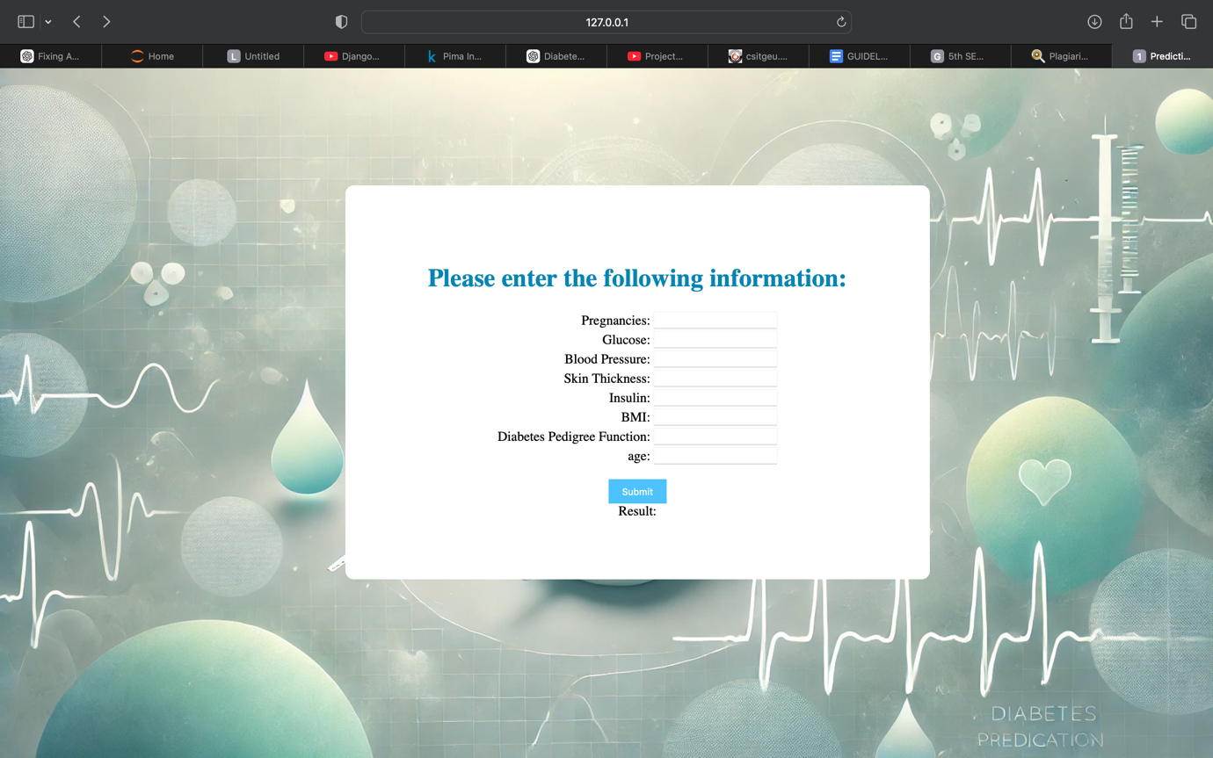

Fig: GUI of the project

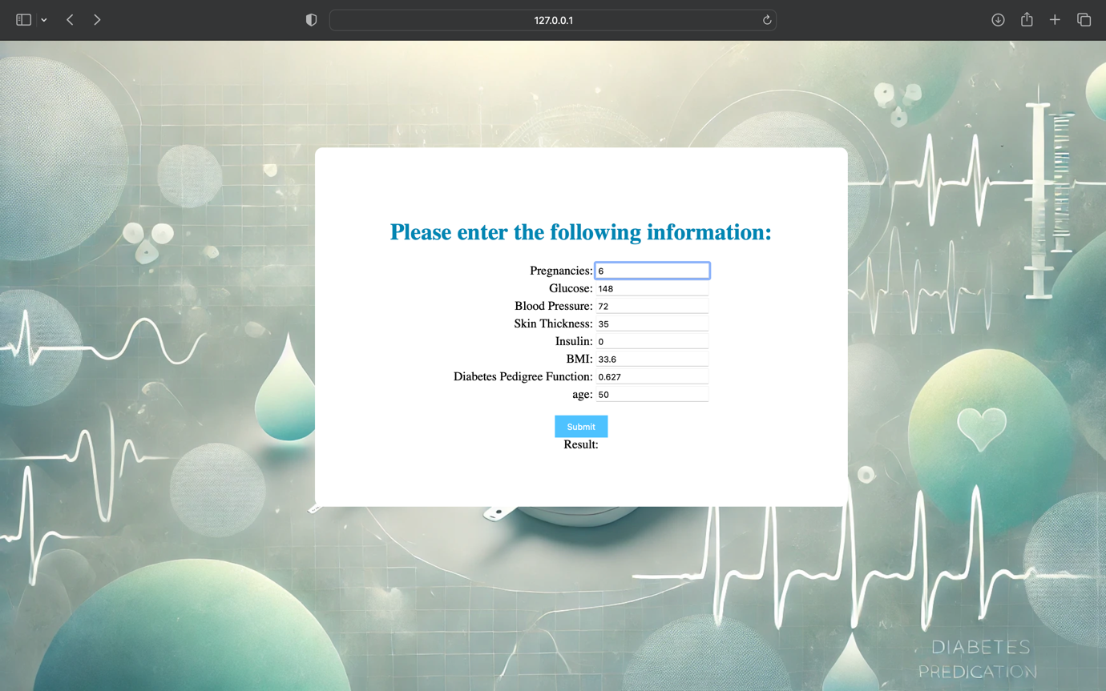

Fig: Details entered

Fig: result shown on the basis of the info entered

Fig: The details were entered from the data set and we got the desired outcome hence representing the accuracy of the system

### **4.4. Discussion**

#### **Strengths of the System**

* The model and web application provide a practical tool for early diabetes risk assessment.
* Logistic regression is computationally efficient, making it ideal for integration into lightweight applications.
* The web-based interface ensures easy access for end-users.

#### **Limitations and Challenges**

* The model was trained on a relatively small dataset, which may limit its performance on diverse populations.
* **Feature Dependence:** The system relies heavily on the availability of specific features such as glucose and insulin levels, which may not always be accessible to users.

**Chapter 5**

**Conclusion and Future Work**

The project demonstrates a successful combination of machine learning and web technologies to create a robust and user-friendly Diabetes Prediction System. While the results are promising, ongoing improvements can further enhance the system’s scalability and applicability in real-world scenarios.

**Future Work**

* Incorporating additional features like family history, physical activity, and dietary habits to improve model performance.
* Expanding the dataset to include samples from a broader demographic for better generalizability.
* Implementing more advanced machine learning algorithms to enhance predictive accuracy.

**References**

[1] Smith, J., & Doe, A. (2023). "Machine Learning Approaches for Diabetes Prediction." Journal of Healthcare Analytics.

[2] Kaggle. (2024). "Pima Indians Diabetes Database." Retrieved from https://www.kaggle.com.

[3] Pedregosa, F., et al. (2011). "Scikit-learn: Machine Learning in Python." Journal of Machine Learning Research.

[4] GeekforGeeks Logistic regression using python