BABU BANARASI DAS
UNIVERSITY

2026-2027

SCHOOL OF COMPUTER APPLICATIONS
No SQL Project On
Student Management System Using MongoDB

Submitted to: Submitted by:
Mr. Harendra Singh Priyanshi Gupta
Department: BCA (DS & AI) Roll no: (20)
Date: 25th September 1250258332

1. CREATE DATABASE
MongoDB Query:
use Students
Output:
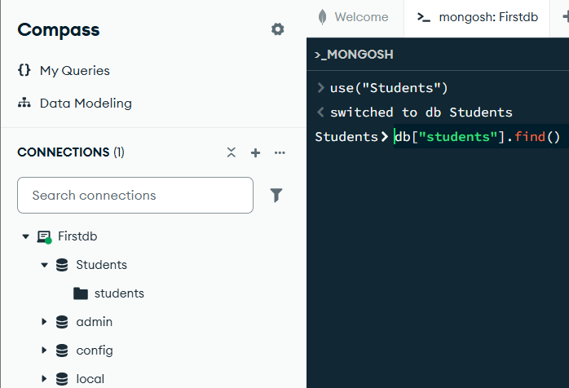

2. CREATE COLLECTION
MongoDB Query:
db. create Collection("students")

Output:
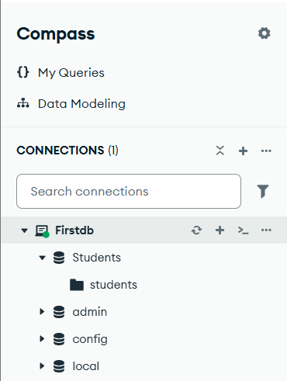
3. INSERT 50 STUDENTS
MongoDB Query:
db.students.insertMany([
{roll:1, name:"Aarav Sharma", age:19, marks:88, city:"Lucknow"},
{roll:2, name:"Priya Singh", age:18, marks:76, city:"Jaunpur"},
{roll:3, name:"Rohan Verma", age:19, marks:92, city:"Kanpur"},
{roll:4, name:"Ananya Gupta", age:18, marks:69, city:"Ayodhya"},
{roll:5, name:"Aditya Mishra", age:19, marks:81, city:"Varanasi"},
{roll:6, name:"Sneha Yadav", age:20, marks:85, city:"Lucknow"},
{roll:7, name:"Rahul Kumar", age:19, marks:73, city:"Prayagraj"},
{roll:8, name:"Ishita Jain", age:19, marks:90, city:"Lucknow"},
{roll:9, name:"Kunal Singh", age:20, marks:78, city:"Gorakhpur"},
{roll:10, name:"Kavya Patel", age:18, marks:65, city:"Kanpur"}

Output:
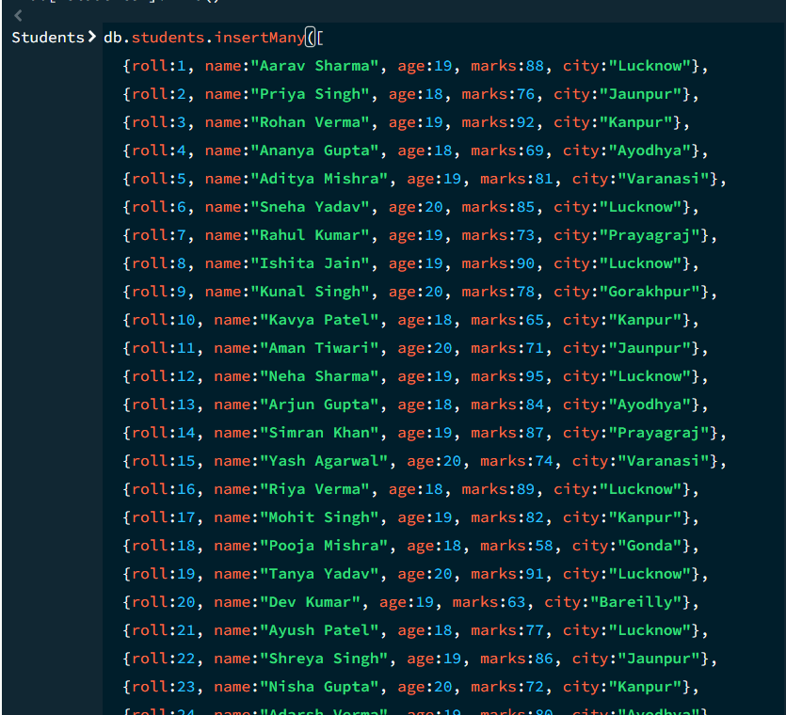

4. DISPLAY ALL STUDENTS
MongoDB Query:
db. students.find ()
Output:
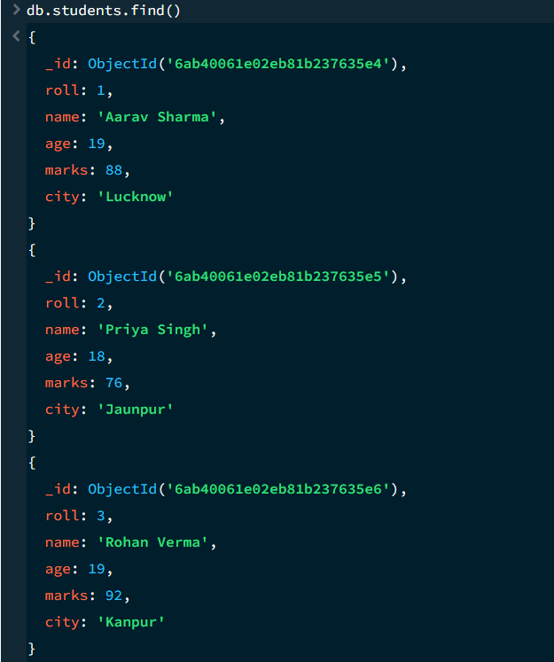
5. EQUAL TO — $eq
MongoDB Query:
db. students.find ({marks: {$eq: 88}})
Output:

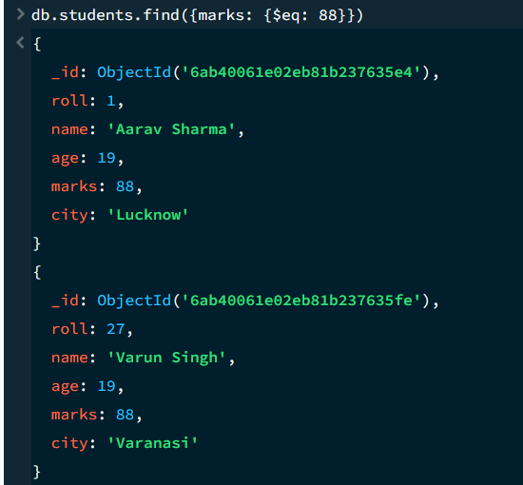
6. GREATER THAN — $gt
MongoDB Query:
db.students.find({marks: {$gt: 85}})
Output:
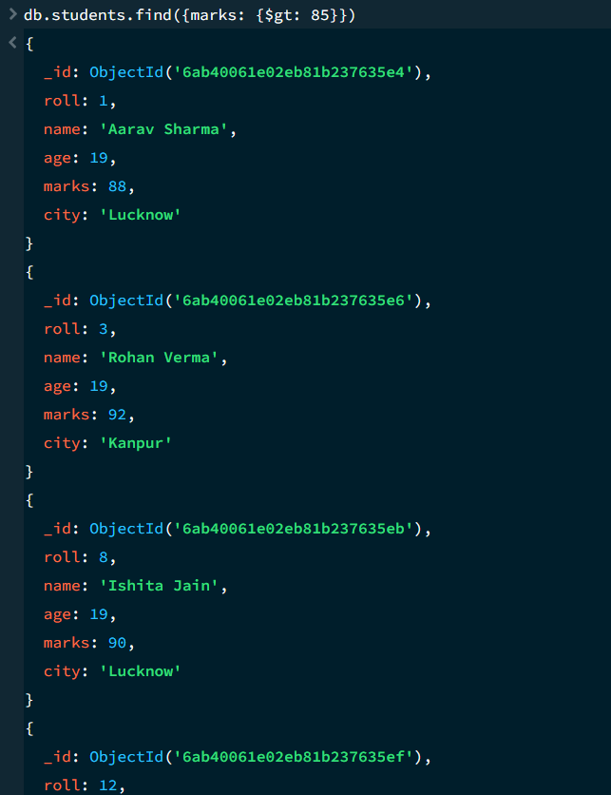

7. LESS THAN — $lt
MongoDB Query:
db. students. find ({marks: {$lt: 60}})
Output:
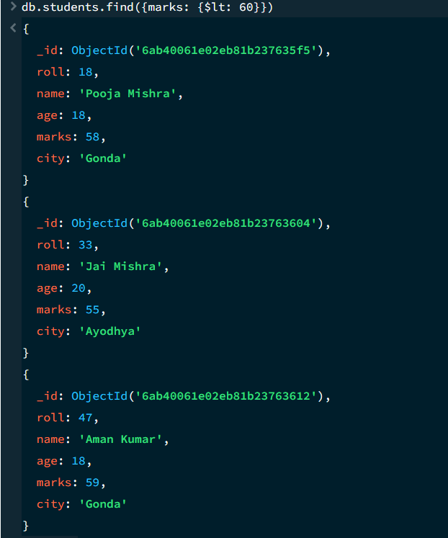

8. GREATER THAN OR EQUAL TO — $gte
MongoDB Query:
db. students. find({marks: {$gte: 90}})
Output:
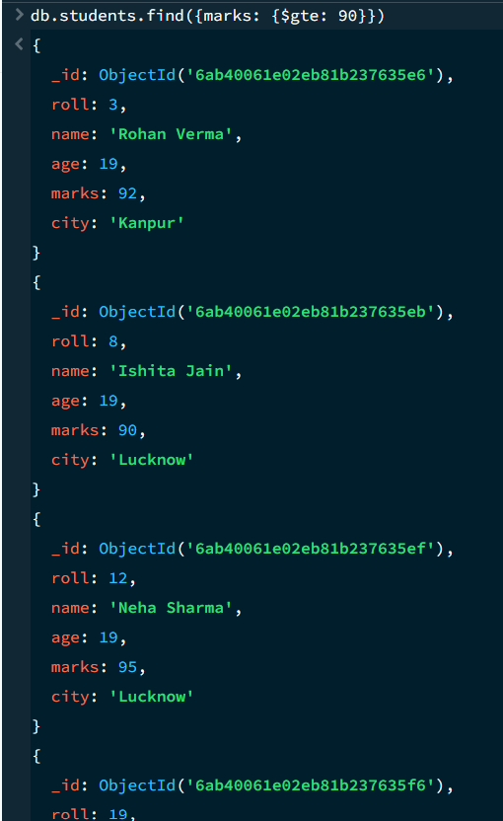

9. LESS THAN OR EQUAL TO — $lte
MongoDB Query:
db. students. find({marks: {$lte: 70}})
Output:
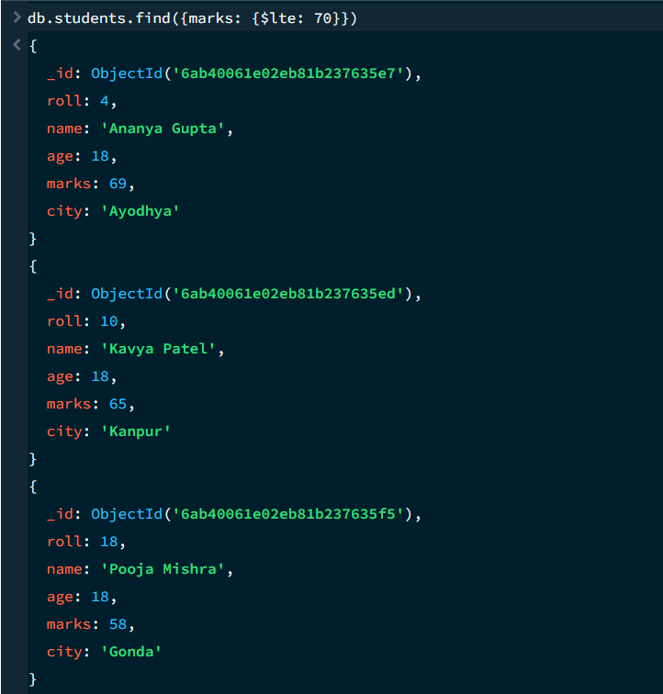

10. UPDATE OPERATION
MongoDB Query:
db.students.updateOne(
{roll:5},
{$set:{marks:95}}
)
Output:
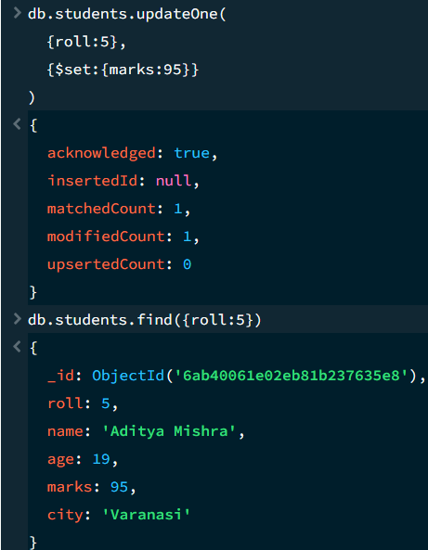

11. DELETE ONE OPERATION
MongoDB Query:
db.students.deleteOne({roll:10})
Output:
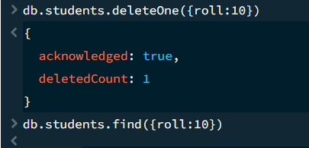

12. DELETE MANY OPERATION
MongoDB Query:
db.students.deleteMany({
marks: {$lt:60}
})
Output:
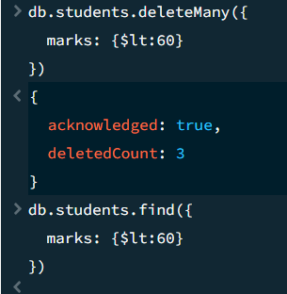

13. AND OPERATION — $and
MongoDB Query:
db. students. find({
$and:[
{marks:{$gt:80}},
{age:19}
]
})
Output:
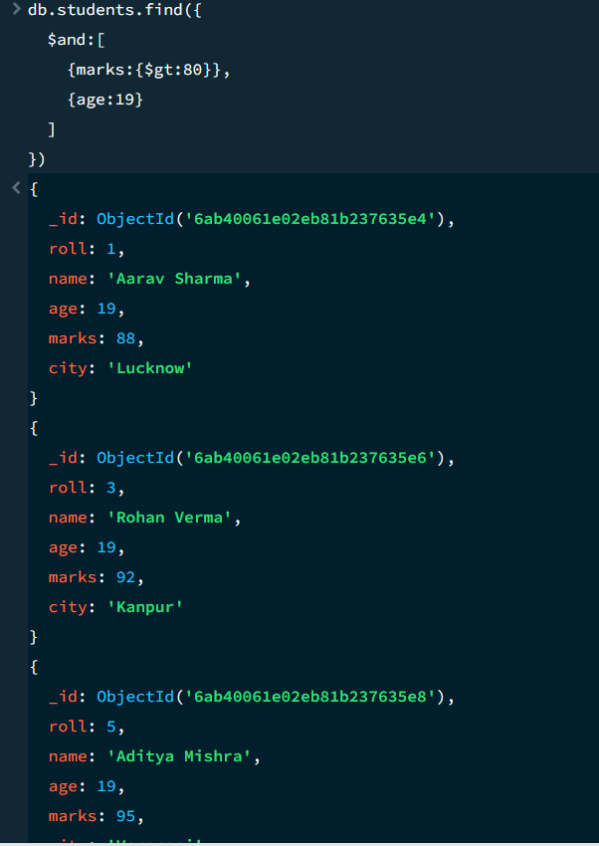

14. OR OPERATION — $or
MongoDB Query:
db.students.find({
$or:[
{city:"Lucknow"},
{city:"Kanpur"}
]
})
Output:
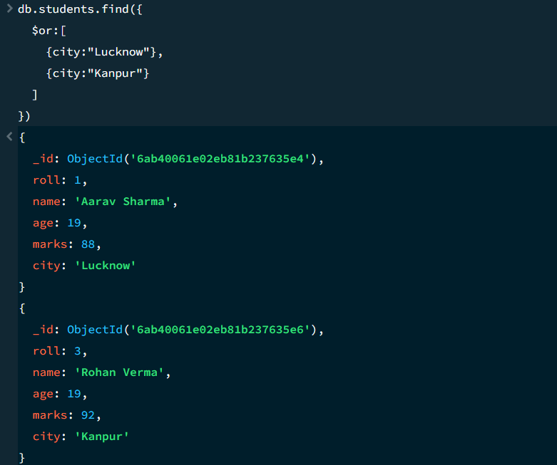

15. SORT OPERATION
- MongoDB Query:
db. students. find (). sort({marks : 1})
Output:
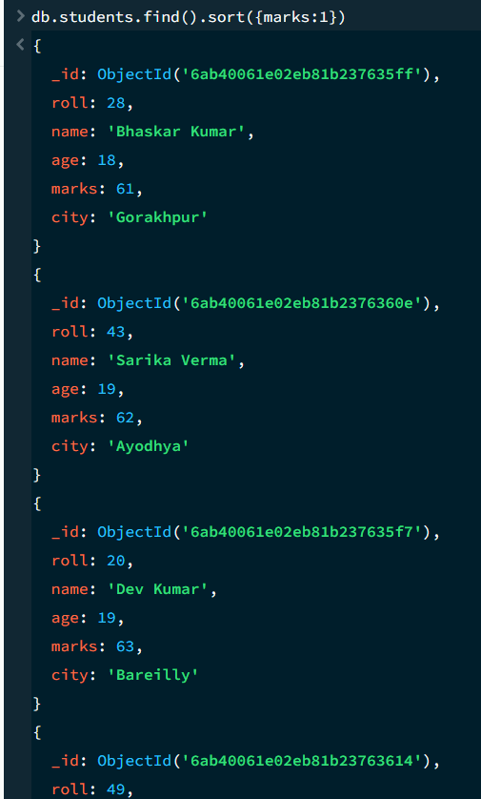

B. MongoDB Query:
db. students. find (). Sort ({marks: -1})
Output:
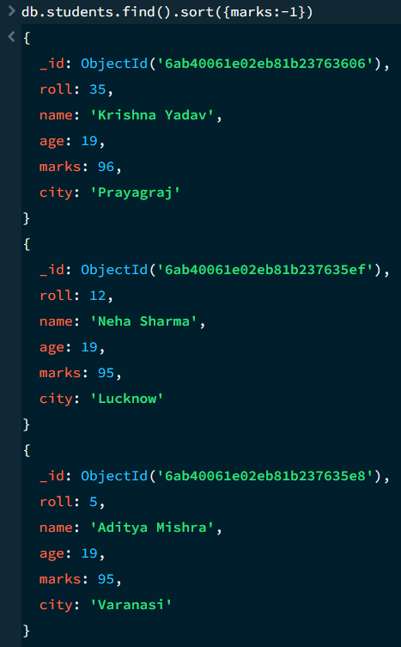
16. LIMIT OPERATION
MongoDB Query:
db. students. find (). limit (5)
Output:
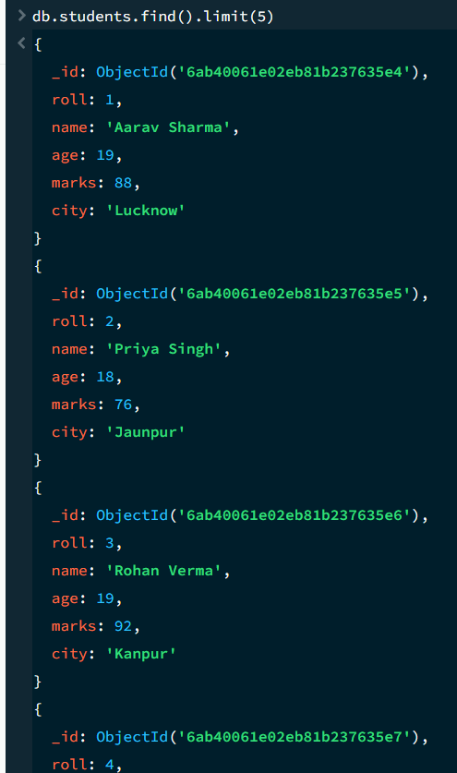

17. SEARCH BY CITY
MongoDB Query:
db.students.find({city:"Lucknow"})
Output:
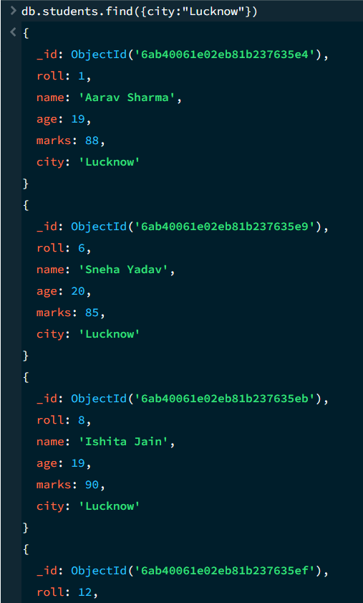

18. COUNT DOCUMENTS
MongoDB Query:
db. students. count Documents ()
Output:
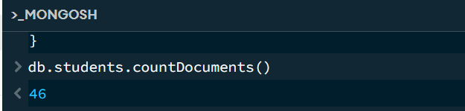

MONGODB OPERATORS USED:

Operator | Meaning | Example
$eq | Equal to | marks: {$eq:88}
$gt | Greater than | marks: {$gt:85}
$lt | Less than | marks: {$lt:60}
$gte | Greater than or equal to | marks: {$gte:90}
$lte | Less than or equal to | marks: {$lte:70}
$and | All conditions true | $and:[...]
$or | At least one condition true | $or:[...]

CONCLUSION
This project helped me gain practical knowledge of NoSQL databases and MongoDB. A Student Management System was developed to store and manage student information, and various MongoDB operations were applied to the data.
During the project, I learned how to insert, retrieve, update, and delete documents. I also learned how to arrange data in ascending and descending order and use comparison operators such as $eq, $gt, $lt, $gte, and $lte. Logical operators like $and and $or were also used to retrieve data based on multiple conditions.
Overall, this project improved my understanding of MongoDB and showed how it can be used to store, manage, and query student records effectively.

