Part A- Coding Practice
Used code chef
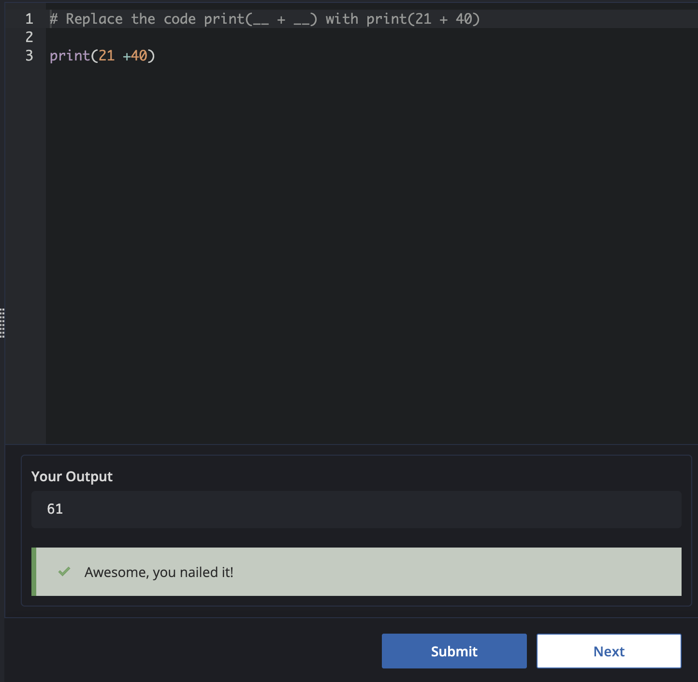

Problem 2:
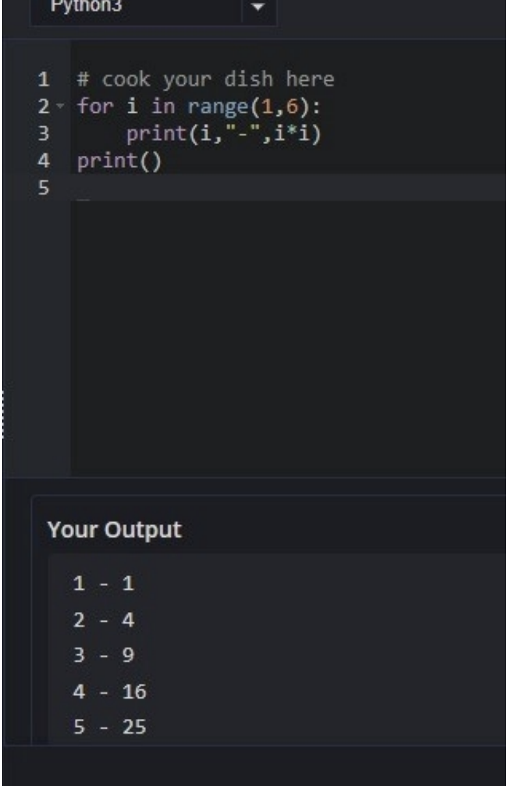
Final Test:
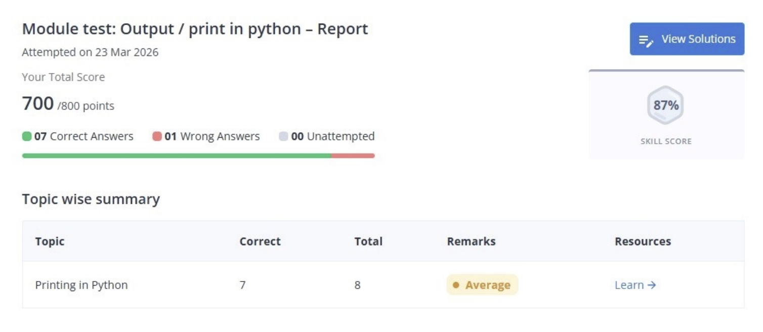
Part B: Google Workspace Collaboration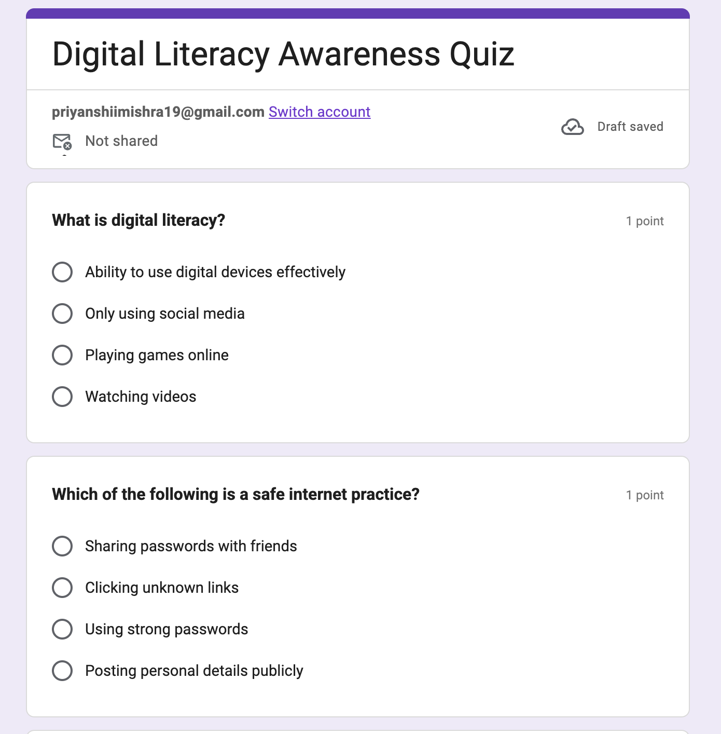

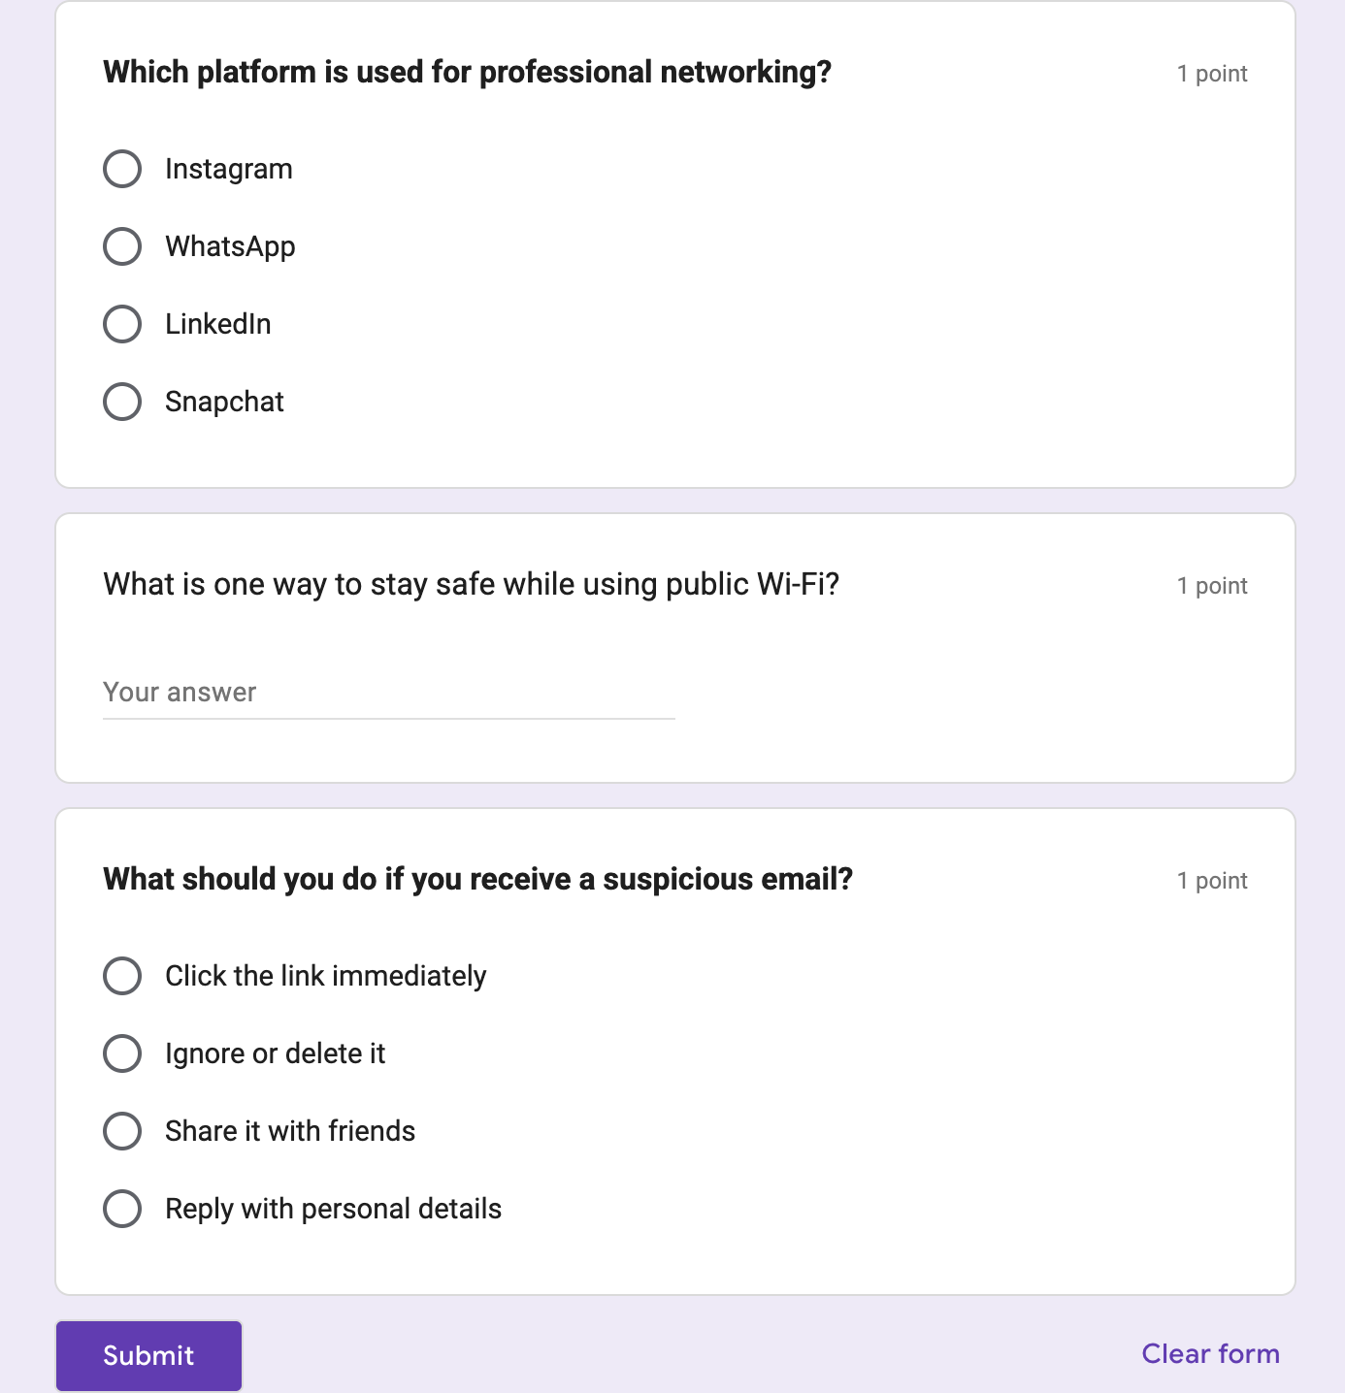
Response Link:
https://docs.google.com/spreadsheets/d/1faoIi4-a1BBPHlbV-UXJ64R331Tij3HSzD7vhZ3jdMw/edit?usp=sharing

