[**MIS 6345.0W1 - High Performance Analytics - F18**](https://elearning.utdallas.edu/webapps/blackboard/execute/launcher?type=Course&id=_141999_1&url=)

**Assignment 1**

**By – Priyanshi Khatri(pxk173330)**

**ERD Script and Data Model**

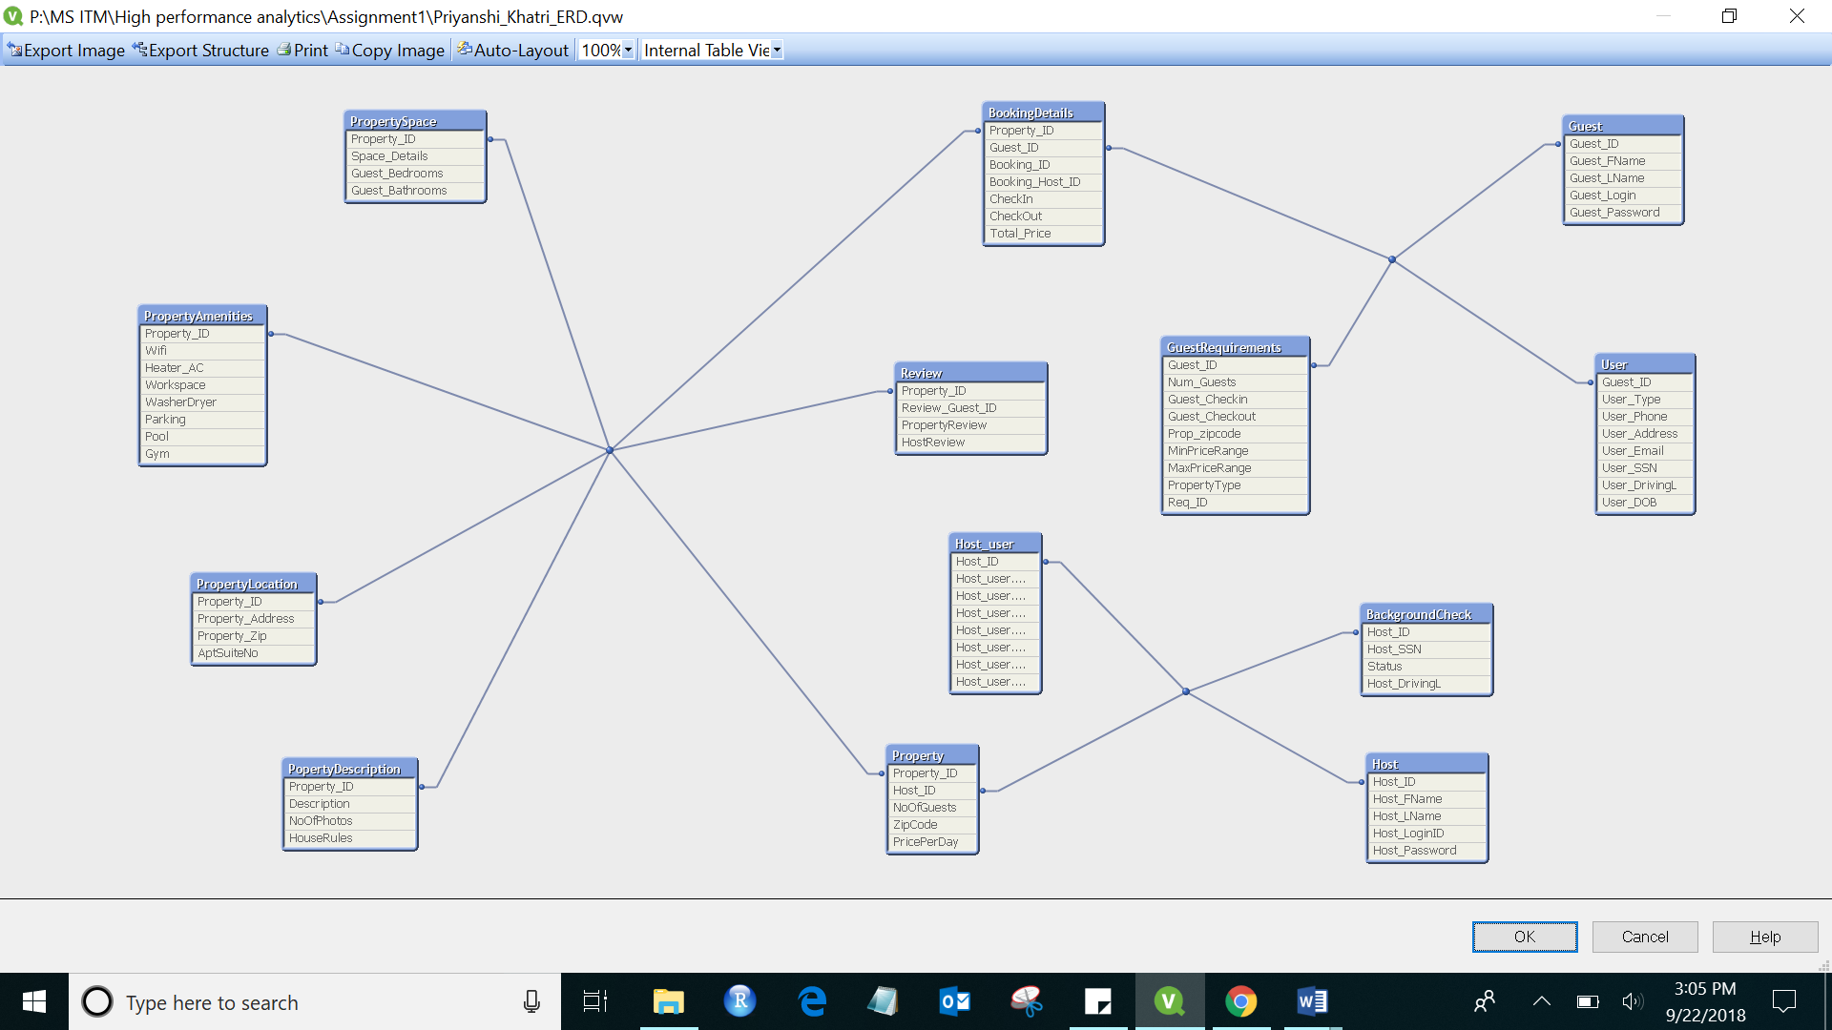

**SET** ***ThousandSep***=',';  
**SET** ***DecimalSep***='.';  
**SET** ***MoneyThousandSep***=',';  
**SET** ***MoneyDecimalSep***='.';  
**SET** ***MoneyFormat***='$#,##0.00;($#,##0.00)';  
**SET** ***TimeFormat***='h:mm:ss TT';  
**SET** ***DateFormat***='M/D/YYYY';  
**SET** ***TimestampFormat***='M/D/YYYY h:mm:ss[.fff] TT';  
**SET** ***MonthNames***='Jan;Feb;Mar;Apr;May;Jun;Jul;Aug;Sep;Oct;Nov;Dec';  
**SET** ***DayNames***='Mon;Tue;Wed;Thu;Fri;Sat;Sun';  
**SET** ***LongMonthNames***='January;February;March;April;May;June;July;August;September;October;November;December';  
**SET** ***LongDayNames***='Monday;Tuesday;Wednesday;Thursday;Friday;Saturday;Sunday';  
**SET** ***FirstWeekDay***=6;  
**SET** ***BrokenWeeks***=1;  
**SET** ***ReferenceDay***=0;  
**SET** ***FirstMonthOfYear***=1;  
**SET** ***CollationLocale***='en-US';  
  
OLEDB **CONNECT32** TO [Provider=SQLOLEDB.1;Integrated Security=SSPI;Persist Security Info=False;Initial Catalog=Airbnb database;Data Source=DESKTOP-DM14P0H\SQLEXPRESS01;Use Procedure for Prepare=1;Auto Translate=True;Packet Size=4096;Workstation ID=DESKTOP-DM14P0H;Use Encryption for Data=False;Tag with column collation when possible=False];

//Multiple Select Statements//  
BackgroundCheck:  
**LOAD** "Host_SSN",  
 Status,  
 "Host_DrivingL",  
 "Host_ID";  
**SQL** SELECT *  
FROM "Airbnb database".dbo.BackgroundCheck;  
  
BookingDetails:  
**LOAD** "Booking_ID",  
 "Host_ID" as "Booking_Host_ID",  
 CheckIn,  
 CheckOut,  
 "Property_ID",  
 "Total_Price",  
 "Guest_ID";  
**SQL** SELECT *  
FROM "Airbnb database".dbo.BookingDetails;  
  
Guest:  
**LOAD** "Guest_ID",  
 "Guest_FName",  
 "Guest_LName",  
 "Guest_Login",  
 "Guest_Password";  
**SQL** SELECT *  
FROM "Airbnb database".dbo.Guest;  
  
GuestRequirements:  
**LOAD** "Guest_ID",  
 NoOfGuests as Num_Guests,  
 CheckIn as Guest_Checkin,  
 CheckOut as Guest_Checkout,  
 "Property_Zip" as "Prop_zipcode",  
 MinPriceRange,  
 MaxPriceRange,  
 PropertyType,  
 "Req_ID";  
**SQL** SELECT *  
FROM "Airbnb database".dbo.GuestRequirements;  
  
Host:  
**LOAD** "Host_FName",  
 "Host_LName",  
 "Host_ID",  
 "Host_LoginID",  
 "Host_Password";  
**SQL** SELECT *  
FROM "Airbnb database".dbo.Host;  
  
Property:  
**LOAD** "Property_ID",  
 NoOfGuests,  
 "Host_ID",  
 ZipCode,  
 PricePerDay;  
**SQL** SELECT *  
FROM "Airbnb database".dbo.Property;  
  
PopertyDescription:**LOAD** Description,  
 NoOfPhotos,  
 "Property_ID",  
 HouseRules;  
**SQL** SELECT *  
FROM "Airbnb database".dbo.PropDesc;  
  
PropertyAmenities:  
**LOAD** Wifi,  
 "Heater_AC",  
 Workspace,  
 WasherDryer,  
 Parking,  
 Pool,  
 Gym,  
 "Property_ID";  
**SQL** SELECT *  
FROM "Airbnb database".dbo.PropAmenities;  
  
PropertyLocation:  
**LOAD** "Property_Address",  
 "Property_Zip",  
 AptSuiteNo,  
 "Property_ID";  
**SQL** SELECT *  
FROM "Airbnb database".dbo.PropLocation;  
  
PropertySpace:  
**LOAD** "Property_ID",  
 "Space_Details",  
 "Guest_Bedrooms",  
 "Guest_Bathrooms";  
**SQL** SELECT *  
FROM "Airbnb database".dbo.PropSpace;  
  
Review:  
**LOAD** "Property_ID",  
 "Guest_ID" as "Review_Guest_ID",  
 PropertyReview,  
 HostReview;  
**SQL** SELECT *  
FROM "Airbnb database".dbo.Reviews;  
  
User:  
**LOAD** "User_ID" as "Guest_ID",  
 "User_Type",  
 //"User_FName",  
 //"User_LName",  
 "User_Phone",  
 "User_Address",  
 "User_Email",  
 "User_SSN",  
 "User_DrivingL",  
 "User_DOB";  
**SQL** SELECT *  
FROM "Airbnb database".dbo."User";  
  
**QUALIFY**\*;  
**UNQUALIFY** Host_ID;  
Host_user:  
**LOAD** "Guest_ID" as "Host_ID",  
 "User_Type",  
 //"User_FName",  
 //"User_LName",  
 "User_Phone",  
 "User_Address",  
 "User_Email",  
 "User_SSN",  
 "User_DrivingL",  
 "User_DOB"  
Resident User;  
//Ending Select Statements//

**Dimensional Model Script and Model**  
  
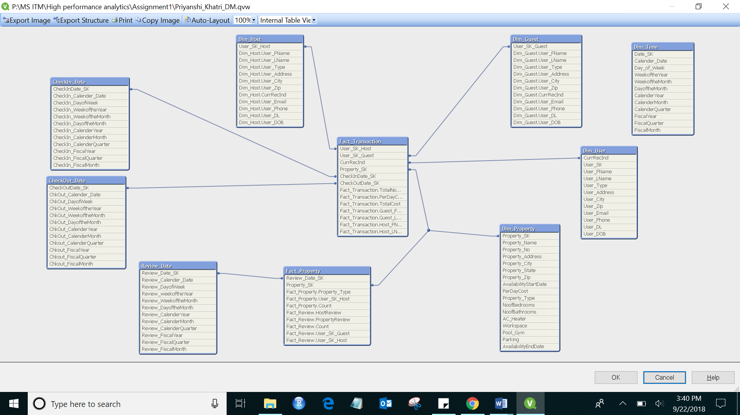

**SET** ***ThousandSep***=',';  
**SET** ***DecimalSep***='.';  
**SET** ***MoneyThousandSep***=',';  
**SET** ***MoneyDecimalSep***='.';  
**SET** ***MoneyFormat***='$#,##0.00;($#,##0.00)';  
**SET** ***TimeFormat***='h:mm:ss TT';  
**SET** ***DateFormat***='M/D/YYYY';  
**SET** ***TimestampFormat***='M/D/YYYY h:mm:ss[.fff] TT';  
**SET** ***MonthNames***='Jan;Feb;Mar;Apr;May;Jun;Jul;Aug;Sep;Oct;Nov;Dec';  
**SET** ***DayNames***='Mon;Tue;Wed;Thu;Fri;Sat;Sun';  
**SET** ***LongMonthNames***='January;February;March;April;May;June;July;August;September;October;November;December';  
**SET** ***LongDayNames***='Monday;Tuesday;Wednesday;Thursday;Friday;Saturday;Sunday';  
**SET** ***FirstWeekDay***=6;  
**SET** ***BrokenWeeks***=1;  
**SET** ***ReferenceDay***=0;  
**SET** ***FirstMonthOfYear***=1;  
**SET** ***CollationLocale***='en-US';  
  
OLEDB **CONNECT32** TO [Provider=SQLOLEDB.1;Integrated Security=SSPI;Persist Security Info=False;Initial Catalog=Airbnb database;Data Source=DESKTOP-DM14P0H\SQLEXPRESS01;Use Procedure for Prepare=1;Auto Translate=True;Packet Size=4096;Workstation ID=DESKTOP-DM14P0H;Use Encryption for Data=False;Tag with column collation when possible=False];

//Dimensions and Fact Tables  
  
Dim_Property:  
**LOAD** "Property_SK",  
 "Property_Name",  
 "Property_No",  
 "Property_Address",  
 "Property_City",  
 "Property_State",  
 "Property_Zip",  
 AvailabilityStartDate,  
 PerDayCost,  
 "Property_Type",  
 NoofBedrooms,  
 NoofBathrooms,  
 "AC_Heater",  
 Workspace,  
 "Pool_Gym",  
 Parking,  
 AvailabilityEndDate;  
**SQL** SELECT *  
FROM "Airbnb database".dbo."Dim_Property";  
  
Dim_Time:  
**LOAD** "Date_SK",  
 "Calender_Date",  
 "Day_of_Week",  
 WeekoftheYear,  
 WeekoftheMonth,  
 DayoftheMonth,  
 CalenderYear,  
 CalenderMonth,  
 CalenderQuarter,  
 FiscalYear,  
 FiscalQuarter,  
 FiscalMonth;  
**SQL** SELECT *  
FROM "Airbnb database".dbo."Dim_Time";  
  
CheckIn_Date:  
**LOAD** "Date_SK" as "CheckInDate_SK",  
 "Calender_Date"as "CheckIn_Calender_Date",  
 "Day_of_Week" as "CheckIn_DayofWeek",  
 WeekoftheYear as CheckIn_WeekoftheYear,  
 WeekoftheMonth as CheckIn_WeekoftheMonth,  
 DayoftheMonth as CheckIn_DayoftheMonth,  
 CalenderYear as CheckIn_CalenderYear,  
 CalenderMonth as CheckIn_CalenderMonth,  
 CalenderQuarter as CheckIn_CalenderQuarter,  
 FiscalYear as CheckIn_FiscalYear,  
 FiscalQuarter as CheckIn_FiscalQuarter,  
 FiscalMonth as CheckIn_FiscalMonth  
Resident Dim_Time;  
  
CheckOut_Date:  
**LOAD** "Date_SK" as "CheckOutDate_SK",  
 "Calender_Date" as "ChkOut_Calender_Date",  
 "Day_of_Week" as "ChkOut_DayofWeek" ,  
 WeekoftheYear as ChkOut_WeekoftheYear,  
 WeekoftheMonth as ChkOut_WeekoftheMonth,  
 DayoftheMonth as ChkOut_DayoftheMonth,  
 CalenderYear as ChkOut_CalenderYear,  
 CalenderMonth as ChkOut_CalenderMonth,  
 CalenderQuarter as Chkout_CalenderQuarter,  
 FiscalYear as Chkout_FiscalYear,  
 FiscalQuarter as Chkout_FiscalQuarter,  
 FiscalMonth as Chkout_FiscalMonth  
Resident Dim_Time;  
  
Review_Date:  
**LOAD** "Date_SK" as "Review_Date_SK",  
 "Calender_Date" as "Review_Calender_Date",  
 "Day_of_Week" as "Review_DayofWeek",  
 WeekoftheYear as "Review_weekoftheYear",  
 WeekoftheMonth as "Review_WeekoftheMonth",  
 DayoftheMonth as Review_DayoftheMonth,  
 CalenderYear as Review_CalenderYear,  
 CalenderMonth as Review_CalenderMonth,  
 CalenderQuarter as Review_CalenderQuarter,  
 FiscalYear as Review_FiscalYear,  
 FiscalQuarter as Review_FiscalQuarter,  
 FiscalMonth as Review_FiscalMonth  
Resident Dim_Time;  
  
Dim_User:  
**LOAD** "User_SK",  
 "User_FName",  
 "User_LName",  
 "User_Type",  
 "User_Address",  
 "User_City",  
 "User_Zip",  
 CurrRecInd,  
 "User_Email",  
 "User_Phone",  
 "User_DL",  
 "User_DOB";  
**SQL** SELECT *  
FROM "Airbnb database".dbo."Dim_User";  
  
**QUALIFY**\*;  
**UNQUALIFY** User_SK_Host;  
Dim_Host:  
**LOAD** "User_SK" as "User_SK_Host",  
 "User_FName",  
 "User_LName",  
 "User_Type",  
 "User_Address",  
 "User_City",  
 "User_Zip",  
 CurrRecInd,  
 "User_Email",  
 "User_Phone",  
 "User_DL",  
 "User_DOB"  
Resident Dim_User;  
  
**QUALIFY**\*;  
**UNQUALIFY** User_SK_Guest;  
Dim_Guest:  
**LOAD** "User_SK" as "User_SK_Guest",  
 "User_FName",  
 "User_LName",  
 "User_Type",  
 "User_Address",  
 "User_City",  
 "User_Zip",  
 CurrRecInd,  
 "User_Email",  
 "User_Phone",  
 "User_DL",  
 "User_DOB"  
Resident Dim_User;  
  
**QUALIFY**\*;  
**UNQUALIFY** "Property_SK","CheckInDate_SK","CheckOutDate_SK","User_SK_Guest","User_SK_Host",CurrRecInd;  
Fact_Transaction:  
**LOAD** "Property_SK",  
 TotalNoOfDays,  
 PerDayCost,  
 TotalCost,  
 "Guest_FName",  
 "Guest_LName",  
 "Host_FName",  
 "Host_LName",  
 CurrRecInd,  
 "User_SK_Guest",  
 "User_SK_Host",  
 "CheckInDate_SK",  
 "CheckOutDate_SK";  
**SQL** SELECT *  
FROM "Airbnb database".dbo."Fact_Transaction";  
  
**QUALIFY**\*;  
**UNQUALIFY** "Property_SK";  
Fact_Property:  
**LOAD** "Property_Type",  
 "User_SK_Host",  
 "Property_SK",  
 "Count";  
**SQL** SELECT *  
FROM "Airbnb database".dbo."Fact_Property";  
  
**QUALIFY**\*;  
**UNQUALIFY** Property_SK,Review_Date_SK;  
Concatenate  
Fact_Review:  
**LOAD** "Property_SK",  
 HostReview,  
 PropertyReview,  
 "Count",  
 "User_SK_Guest",  
 "Review_Date_SK",  
 "User_SK_Host";  
**SQL** SELECT *  
FROM "Airbnb database".dbo."Fact_Review";