[**MIS 6345.0W1 - High Performance Analytics - F18**](https://elearning.utdallas.edu/webapps/blackboard/execute/launcher?type=Course&id=_141999_1&url=)

**Assignment 2**

**By – Priyanshi Khatri(pxk173330)**

**Data Model and Script**

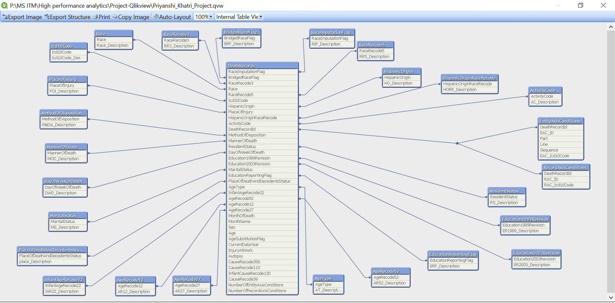

**SET** ***MoneyThousandSep***=',';  
**SET** ***MoneyDecimalSep***='.';  
**SET** ***MoneyFormat***='$#,##0.00;($#,##0.00)';  
**SET** ***TimeFormat***='h:mm:ss TT';  
**SET** ***DateFormat***='M/D/YYYY';  
**SET** ***TimestampFormat***='M/D/YYYY h:mm:ss[.fff] TT';  
**SET** ***MonthNames***='Jan;Feb;Mar;Apr;May;Jun;Jul;Aug;Sep;Oct;Nov;Dec';  
**SET** ***DayNames***='Mon;Tue;Wed;Thu;Fri;Sat;Sun';  
**SET** ***LongMonthNames***='January;February;March;April;May;June;July;August;September;October;November;December';  
**SET** ***LongDayNames***='Monday;Tuesday;Wednesday;Thursday;Friday;Saturday;Sunday';  
**SET** ***FirstWeekDay***=6;  
**SET** ***BrokenWeeks***=1;  
**SET** ***ReferenceDay***=0;  
**SET** ***FirstMonthOfYear***=1;  
**SET** ***CollationLocale***='en-US';  
  
ODBC **CONNECT** TO Howppldie;

DeathRecords:  
**LOAD** Id as DeathRecordId ,  
 ResidentStatus,  
 Education1989Revision,  
 Education2003Revision,  
 EducationReportingFlag,  
 MonthOfDeath,  
 Month(MakeDate(2014,MonthOfDeath)) as MonthName,  
 Sex,  
 AgeType,  
 Age,  
 AgeSubstitutionFlag,  
 AgeRecode52,  
 AgeRecode27,  
 AgeRecode12,  
 InfantAgeRecode22,  
 PlaceOfDeathAndDecedentsStatus,  
 MaritalStatus,  
 DayOfWeekOfDeath,  
 CurrentDataYear,  
 InjuryAtWork,  
 MannerOfDeath,  
 MethodOfDisposition,  
 Autopsy,  
 ActivityCode,  
 PlaceOfInjury,  
 Icd10Code,  
 CauseRecode358,  
 CauseRecode113,  
 InfantCauseRecode130,  
 CauseRecode39,  
 NumberOfEntityAxisConditions,  
 NumberOfRecordAxisConditions,  
 Race,  
 BridgedRaceFlag,  
 RaceImputationFlag,  
 RaceRecode3,  
 RaceRecode5,  
 HispanicOrigin,  
 HispanicOriginRaceRecode;  
**SQL** SELECT *  
FROM DeathRecords;  
  
ActivityCode:  
**LOAD** Code as ActivityCode,  
 Description as AC_Description;  
**SQL** SELECT *  
FROM ActivityCode;  
  
AgeRecode12:  
**LOAD** Code as AgeRecode12,  
 Description as AR12_Description;  
**SQL** SELECT *  
FROM AgeRecode12;  
  
AgeRecode27:  
**LOAD** Code as AgeRecode27,  
 Description as AR27_Description;  
**SQL** SELECT *  
FROM AgeRecode27;  
  
AgeRecode52:  
**LOAD** Code as AgeRecode52,  
 Description as AR52_Description;  
**SQL** SELECT *  
FROM AgeRecode52;  
  
AgeType:  
**LOAD** Code as AgeType,  
 Description as AT_Description;  
**SQL** SELECT *  
FROM AgeType;  
  
BridgedRaceFlag:  
**LOAD** Code as BridgedRaceFlag,  
 Description as BRF_Description;  
**SQL** SELECT *  
FROM BridgedRaceFlag;  
  
DayOfWeekOfDeath:  
**LOAD** Code as DayOfWeekOfDeath,  
 Description as DWD_Description;  
**SQL** SELECT *  
FROM DayOfWeekOfDeath;  
  
Education1989Revision:  
**LOAD** Code as Education1989Revision,  
 Description as ER1989_Description;  
**SQL** SELECT *  
FROM Education1989Revision;  
  
Education2003Revision:  
**LOAD** Code as Education2003Revision,  
 Description as ER2003_Description;  
**SQL** SELECT *  
FROM Education2003Revision;  
  
EducationReportingFlag:  
**LOAD** Code as EducationReportingFlag,  
 Description as ERF_Description;  
**SQL** SELECT *  
FROM EducationReportingFlag;  
  
EntityAxisConditions:  
**LOAD** Id as EAC_ID,  
 DeathRecordId,  
 Part,  
 Line,  
 Sequence,  
 Icd10Code as EAC_Icd10Code;  
**SQL** SELECT *  
FROM EntityAxisConditions;  
  
HispanicOrigin:  
**LOAD** Code as HispanicOrigin,  
 Description as HO_Description;  
**SQL** SELECT *  
FROM HispanicOrigin;  
  
HispanicOriginRaceRecode:  
**LOAD** Code as HispanicOriginRaceRecode,  
 Description as HORR_Description;  
**SQL** SELECT *  
FROM HispanicOriginRaceRecode;  
  
Icd10Code:  
**LOAD** Code as Icd10Code,  
 Description as Icd10Code_Des;  
**SQL** SELECT *  
FROM Icd10Code;  
  
InfantAgeRecode22:  
**LOAD** Code as InfantAgeRecode22,  
 Description as IAR22_Description;  
**SQL** SELECT *  
FROM InfantAgeRecode22;  
  
MannerOfDeath:  
**LOAD** Code as MannerOfDeath,  
 Description as MOD_Description;  
**SQL** SELECT *  
FROM MannerOfDeath;  
  
MaritalStatus:  
**LOAD** Code as MaritalStatus,  
 Description as MS_Description;  
**SQL** SELECT *  
FROM MaritalStatus;  
  
MethodOfDisposition:  
**LOAD** Code as MethodOfDisposition,  
 Description as MeDis_Description;  
**SQL** SELECT *  
FROM MethodOfDisposition;  
  
PlaceOfDeathAndDecedentsStatus:  
**LOAD** Code as PlaceOfDeathAndDecedentsStatus,  
 Description as place_Description;  
**SQL** SELECT *  
FROM PlaceOfDeathAndDecedentsStatus;  
  
PlaceOfInjury:  
**LOAD** Code as PlaceOfInjury,  
 Description as POI_Description;  
**SQL** SELECT *  
FROM PlaceOfInjury;  
  
Race:  
**LOAD** Code as Race,  
 Description as Race_Description;  
**SQL** SELECT *  
FROM Race;  
  
RaceImputationFlag:  
**LOAD** Code as RaceImputationFlag,  
 Description as RIF_Description;  
**SQL** SELECT *  
FROM RaceImputationFlag;  
  
RaceRecode3:  
**LOAD** Code as RaceRecode3,  
 Description as RR3_Description;  
**SQL** SELECT *  
FROM RaceRecode3;  
  
RaceRecode5:  
**LOAD** Code as RaceRecode5,  
 Description as RR5_Description;  
**SQL** SELECT *  
FROM RaceRecode5;  
  
RecordAxisConditions:  
**LOAD** Id as RAC_ID,  
 DeathRecordId,  
 Icd10Code as RAC_Icd10Code;  
**SQL** SELECT *  
FROM RecordAxisConditions;  
  
ResidentStatus:  
**LOAD** Code as ResidentStatus ,  
 Description as RS_Description;  
**SQL** SELECT *  
FROM ResidentStatus;

**QlikView Front End**

1. **Introduction**

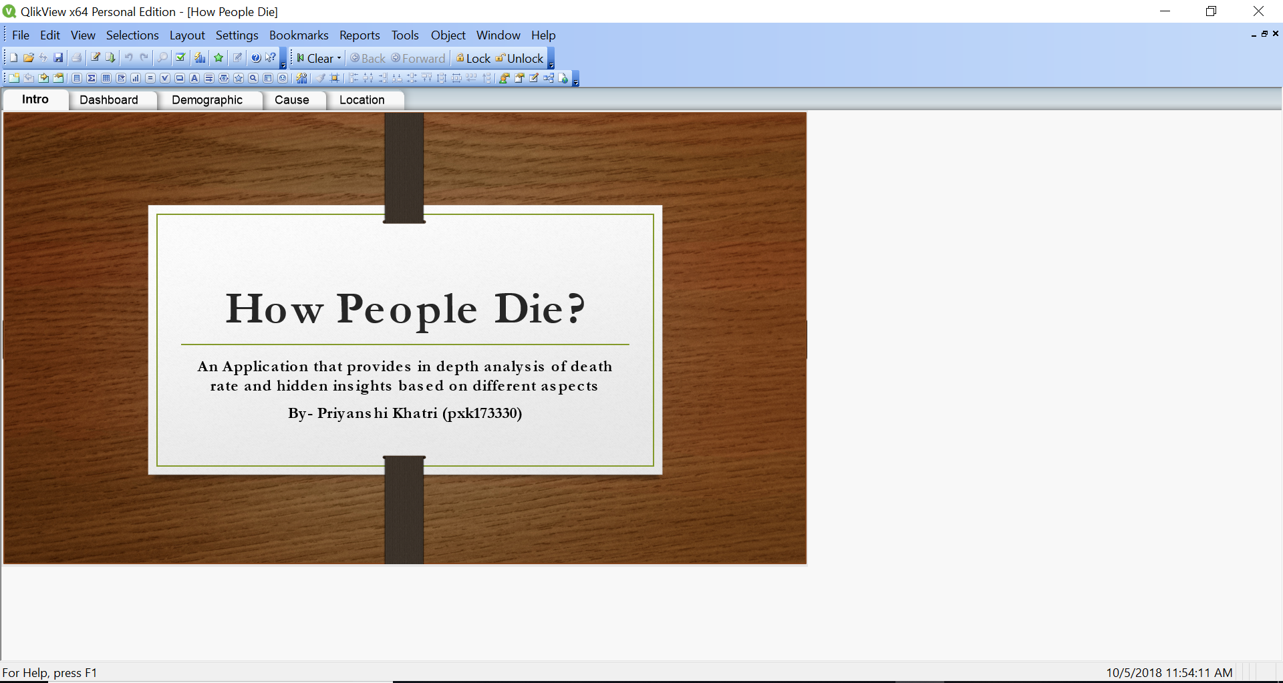

1. **Dashboard**

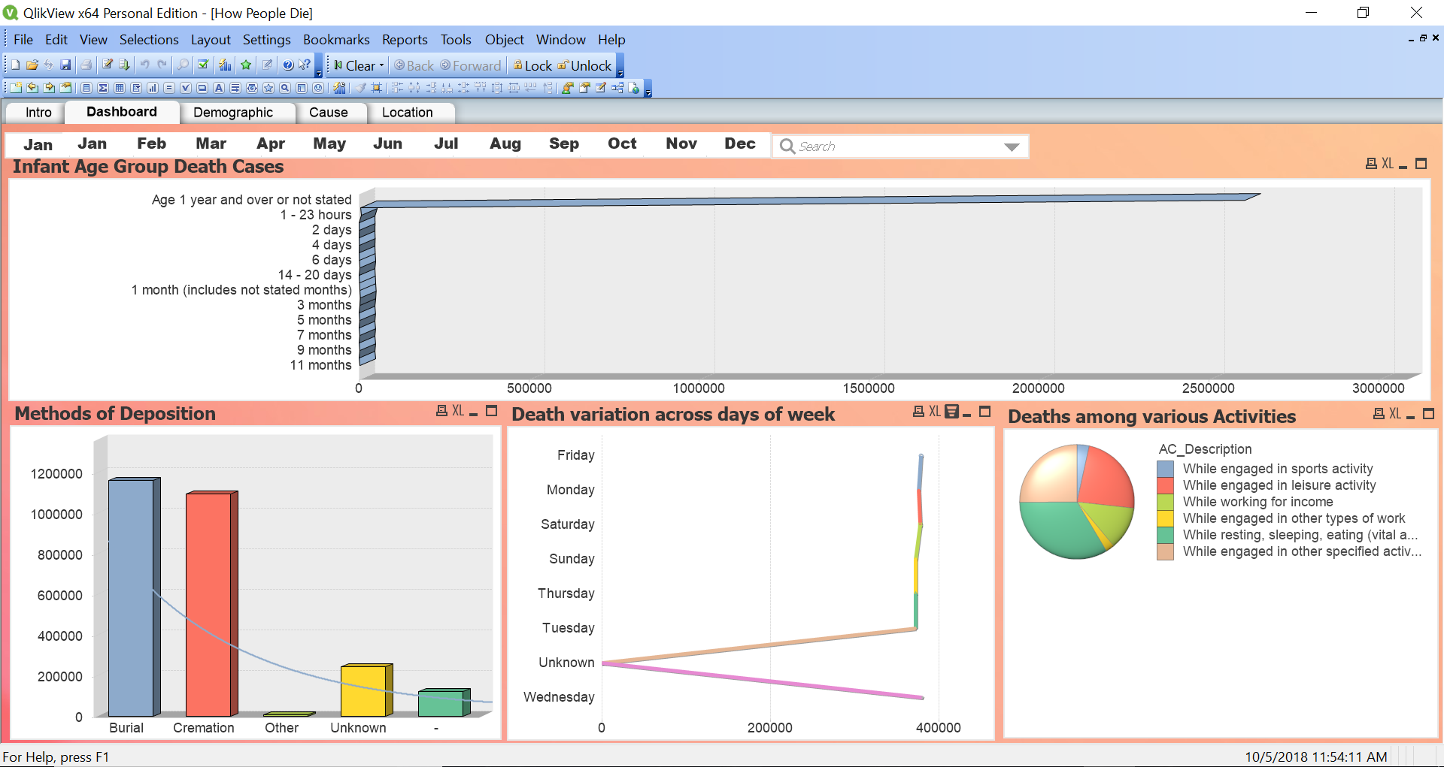

1. **Demographic**

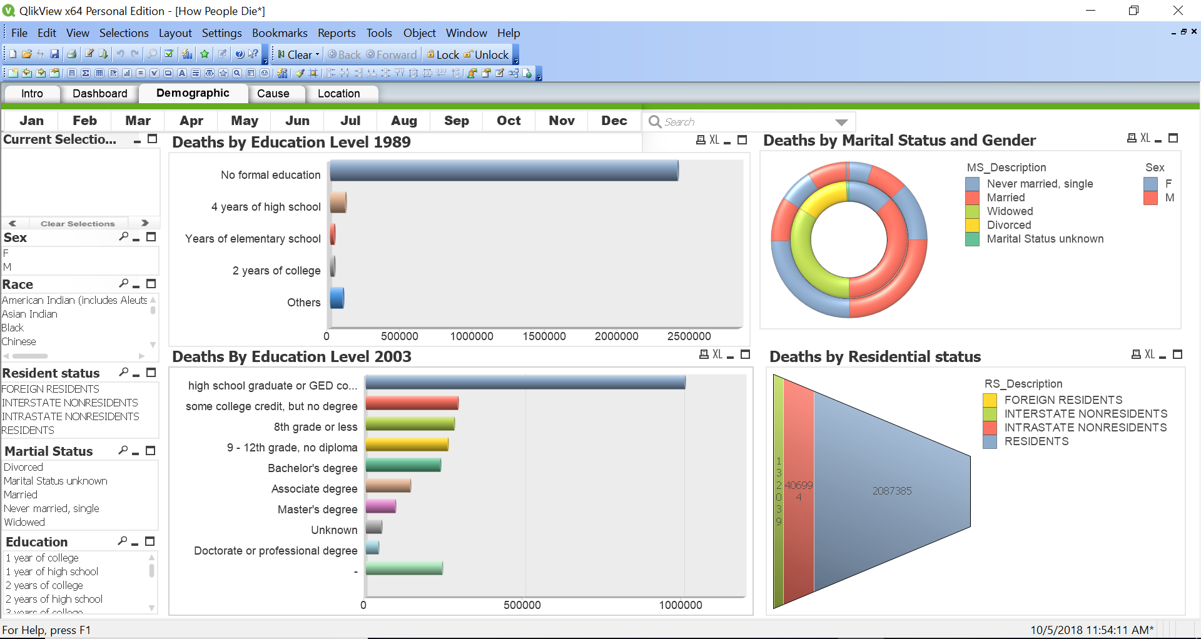

1. **Cause**

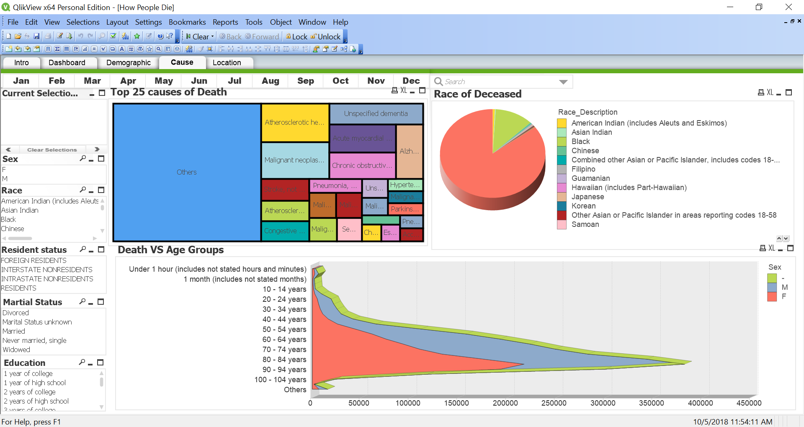

1. **Location**

