WEEK 4 INTERNSHIP TASK
Security Policy Review, Evaluation,
and Improvement Recommendations
A structured review of a hypothetical Generic Organizational Security Policy
benchmarked against contemporary cybersecurity practices

Internship Platform | YUV Intern
Task | Week 4 – Security Policy Review
Student Name | Priyanshi Vasantbhai patel
Course / Program | B.Sc. IT / Cyber Security
Date | 1st October 2026
Prepared for internship submission

1. Executive Summary
This report reviews a hypothetical Generic Organizational Security Policy for a medium-sized organization. The policy covers access control, data protection, incident response, acceptable use, passwords and authentication, remote work, security awareness, backups, third-party access, and policy review.
The review uses NIST Cybersecurity Framework (CSF) 2.0 as the main benchmarking framework, supported by ISO/IEC 27001:2022 and NIST SP 800-53 Rev. 5. NIST CSF 2.0 organizes cybersecurity outcomes into six Functions: Govern, Identify, Protect, Detect, Respond, and Recover. ISO/IEC 27001:2022 defines requirements for an information security management system (ISMS), while NIST SP 800-53 Rev. 5 provides a broad catalog of security and privacy controls.
The hypothetical policy has several useful foundations, particularly basic access control, password rules, incident reporting, employee awareness, and backups. However, it has important gaps if it is expected to support a modern security program. The main improvements recommended are stronger identity and access management, multi-factor authentication, risk-based asset management, centralized logging and monitoring, formal incident-response procedures and exercises, tested backups, third-party risk management, secure configuration and patching, clearer data classification, measurable security metrics, and regular policy review.

2. Scope and Methodology
The assignment asks for a critical review of an existing generic policy. Because no confidential organizational policy was supplied, this report creates a hypothetical baseline policy for evaluation. This avoids making claims about a real organization's controls.
- Define the hypothetical organization and baseline security policy.
- Map major policy areas to NIST CSF 2.0 Functions and relevant security-control concepts.
- Identify strengths, weaknesses, missing controls, and potentially outdated practices.
- Compare the baseline with contemporary practices described by NIST and ISO/IEC 27001.
- Develop actionable recommendations, priorities, owners, and implementation timeframes.
- Define measurable indicators that can be used to track improvement.

3. Industry Standards and Best-Practice Benchmark
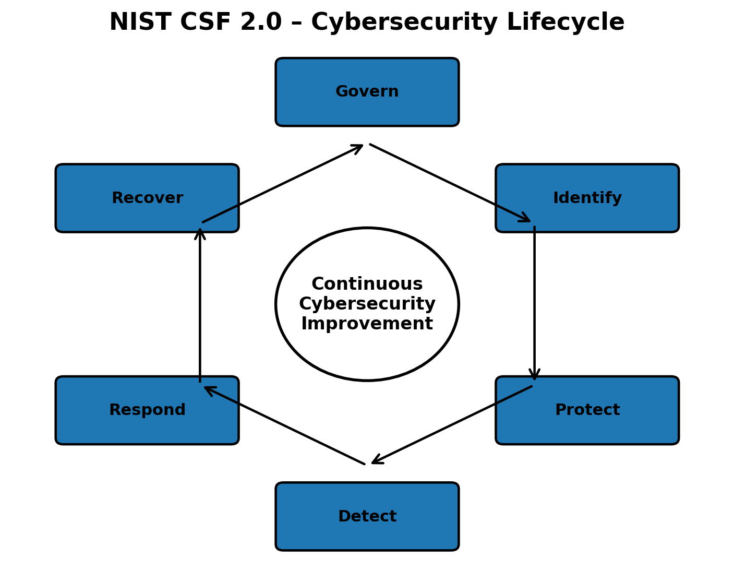
Figure 1. NIST CSF 2.0 cybersecurity lifecycle: Govern → Identify → Protect → Detect → Respond → Recover.
The benchmark is intentionally practical rather than treating any framework as a simple checklist. NIST CSF 2.0 is outcome-oriented and is designed to help organizations understand, assess, prioritize, and communicate cybersecurity risk. It does not prescribe a single implementation method.
Framework / Standard | Main purpose | How used in this review
NIST CSF 2.0 | Risk-management framework with six Functions: Govern, Identify, Protect, Detect, Respond, Recover. | Primary structure for evaluating policy coverage and lifecycle.
ISO/IEC 27001:2022 | Requirements for an Information Security Management System (ISMS). | Benchmark for governance, risk management, continual improvement, and systematic security management.
NIST SP 800-53 Rev. 5 | Catalog of security and privacy controls. | Reference for control areas such as access control, audit/accountability, incident response, contingency planning, and supply chain risk.
NIST CSF 2.0 was published on February 26, 2024. NIST describes its six Functions as Govern, Identify, Protect, Detect, Respond, and Recover. ISO lists ISO/IEC 27001:2022 as the international standard defining requirements for an ISMS. NIST SP 800-53 Rev. 5 contains control families including Access Control, Awareness and Training, Audit and Accountability, Contingency Planning, Identification and Authentication, Incident Response, Risk Assessment, System and Communications Protection, System and Information Integrity, and Supply Chain Risk Management.

4. Hypothetical Generic Security Policy – Baseline
Organization profile: a hypothetical medium-sized organization with approximately 250 employees, office and remote users, cloud services, laptops, an internal network, customer information, and common business applications.
Policy area | Baseline requirement
1. Access Control | Employees receive accounts based on job needs. Managers approve access. Shared accounts should be avoided.
2. Passwords | Users must use strong passwords and change them periodically. Passwords must not be shared.
3. Authentication | Administrative accounts should use stronger authentication where available.
4. Data Protection | Sensitive business and customer data must be stored only in approved systems and shared only with authorized users.
5. Acceptable Use | Company devices and networks must be used for legitimate business purposes; unauthorized software is prohibited.
6. Incident Reporting | Employees must report suspected phishing, malware, data loss, or unauthorized access to IT/security.
7. Backups | Important business data is backed up regularly. Backup copies are retained for recovery.
8. Remote Work | Remote users must use approved devices and secure connections and must protect devices from unauthorized access.
9. Security Awareness | Employees receive basic security awareness training.
10. Third Parties | Vendors are expected to follow applicable security requirements and protect organizational information.
11. Physical Security | Employees must protect laptops, badges, documents, and restricted areas.
12. Policy Review | The policy is reviewed periodically and updated when major technology or business changes occur.

5. Critical Assessment of the Baseline Policy
The following assessment distinguishes between controls that provide a useful foundation and areas where the baseline should become more specific, measurable, risk-based, and continuously monitored.
Area | Strength | Gap / weakness | Priority
Access control | Clear job-based access concept and manager approval. | No explicit least-privilege review cycle, privileged-access management, or joiner/mover/leaver SLA. | Medium-High
Authentication | Recognizes stronger authentication for administrators. | MFA is not mandatory for all high-risk or remote access; no phishing-resistant MFA requirement. | High
Passwords | Prohibits sharing and asks for strong passwords. | Periodic password changes alone are not a complete modern identity strategy; no password-manager or compromised-credential process. | Medium
Data protection | Restricts storage/sharing to approved systems. | No formal classification levels, encryption requirements, retention rules, DLP expectations, or secure disposal details. | High
Incident response | Provides a reporting route. | No severity levels, roles, evidence handling, containment/recovery steps, communications plan, or exercise schedule. | High
Logging & monitoring | Implicitly supported by IT operations. | No explicit centralized logging, alerting, retention, time synchronization, or review responsibilities. | High
Backups | Regular backups are required. | No stated RPO/RTO, backup isolation, immutable/offline copy, restore testing, or ownership. | High
Remote work | Requires approved devices and secure connections. | No detailed device security baseline, endpoint management, screen/privacy controls, or lost-device process. | Medium-High
Awareness | Basic awareness training is required. | No role-based training, phishing simulations, completion target, or measurement. | Medium
Third parties | Vendors are expected to protect information. | No due diligence, contract controls, risk tiering, security assessment, or offboarding requirements. | High
Vulnerability/patching | Not explicitly defined. | Missing patch timelines, vulnerability scanning, exception process, and remediation tracking. | High
Governance | Periodic policy review exists. | No defined policy owner, risk acceptance authority, metrics, exception register, or management review cycle. | Medium-High

6. Benchmark Mapping to NIST CSF 2.0
CSF Function | Relevant outcomes | Baseline status | Improvement needed
Govern | Policy ownership, roles, risk tolerance, legal/contractual obligations, supplier governance. | Partially covered | Define governance roles, risk register, policy owner, exception and risk-acceptance process.
Identify | Asset inventory, data classification, business impact, vulnerabilities, supplier risks. | Weak / partial | Maintain asset and data inventories; perform periodic risk assessments and supplier risk reviews.
Protect | Identity, MFA, awareness, data security, secure configuration, patching, backups. | Partial | Make MFA and secure configuration explicit; define patch SLAs, encryption, training, and backup protections.
Detect | Logging, monitoring, anomaly detection, vulnerability detection. | Weak | Centralize logs, define alerting and review responsibilities, and establish monitoring coverage.
Respond | Incident reporting, containment, communication, analysis, mitigation. | Partial | Create an incident-response plan with severity levels, roles, playbooks, evidence handling, and exercises.
Recover | Recovery planning, backups, restoration, communications, lessons learned. | Partial | Define RTO/RPO, test restores, maintain recovery plans, and document lessons learned.

7. Strengths of the Existing Policy
- It establishes a security baseline that applies to common employee activities.
- It recognizes access control and the principle that users should receive access based on job needs.
- It addresses passwords, acceptable use, incident reporting, backups, remote work, awareness, vendors, and physical security.
- It creates a foundation for accountability because users and managers have defined responsibilities.
- It includes policy review, which supports continual improvement.
- Its language is generic enough to be adapted to organizations of different sizes.

8. Key Weaknesses and Security Gaps
- MFA is not mandatory across critical applications, remote access, privileged accounts, and other high-risk scenarios.
- Access reviews and privileged-access controls are not defined with measurable frequency or approval requirements.
- Asset inventory and data classification are not sufficiently formalized.
- The policy does not establish clear patch-management and vulnerability-remediation deadlines.
- Logging, monitoring, alerting, and log-retention requirements are missing.
- Incident response is limited to reporting; it does not define a complete response lifecycle.
- Backup requirements do not specify recovery objectives or restore testing.
- Third-party risk management is too general to consistently assess vendors.
- Security awareness is not tied to measurable completion and effectiveness metrics.
- No explicit policy exception, risk acceptance, or disciplinary/enforcement process is defined.
- There is no clear schedule for management review, control testing, or policy effectiveness measurement.

9. Actionable Improvement Recommendations
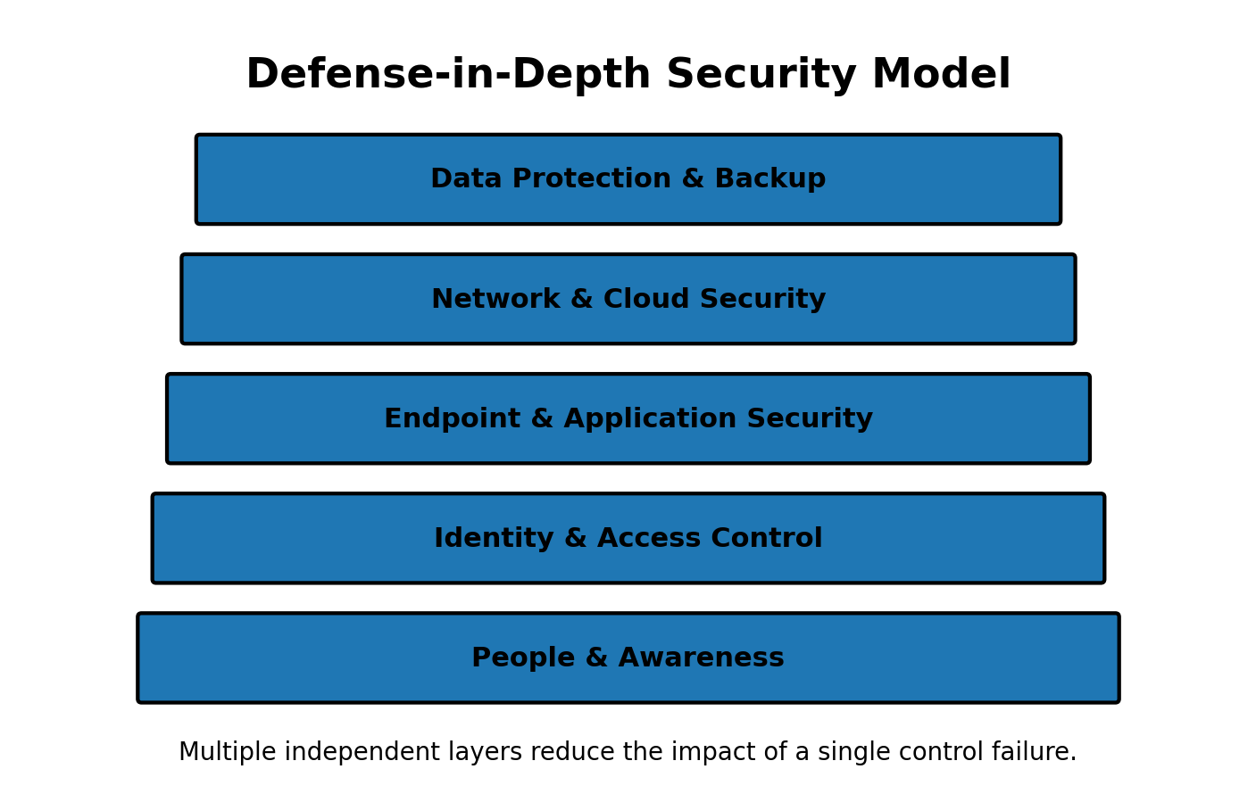
Figure 2. Defense-in-depth model showing multiple complementary security layers.
ID / Recommendation | Action | Expected impact | Timeframe | Owner
R1 – Enforce MFA | Require MFA for privileged accounts, remote access, email, cloud administration, and other high-risk systems; use phishing-resistant methods where practical. | Reduces risk from stolen passwords and account takeover. | 0–3 months | IT/Security
R2 – Formalize IAM | Implement joiner-mover-leaver procedures, least privilege, periodic access reviews, and privileged-account separation. | Limits unnecessary access and reduces orphaned or excessive permissions. | 0–3 months | IT + HR
R3 – Create asset & data inventories | Maintain an owner, classification, location, criticality, and lifecycle status for important assets and data. | Improves risk visibility and supports incident response and recovery. | 0–6 months | IT/Data Owners
R4 – Define patch SLAs | Set risk-based remediation deadlines for critical/high vulnerabilities and track exceptions. | Reduces exposure to known vulnerabilities. | 0–3 months | IT/Security
R5 – Centralize logging | Collect key authentication, endpoint, network, cloud, and security logs in a centralized monitoring solution with defined retention and review. | Improves detection and investigation capability. | 3–6 months | Security/IT
R6 – Build an incident-response plan | Define severity levels, roles, escalation, containment, evidence preservation, communications, recovery, and post-incident review. | Creates a repeatable response process and reduces confusion during incidents. | 0–3 months | Security/Management
R7 – Test backups and recovery | Define RTO/RPO for critical services, protect backups from unauthorized alteration, and perform scheduled restore tests. | Improves resilience against ransomware, accidental deletion, and outages. | 0–6 months | IT/BCP
R8 – Strengthen vendor security | Tier suppliers by risk; perform due diligence and include security, breach notification, access, data handling, and offboarding clauses. | Reduces supply-chain and third-party risk. | 3–9 months | Procurement + Security
R9 – Improve awareness | Provide annual baseline training plus role-based training and periodic phishing exercises. | Improves human-layer defenses and provides measurable awareness outcomes. | 0–6 months | HR + Security
R10 – Governance & metrics | Assign policy ownership, maintain exceptions/risk acceptance, review metrics quarterly, and perform an annual policy review. | Creates accountability and continual improvement. | 0–3 months | Management + Security

10. Implementation Roadmap
Period | Priority activities | Expected result
0–30 days | Appoint policy owner; identify critical systems; require MFA for privileged accounts and remote access; create incident-response contacts; review backup status. | Immediate risk reduction and ownership.
31–90 days | Complete access review; establish patch SLAs; formalize incident-response plan; start security metrics; document policy exceptions. | Build repeatable core controls.
3–6 months | Centralize priority logs; establish asset/data inventories; test backup restoration; improve awareness program; begin vendor risk tiering. | Improve visibility and resilience.
6–12 months | Expand monitoring; complete supplier reviews; conduct incident-response exercise; mature risk assessments; review policy effectiveness. | Move toward continuous improvement.

11. Suggested Security Metrics
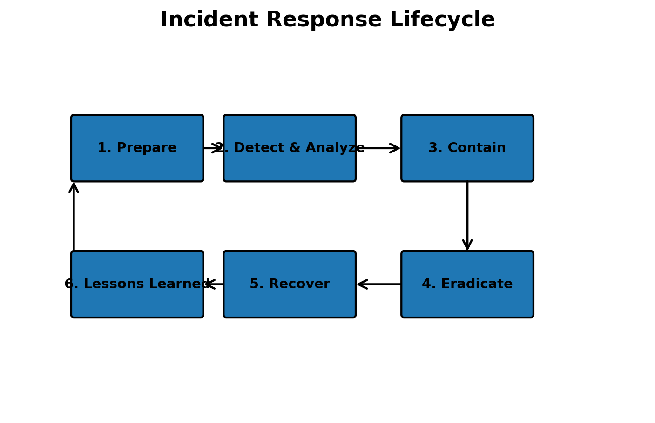
Figure 3. Incident response lifecycle used to organize preparation, detection, containment, recovery, and learning.
Metric | What it measures | Example target
MFA coverage | Percentage of in-scope accounts protected by MFA | Target: 100% for privileged and remote-access accounts
Access review completion | Percentage of scheduled access reviews completed on time | Target: 100%
Critical patch compliance | Percentage of critical vulnerabilities remediated within the defined SLA | Target: ≥95% (organization should set final target based on risk)
Backup restore success | Percentage of scheduled restore tests that successfully recover required data | Target: 100% for critical backup sets
Security training completion | Percentage of users completing required training by deadline | Target: ≥95–100%, depending on policy
Incident response exercise | Number of exercises completed and lessons closed | At least annual exercise for critical processes
Logging coverage | Percentage of critical systems sending required logs | Target: 100% of defined critical sources
Vendor review coverage | Percentage of high-risk suppliers assessed before/within review cycle | Target: 100%

12. Proposed Improved Policy Structure
- Purpose and scope
- Roles and responsibilities
- Risk management and security governance
- Asset management and data classification
- Identity and access management
- Authentication and password management
- Endpoint and secure configuration requirements
- Vulnerability and patch management
- Network, cloud, and communications security
- Logging, monitoring, and detection
- Data protection, encryption, retention, and secure disposal
- Security awareness and role-based training
- Acceptable use and remote work
- Incident response and breach notification
- Backup, business continuity, and disaster recovery
- Third-party and supply-chain security
- Physical security
- Policy exceptions, enforcement, and risk acceptance
- Review, audit, metrics, and continual improvement

13. Before-and-After Comparison
Area | Baseline policy | Improved policy
Authentication | Stronger authentication mainly for administrators | MFA required for privileged, remote, and high-risk access; stronger methods where practical
Access review | Manager approval | Formal periodic reviews plus joiner/mover/leaver process
Data | Approved storage and sharing | Classification, encryption, retention, access, and secure disposal
Monitoring | Not specified | Centralized logging and defined monitoring responsibilities
Incidents | Report suspected incidents | Full lifecycle: prepare, detect, analyze, contain, eradicate, recover, learn
Backups | Regular backups | Defined RTO/RPO, protected copies, restore tests, ownership
Vendors | General security expectation | Risk-tiering, due diligence, contract requirements, monitoring, offboarding
Governance | Periodic review | Named owner, risk acceptance, metrics, management review, continual improvement

14. Risks of Leaving the Gaps Unaddressed
- Compromised credentials could lead to unauthorized access when MFA and least privilege are weak.
- Unpatched vulnerabilities can provide attackers with known paths into systems.
- Insufficient logging can delay detection and make investigation harder.
- Untested backups may fail when recovery is urgently required.
- Unstructured incident response can increase confusion, downtime, and inconsistent communications.
- Weak supplier controls can expose organizational information through third parties.
- Unclear governance can result in security responsibilities being missed or duplicated.

15. Conclusion
The hypothetical security policy provides a useful starting point because it covers several fundamental areas. However, a modern cybersecurity program requires more than broad statements. Policies should be supported by defined responsibilities, measurable requirements, technical controls, risk-based priorities, monitoring, testing, and continual improvement.
The recommendations in this report focus first on identity protection, access management, incident response, patching, logging, backup resilience, and governance because these areas directly strengthen prevention, detection, response, and recovery. The organization should implement the recommendations according to its own risk profile, resources, legal obligations, and business requirements.

16. Limitations and Assumptions
- The policy reviewed in this report is hypothetical and generic; it is not an assessment of a real organization's confidential controls.
- A full ISO/IEC 27001 conformity assessment would require evidence, documented processes, interviews, and audit activities beyond this report.
- NIST CSF 2.0 is used as a risk-management framework and not as a certification checklist.
- The example targets and timeframes are practical starting points and should be adjusted after a formal risk assessment.

17. References
NIST – The NIST Cybersecurity Framework (CSF) 2.0 — Official NIST publication page, published February 26, 2024. https://www.nist.gov/publications/nist-cybersecurity-framework-csf-20
NIST – Cybersecurity Framework 2.0 Resource & Overview Guide — Official guide describing the six CSF 2.0 Functions and how organizations can use the framework. https://nvlpubs.nist.gov/nistpubs/SpecialPublications/NIST.SP.1299.pdf
ISO – ISO/IEC 27001:2022 Information security management systems — Official ISO standard page describing ISO/IEC 27001:2022 and ISMS requirements. https://www.iso.org/standard/27001
NIST CSRC – SP 800-53 Rev. 5 — Official NIST control catalog covering security and privacy control families. https://csrc.nist.gov/pubs/sp/800/53/r5/final
NIST – Cybersecurity Framework Resource Center — Official NIST CSF resource center and current CSF 2.0 resources. https://www.nist.gov/cyberframework

18. Assessment at a Glance
Overall assessment: The baseline policy is a useful foundation, but several controls need clearer ownership, measurable requirements, technical implementation, monitoring, testing, and regular review.
Security Area | Baseline | Main Gap | Recommended Direction
Identity | Basic | MFA / access reviews | Strengthen IAM + MFA
Data | Basic | Classification / encryption | Formal data protection
Detection | Limited | Logging / monitoring | Centralized monitoring
Response | Reporting only | No full lifecycle | IR plan + exercises
Recovery | Backups | No restore testing | RTO/RPO + recovery tests
Governance | Periodic review | No metrics / exceptions | Ownership + KPIs
End of Report

