**Assignment:**

**Module -1: Understanding of Hardware and Its Components**

**Section 1: Multiple Choice**

1. Which of the following is NOT a component of the CPU?  
   a) ALU  
   b) RAM  
   c) CU  
   d) 1 and 3 both  
   Answer: d) 1 and 3 both
2. What is the function of RAM in a computer?  
   Answer: RAM (Random Access Memory) is a primary storage device that temporarily stores data. It provides the CPU with quick access to the programs and data needed for running tasks efficiently.
3. Which of the following is a primary storage device?  
   a) HDD  
   b) SSD  
   c) SD card  
   d) 1 and 2 both  
   Answer: d) 1 and 2 both
4. What is the purpose of a GPU?  
   Answer: A GPU (Graphics Processing Unit) is responsible for handling the graphics in a computer, such as videos, images, and games. It operates very quickly and provides high-quality visuals.

**Section 2: True or False**

1. The motherboard is the main circuit board of a computer where other components are attached.  
   Answer: True
2. A UPS (Uninterruptible Power Supply) is a hardware device that provides emergency power to a load when the input power source fails.  
   Answer: True
3. An expansion card is a circuit board that enhances the functionality of a component.  
   Answer: True

**Section 3: Short Answer**

1. Explain the difference between HDD and SSD.  
   Answer:

**Difference Between HDD (Hard Disk Drive) and SSD (Solid State Drive)**

| **Feature** | **HDD (Hard Disk Drive)** | **SSD (Solid State Drive)** |
| --- | --- | --- |
| **Technology** | Uses spinning magnetic disks and a mechanical read/write head. | Uses flash memory with no moving parts. |
| **Speed** | Slower due to mechanical parts. | Much faster due to electronic circuits. |
| **Durability** | Prone to damage from shocks and vibrations. | More durable as it has no moving parts. |
| **Noise and Heat** | Produces noise and heat due to spinning disks. | Silent and generates less heat. |
| **Storage Capacity** | Available in larger capacities (up to 10TB or more). | Usually available in smaller capacities (up to 4TB). |
| **Cost** | Cheaper per GB, making it more affordable. | More expensive per GB but becoming more affordable. |
| **Power Consumption** | Consumes more power due to spinning disks. | Consumes less power, extending battery life in laptops. |
| **Performance** | Slower boot times, file transfers, and data access. | Faster boot times, quick file transfers, and instant access. |
| **Use Cases** | Best for storing large amounts of data at a low cost. | Ideal for operating systems, gaming, and fast applications. |

1. Describe the function of BIOS in a computer system.  
   Answer: BIOS( Basic Input/Output System)

Key functions of BIOS:

**Boot Sequence:**

Initiates the booting process by determining which devices to check for the operating system to load.

**Hardware Detection:**

Identifies and configures connected hardware components like CPU, RAM, hard drive, and video card.

**System Settings:**

Allows users to adjust system settings like time, date, boot order, and security options through the BIOS setup menu.

**Post (Power-On Self Test):**

Performs a basic check on hardware components to ensure they are functioning correctly before booting.

**Interrupt Handling:**

Manages communication between the operating system and hardware interrupts, like keyboard presses.

Important points about BIOS:

**Stored in ROM:**

BIOS is typically stored in a Read-Only Memory (ROM) chip on the motherboard, ensuring it is accessible even before the operating system loads.

**CMOS Setup:**

The BIOS configuration menu is often referred to as the CMOS setup, which allows users to modify settings.

**Updating BIOS:**

BIOS can be updated with new versions to add features or fix compatibility issues with newer hardware.

1. List and briefly explain three input devices commonly used with computers.  
   Answer: Common input devices for computers include keyboards, mice, scanners, microphones, joystick, trackball, touchpad.

**Keyboard** – A keyboard allows users to input text, numbers, and commands into a computer. It includes keys for letters, numbers, symbols, and special functions.

**Mouse** – A mouse is a pointing device that enables users to interact with a computer’s graphical user interface (GUI). It typically has buttons and a scroll wheel for selecting, opening, and navigating items.

**Microphone** – A microphone captures audio input, enabling voice commands, recordings, and communication via applications like video calls or speech-to-text software.

**Section 4: Practical Application**

1. Identify and label the following components on a diagram of a motherboard:

* CPU
* RAM slots
* SATA connectors
* PCI-E slot  
  Answer: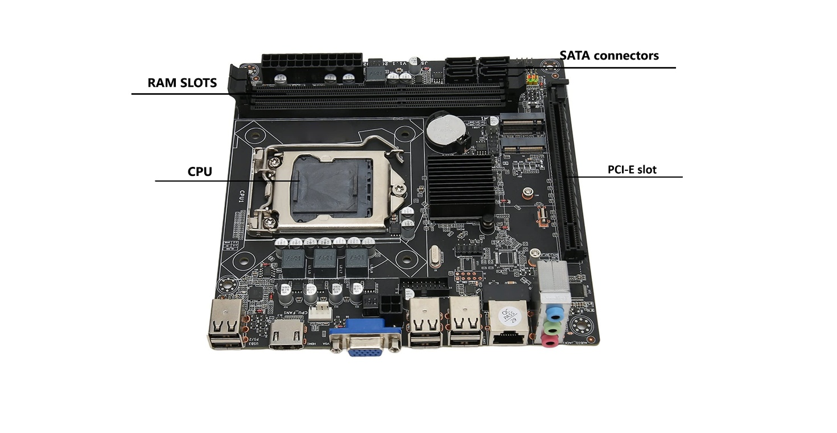

1. Demonstrate how to install a RAM module into a computer.  
   Answer: Installing RAM (Memory) in a Computer

1. Turn Off and Unplug:

- Make sure the computer is completely off and unplugged from the power.

2. Open the Case:

- Unscrew the side panel of the computer case and take it off.

3. Find the RAM Slots:

- Look for the long, thin slots on the motherboard where the RAM goes.

4. Get the RAM Ready:

- Carefully hold the new RAM stick by the edges, avoiding touching the metal parts.

5. Line Up the RAM:

- Match the notches on the RAM stick with the notches in the RAM slot.

6. Insert the RAM:

- Push the RAM stick into the slot gently but firmly until you hear a click.

7. Lock the RAM in Place:

- The clips on the sides of the slot should snap into place, holding the RAM securely.

8. Close the Case:

- Put the side panel back on the computer case and screw it back in place.

9. Plug In and Turn On:

- Plug the computer back in and turn it on. The new RAM should be recognized and ready to use

1. Discuss the importance of proper cooling mechanisms in a computer system. Include examples of cooling methods and their effectiveness.  
   Answer:

Importance of Cooling Mechanisms

1. Preventing Overheating:

- Overheating can cause system crashes, slow performance, and even permanent damage to components. Proper cooling keeps temperatures within safe limits.

2. Enhancing Performance:

- Cooler components often perform better. For instance, CPUs and GPUs can maintain higher clock speeds and work more efficiently when they are properly cooled.

3. Increasing Lifespan:

- Heat can degrade electronic components over time. Effective cooling prolongs the life of your hardware by minimizing thermal stress.

Examples of Cooling Methods

1. Air Cooling:

- Fans:

- Effectiveness: Fans are a common and cost-effective cooling method. They expel hot air from the case and draw in cooler air from the environment.

- Use Case: Suitable for most standard computers and gaming rigs.

2. Liquid Cooling:

- Liquid Coolers:

- Effectiveness: Liquid cooling is highly effective for dissipating heat, especially in high-performance systems. It uses a liquid coolant circulated through tubes and radiators to transfer heat away from components.

- Use Case: Ideal for overclocked systems, gaming PCs, and workstations requiring intense processing power.

3. Thermal Paste:

- Thermal Compound:

- Effectiveness: Thermal paste is applied between the CPU/GPU and their heat sinks to improve heat transfer. It ensures that there are no air gaps, which can impede heat dissipation.

- Use Case: Essential for all CPUs and GPUs to enhance heat transfer to their cooling solutions.

4. Heat Sinks:

- Passive Heat Sinks:

- Effectiveness: Heat sinks are metal blocks with fins that absorb and dissipate heat from components like the CPU and GPU. Passive heat sinks rely on natural convection.

- Use Case: Commonly used in conjunction with fans or liquid cooling systems.

5. Hybrid Cooling:

- Combination Systems:

- Effectiveness: Hybrid systems combine air and liquid cooling to achieve optimal cooling performance. They use air to cool the radiators in liquid cooling systems.

- Use Case: High-end custom-built PCs and servers.

1. Explain the concept of bus width and its significance in computer architecture.  
   Answer:

**Bus Width in Computer Architecture:-**

In computer architecture, **bus width** refers to the number of bits that a bus can transmit simultaneously. A bus is a communication system that transfers data between components inside a computer, such as the CPU, memory, and peripherals. Bus width is typically measured in bits, with common sizes including 8-bit, 16-bit, 32-bit, and 64-bit buses.

**Types of Buses**

* **Data Bus:** Transfers actual data between components. The width of the data bus directly affects how much data can be transmitted at once.
* **Address Bus:** Carries the addresses of memory locations that the CPU wants to access. Its width determines the maximum amount of addressable memory.
* **Control Bus:** Sends control signals to manage data flow and device operations.

**Importance of Bus Width**

1. **Data Throughput:** A wider data bus allows more data to be transferred in a single clock cycle, increasing overall system performance. For example, a 64-bit data bus can transfer eight times more data per cycle than an 8-bit bus.
2. **Memory Addressing:** The width of the address bus determines the maximum amount of memory a system can use. For instance, a 32-bit address bus can address up to 4 GB of memory, while a 64-bit address bus can address 18 exabytes.
3. **System Speed:** With a wider bus, fewer cycles are needed to transfer large amounts of data, reducing latency and improving speed.
4. **Compatibility and Performance:** The bus width must match or be compatible with other hardware components. A mismatch can limit system performance even if other parts are advanced.

In modern computer systems, increasing bus width has been crucial in supporting advanced applications and large datasets, ensuring faster data transfer and more efficient memory usage. This enhancement is essential for improving both computational speed and overall system performance.