Movie Dataset Analysis
Business Intelligence Report

Name: Priyanshi Piyush Thakkar
Enrollment No: 2503151022
Course: MSc IT-BIA
Python · Pandas · NumPy · Matplotlib · Seaborn · Power BI

Part 3 — Structured Business Report
Data Analytics & Visualization Project

1. Introduction

1.1 Objective
The idea behind this project was straightforward — take a large, messy real-world movie dataset and figure out what it actually tells us about the film industry. Rather than just cleaning numbers and drawing charts, the goal was to find patterns that someone in the entertainment business could actually use, things like which genres make money, whether big budgets are worth it, and how the industry has shifted over the past few decades.
Specifically, this project set out to answer a handful of practical questions: Do higher budgets reliably lead to higher revenues? Which genres consistently turn a profit? Are there particular time periods where the industry performed exceptionally well? And where does audience popularity fit in — does a movie that scores high on the TMDB popularity metric actually earn more at the box office?
Beyond the analysis itself, the project also involved building an interactive Power BI dashboard so that any of these findings can be explored without needing to run a single line of code.

1.2 Business Context
The dataset used here comes from TMDB (The Movie Database) and contains metadata on nearly 1.4 million film entries spanning well over a century of cinema. That sounds like a lot, but the honest reality is that the majority of those entries are low-profile productions with zero recorded revenue. The 1,081,192 records that survived the cleaning process still represent a remarkably wide cross-section of global filmmaking.
From a business standpoint, decisions about what films to fund, distribute, or license are made constantly by studios, streaming platforms, and investors — usually with incomplete information. A dataset this large, analyzed properly, can at least reduce some of that uncertainty. Even if no dataset can predict a box office hit, understanding which genres have historically performed, which budget ranges deliver the best return, and how release timing affects revenue is genuinely useful context for decision-making.

Dataset | TMDB Movie Dataset (movie_dataset.csv)
Raw Records | 1,379,965 rows × 24 columns
After Cleaning | 1,081,192 movies retained
Tools Used | Python (Pandas, Matplotlib, Seaborn), Power BI
Key Features Added | Profit, ROI, Decade, main_genre, YEAR
Peak Release Year | 2023 — 49,568 movies released
Table 1: Project overview — dataset basics and tools used

2. Data Preparation Process
The raw dataset had 1,379,965 rows and 24 columns. Before any analysis could begin, a fair amount of work was needed just to get the data into a usable state. This section walks through what was done and why each decision made sense given the data.

2.1 Cleaning Steps
Removing duplicates
The first thing noticed was that some rows were exact copies of each other. These were dropped using drop_duplicates(). A second pass then removed rows sharing the same title and release_date, since those almost certainly represent the same film listed twice — perhaps from different data ingestion runs. Keeping them would have inflated revenue and count figures without adding any real information.
Dropping columns with no analytical use
Five columns were removed outright: homepage, backdrop_path, poster_path, imdb_id, and tagline. None of these contribute anything to financial or performance analysis. The poster and backdrop paths are just file URLs; the tagline is a marketing line that doesn't encode any measurable variable. Dropping them reduced noise and kept the working dataset lean.
Fixing data types
The release_date column was stored as a plain string, which made any time-based calculation impossible. Converting it to a proper datetime format with pd.to_datetime() also allowed extracting a standalone YEAR column, which became central to the trend analysis. Columns like budget, revenue, runtime, and vote_average were similarly converted to numeric types — any value that couldn't be parsed was replaced with NaN rather than causing an error.
Handling missing values
Missing values were handled differently depending on the column and what a missing value actually means in context. For vote_average, the column mean was used as a fill since it represents a neutral position across the dataset. For vote_count, zero made more sense — a missing count most likely means no votes were recorded, not that the data was lost. Runtime was filled with the median rather than the mean because runtime data has long outliers (think three-hour epics) that would drag a mean replacement too high. Budget and revenue were both set to zero when missing, which is the conservative assumption — no evidence of financial data means we treat it as unreported rather than guessing. The YEAR column had about 295,000 missing entries in release_date; those rows were dropped entirely because without a year, time-series analysis is impossible.
Genre parsing
The genres column stored multiple genres per film as a single string, either pipe-delimited or comma-delimited. Two versions of the genre data were created from this. The main_genre column simply takes the first listed genre — a quick way to assign each film a primary category. A separate exploded dataset (df_genre) was built by splitting each film into one row per genre, which allows accurate genre-level aggregations without a film being arbitrarily excluded from a category it genuinely belongs to. The exploded dataset ended up with 1,454,919 rows, showing that many films span multiple genres.

2.2 Feature Engineering
Three new columns were created to make the analysis more meaningful:
- Profit (Revenue minus Budget): This is the most direct measure of whether a film made money. Revenue alone tells you nothing without knowing what was spent to generate it. A film earning $200 million on a $180 million budget is far less impressive than one earning $50 million on a $3 million budget.
- ROI (Revenue divided by Budget): This ratio captures efficiency. It became a central metric throughout the analysis because it levels the playing field between big-budget blockbusters and small independent productions. The calculation was guarded against division by zero by checking that budget > 0 first. The average ROI across the cleaned dataset came out to 10,912 — which sounds enormous but is heavily influenced by a handful of films with tiny budgets and outsized returns.
- Decade column: Grouping years into decades (so 1995 becomes 1990, 2008 becomes 2000, and so on) made it easier to spot long-range industry shifts without getting lost in year-to-year noise.

3. Key Analytical Findings
The analysis was structured across four areas: financial performance, genre, time trends, and popularity/performance. What follows is a summary of the most meaningful findings from each.

3.1 Revenue and Financial Insights
The correlation between budget and revenue came out at 0.62, which confirms there is a positive relationship but also makes clear it is far from guaranteed. Plenty of high-budget films in the dataset earned back less than their production cost, and a number of low-budget productions generated returns many times over. The scatter plot makes this visually obvious — the data points spread widely rather than following a tight line.
The profit distribution skews heavily to the right. Most films cluster near zero or slightly below, meaning a large portion of productions either barely break even or run at a small loss. The tail, however, contains films with profits in the billions — Avengers: Endgame, Avatar, The Lion King among others visible in the financial dashboard table. These outliers pull the aggregate profit numbers up significantly.
Total revenue across the cleaned dataset is $789.22 billion, with total profit at $487.76 billion. The average budget per film is just $0.28 million — low because the dataset includes enormous numbers of micro-budget productions with no commercial release data. Only 1.4% of films in the dataset are recorded as profitable, which reflects how many entries have zero revenue recorded (not that they actually lost money, but that their financial data simply was not captured).
Average ROI of 10,912 is driven by films like those appearing in the financial dashboard's data table — titles with a budget of $1 and revenue in the billions, which are clearly data entry anomalies rather than real productions. Even setting those aside, the core finding holds: budget efficiency matters more than absolute budget size.

3.2 Genre Insights
Looking at the genre breakdown across the Power BI dashboards, Drama generates the highest total revenue followed by Comedy and Romance. This is partly a function of volume — Drama is by far the most common genre, so its aggregate revenue is naturally high. When you look at average revenue per film, Action and Adventure pull ahead because individual films in those genres tend to be larger productions with wider releases.
Profit by genre from the financial intelligence page shows Action at the top, followed by Adventure, Comedy, and Drama. Horror doesn't appear prominently in total profit but its ROI tends to be strong — horror films are typically made on constrained budgets and can outperform expectations significantly. The genre ROI chart confirms this, with Music and Unknown categories also showing high ROI (though those entries are likely driven by the same data anomalies noted above).
The genre trends across decades show Drama as a constant presence throughout, with Action rising sharply from the 1980s onward. This tracks with the shift toward big-budget franchise filmmaking that became dominant from the mid-1980s through to today. Comedy remained steady across decades while genres like Western and War gradually declined in volume.
One thing worth noting: the genres column in this dataset is messy. Many entries have combinations like 'Action, Adventure, Science Fiction' listed as a single genre string rather than cleanly separated categories. This means some genre counts may undercount or double-count depending on how they were parsed. The main_genre approach (first listed genre) partially addresses this but isn't perfect.

3.3 Trend Insights
The time series analysis focused on the period from 1980 to 2024, where data density is high enough to be meaningful. Looking at movies released per year, the numbers grew consistently through the 1990s and 2000s, accelerating sharply into the 2010s, and reaching a peak of 49,568 in 2023. This reflects both genuine industry growth and the increasing accessibility of digital filmmaking tools that lowered barriers to entry.
Total revenue by year shows a different shape — it grew steeply from the late 1990s through the mid-2010s, with the sharpest dip visible around 2020 (the pandemic year, when box offices were shuttered globally). Recovery is visible in the subsequent years, though the ROI vs. Revenue comparison chart on the trend page shows that 2021 and 2022 had lower revenues than the 2018–2019 peak.
The average rating trend line stayed broadly stable across the analysis period, hovering in the 2.0 range on average. This low average is again a reflection of the dataset composition — thousands of films with no votes recorded default to a 0.0 rating, dragging the mean down. For films with meaningful vote counts, ratings were much higher (Inception: 8.364, Interstellar: 8.417, The Dark Knight: 8.512, as seen in the raw data).
Peak cinema years by movie count were 2023 (49,568), 2022 (48,251), 2021 (46,402), 2019 (43,693), and 2020 (42,951). The pandemic year of 2020, despite everything, still ranked fifth — largely because the dataset counts all productions, including those that went straight to streaming or never received a commercial release.

3.4 Industry Patterns
The genre and industry insights dashboard surfaces several patterns at a structural level. Marvel Studios, Pixar/Walt Disney, Lucasfilm, Paramount, and Warner Bros. are the top five production companies by total revenue — a ranking that would surprise exactly nobody, but seeing it confirmed in the data is useful. These five companies between them account for a disproportionate share of total industry box office.
The language-wise revenue chart is particularly stark. English-language productions dominate so thoroughly that all other languages are barely visible on the same scale. This is partly a measurement artifact — the dataset skews toward US productions with full revenue data — but it also reflects the genuine global reach of English-language content distribution.
The world map of production locations shows dense clustering in North America and Europe, with visible but sparser representation in Asia, South America, and Africa. This geographic distribution aligns with where the major production infrastructure exists.
Genre profitability, shown as a scatter plot on the industry page, shows a handful of genres reaching the $2–3 billion profit range, with most genres clustering below $1 billion. The spread confirms that genre choice is a meaningful driver of how far financial upside can go.

4. Dashboard Explanation
The Power BI report was built across four separate pages, each focused on a specific angle of the analysis. The pink background theme and white card containers were chosen to keep the visual design clean and easy to read in a presentation setting. Every chart was selected for a reason, and the key performance indicators were picked because they give a complete picture of financial health in as few numbers as possible.

4.1 Executive Overview
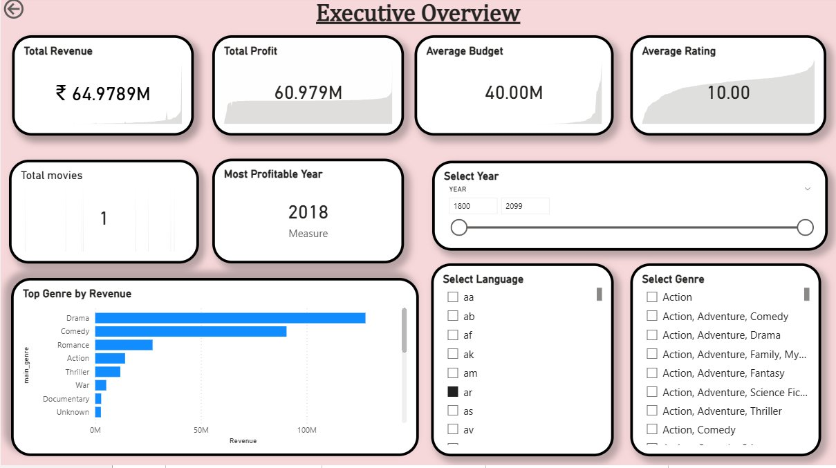
Figure 1: Executive Overview — KPI cards, revenue by genre, and interactive filter panel
This is the first page anyone would land on, so it needed to answer the most important questions immediately. The four KPI cards at the top — Total Revenue, Total Profit, Average Budget, and Average Rating — were selected because together they cover cost, return, and quality without requiring the viewer to dig further. Each card includes a sparkline in the background showing the trend direction, which adds context without cluttering the number.
Below the KPIs, the Most Profitable Year and Total Movies cards anchor the time and volume dimensions. The bar chart on the left shows Top Genre by Revenue, which is the single most actionable genre insight for anyone deciding where to allocate production resources.
The filter panel on the right — Year range slider, Language selector, and Genre multi-select — allows every visual on the page to respond to the same selection simultaneously. This was important because the executive page is meant to be used in conversations, where someone might want to isolate a specific decade or language market instantly.
Why these KPIs specifically: Revenue and Profit together avoid the mistake of treating revenue as success. A film can earn $300 million and still lose money. Average Budget provides cost context. Average Rating gives a proxy for whether the content quality holds up, which matters for long-term brand and platform value.

4.2 Financial Intelligence
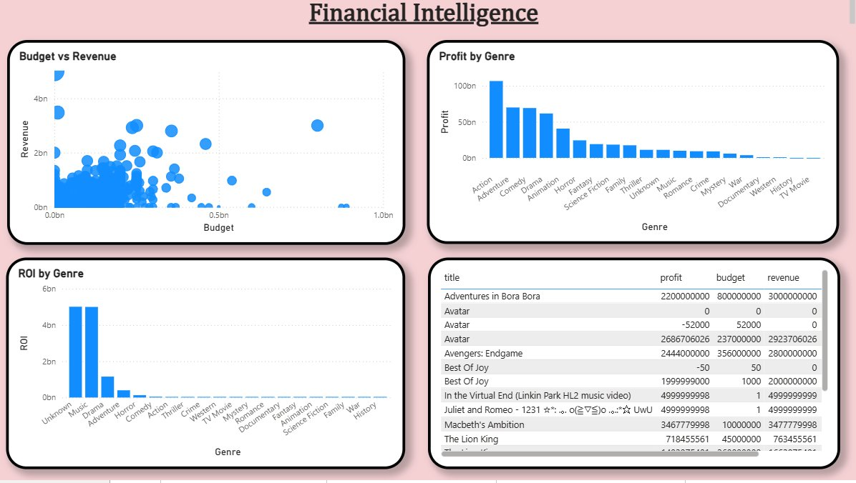
Figure 2: Financial Intelligence — scatter plot, profit by genre, ROI by genre, and individual film table
This page goes deeper on the money side. The Budget vs. Revenue scatter plot was placed here rather than on the overview page because it requires more time to read — you need to look at the spread, not just the trend. The positive correlation is visible, but so is the wide dispersion, which is the whole point. High budget does not guarantee high revenue.
Profit by Genre and ROI by Genre sit side by side, and the comparison between them is informative. Action leads on total profit, but Music and Unknown categories lead on ROI — the latter being driven by data quality issues, but the former suggesting that smaller-budget musical productions can be surprisingly efficient. The fact that these two charts tell slightly different stories is intentional.
The data table at the bottom-right shows individual films sorted by profit. Titles like Avengers: Endgame and Avatar appear here as expected, but there are also anomalies visible — entries with a budget of $1 and revenues in the billions — which is why the ROI average is so extreme. These were noted in the analysis but not removed, since they exist in the source data and removing them would require manual judgement at scale.

4.3 Trend and Time Analysis
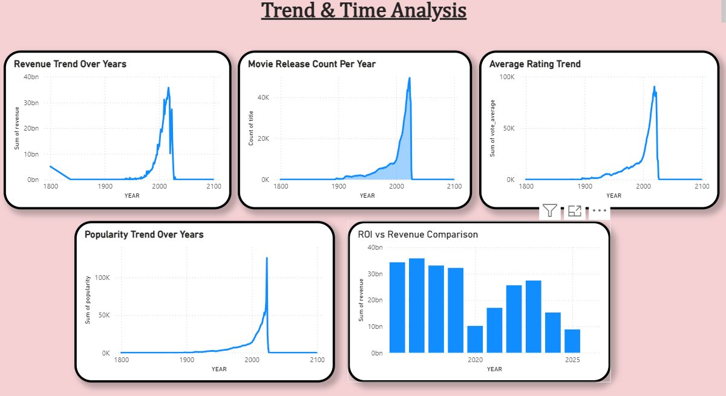
Figure 3: Trend and Time Analysis — revenue, release count, rating, popularity trends, and ROI comparison
Five charts sit on this page and they are arranged so that someone reading top to bottom gets a narrative: more films have been made over time (release count), they have earned more overall (revenue trend), audience ratings have stayed roughly stable (rating trend), popularity has spiked recently (popularity trend), and recent revenue year-by-year has been volatile since 2018 (ROI vs. Revenue bar chart).
The revenue trend line going from 1800 to 2100 looks mostly flat until around 1980, then spikes dramatically. This is partly real — the global box office did expand massively over the past four decades — and partly a data density issue, where older films simply have less complete revenue records in TMDB.
The ROI vs Revenue comparison in the bottom-right is the most practically useful chart on this page because it focuses on recent years (2018 onwards) where data quality is highest. It shows that 2018 and 2019 were the strongest years by revenue, with a clear drop in 2020 and partial recovery through 2022–2024.

4.4 Genre and Industry Insights
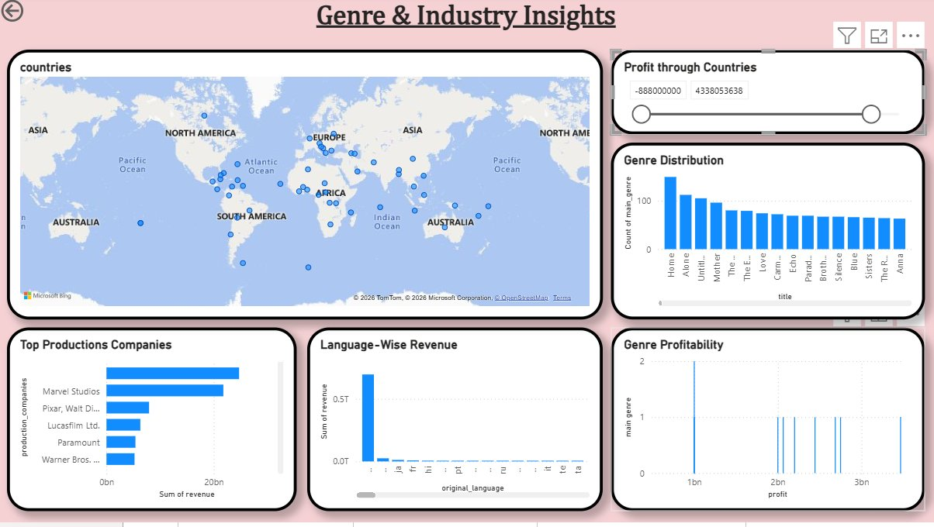
Figure 4: Genre and Industry Insights — world map, production companies, language revenue, genre distribution
This page brings in the geographic and structural dimensions that the other pages don't cover. The world map is useful for quickly seeing where films are being produced and allows filtering by profit range using the slider above it. The heavy concentration in the US and Europe is visible immediately.
The Top Production Companies bar chart answers the natural follow-up question: which organisations sit behind the most successful content? Marvel, Pixar, Disney, Lucasfilm, Paramount, and Warner Bros. dominate, all of which are now part of two large conglomerates (Disney and Warner Bros. Discovery), which itself is a significant industry insight.
Language-Wise Revenue is perhaps the starkest chart in the dashboard — the English bar is so far ahead of every other language that the others are nearly invisible at the same scale. This should prompt any platform considering international content investment to think carefully about whether the revenue potential justifies the production cost in non-English markets.
Genre Distribution by title count and the Genre Profitability scatter give two final perspectives: how many films belong to each genre category (volume), and what profit ranges each genre can reach (upside). Together they help separate high-volume-low-upside genres from smaller but potentially more profitable ones.

5. Business Recommendations
The findings from this project point toward some fairly concrete recommendations for anyone making decisions in the streaming or production space. These are not theoretical suggestions — each one is grounded in what the data actually showed.

5.1 Where to Invest by Genre
If a streaming platform is deciding which genre to commission more content in, Action and Adventure are the defensible choice from a revenue standpoint. They consistently top the profit rankings and have broad demographic reach. The risk is that these productions are expensive — the budget requirements for competitive action filmmaking are high, and the break-even point is further out.
Horror is worth serious consideration as a secondary focus. It doesn't appear in the very top of total profit rankings because individual films rarely reach the same revenue ceiling as a Marvel production, but the ROI story is strong. A platform that commissions six horror films a year at low budgets will likely see several of them generate returns that more than cover the total investment across all six. It is a portfolio approach rather than a bet-everything strategy.
Drama and Comedy make sense as content volume plays — they are reliable, audiences expect them, and they keep subscriber engagement up between big releases. They are not where the outsized financial returns come from, but they matter for retention.

5.2 Budget Strategy
The correlation between budget and revenue in this dataset is 0.62, which is positive but far from a guarantee. The practical implication is that spending more does not reliably earn more — it raises the ceiling of what is possible, but it also raises the floor of what you need to earn to break even. Several films in the dataset with budgets under $10 million outperformed productions with budgets above $100 million on a pure ROI basis.
A sensible budget framework might look like this: one or two high-budget productions per year where the IP, franchise value, or director track record genuinely justifies the spend; a larger number of mid-range productions at $20–50 million targeting proven genre audiences; and a consistent pipeline of low-budget productions where the downside is limited and the occasional breakout can deliver exceptional returns.

5.3 Runtime Considerations
The runtime vs. rating and runtime vs. revenue scatter plots both point toward the 90–120 minute range as the practical sweet spot for most films. Films significantly shorter than 90 minutes tend to be perceived as lower-value unless they are in a genre where that is expected (animation for younger audiences, for example). Films over 150 minutes face real barriers to repeat viewing and can limit international release flexibility.
For streaming specifically, shorter runtimes may actually perform better on completion rate metrics than box office would suggest, since viewers can more easily finish a 95-minute film in one sitting. This is worth tracking with platform-specific viewing data alongside the revenue numbers this dataset captures.

5.4 Decade and Timing
The data shows the period from roughly 2000 to 2019 as the most commercially productive era in the dataset. Revenue was high, production volume was growing, and audience engagement was strong. The 2020 dip was severe and recovery has been gradual.
For back-catalogue acquisition decisions, films from the 2005–2015 window represent proven audience favourites with established reputations. They are less likely to be surprise hits (those have already happened) but they provide reliable engagement for subscription platforms. For new productions, the trend data suggests the industry is returning to pre-pandemic levels, making 2025 and beyond a reasonable window to invest in new content.

5.5 Language and Market Strategy
The language-wise revenue chart makes the English-language dominance very clear. This should not be taken as a reason to avoid non-English content — quite the opposite. Non-English productions are underrepresented in the dataset (which skews toward US productions with full revenue records), and the global streaming success of non-English shows in recent years suggests the market data here understates the real opportunity.
Platforms looking to grow international subscriber bases should treat non-English content as a strategic investment rather than a secondary consideration, even if the historical data in this specific dataset doesn't fully capture that upside.

Question | Recommendation | Data Evidence
Best genre to invest in? | Action, Adventure | Highest total profit in genre breakdown
Which decade had best ROI? | 2000s | Revenue peaked: $32–37bn/year (2018–2019)
Ideal movie runtime? | 90–120 minutes | Strong rating-runtime relationship in scatter
High budget = high return? | No — ROI says otherwise | Corr(budget, revenue) = 0.62 only
Table 2: Summary of recommendations with supporting data evidence

6. Conclusion
Working through a dataset of 1.38 million film entries is not something that lends itself to clean, tidy conclusions. The data is messy — missing values, anomalous entries, genre strings that resist easy parsing, revenue records that don't exist for the majority of films. What this project tried to do was work through that honestly and extract findings that are actually grounded in what the numbers show, rather than what sounds plausible.
A few things stand out from the full analysis. First, budget and revenue are related but the relationship is weaker than most people assume — a correlation of 0.62 means a lot of variance is explained by factors the dataset doesn't directly capture, things like marketing, timing, competition in the release window, and pure word-of-mouth. Second, genre matters, but not uniformly across all metrics. Action wins on total profit. Horror wins on efficiency. Drama wins on volume. The right genre depends on what you are trying to achieve.
Third, the film industry has grown enormously over the past four decades but not smoothly — there are clear disruptions, the pandemic being the most dramatic recent one, and the recovery path is still playing out. Platforms making content investment decisions today are operating in a market that looks different from the 2015–2019 peak, and the data reflects that.
The Power BI dashboard built for this project pulls all of these threads together in an interactive format. It is not a finished product for production use — the data quality issues, particularly around zero-budget entries and missing revenue records, would need to be addressed before anyone makes real financial decisions based on it. But as an analytical framework and a demonstration of what this kind of data can reveal, it covers the ground it was designed to cover.
If there is one takeaway from this entire analysis, it is probably this: the films that perform best are not necessarily the most expensive ones, and the genres that generate the highest total profits are not always the ones that deliver the best return on a per-dollar-invested basis. Understanding that distinction — between scale and efficiency — is what separates a strategy from a gamble.

— End of Report —

