**SOL 1:**

**#include <stdio.h>**

**int fact(int n);**

**int main()**

**{**

**int n,res;**

**printf("Enter a number:",n);**

**scanf("%d",&n);**

**res=fact(n);**

**printf("n!=%d\n",res);**

**return 0;**

**}**

**int fact(int n)**

**{**

**int res;**

**if (n==0)**

**{**

**return 1;**

**}**

**else**

**{**

**return n*fact(n-1);**

**}**

**}**

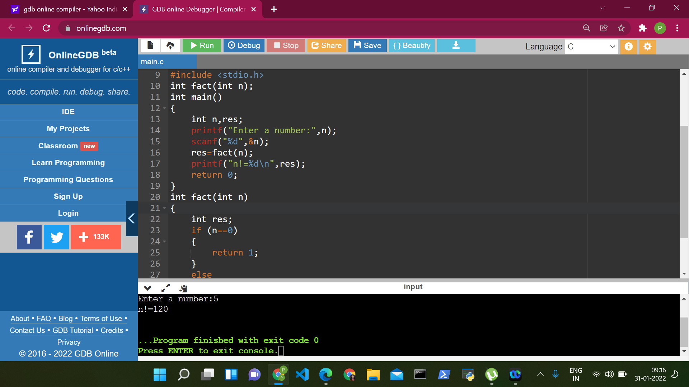

**SOL 2:**

**#include<stdio.h>**

**int gcd(int a, int b);**

**int main()**

**{**

**int n1, n2;**

**printf("Enter two numbers : ");**

**scanf("%d,%d", &n1,&n2);**

**int result = gcd (n1, n2);**

**printf("The GCD of %d and %d = %d", n1, n2, result);**

**return 0;**

**}**

**int gcd(int a, int b)**

**{**

**int hcf;**

**for(int i=1; i<=a && i<=b; i++)**

**{**

**if(a%i==0 && b%i==0)**

**{**

**hcf = i;**

**}**

**}**

**return hcf;**

**}**

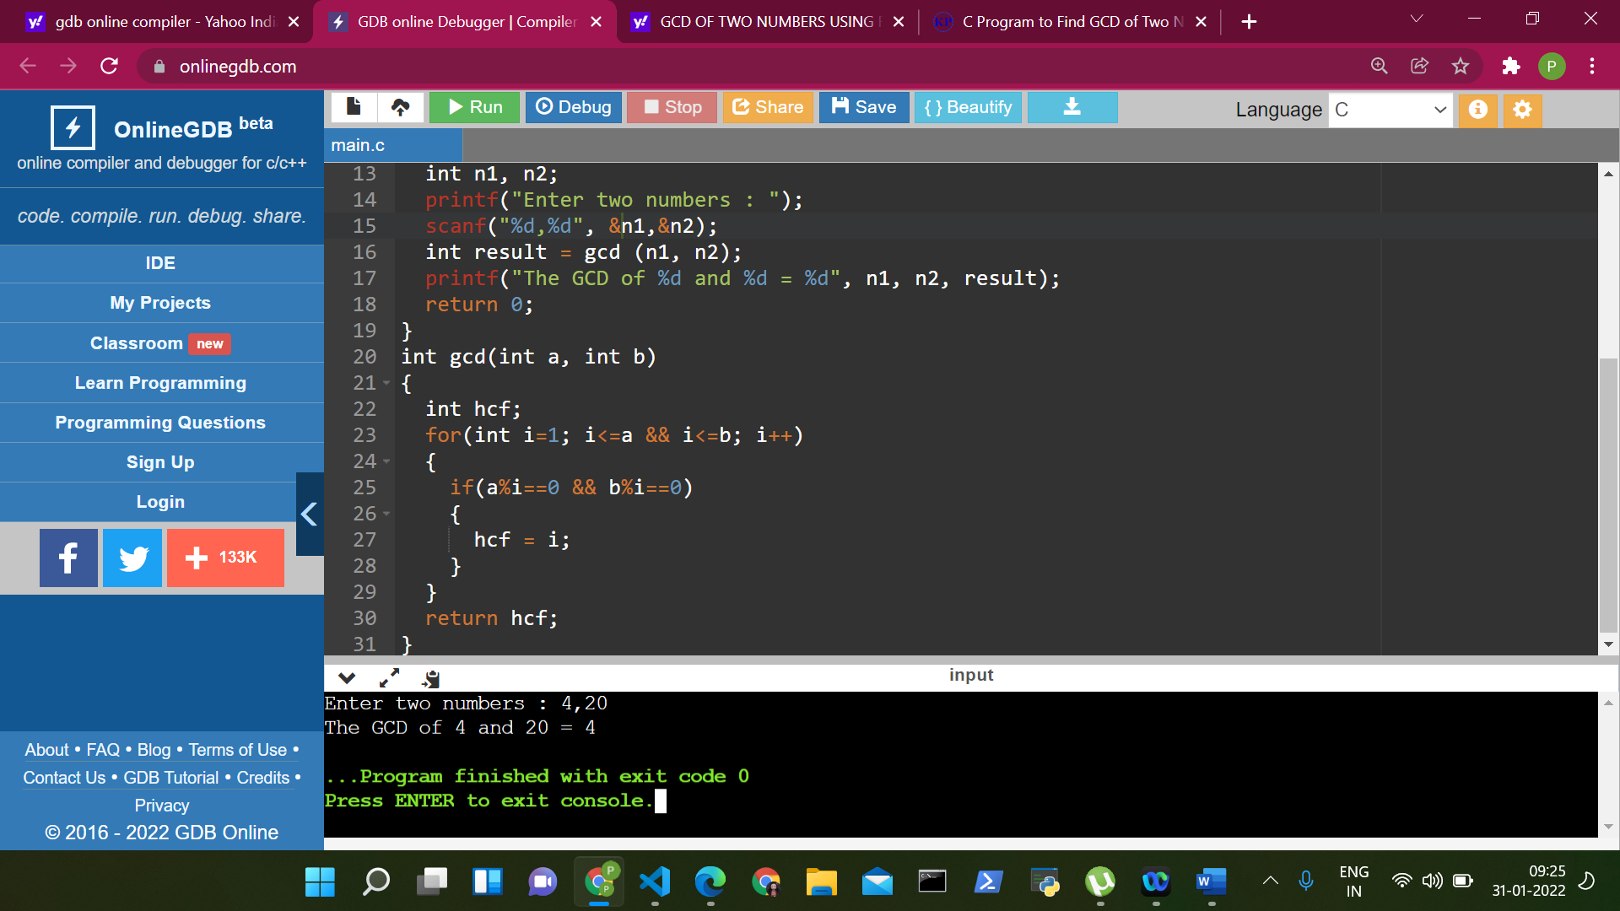

**SOL 3:**

**#include<stdio.h>**

**void fibonacciSeries(int range)**

**{**

**int x=0, y=1, z;**

**while (x<=range)**

**{**

**printf("%d\t", x);**

**z = x+y;**

**x = y;**

**y = z;**

**}**

**}**

**int main()**

**{**

**int range;**

**printf("Enter range: ");**

**scanf("%d", &range);**

**printf("The fibonacci series is: \n");**

**fibonacciSeries(range);**

**return 0;**

**}**

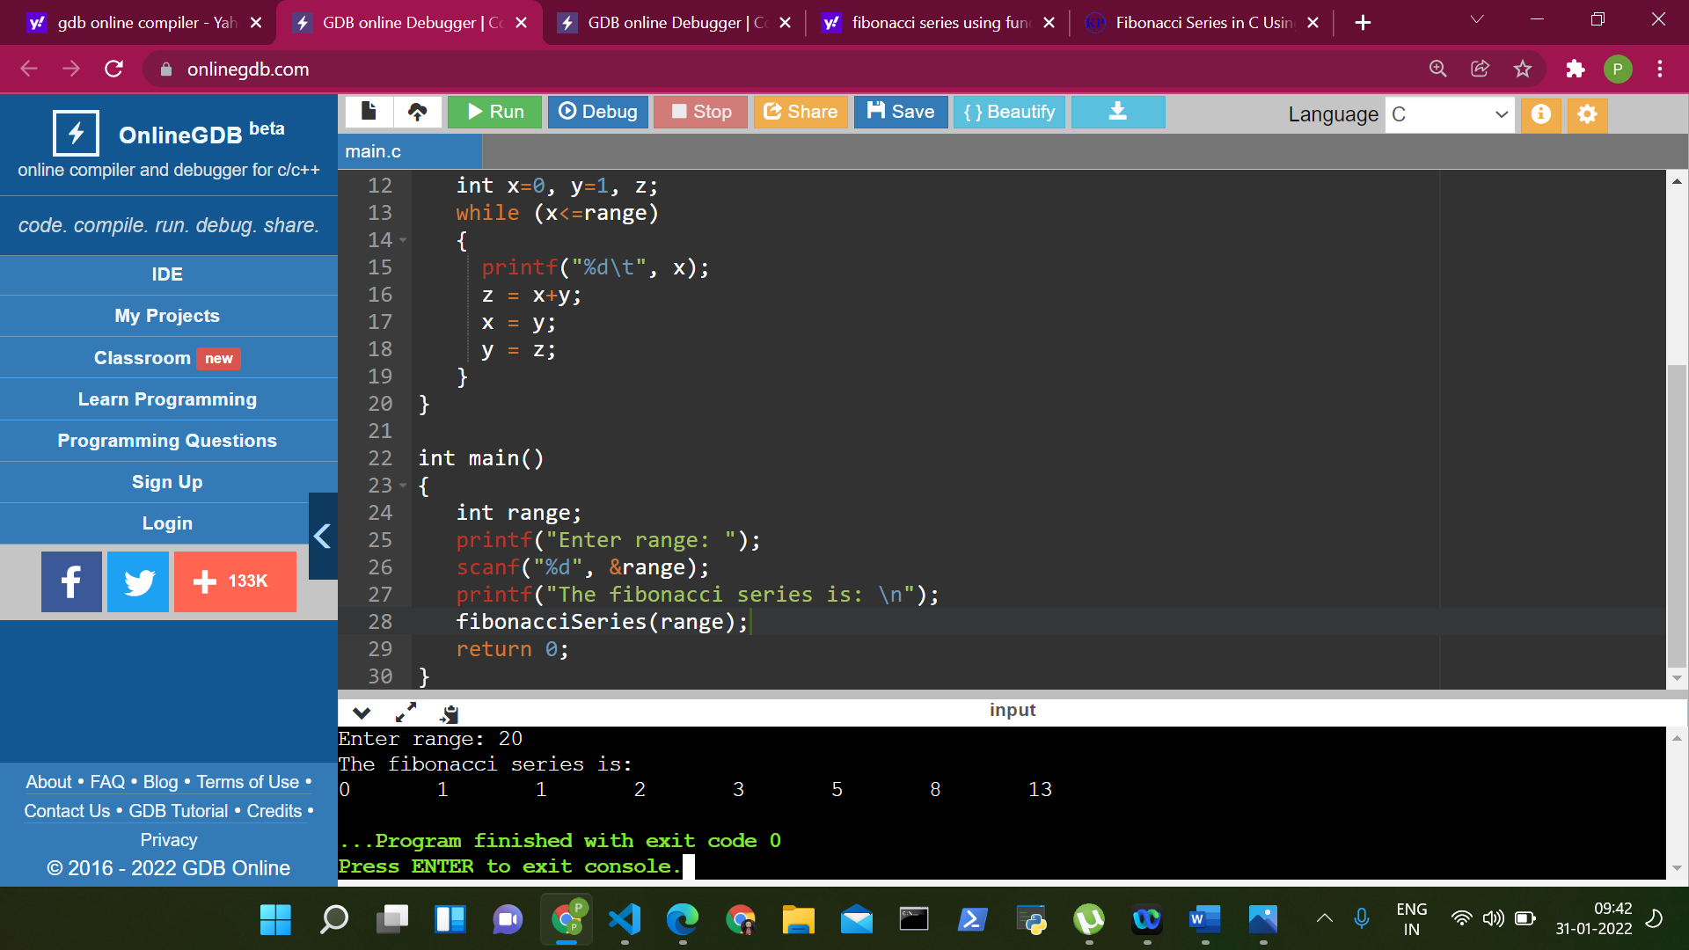

**SOL 4:**

**#include<stdio.h>**

**#include<math.h>**

**int power(int n1, int n2);**

**int main()**

**{**

**int base,exp;**

**printf("Enter the base:");**

**scanf("%d",&base);**

**printf("Enter its power:");**

**scanf("%d",&exp);**

**printf("%d^%d=%d",base,exp,power(base,exp));**

**return 0;**

**}**

**int power(int n1,int n2)**

**{**

**if (n2 != 1)**

**{**

**return n1*pow(n1,(n2-1));**

**}**

**}**

