SOL 1:

#include<stdio.h>

int main()

{

int arr[5],i;

for(i=0; i<5; i++)

{

printf("Enter the value for arr[%d] : ",i);

scanf("%d", &arr[i]);

}

printf("The array elements are : \n");

for(i=0; i<5; i++)

printf("%d\t", arr[i]);

printf("\n");

}

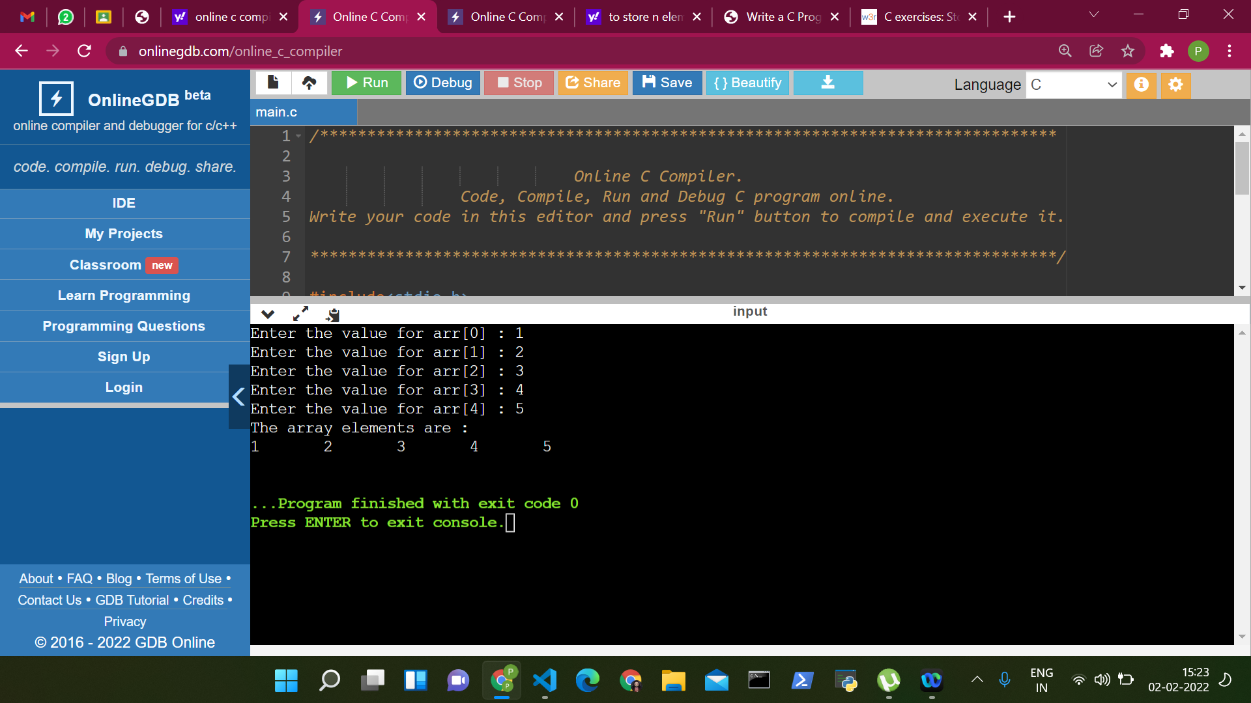

SOL 2:

#include <stdio.h>

#include <conio.h>

int main()

{

int a[1000],i,n,sum=0;

printf("Enter size of the array : ");

scanf("%d",&n);

printf("Enter elements in array : ");

for(i=0; i<n; i++)

{

scanf("%d",&a[i]);

}

for(i=0; i<n; i++)

{

sum+=a[i];

}

printf("sum of array is : %d",sum);

return 0;

}

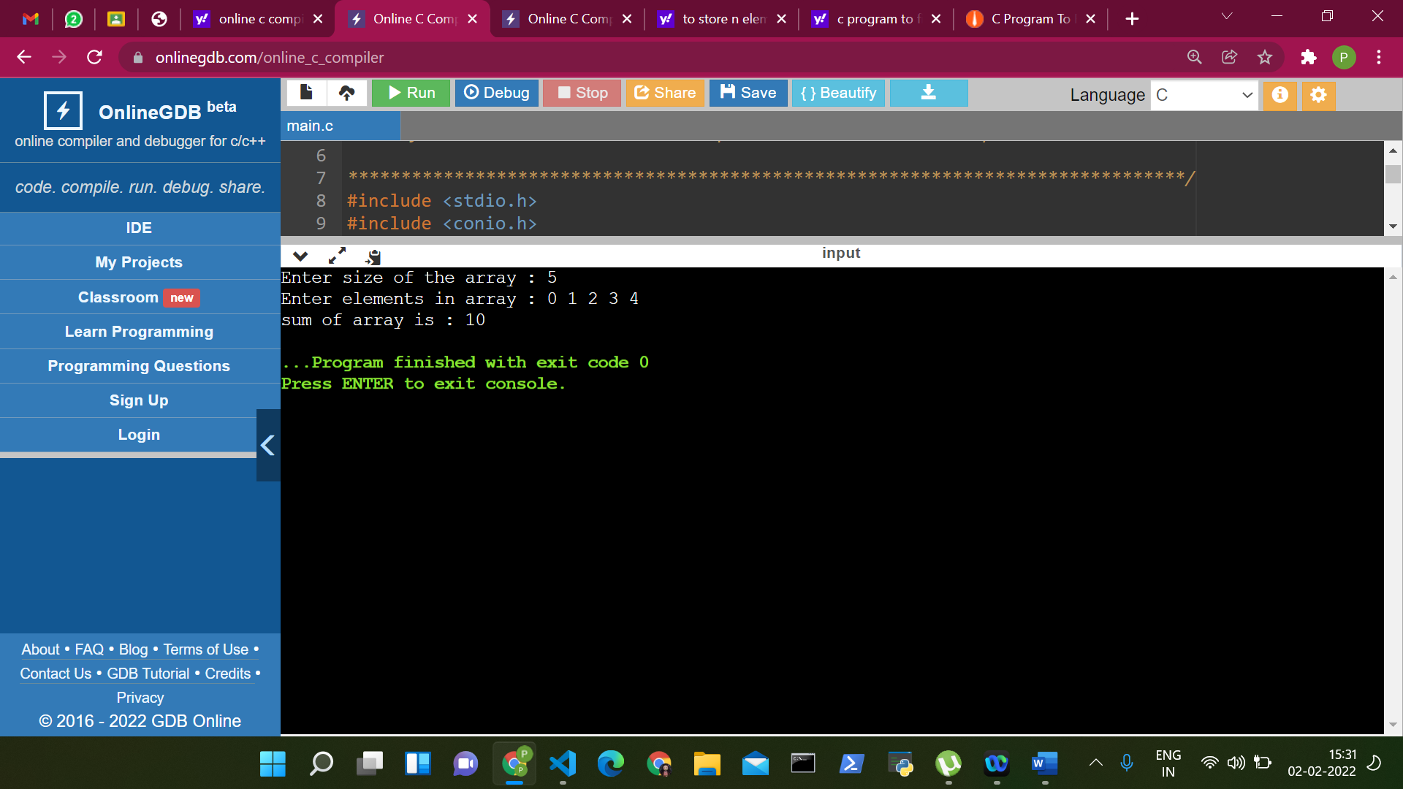

SOL 3:

#include <stdio.h>

int main()

{

int arr1[] = {1, 2, 3, 4, 5};

int length = sizeof(arr1)/sizeof(arr1[0]);

int arr2[length];

for (int i = 0; i < length; i++) {

arr2[i] = arr1[i];

}

printf("Elements of original array: \n");

for (int i = 0; i < length; i++) {

printf("%d ", arr1[i]);

}

printf("\n");

printf("Elements of new array: \n");

for (int i = 0; i < length; i++) {

printf("%d ", arr2[i]);

}

return 0;

}

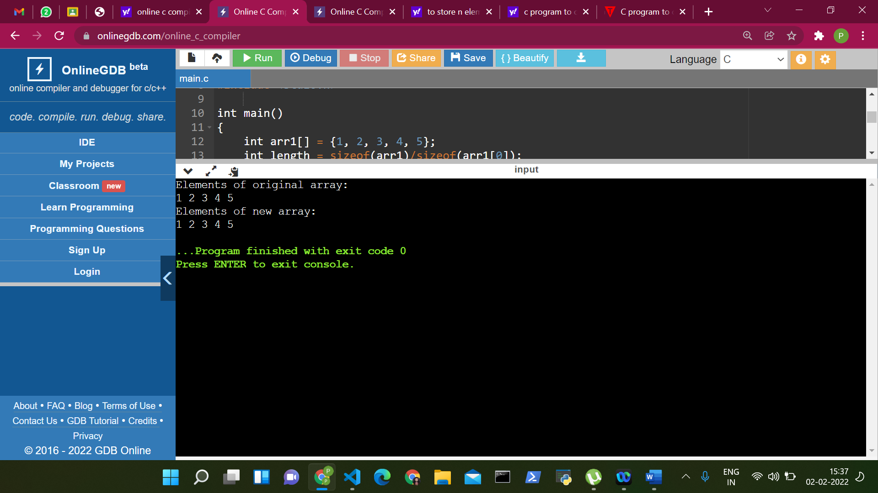

SOL 4:

#include <stdio.h>

int main()

{

int arr[10], i, j, Size, Count = 0;

printf("\n Please Enter Number of elements in an array : ");

scanf("%d", &Size);

printf("\n Please Enter %d elements of an Array : ", Size);

for (i = 0; i < Size; i++)

{

scanf("%d", &arr[i]);

}

for (i = 0; i < Size; i++)

{

for(j = i + 1; j < Size; j++)

{

if(arr[i] == arr[j])

{

Count++;

printf("Duplicate elements are at %d and %d \n",i,j);

break;

}

}

}

printf("\n Total Number of Duplicate Elements in this Array = %d ", Count);

return 0;

}

