**SOL 1:**

**#include <stdio.h>**

**int calcMax(int arr[]);**

**int calcMin(int arr[]);**

**int main()**

**{**

**int arr[1000];**

**int i, max, min, n;**

**printf("Enter size of the array: ");**

**scanf("%d", &n);**

**for(i=0; i<n; i++)**

**{**

**printf("Enter %d element in the array: ", i+1);**

**scanf("%d", &arr[i]);**

**}**

**max = calcMax(arr);**

**min = calcMin(arr);**

**printf("Maximum element = %d", max);**

**printf("\nMinimum element = %d", min);**

**return 0;**

**}**

**int calcMax(int arr[]){**

**int max,i;**

**for(i=0; i<5; i++)**

**{**

**if(arr[i] > max)**

**{**

**max = arr[i];**

**}**

**}**

**return max;**

**}**

**int calcMin(int arr[]){**

**int min,i;**

**for(i=0; i<5; i++)**

**{**

**if(arr[i] < min)**

**{**

**min = arr[i];**

**}**

**}**

**return min;**

**}**

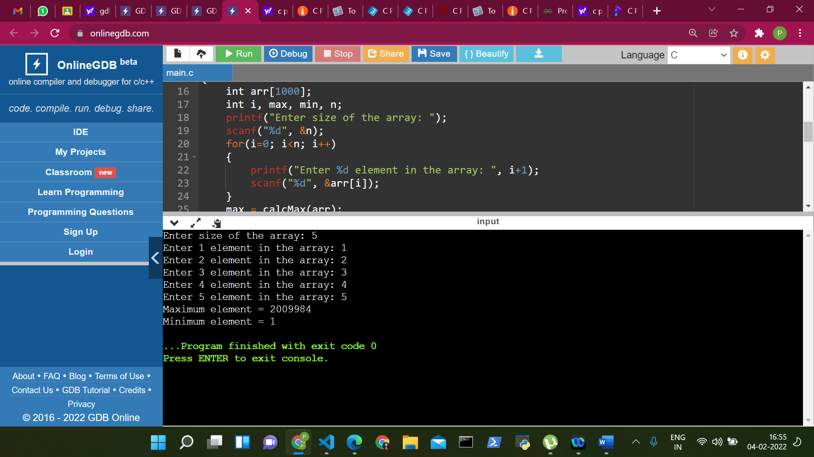

**SOL 2:**

**#include<stdio.h>**

**int main()**

**{**

**int i, j, rows, columns, a[10][10], b[10][10];**

**int Addition[10][10];**

**printf("\n Please Enter Number of rows and columns : ");**

**scanf("%d %d", &i, &j);**

**printf("\n Please Enter the First Matrix Elements\n");**

**for(rows = 0; rows < i; rows++)**

**{**

**for(columns = 0; columns < j; columns++)**

**{**

**scanf("%d", &a[rows][columns]);**

**}**

**}**

**printf("\n Please Enter the Second Matrix Elements\n");**

**for(rows = 0; rows < i; rows++)**

**{**

**for(columns = 0; columns < j; columns++)**

**{**

**scanf("%d", &b[rows][columns]);**

**}**

**}**

**for(rows = 0; rows < i; rows++)**

**{**

**for(columns = 0; columns < j; columns++)**

**{**

**Addition[rows][columns] = a[rows][columns] + b[rows][columns];**

**}**

**}**

**printf("\n The Sum of Two Matrix a and b = a + b \n");**

**for(rows = 0; rows < i; rows++)**

**{**

**for(columns = 0; columns < j; columns++)**

**{**

**printf("%d \t ", Addition[rows][columns]);**

**}**

**printf("\n");**

**}**

**return 0;**

**}**

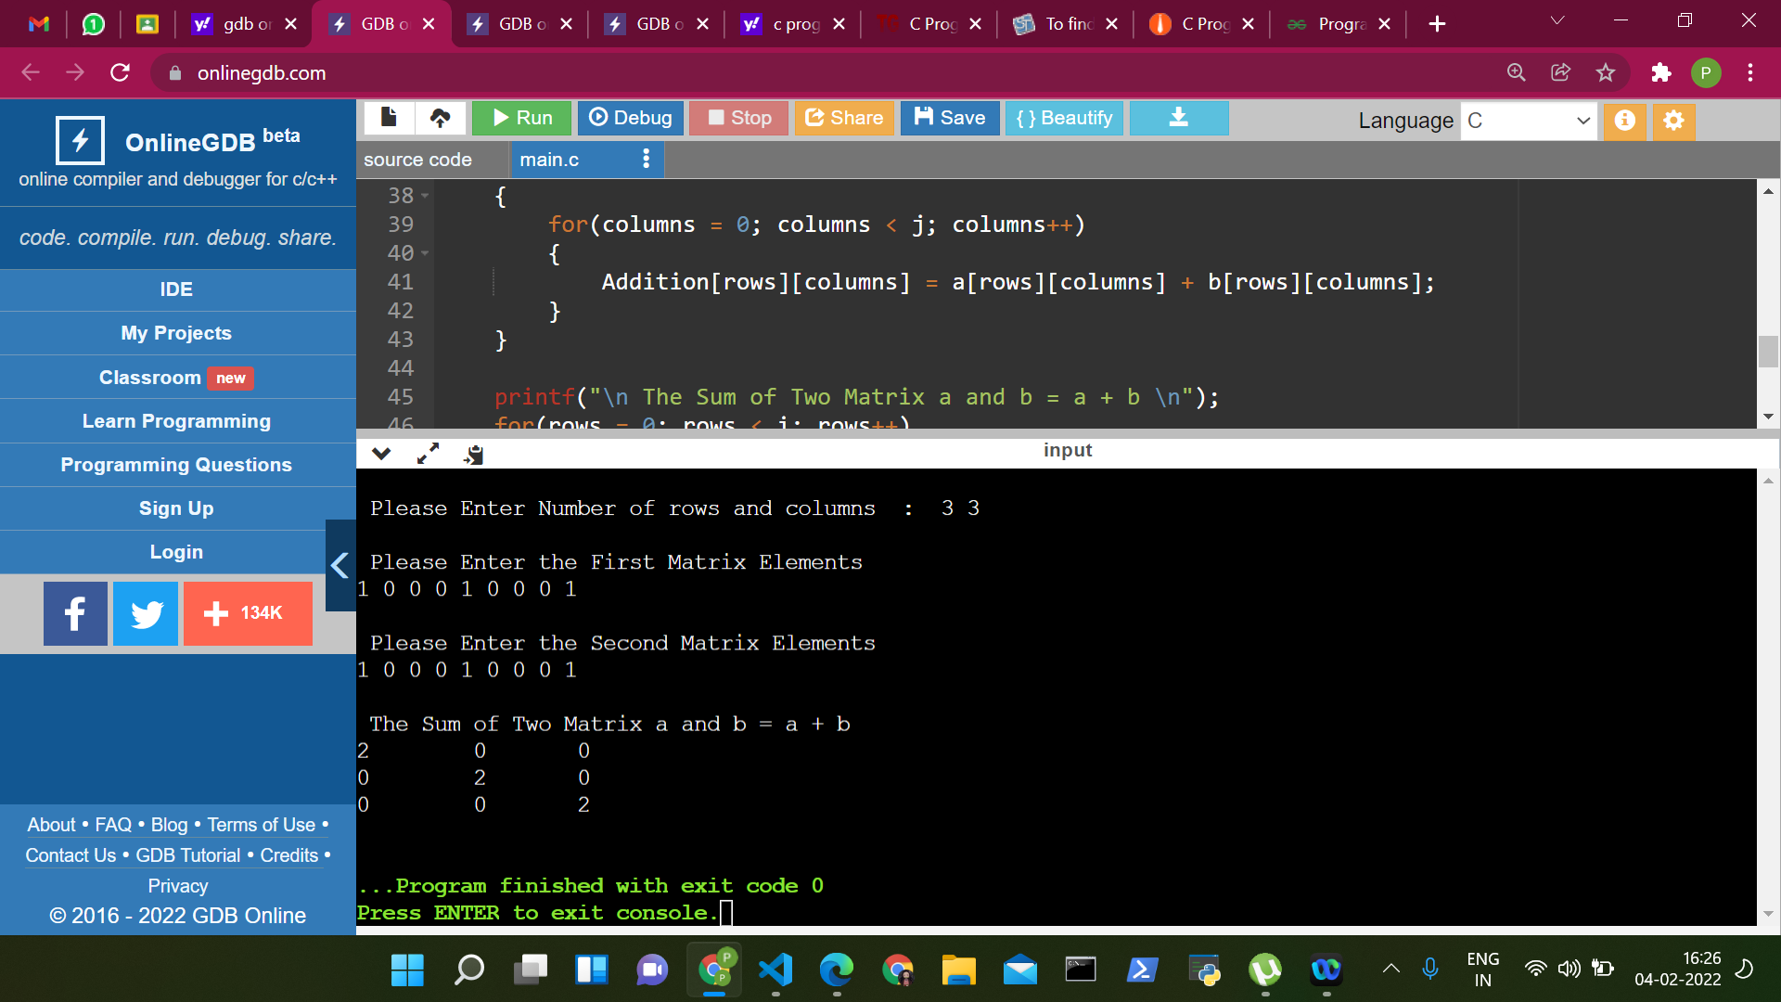

**SOL 3:**

**#include<stdio.h>**

**int main()**

**{**

**int i, j, rows, columns, a[10][10];**

**int Transpose[10][10];**

**printf("\n Please Enter Number of rows and columns : ");**

**scanf("%d %d", &i, &j);**

**printf("\n Please Enter the Matrix Elements\n");**

**for(rows = 0; rows < i; rows++)**

**{**

**for(columns = 0; columns < j; columns++)**

**{**

**scanf("%d", &a[rows][columns]);**

**}**

**}**

**for(rows = 0; rows < i; rows++)**

**{**

**for(columns = 0; columns < j; columns++)**

**{**

**Transpose[rows][columns] = a[columns][rows];**

**}**

**}**

**printf("\n The Transpose of matrix a = a' \n");**

**for(rows = 0; rows < i; rows++)**

**{**

**for(columns = 0; columns < j; columns++)**

**{**

**printf("%d \t ", Transpose[rows][columns]);**

**}**

**printf("\n");**

**}**

**return 0;**

**}**

