SOL 1:

#include <stdio.h>

#include <string.h>

int main()

{

char s[1000];

int i,alphabets=0,digits=0,specialcharacters=0;

printf("Enter the string : ");

gets(s);

for(i=0;s[i];i++)

{

if((s[i]>=65 && s[i]<=90)|| (s[i]>=97 && s[i]<=122) )

alphabets++;

else if(s[i]>=48 && s[i]<=57)

digits++;

else

specialcharacters++;

}

printf("Alphabets = %d\n",alphabets);

printf("Digits = %d\n",digits);

printf("Special characters = %d", specialcharacters);

return 0;

}

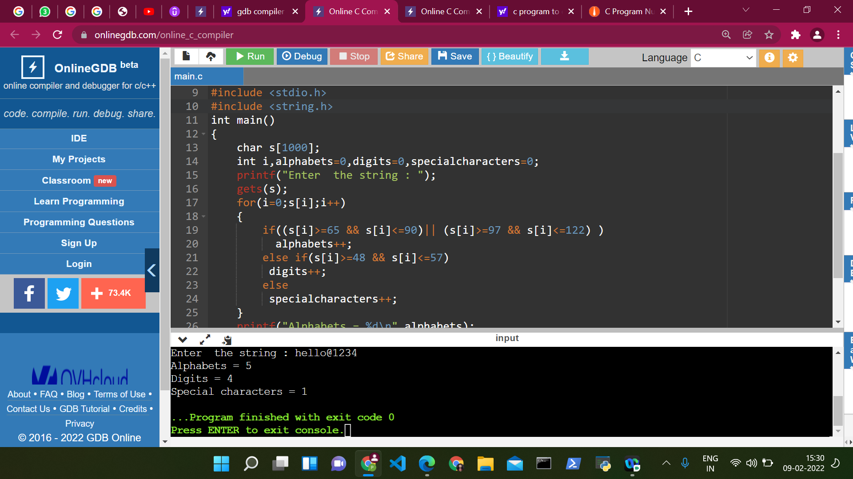

SOL 2:

#include <stdio.h>

int main()

{

int i,count=0;

char line[150];

printf("Enter A String:");

scanf("%[^\n]",line);

for (i=0;line[i]!='\0';i++)

{

++count;

}

printf("Length Of String: %d",count);

return 0;

}

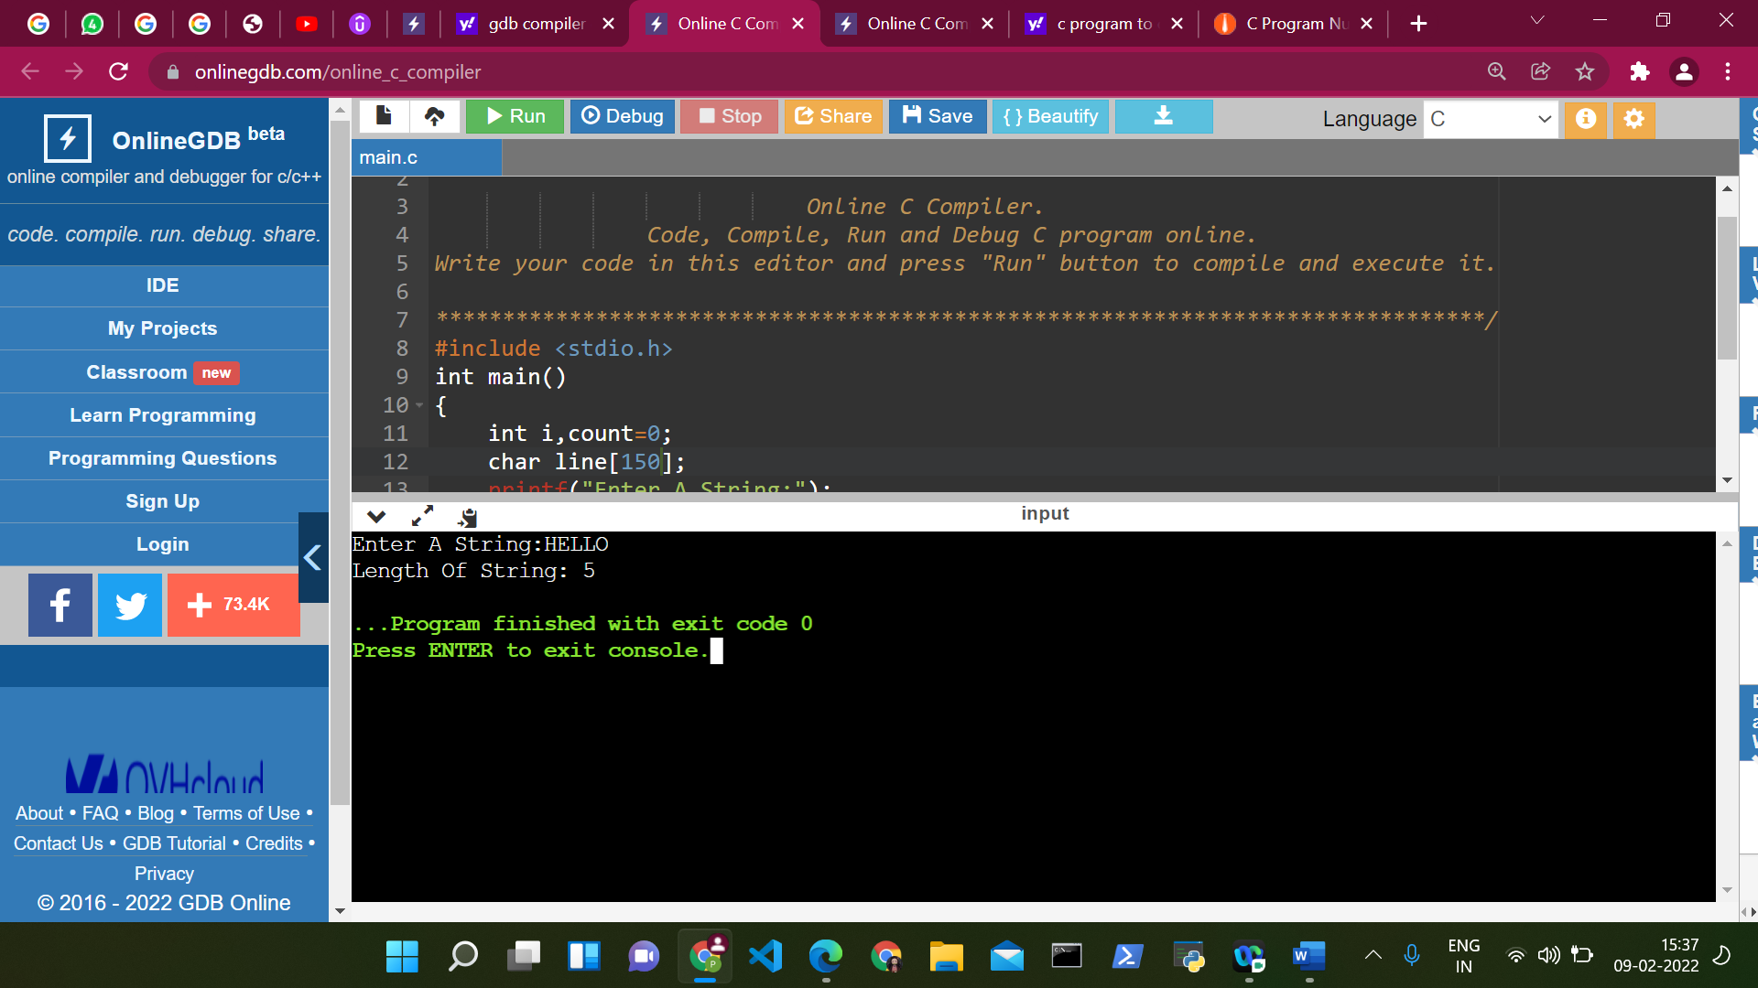

SOL 3:

#include<stdio.h>

int main()

{

char str1[30], str2[30];

int i;

printf("\nEnter two strings :");

gets(str1);

gets(str2);

i = 0;

while (str1[i] == str2[i] && str1[i] != '\0')

i++;

if (str1[i] > str2[i])

printf("str1 > str2");

else if (str1[i] < str2[i])

printf("str1 < str2");

else

printf("str1 = str2");

return (0);

}

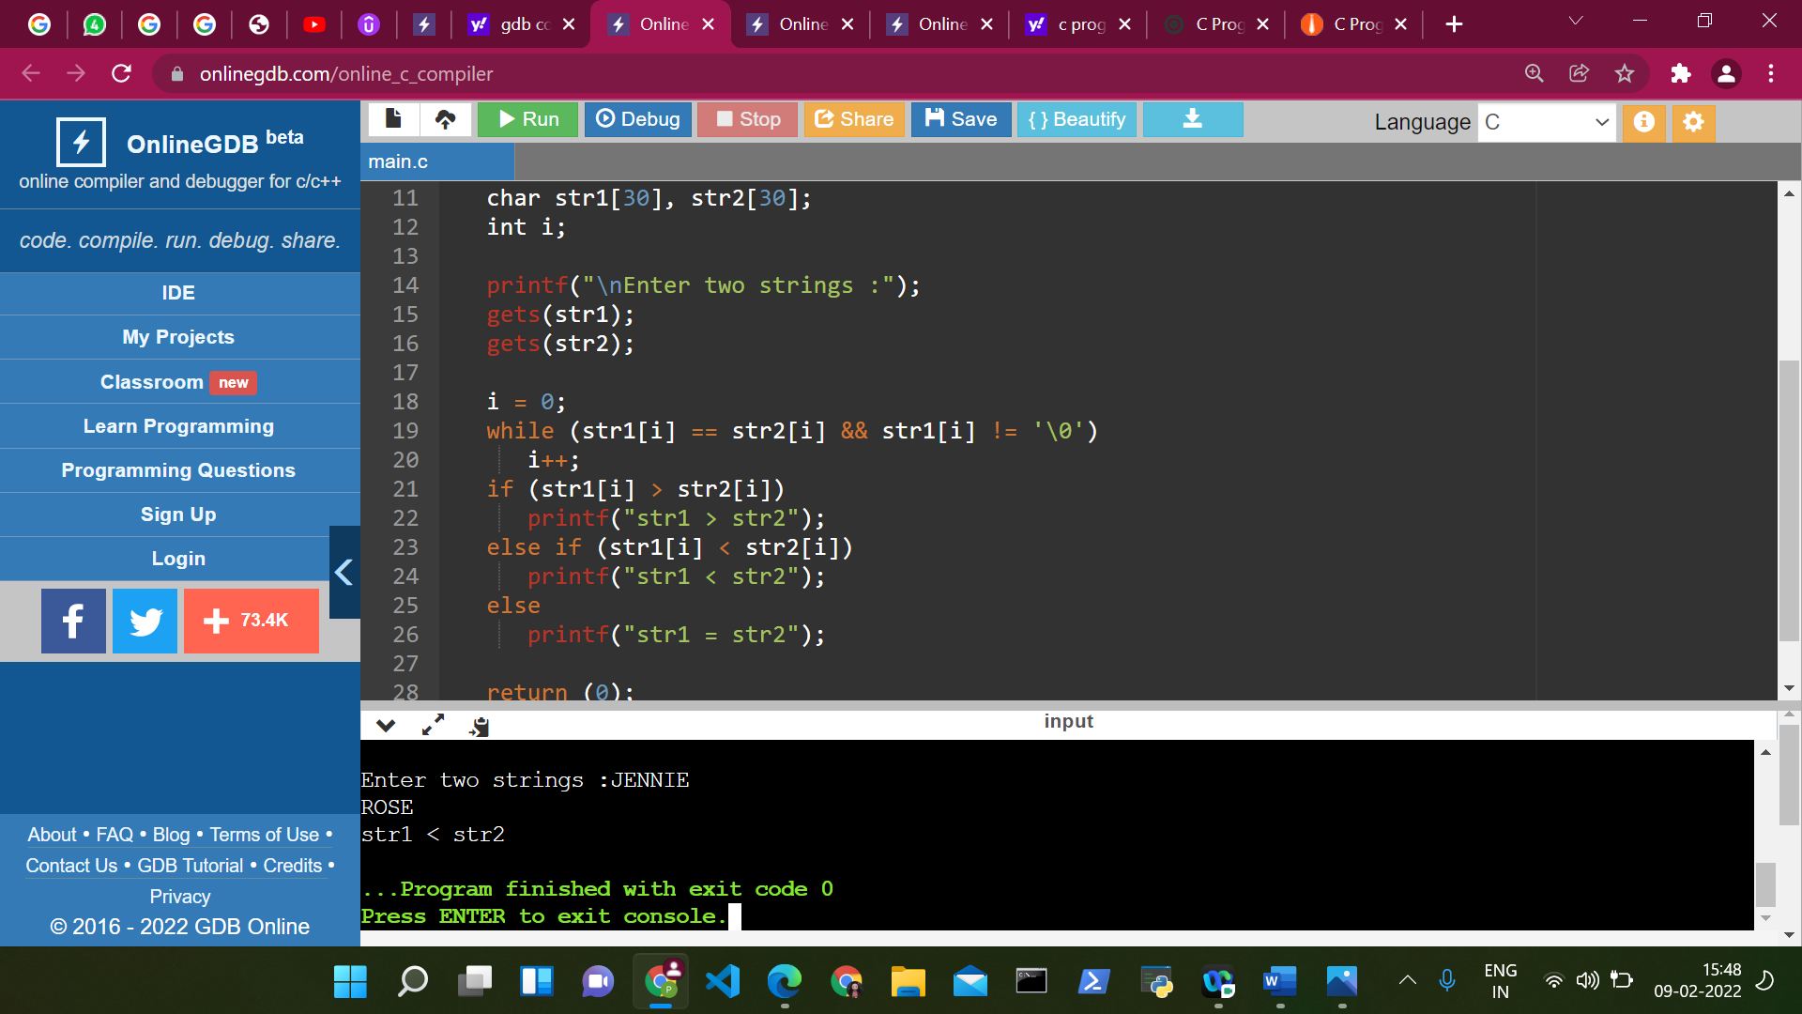

SOL 4:

#include<stdio.h>

int main()

{

char s1[100], s2[100];

int i;

printf("\nEnter the string :");

gets(s1);

i = 0;

while (s1[i] != '\0') {

s2[i] = s1[i];

i++;

}

s2[i] = '\0';

printf("\nCopied String is %s ", s2);

return (0);

}

