SOL 1:

#include <stdio.h>

#include <string.h>

int main()

{

char str[100], result;

int i, len;

int max = 0;

int freq[256] = {0};

printf("\nInput the string : ");

gets(str);

len = strlen(str);

for(i = 0; i < len; i++)

{

freq[str[i]]++;

}

for(i = 0; i < 256; i++)

{

if(freq[i] > freq[max])

{

max = i;

}

}

printf("The Highest frequency of character '%c'\nappears numbers of times:%d", max, freq[max]);

return 0;

}

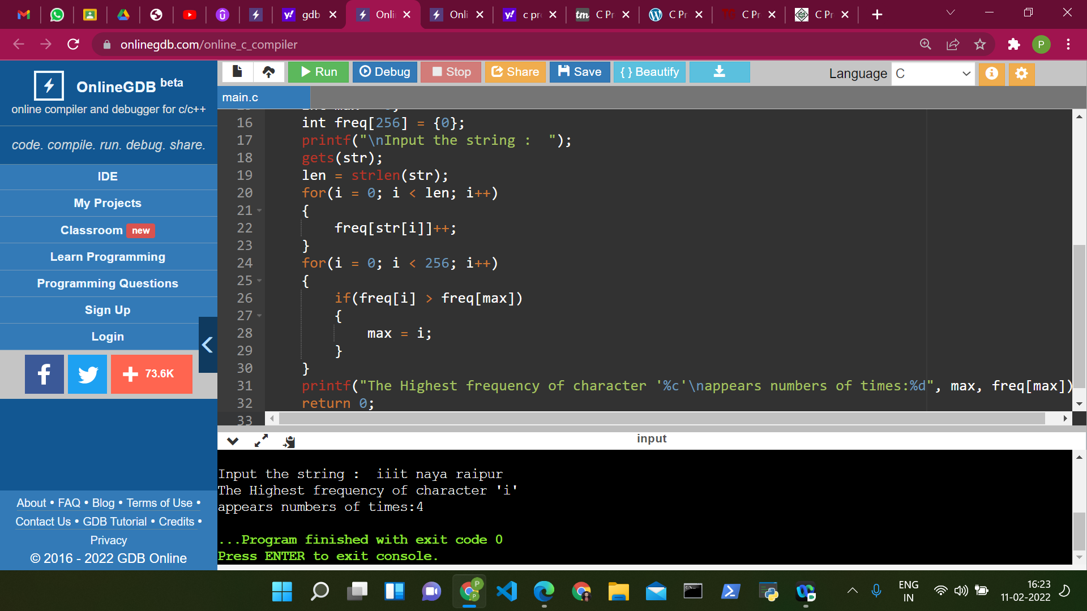

SOL 2:

#include<stdio.h>

int main()

{

char str[80], search[10];

int count1 = 0, count2 = 0, i, j, flag;

printf("Enter a string:");

gets(str);

printf("Enter substring to be searched:");

gets(search);

while (str[count1] != '\0')

count1++;

while (search[count2] != '\0')

count2++;

for (i = 0; i <= count1 - count2; i++)

{

for (j = i; j < i + count2; j++)

{

flag = 1;

if (str[j] != search[j - i])

{

flag = 0;

break;

}

}

if (flag == 1)

break;

}

if (flag == 1)

printf("Substring exists");

else

printf("Substring not found");

return 0;

}

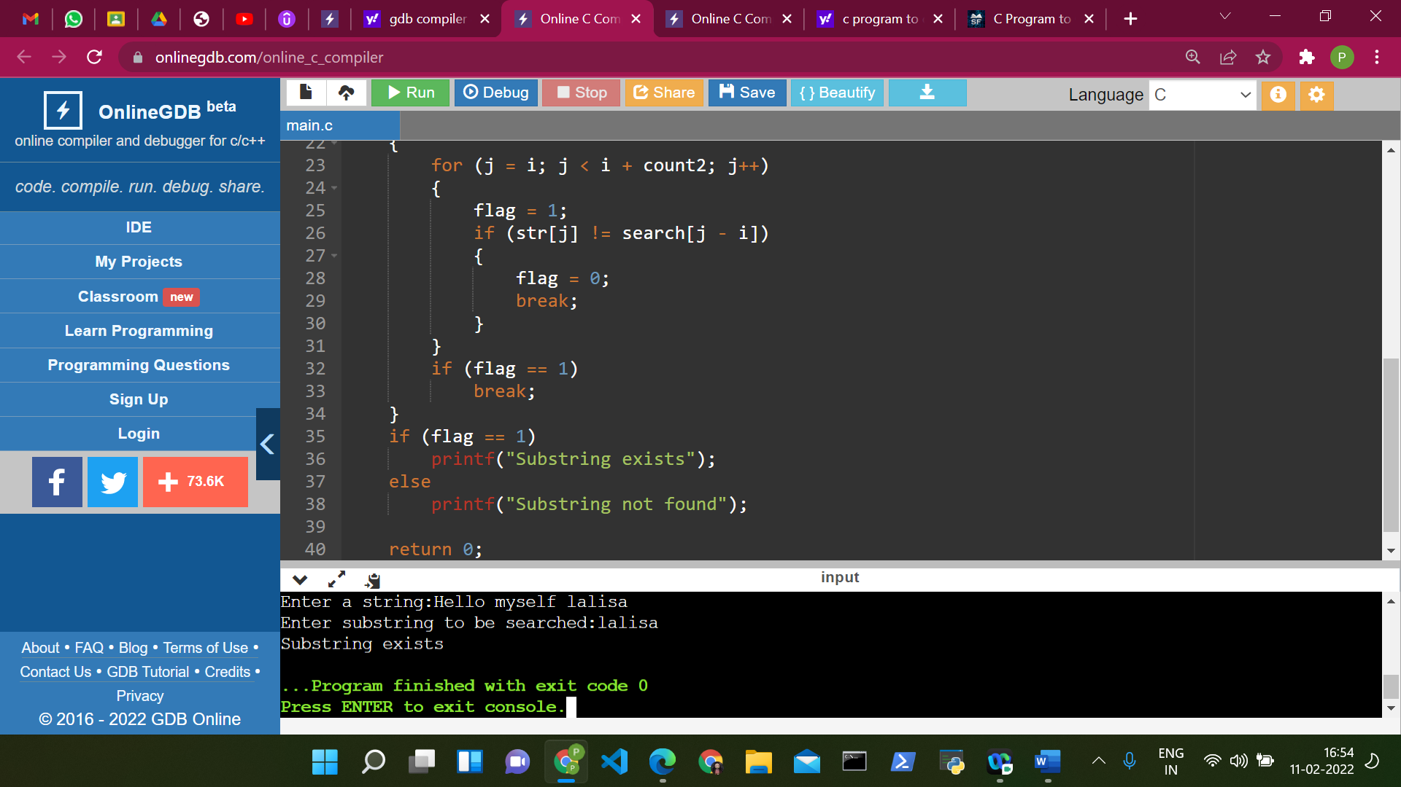

SOL 3:

#include <stdio.h>

int main ()

{

int c = 0;

char ch, s[1000];

printf("Input a string: ");

gets(s);

while (s[c] != '\0')

{

ch = s[c];

if (ch >= 'A' && ch <= 'Z')

s[c] = s[c] + 32;

else if (ch >= 'a' && ch <= 'z')

s[c] = s[c] - 32;

c++;

}

printf("Swapped case string: %s", s);

return 0;

}

