SOL 1:

#include <stdio.h>

int main() {

char line[150];

printf("Enter a string: ");

fgets(line, sizeof(line), stdin);

for (int i = 0, j; line[i] != '\0'; ++i)

{

while (!(line[i] >= 'a' && line[i] <= 'z') && !(line[i] >= 'A' && line[i] <= 'Z') && !(line[i] == '\0'))

{

for (j = i; line[j] != '\0'; ++j)

{

line[j] = line[j + 1];

}

line[j] = '\0';

}

}

printf("Output String: ");

puts(line);

return 0;

}

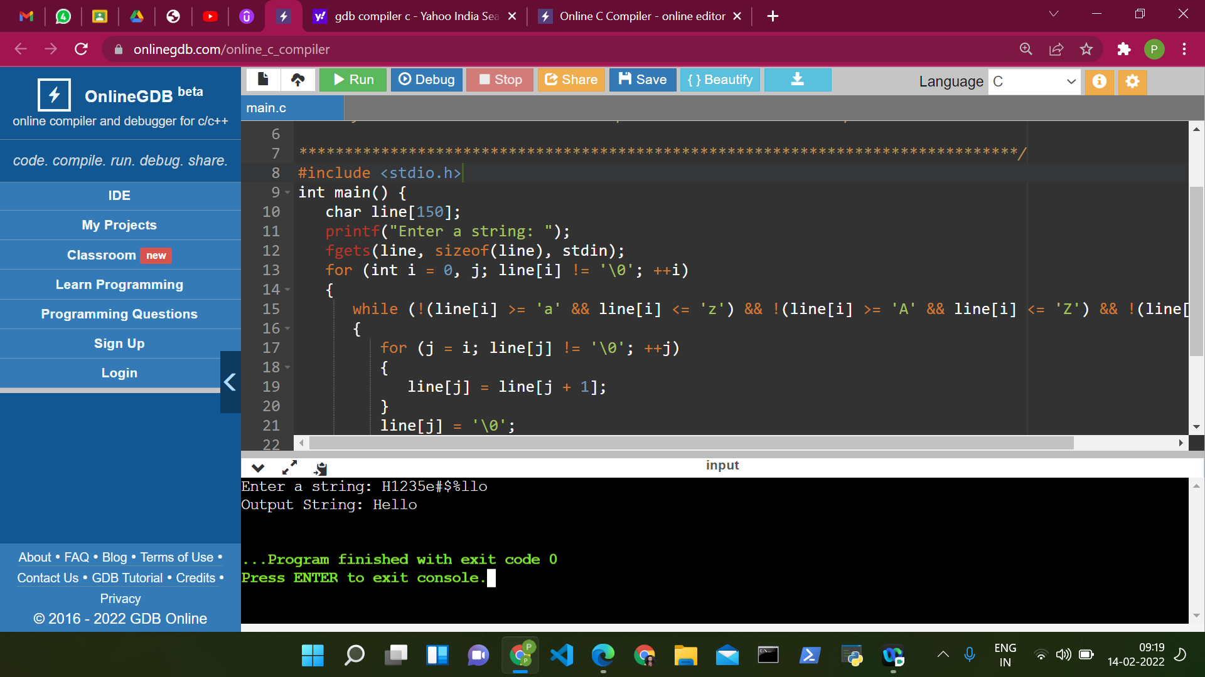

SOL 2:

#include<stdio.h>

#include<string.h>

void main()

{

int i=0,j=0,k=0,a,minIndex=0,maxIndex=0,max=0,min=0;

char str1[100]={0},substr[100][100]={0},c;

printf("Enter a sentence:");

gets(str1);

while(str1[k]!='\0')

{

j=0;

while(str1[k]!=' '&&str1[k]!='\0')

{

substr[i][j]=str1[k];

k++;

j++;

}

substr[i][j]='\0';

i++;

if(str1[k]!='\0')

{

k++;

}

}

int len=i;

max=strlen(substr[0]);

min=strlen(substr[0]);

for(i=0;i<len;i++)

{

a=strlen(substr[i]);

if(a>max)

{

max=a;

maxIndex=i;

}

if(a<min)

{

min=a;

minIndex=i;

}

}

printf("Largest Word is: %s \nSmallest word is: %s\n",substr[maxIndex],substr[minIndex]);

}

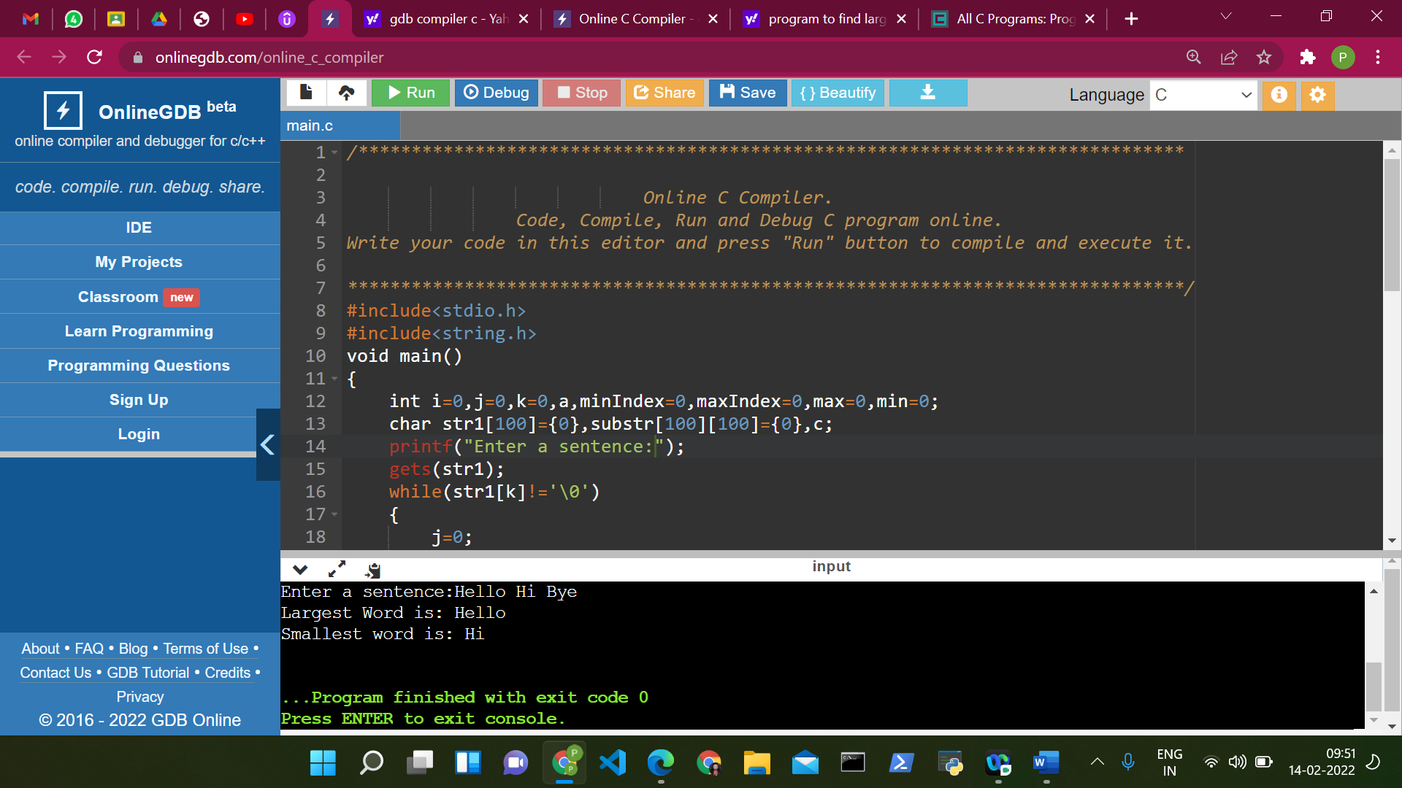

SOL 3:

#include <stdio.h>

#include <string.h>

int main()

{

char string[] = "When pigs fly";

char ch = '-';

for(int i = 0; i < strlen(string); i++){

if(string[i] == ' ')

string[i] = ch;

}

printf("String after replacing spaces with given character: \n");

printf("%s", string);

return 0;

}

