SOL 1:

#include <stdio.h>

int main()

{

int x,y;

int \*ptr;

x=10;

ptr=&x;

y=\*ptr;

printf("%d is stored in location %u\n", x,&x);

printf("%d is stored in location %u\n", \*&x,&x);

printf("%d is stored in location %u\n", \*ptr,ptr);

printf("%d is stored in location %u\n", y,&\*ptr);

printf("%u is stored in location %u\n", ptr,&ptr);

printf("%u is stored in location %u\n", y,&y);

return 0;

}

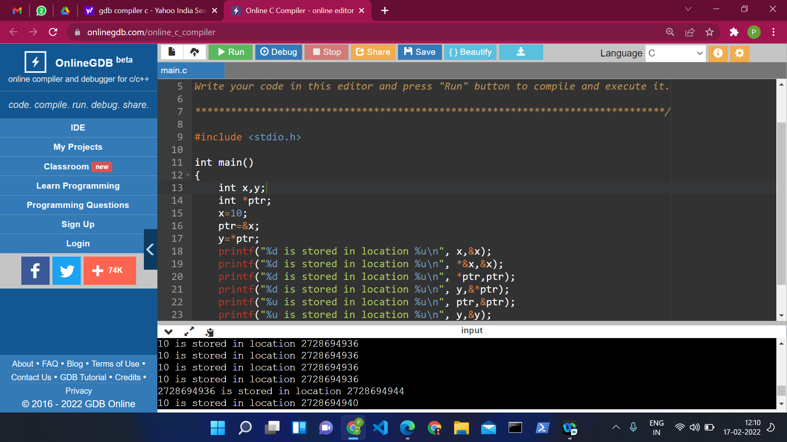

SOL 2:

#include <stdio.h>

void main()

{

int \*ptr1,\*ptr2,a,b;

printf("Enter two nos.:");

scanf("%d %d",&a,&b);

ptr1=&a;

ptr2=&b;

printf("Sum of two nos. using pointers:\n");

printf("%d + %d = %d",a,b,\*ptr1+\*ptr2);

}

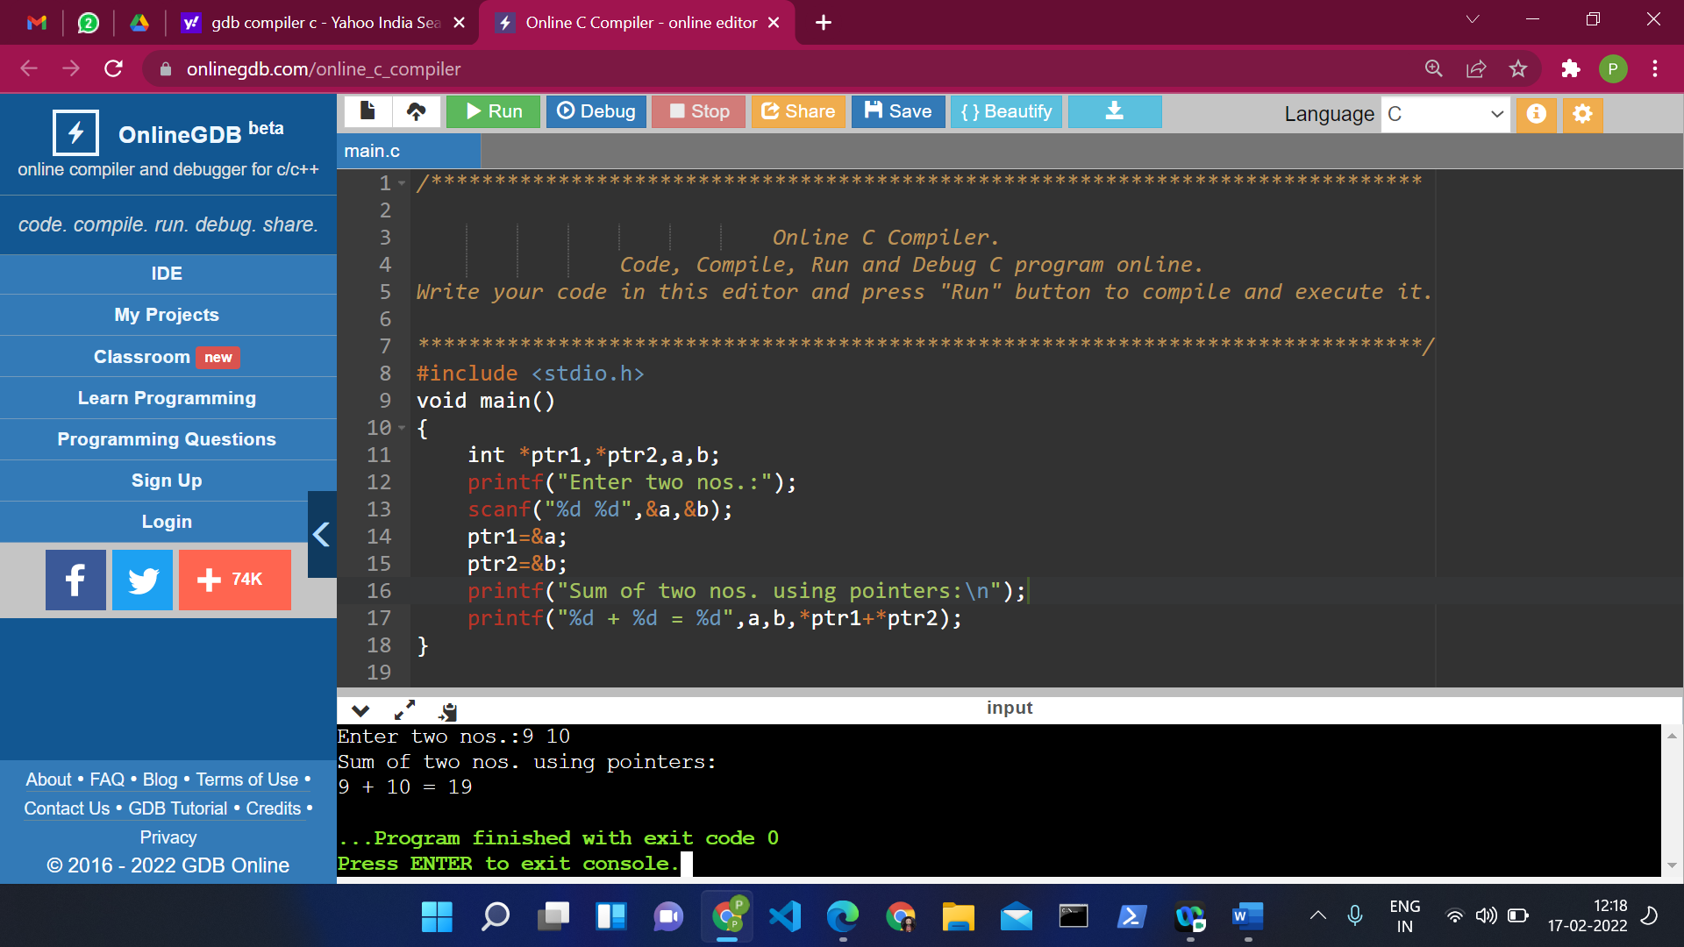

SOL 3:

#include <stdio.h>

void main()

{

int a,b,c,big;

int \*ptr,\*ptr1,\*ptr2,\*ptr3;

printf("Enter 3 nos. to compare:");

scanf("%d %d %d",&a,&b,&c);

ptr1=&a;

ptr2=&b;

ptr3=&c;

big=((\*ptr1>\*ptr2 && \*ptr1>\*ptr3)?\*ptr1:\*ptr2>\*ptr3?\*ptr2:\*ptr3);

ptr=&big;

printf("The maximum of the given 3 nos. using pointer is: %d",\*ptr);

}

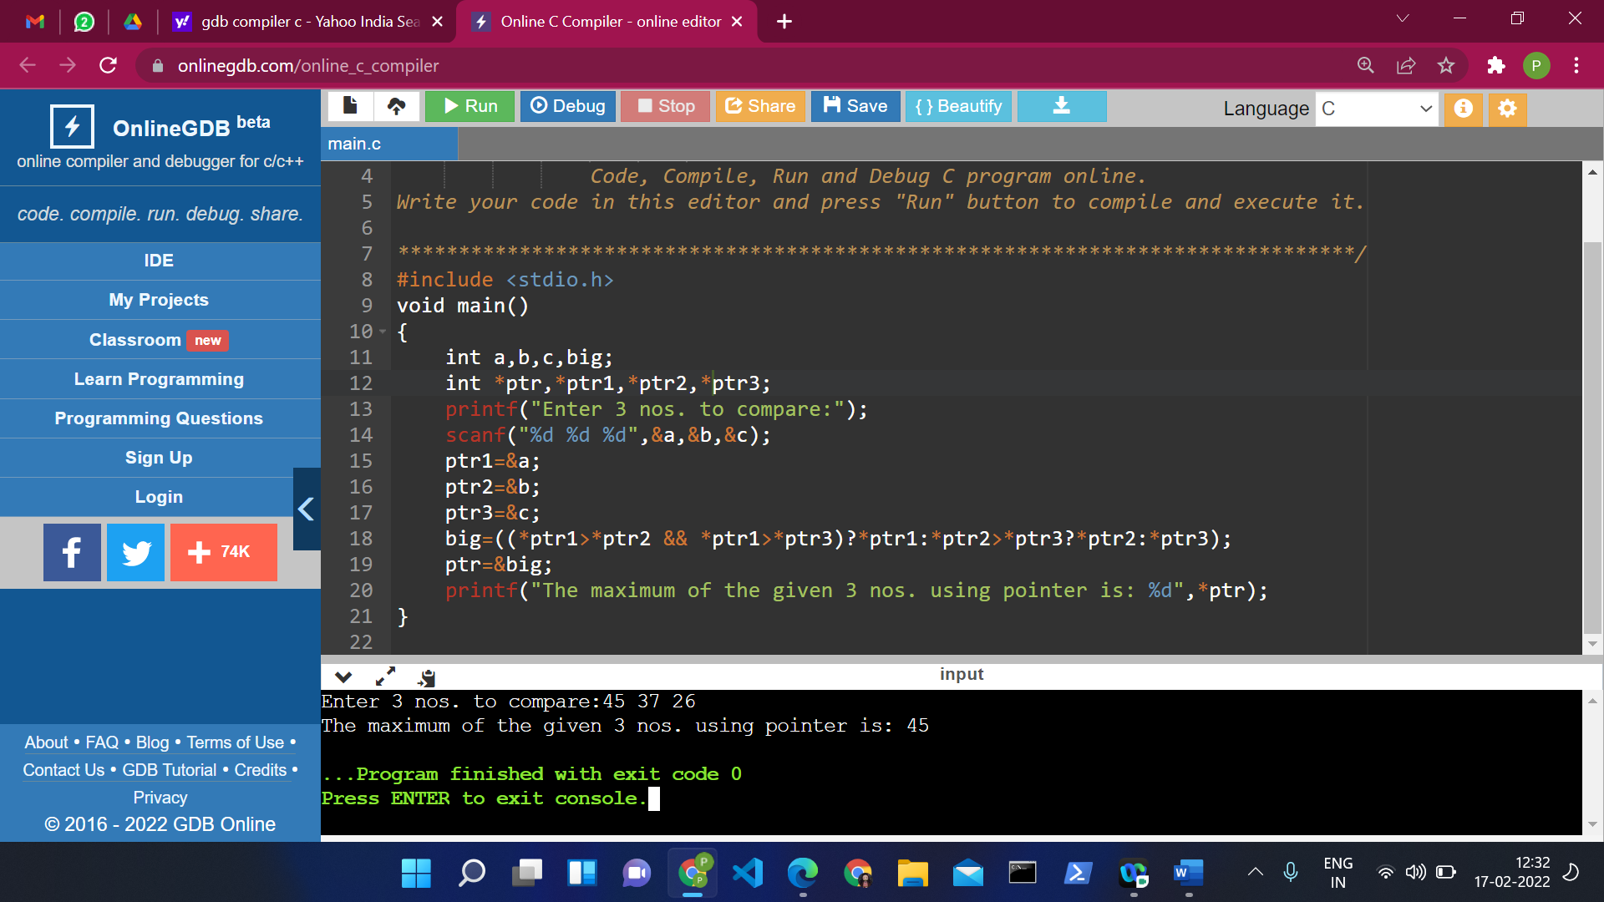

SOL 4:

#include <stdio.h>

void main()

{

int n,x[50],i;

int \*p;

p=x;

printf("Enter no. of elements to store in array:");

scanf("%d",&n);

printf("Input %d number of elements in the array:\n",n);

for(i=0;i<n;i++)

{

printf("element - %d : ",i);

scanf("%d",x+i);

}

printf(" The elements you entered are : \n");

for(i=0;i<n;i++)

{

printf("element - %d : %d \n",i,\*p+i);

}

}

