SOL 1:

#include <stdio.h>

#include <string.h>

void swap(char *x, char *y)

{

char c;

c = *x;

*x = *y;

*y = c;

}

void p(char *a, int l, int r)

{

int i;

if (l == r)

printf("%s ", a);

else

{

for (i = l; i <= r; i++)

{

swap((a + l), (a + i));

p(a, l + 1, r);

swap((a + l), (a + i));

}

}

}

int main()

{

char str[] = "abcd";

int n = strlen(str);

p(str, 0, n-1);

return 0;

}

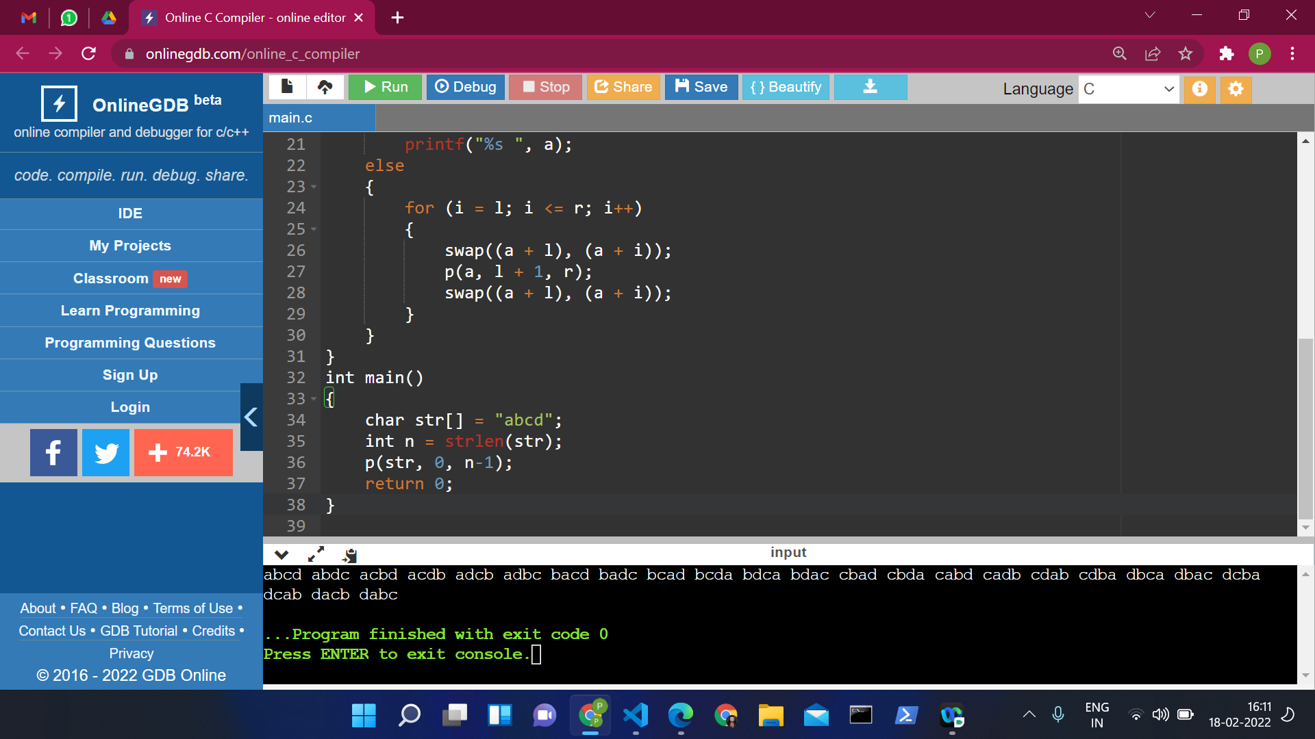

SOL 2:

#include<stdio.h>

#include<conio.h>

int string_ln(char*);

void main() {

char str[20];

int length;

printf("\nEnter any string : ");

gets(str);

length = string_ln(str);

printf("The length of the given string %s is : %d", str, length);

}

int string_ln(char*p)

{

int count = 0;

while (*p != '\0') {

count++;

p++;

}

return count;

}

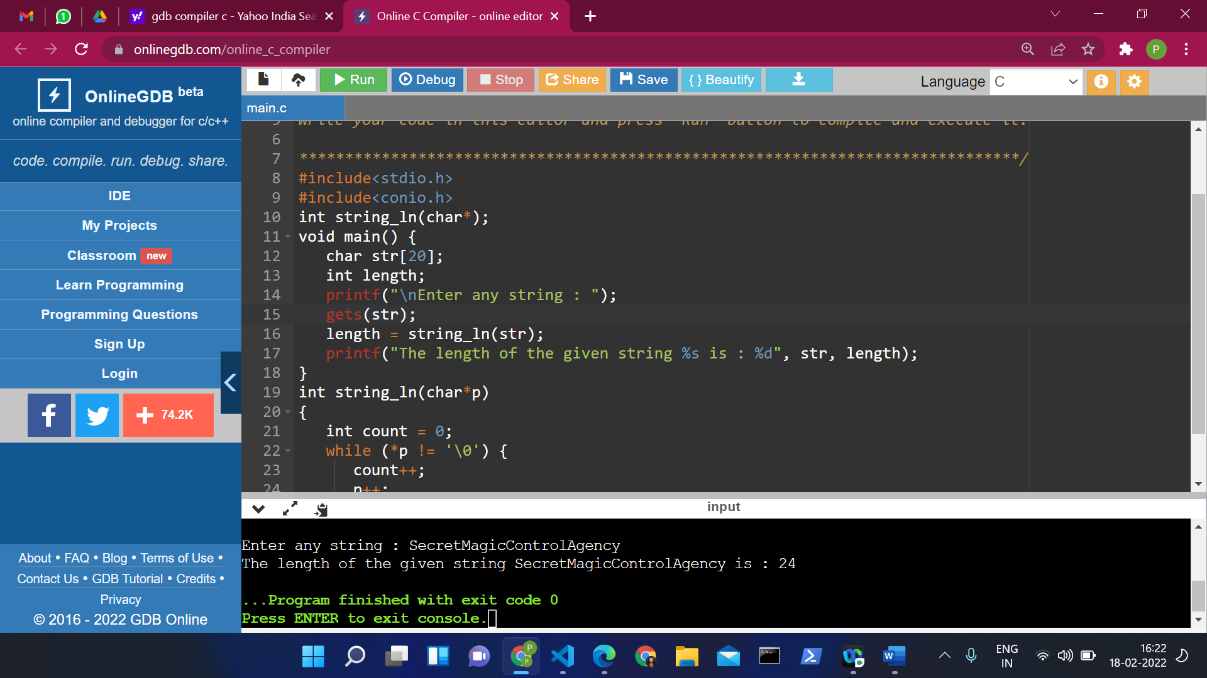

SOL 3:

#include <stdio.h>

void findFactorial(int, int *);

int main()

{

int i,fact,num;

printf("Enter a number: ");

scanf("%d",&num);

findFactorial(num, &fact);

printf("Factorial of %d is: %d",num,fact);

return 0;

}

void findFactorial(int num, int *fact)

{

int i;

*fact=1;

for(i=1; i<=num; i++)

{

*fact=*fact*i;

}

}

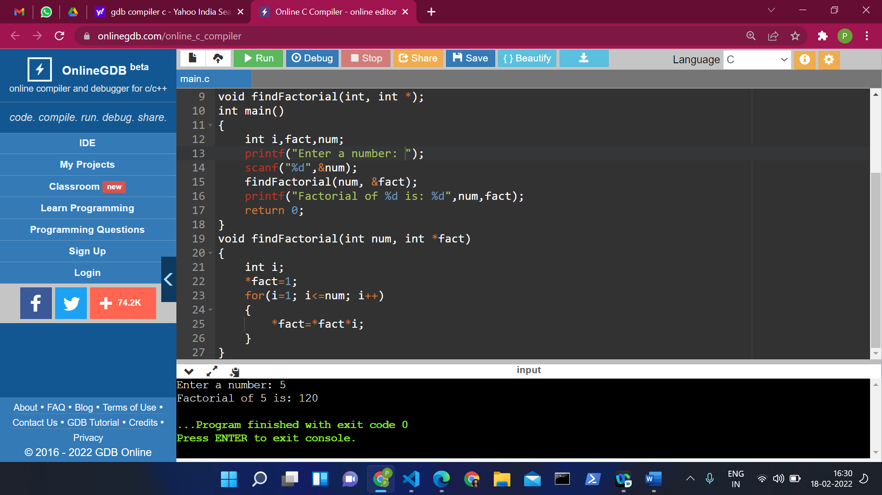

SOL 4:

#include <stdio.h>

int main()

{

char str[100];

char *ptr;

int vowel,consonant;

printf("Enter any string: ");

scanf("%s",str);

ptr=str;

vowel=consonant=0;

while(*ptr!='\0')

{

if(*ptr=='A' ||*ptr=='E' ||*ptr=='I' ||*ptr=='O' ||*ptr=='U' ||*ptr=='a' ||*ptr=='e' ||*ptr=='i' ||*ptr=='o' ||*ptr=='u')

vowel++;

else

consonant++;

ptr++;

}

printf("\nTotal number of,\nVOWELS : %d \nCONSONANTS : %d",vowel,consonant);

return 0;

}

